Achieve objectives of engineering design course through theo jansen project and a design sample
Yucheng Liu, Aaron Artigue, Jeremy Sommers
Department of Mechanical Engineering
Terrence L. Chambers
College of Engineering
University of Louisiana
Lafayette, LA 70504, USA
Abstract: Objectives of a project oriented course in mechanical engineering, Engineering Design, were achieved through a design project where students designed, built, and demonstrated an extreme version of basic Theo Jansen device. Through this project, junior students in University of Louisiana fully developed the capability of applying mathematic and kinematic knowledge in the analysis and design of mechanisms. Students also developed oral and written communication skills as they were used in design environments through the presentation of results in both oral and written forms. An assessment of the design project indicated that effective teaching and learning spread through the semester with the junior students acting as project managers and experiencing design practices. An example of student designed Theo Jansen device is presented in this paper to show the study results achieved by our students.
- Introduction
Engineering Design is a core course in mechanical engineering, which introduces fundamentals in kinematic design of mechanism and application of dynamics to the design of machine elements. In University of Louisiana, this course is designed for junior students to develop effective design practices through the application of dynamic and kinematic backgrounds; to develop design experiences at both the component and system levels; and to develop oral and written communications. In such a design directed engineering course, a design project is an effective tool to expose students to real-world industrial or research projects thereby achieving the course objectives, which is offered by most universities.
Faculty from mechanical engineering and manufacturing engineering at Brigham Young University have jointly developed a new senior capstone design course, which centered on industrial design and manufacturing projects. Those projects involve both product and process design activities and students are required to deliver a functional specification, product and process design, prototype, and first production sample by the end of the semester [1]. Dym [2] offered a collection of meaningful projects such as to design a swing for wheelchair-bound students and to design a robotics arm to feed handicapped students in his engineering design course and receive favorable outcomes. Sheppard and Jenision [3] reviewed examples of design projects that were assigned in engineering design courses at different universities. It is proved that those design projects successfully helped students develop a set of design qualities associated with their competencies and attributes. Giralt et al. [4] embedded a project in the undergraduate chemical engineering curriculum and through this project, horizontal and vertical integration of engineering was achieved. An assessment of the integrated design project indicates that this project greatly helped students to get acquainted with total quality management principles and design processes.
Besides the listed examples, the significance of course project, especially team-based project in engineering education has been fully demonstrated in a number of publications [5-10]. Also, according to the newest criteria of the Accreditation Board for Engineering and Technology (ABET), the design requirements for the engineering program are becoming higher [11]. Therefore, in our Engineering Design class, we offer a team-based project in order to facilitate effective teaching and learning. The objective of this project is to design, build, and analyze an “extreme” version of the basic Theo Jansen device.
- Theo Jansen Project
Theo Jansen devices are built by the Dutch artist and kinetic sculptor, Theo Jansen, which resemble skeletons of animals and are able to walk on the wind. The basic Theo Jansen device is a 13-bar linkage system that “walks” when a crank is turned (Fig. 1). The “Strandbeest”, one of Theo Jansen’s most famous models, is basically a collection of many of the basic devices and it is these devices that offer walking mobility that wheels may struggle with (Fig. 2). In this project, students were required to design an “extreme” version of the basic Theo Jansen device, where they have to first build a basic Theo Jansen device which can walk when a human turns a crank, and then make the device extreme by making it especially large or small, radio-controlled, motorized, wind-powered, etc. This project was worth 10% of the overall grade for the Engineering Design class.
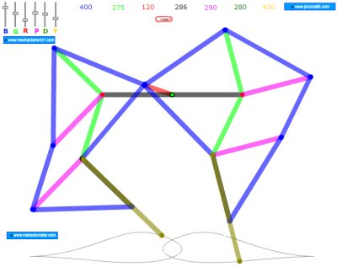
Figure 1. Basic Theo Jansen device

Figure 2. Strandbeest
In our class, students were organized into groups of 3 or 4 members to work on the team-based project, in which they will choose appropriate specification and linkage lengths to design their Theo Jansen device; perform a complete 2D kinematic analysis of both legs of the planar device; plot the x and y position of each foot with respect to the input crank angle; and make the project “extreme” in some way. This project was assigned early in a semester so that students can timely apply the knowledge they learned from the class on this project. Each team consists of 3 to 4 students and the team leader was selected by the team members, who took responsible for calling group meetings and distributing job duties. Deliverables of this project include a one-page project proposal, a Theo Jansen model with excellent craftsmanship, a final report that includes description of the design procedure, kinematic analysis results and calculation steps, and a complete set of engineering drawings. Each group will also make an oral presentation of their works.
- Sample of student design
The Theo Jansen design project highly inspired students’ interests so that they devoted much time and effort working with each other on this project and accomplished excellent design by the end of semester. A sample of our student designs is presented here.
Design procedure
This design was started by determining lengths for each link according to the ratios designed by Theo Jansen. With the given ratios, we only need to arbitrarily pick one link length and the other lengths can be determined using the selected length and ratios. These links would be fabricated on a machine mill, so the length of the longest link did not exceed the maximum length that could be feasibly machined on the mill.
Early in the project, it was realized that a crankshaft was necessary to transfer power to all the linkage systems from one central power source. At first the ideas of using pillow bearings with a machined crankshaft was considered, but later it was deemed more feasible to use wrist pins installed in connecting rods (Fig. 3). The crank throw was designed to be welded to the wrist pins. Three crank throws were fabricated and assembled on each side of the Theo Jansen device, which were spaced 120º apart to ensure that the walker will operate smoothly (Fig. 4).
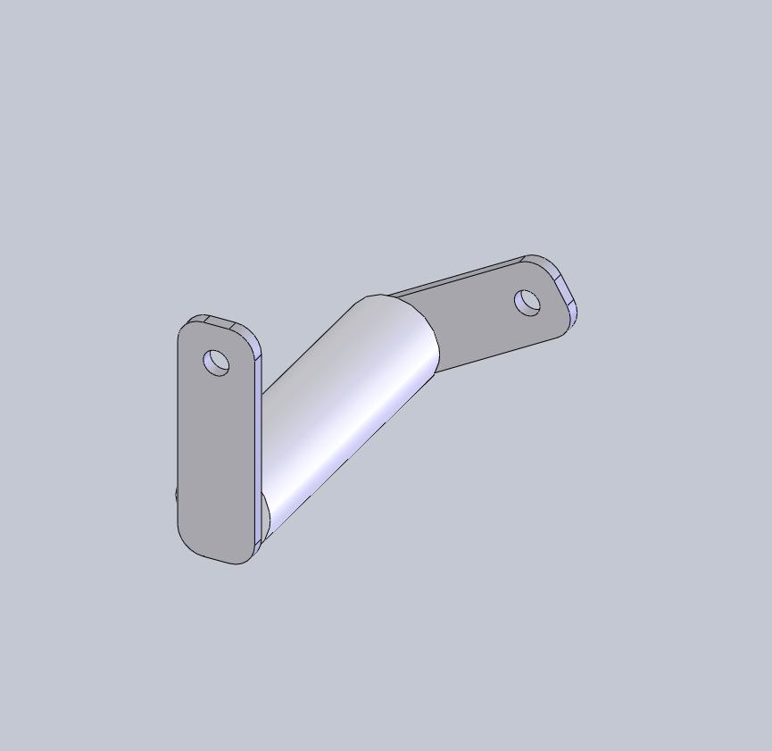
Figure 3. Modeling of using wrist pins in connecting rods
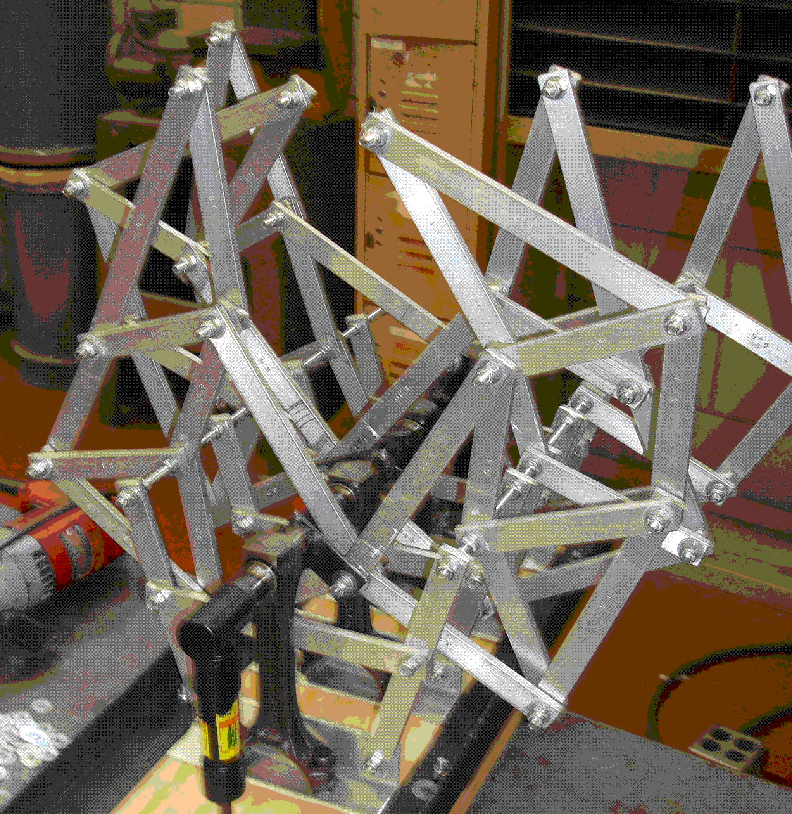
Figure 4. Three crank throws spaced 120º
Before construction for testing the linkage movement, the determined linkage lengths were first used to create a CAD model using SolidWorks to test its mobility and check for potential interferences and possible toggles (Fig. 5) in the assembly. It was found that there would be a crash between a link and a pivot, which is because the Theo Jansen’s ratios did not account for width of link’s material. Based on this finding, we corrected the crank throw length to fully avoid such crash.
A total of 12 links were fabricated from a 1/4” × 3/4” aluminum flat bar, which was cut to size on a horizontal saw. These links were then chucked in a mill so that holes could be drilled precisely and joints could be located properly on the links. After that, all linkage sets were assembled at their joints with 1/4” bolts and nuts, spacing apart each link from its adjacent one with silicone washers to reduce friction (Fig. 6). After constructing the linkage model, each linkage set was rotated individually and manually to assure that no interference between the links existed.
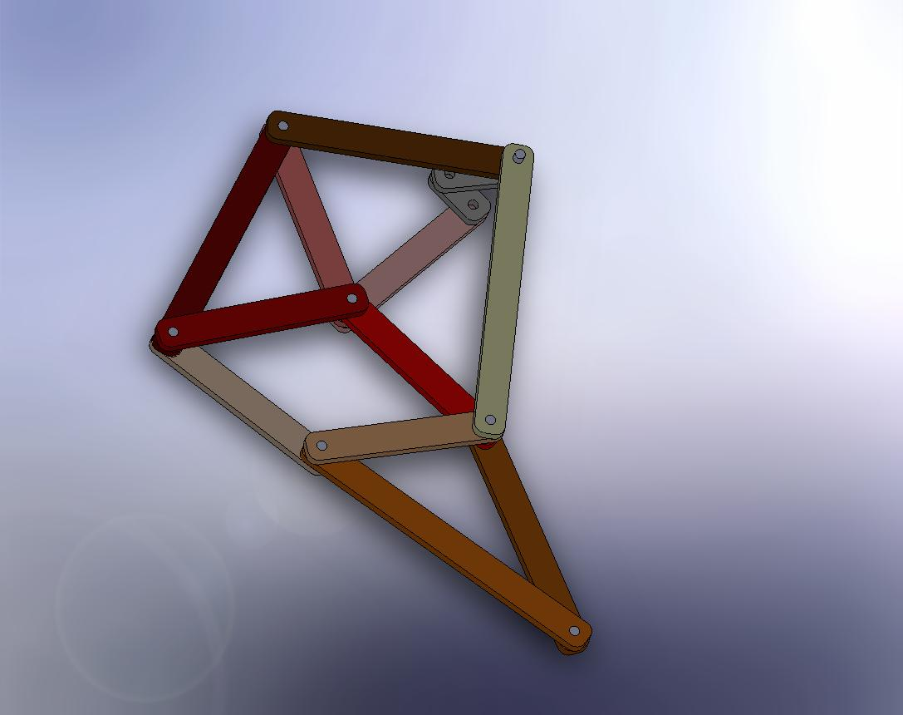
Figure 5. Linkage stack CAD model to check for possible toggles
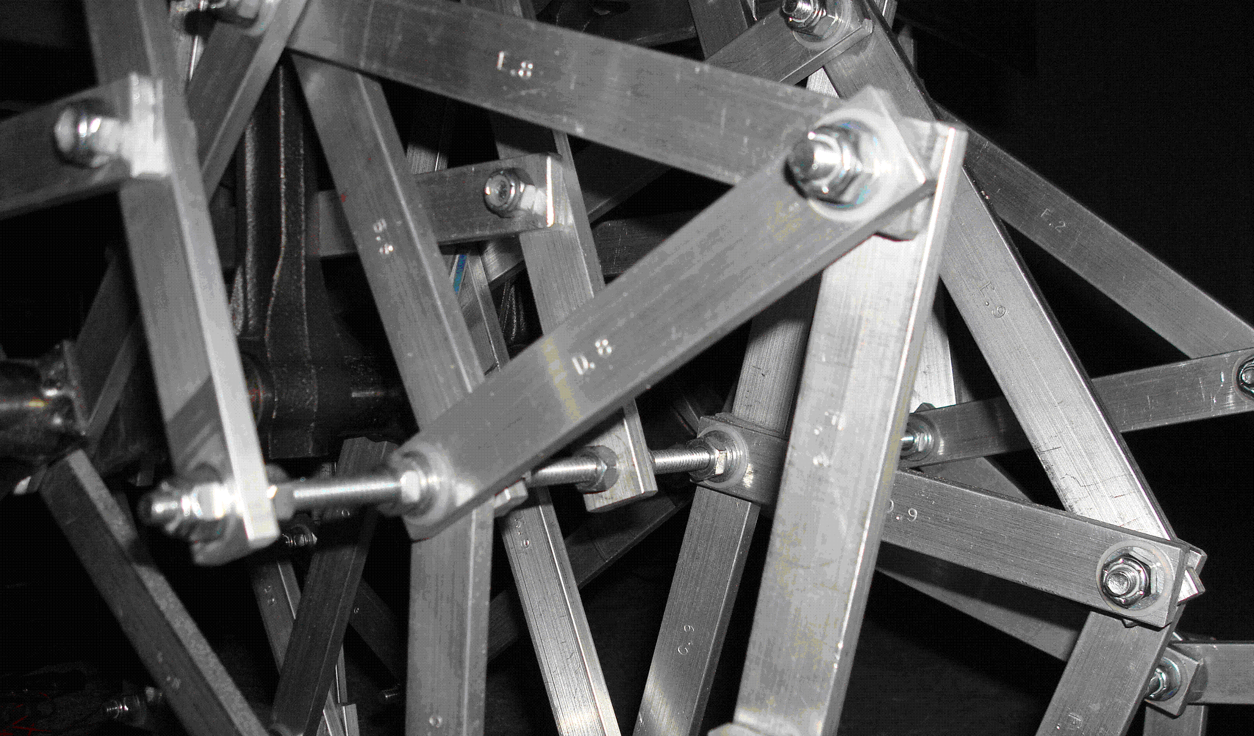
Figure 6. Aluminum linkage with bolts, nuts, and silicon washers
The usual fit between the wrist pins and connecting rods is a press fit, so the pins were turned down appropriately to achieve a 0.010” clearance between themselves and the connecting rod inner diameter. This allowed the wrist pins to rotate freely inside the connecting rods with little resistance (Fig. 3). Further steps were taken to machine grooves in the pins to accommodate snap rings in order to position the wrist pins on the connecting rods. After positioning the wrist pins, the snap rings were installed on either side to secure the wrist pins in place. Crank throws were then machined from a 1/8” steel flat bar, drilled precisely to the calculated link lengths, and then fastened to the wrist pins (Fig. 7). As the wrist pin steel was too hard to drill or/and tap, the crank throws were welded onto the wrist pin ends every 120 degrees, so that all crank throw sets were offset by a third of a rotation.
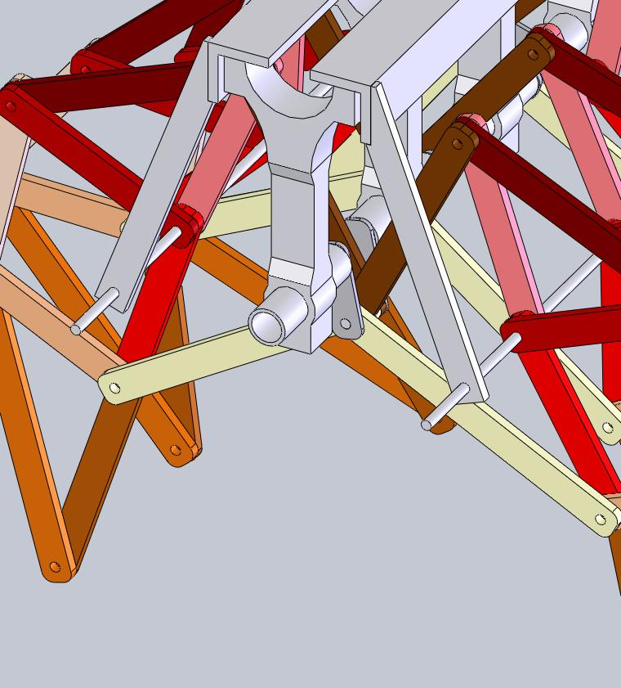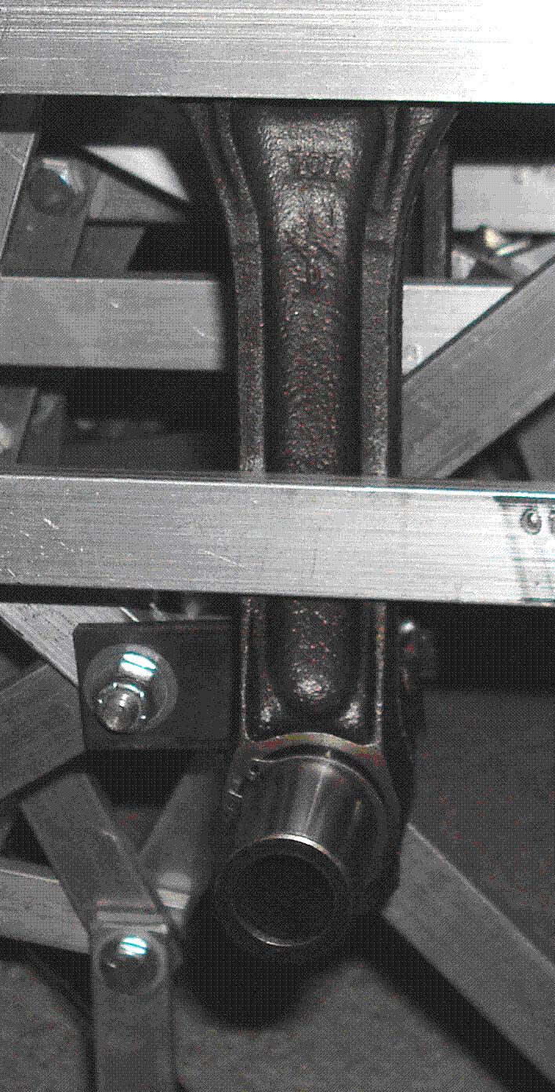
Figure 7. CAD and real model showing the connection of the crank throw and wrist pin
Once the linkage systems, crankshaft system, and crankshaft supports were finished, a base needs to be designed to assemble all the systems. This base was firstly fabricated using aluminum angle (1.5” × 1.5” with 0.125” thick) through cutting and welding (Figs. 8, 9). After creating this base and properly installing the connecting rods and linkage systems, it was found that due to the warping of the aluminum angle, the connecting rods were not parallel to each other along their longitudinal dimension, and therefore every crank throw/pin/link interface would bind during the rotation. Such warping deformation was caused during the heating and cooling of the aluminum material.
In order to overcome such problem, a second base was designed for the walker (linkage systems). In such base, a 4’ × 10” with 3/4” thick plywood was used as the base plate, which was strengthened by that angle iron across the long sections and the aluminum angle as cross braces (Fig. 10). The holes were drilled in the plywood for connecting rods and links on a mill, thereby achieving a higher accuracy than what was attained with a hand drill. The cross braces were cut to length and then were precisely drilled on a mill with the correct hole spacing. When assembling the walker to this base, all the joints lined up correctly so that there was minimal binding (Fig. 11).
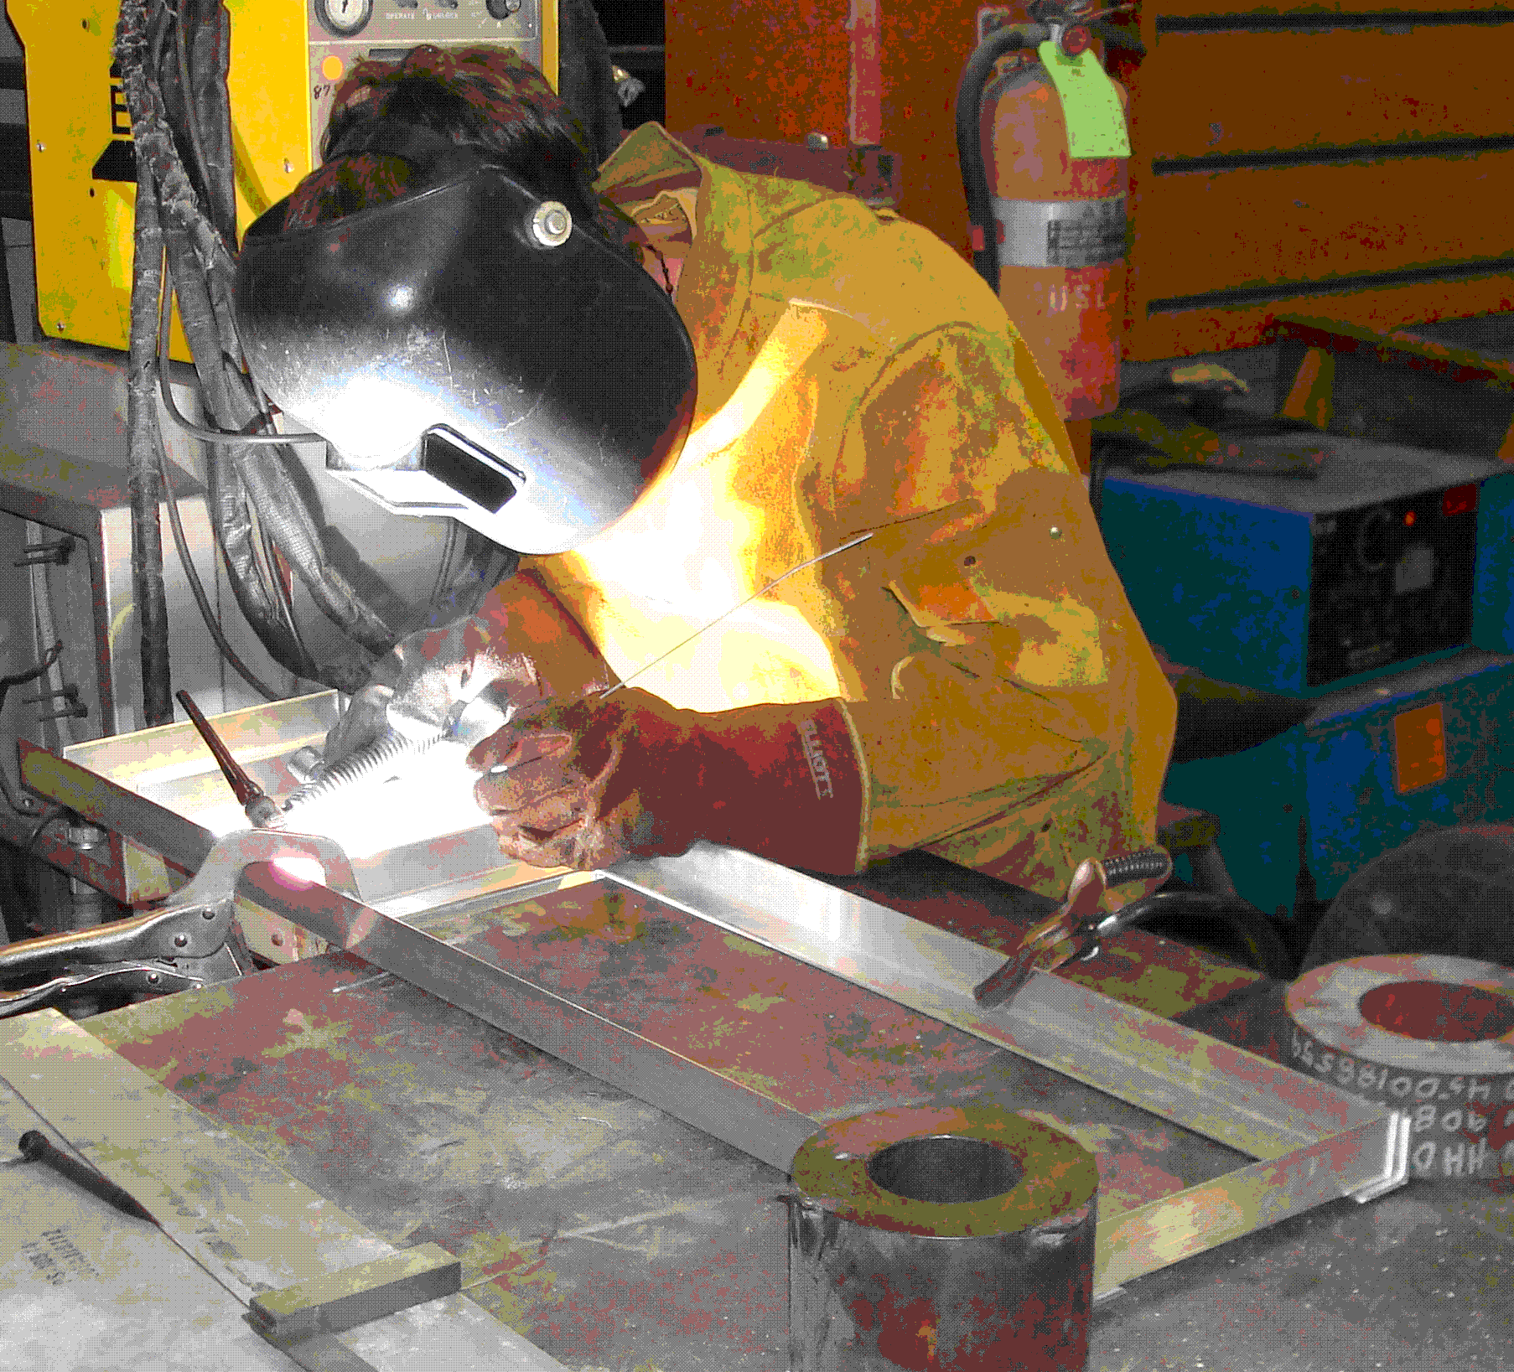
Figure 8. Fabricating the aluminum base

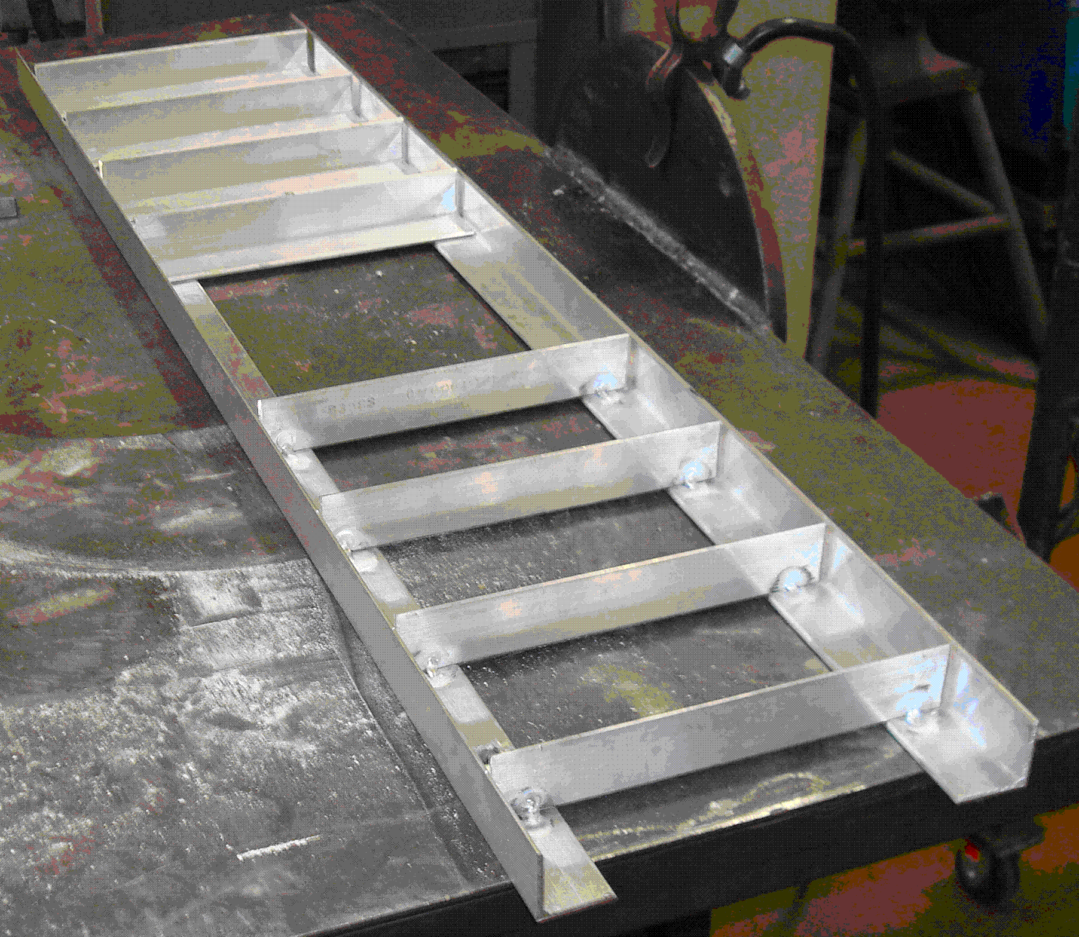
Figure 9. Base made of aluminum angle, with cross braces
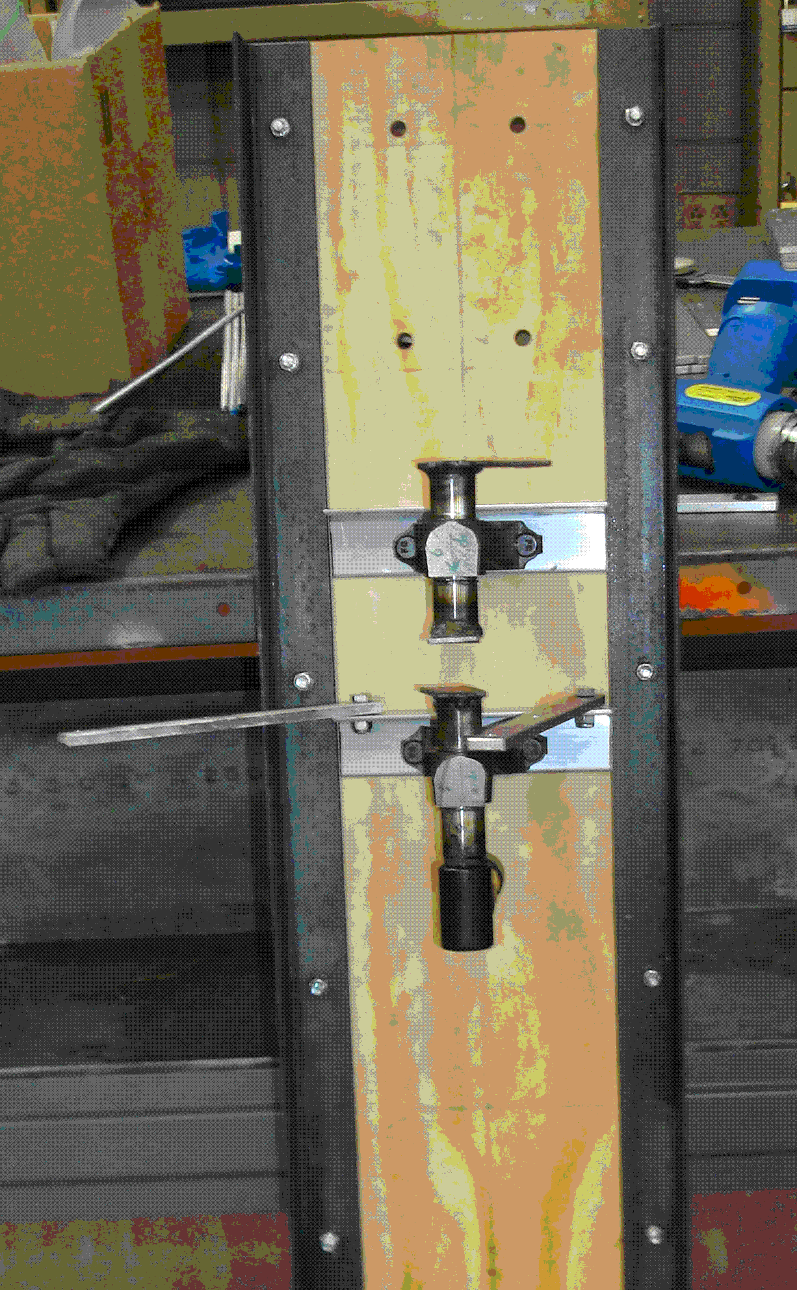
Figure 10. Improved base with plywood and angle iron
Figure 11. Assembling walker to the plywood base
After constructing the base, two steps were taken to design a method of mounting a DC motors onto this base to drive this Theo Jansen device. First, a set of adapters were machined from the threaded drill shafts to the hex-drive rod of the 90 degree adapters, which were connected to the crankshafts. This step was accomplished by first drilling one end of a 3/4” cold rolled steel rod and threading it to fit the driveshaft of the drill motor. On the other side of this adapter, a square-cross-sectioned component was machined to press-fit into a 3/8” drive socket. This socket was sized to fit the hex driveshaft of the 90 degree adapter. The parts were press-fit into place, and then threaded onto the motors. Next, the motors were mounted onto the base using a combination of aluminum angle, drilled and tapped cylinder halves, as well as nuts and bolts. The motors were mounted vertically on the base, with a hole drilled through the base to allow passage of the modified drive adapters (Fig. 12). After testifying this assembly, it was found that such mount scheme was sturdy enough but it did not provide enough power to the crankshaft in turning the linkages. When the walker was working, the gears in the 90º adapters failed and caused overheat and failure of the motors.
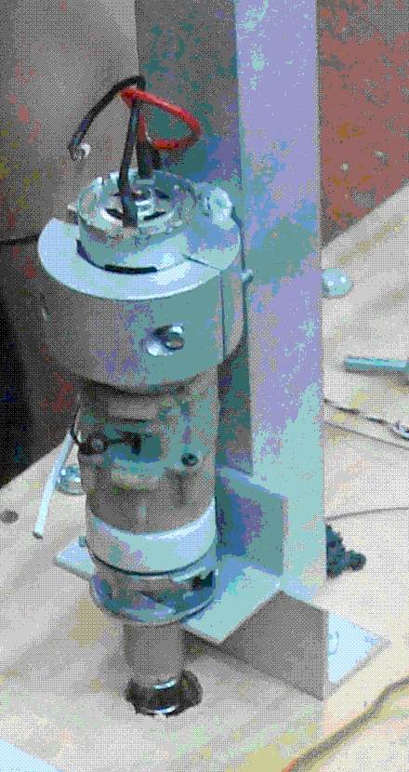
Figure 12. Mounting a DC motor vertically to the base plate
Based on the results of test of the initial driveshaft design, it was deemed that an in-line system was necessary for providing enough power. In the enhanced driveshaft design, the 90º adapters were removed and the motors were mounted axially with the crankshaft. Since both of the motor threads and the threads in crankshaft were the right-hand threads, a motor had to be mounted on outside of the walker so as to move the linkages in the same direction. Meanwhile, AC motors were selected to replace the DC motors because with the same target price, the AC motors provided much more power than the DC motors therefore would not overheat during the regular operation. Tests showed that the AC motors put out sufficient torque to actuate the linkage systems and drove the walker without burning out. However, by using the AC motors, there was no way to control the walker’s speed and direction.
Test and Modification
On completion of all major assembly, this device was tested and a kinematic analysis was performed to ensure that the output motion was acceptable. In order to perform the kinematic analysis, a reference coordinate system was fixed to one of the linkages. The horizontal and vertical distances from the origin to the foot of the linkage system were measured every 5º of the input crankshaft angle. The recorded data were then plotted in Excel and a path for one foot was achieved. Figs. 13 and 14 showed that in each cycle, the foot was lifted in the first stroke and pushed down to the ground during the return stroke.
Figure 13. X-displacement of the foot
Figure 14. Y-displacement of the foot
Evaluation of final design
The test results indicated that the designed linkage system performed very well in walking test and successfully met all design requirements. It was proved that the Theo Jansen’s ratios can be used to determine the link lengths for a linkage system. By using these ratios, designer only needs to choose an arbitrary length for one link, and all the other link lengths can be easily calculated. Also the method of construction was proved to be practical, allowing only a small amount of looseness in the link joints.
From the assembly test, it was evident that a high precision in fabricating and assembling is critical to guarantee the clearance between crank throw and link so as to avoid binding. In order to eliminate the warping, heat resistant material such as plywood was used to make the base plate and the metallic materials (iron, aluminum) were given enough time to cool down before clamps being released.
Critical to the design of any Theo Jansen device is the power input to the crank shaft. As found in this project, gear transfers and adapters should be omitted in a design if possible because they would reduce the drive train efficiency and may cause slip. Also, motors with sufficient torque need to be selected depending on the walker/linkage design. In this project, the AC motors were selected to provide enough input torque. However, in the future, powerful DC motors need to be used instead of the AC motors, which allow the use of remote control electronics in the original design, and enable independent control of each linkage set.
Budget control was another issue considered in the project. The cost of this design was initially estimated as no more than 300 dollars. After several revisions and a few failed motors, the final cost was about 450 dollars. It was also found that the current design can be improved further in appropriate was to lower the total cost.
All the machining, fabricating, and assembling works were finished in the manufacturing workshop of Mechanical Engineering Department at University of Louisiana – Lafayette.
This example was finished by one project team. Each group designed its own Theo Jansen walker and made it extreme through different ways, such as making it very large or small, adding radio control, using wind power, etc.
- Conclusion
This paper introduces a way to enhance teaching effects in Engineering Design course by using the Theo Jansen “Extreme” design project. Feedbacks from the students indicated that this project is an educational and rewarding task, in which diverse knowledge and techniques such as engineering design, computer modeling and drawing, kinematic analysis, material, machining, fabrication, electronics, and many other aspects of engineering were applied. In this project, students were able to apply their previous experience in machining and fabrication, use design techniques learned from the Engineering Design course, and even refer to the knowledge attained from other resources (internet, library, etc.) to make logical decisions and attain optimal prototype along the process. The experiences of team work and budget control in the project did expose the students to real-world industrial or research problems. After finishing this design project, each group explained their design procedure and demonstrated the prototype through oral presentations, and also documented all the design works, analysis results, and conclusions in a technical report. The experiences of oral presentation and drafting technical report developed students’ oral and written communication skills.
As for the actual walker mechanism, much was learned about Theo Jansen devices during the course of this project, including joint quality, required number of linkage sets for stability, weight considerations, and driven power availability, etc. With all the knowledge and techniques acquired from the project, the students were confident of designing and fabricating a greatly improved Theo Jansen device within a shorter time.
In summary, the project gave students unique experiences in team-based design, build, and analysis and all objectives of the Engineering Design course as required by ABET were satisfyingly met. An assessment from students also verified the effectiveness of this instructional method. In spite of all its advantages, in the future new elements can be integrated into this project to enhance its efficacy and better simulate a real industrial design environment. For example, the improved design project will give students an opportunity to work with other engineers in small design teams, to develop client relations, and to consider more non-technical constraints (ethical, political, aesthetic, environmental, economic, culture) in their work.
Reference
[1] R.H. Todd, C.D. Sorensen, S.P. Magleby, “Designing a senior capstone course to satisfy industrial customers”, ASEE Journal of Engineering Education, 82(2), 1993, 92-100.
[2] C.L. Dym, “Teaching design to freshmen: style and content”, ASEE Journal of Engineering Education, 83(4), 1994, 303-310.
[3] S. Sheppard and R. Jenision, “Examples of freshman design education”, International Journal of Engineering Education, 13(4), 1997, 248-261.
[4] F. Giralt, J. Herrero, F.X. Grau, J.R. Alabart, M. Medir, “Two way integration of engineering education through a design project”, ASEE Journal of Engineering Education, 89(2), 2000, 219-229.
[5] N.A. Pendergrass, R.E. Kowalczyk, J.P. Dowd, R.N. Laoulache, W. Nelles, J.A. Golen, E. Fowler, “Improving first-year engineering education”, ASEE Journal of Engineering Education, 90(1), 2001, 33-41.
[6] R.M. Marra, B. Palmer, T.A. Litzinger, “The effect of a first-year engineering design course on student intellectual development as measured by the Perry scheme”, ASEE Journal of Engineering Education, 89(1), 2000, 39-45.
[7] R.L. Miller, B.M. Olds, “A model curriculum for a capstone course in multidisciplinary engineering design”, ASEE Journal of Engineering Education, 83(4), 1994, 1-6.
[8] C.L. Dym, A.M. Agogino, O. Eris, D.D. Frey, L.J. Leifer, “Engineering design thinking, teaching, and learning”, ASEE Journal of Engineering Education, 94(1), 2005, 103-120.
[9] I. Yellowley, P-H. Gu, “Design directed engineering education”, Journal of Engineering Design and Innovation, 1(1), 2005, 1-7.
[10] R.M. Felder, R. Brent, “Designing and teaching courses to satisfy the ABET engineering criteria”, ASEE Journal of Engineering Education, 92(1), 2003, 7-25.
[11] “2009-2010 Criteria for Accrediting Engineering Programs”, Accreditation Board for Engineering and Technology (ABET), 12/1/2008.

