Data Structuring For Statistical
Analysis Of Effectiveness Of Rumble Stripes On Highway Safety
Tulio Sulbaran, Ph.D , David Marchman

Abstract: The United States (U.S.) heavily relies on the roadway infrastructure and a considerable number of highway vehicle miles are driven every year. Unfortunately, the number of fatalities is staggering with accidents becoming more frequent. Every year on U.S highways, there are over 700 fatalities, 40,000 injuries, and 52,000 property-damage-only accidents. Most of the 700 fatalities are due to roadway departures. On average, one roadway departure fatality occurs every 23 minutes, and a roadway departure injury occurs every 43 seconds. It is estimated that the annual cost of roadway departure is $100 billion. The Federal Highway Administration (FHWA) indicates that improvements in infrastructure have helped keep the fatalities number from increasing. However, higher traffic volumes have counteracted any real reductions in the number of fatalities due to roadway departure [Public Roads 2005].

Therefore, countermeasures to prevent or lessen the occurrence of roadway departures are important steps towards improving the safety of U.S. roadways. Roadway departure countermeasures must be designed to keep the motorists in lanes and on the roads, enable the drivers to recover and safely return errant vehicles to the roadway, and keep vehicle occupants from greater harm if a vehicle does leave the roadway.

This paper will focus on a project funded by the MDOT to determine the safety effectiveness of one roadway departure countermeasure, rumble stripes, in Mississippi. More specifically, this paper presents a focuses on the process implemented to restructure and consolidate the data obtained from multiple divisions and districts to be able to measure the impact of rumble stripes on highway’ safety.

The content of this paper was later used as the foundation for statistical analysis. The results presented in this paper reveal the importance of inter division and district collaboration, the need to establish a common data structure to facilitate the exchange of information among divisions and districts and the importance of using real life applied research experiences for making the connections that facilitate engineering education.

Keywords: Rumble Stripes, Rumble Strips, Safety, Data, Structuring

Introduction to Roadway Fatalities

The United States (U.S.) heavily relies on the roadway infrastructure. As shown in Table 1 a considerable number of highway vehicle miles are driven every year. Unfortunately, the number of fatalities is staggering with accidents becoming more frequent, resulting in situations as the one depicted in Figure 1.

Every year on U.S highways, there are over 700 fatalities, 40,000 injuries, and 52,000 property-damage-only accidents [Mohan & Gautam, 2002]. Most of the 700 fatalities are due to roadway departures. On average, one roadway departure fatality occurs every 23 minutes, and a roadway departure injury occurs every 43 seconds. It is estimated that the annual cost of roadway departure is $100 billion [FHWA Resource Center 2006]

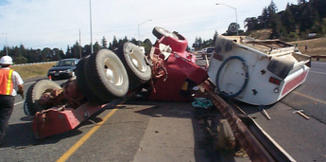

Figure 1. Crash Sample Picture [Public Roads 2004]

The Federal Highway Administration (FHWA) indicates that improvements in infrastructure have helped keep the fatalities number from increasing. However, higher traffic volumes have counteracted any real reductions in the number of fatalities due to roadway departure [Public Roads 2005].

Therefore, countermeasures to prevent or lessen the occurrence of roadway departures are important steps towards improving the safety of U.S. roadways. Roadway departure countermeasures must be designed to keep the motorists in lanes and on the roads, enable the drivers to recover and safely return errant vehicles to the roadway, and keep vehicle occupants from greater harm if a vehicle does leave the roadway [Public Roads 2005].

This paper will focus on a project funded by the Mississippi Department of Transportation (MDOT) to determine the safety effectiveness of one roadway departure countermeasure, rumble stripes, in Mississippi. More specifically, this paper focuses on the process implemented to restructure and consolidate the data obtained from multiple divisions and districts to be able to measure the impact of rumble stripes on highway’ safety.

The content of this paper was later used as the foundation for statistical analysis. The results presented in this paper reveal the importance of inter division and district collaboration and the need to establish a common data structure to facilitate the exchange of information among divisions and districts.

Overview Of The MDOT Divisions and

District Offices and their Collected Data
Collecting, processing, archiving and retrieving data/information are a costly, demanding and necessary MDOT divisions and district offices. Each division and district office manages data/information in a different way for a variety of purposes to fulfill their primary responsibility/mission.

The first step in consolidating the data was to identify the divisions and district offices with needed data, and their responsibility/roles in collecting data. Figure 2 shows the information needed for this project and the particular MDOT division and/or district responsible for the data.

Then, the MDOT leader of this project contacted the divisions and district offices and provided a brief description of the project and the research team. The research team followed-up this initial contact by requesting a meeting with the representatives of the divisions and district offices to provide an overview of the project and initiate the turn-over of the data that had been collected by the divisions and district offices.
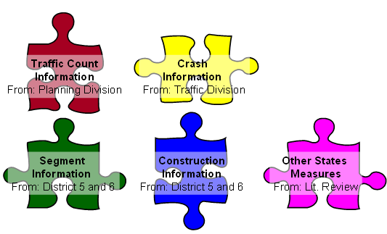
Figure 2. Data Needed for the Study and Sources

During, this initial meeting an informal interview was conducted with the divisions and district offices representative to explicitly identify the data that the divisions and district offices had already collected, the structure, and the media in which the data was stored as well as the retrieval means of the agency. Upon agreeing with the divisions and district offices concerning the data to be retrieved, a mechanism to transfer the data was established. As expected and evidenced below, each divisions and district offices used a different structure to archive the data. The following is a brief description of the data collected by different divisions and district offices involved in Rumble Strip/Stripes on Mississippi roads:

Districts 5 and 6 Data - Mississippi Department of Transportation (MDOT)
The MDOT District 5 and6 Office had all the construction documents developed by engineering prior to the construction as well as all the construction documents generated during the construction process. Given the diversity of the information handled by this office, there was no common structure in the data archived. This office handled descriptive, pictorial and numerical information. Information ranged from specific in nature (either by location or day) to very broad. One of the most valuable pieces of information provided by the District offices to the research team was the segments that could be used for this project as shown Table 1.

Table 1. Road Segments Included in the Study

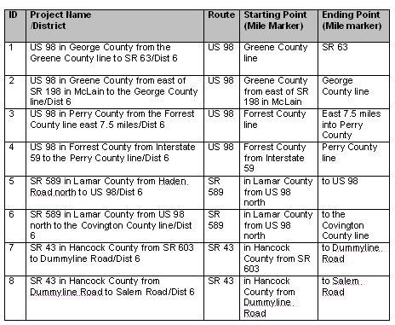

Continue.. Table 1. Road Segments Included in the Study

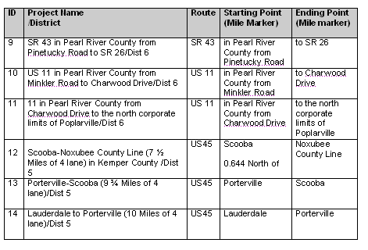

Planning Division Data - Mississippi Department of Transportation (MDOT)
The MDOT Planning Division had placed a number of traffic recording devices around the state. The data/information collected from these devices was mainly handled/presented in pictorial and numerical form. One of the most valuable pieces of information provided by the Planning Division to the research team was traffic volume in the studied area. Figure 3 through Figure 6 shows a sample of types of traffic volume data obtained from the Planning Division.

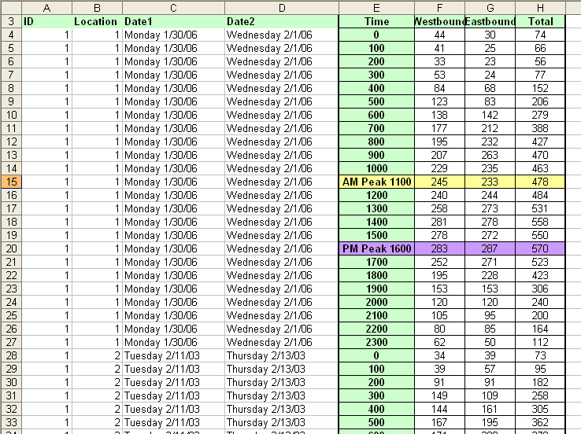

Figure 3. A Sample of the Hourly Traffic Volume Data Received from Planning

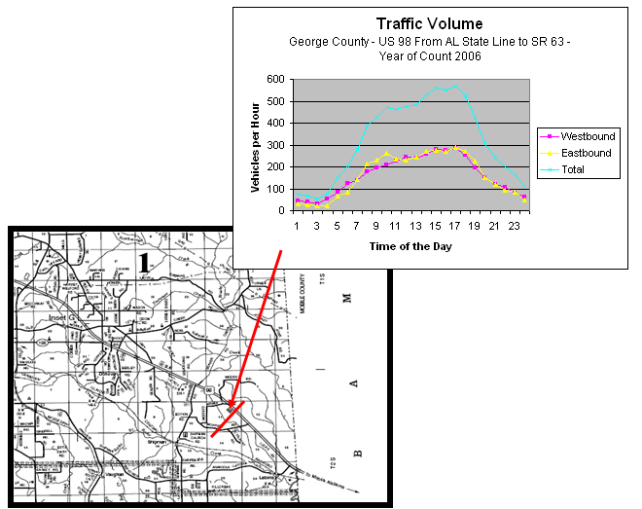

Figure 4. A Sample of the Hourly Traffic Volume Data Received from Planning

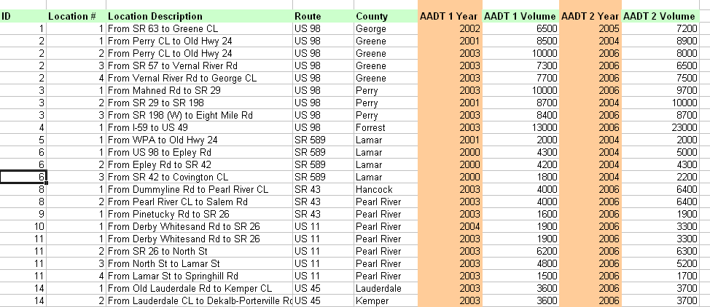

Figure 5. Annual Average Daily Traffic over Time Received from Planning

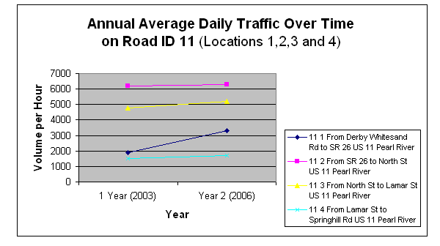

Figure 6. A Sample of the Annual Average Daily Traffic Over Time
Receive from Planning

Traffic Engineering Division Data – Mississippi Department of Transportation (MDOT)
The MDOT Traffic Engineering Division continuously collects safety related information. All information provided by this office to the research team was in electronic files. Several files were provided to the research team to analyze the safety conditions of the studied area. Although, all the data was electronically stored, given the diversity of the data, few (if any) of the fields were common to all the data stored. The most valuable pieces of information provided by the Traffic Engineering Division to the research team were the crash data. Figure 7 to 9 show a sample of crash data obtained from the Traffic Engineering Division.

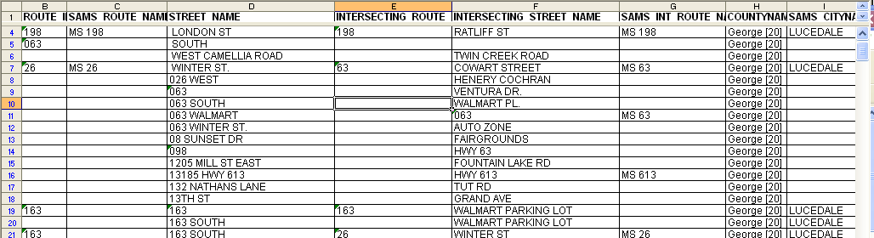

Figure 7. Sample Crash Information with Components and their Elements

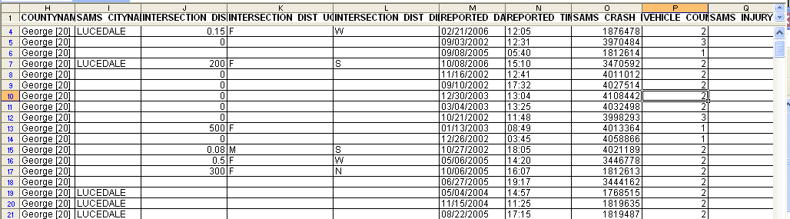

Figure 8. Sample Crash Information with Components and their Elements

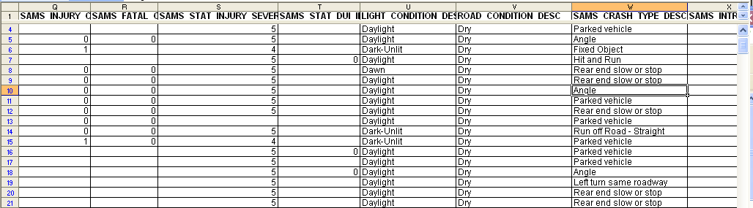

Figure 9. Sample Crash Information with Components and their Elements

The Restructuring and Consolidation of the Available Data for The Analysis
The restructuring and consolidation of the data was driven by the main objective of the project which was to evaluate the effectiveness of Rumble Strip/Stripes on highway safety. To achieve this main objective, eleven specific statistical analyses were established aiming to determine if there was any correlation between the studied variables. The eleven analyses were as follows:

Analysis 1 – Rumble Stripe on the Road Vs. Number of Overall Crash
Analysis 2 – Rumble Stripe on the Road Vs. Number of Roadway Departure
Analysis 3 – Rumble Stripe Overtime Vs. Number of Overall Crash
Analysis 4 – Rumble Stripe Overtime Vs. Number of Roadway Departure
Analysis 5 – Lighting Conditions (Day/Night) Vs. Number of Overall Crash.
Analysis 6 – Lighting Conditions (Day/Night) Vs. Number of Roadway Departure
Analysis 7 – Road Conditions (Wet/Dry) Vs. Number of Overall Crash.
Analysis 8 – Road Conditions (Wet/Dry) Vs. Number of Road Way Departures.
Analysis 9 – Rumble Stripe on Road Vs -Crash Severity of Overall Crashes
Analysis 10 – Rumble Stripe on Road Vs Crash Severity of Road Way Departure
Analysis 11 – Rutting Condition Vs. Number of Overall Crash.
Analysis 12 – Rutting Condition Vs. Number of Road Way Departures.

Based on the eleven analyses, the following data was required:
- Construction starting and ending data of each studied segment
- Crashes in each of the studied segments
- Crash types/descriptions (Roadway departures, Overturn, etc)
- Crash dates
- Lighting conditions (Dark / Lighten)
- Road condition (Dry / Wet / Snow)
- Crash Injury Severity (Property Damage Only, Complain of Pain, Moderate, Life Threatening, Fatal)
- Rutting Condition

Upon comparing the required statistical analysis and the data available from the MDOT division and/or district, it was recognized that there were four distinctive data sets (as shown in Figure 10): 1- Segments Information, 2- Crash Information 3- Traffic Volume Information, and 4- Pavement Analysis.
  Segments Information
  Data Set
  Segment ID
  Project Name
  Route
  Starting Point
  Ending Point
  Intersecting Roads
  Construction Start Date
  Construction Ending Date
  Crash Information
  Data Set
  Segment ID
  Date
  Crash type/description
  Lighting conditions
  Road conditions
  Crash Injury Severity
  Traffic Volume
  Data Set
  Segment ID
  Date
  Traffic Count
  Pavement Analysis
  Data Set
  Segment ID
  Date
  Rutting Conditions
Figure 10. Data Sets for Analyses
The following is a brief description of the restructuring of the data from the different MDOT divisions and/or districts involved:

Restructuring Districts 5 and 6 Data - Mississippi Department of Transportation (MDOT) Data
The segment information received from District 5 & 6 (shown in Table 1) was modified to include all the elements of the “Segment Information” data set. Figure 11 shows a portion of the enhanced segment information with all the needed elements

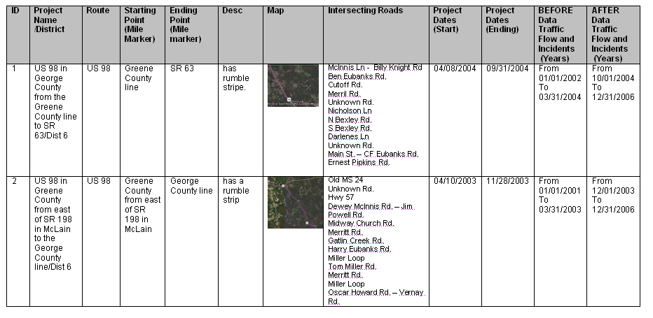
Figure 11. Enhanced Segment Information

The segment id, project name, district, route, starting and ending points were used as received without re-structuring. Intersecting roads were found and added to the information to facility the collection of the crash and traffic volume information. The project start and ending date were used to identify the before and after periods to collect and perform comparative analysis.

The date field in the received data was defined as “Ordinal” because it represented an intrinsic order. Additionally, the year and month were extracted from the date and defined as “Ordinal” with values between 1 and 12 representing each month of the year as shown in Figure 12. The month information extracted allows further analysis based on the month.

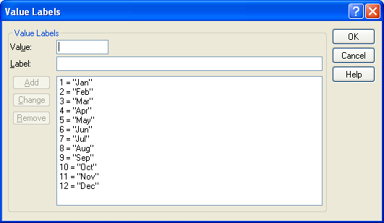
Figure 12. Month Values for Statistical Analysis

Restructuring Planning Division Data - Mississippi Department of Transportation (MDOT)

The traffic volume information received from the MDOT Planning Division (shown in Figure 4) was re-structured to two variables: Time of the Day and Volume. The variable Time of the Day was defined as “Ordinal” and since the “Volume” variable represented magnitude it was defined as “Scale”.

The Time of the Day variable was assigned a number between 0 and 23 representing a 24 hours clock which begins at midnight (which is 0000 hours). The Volume variable was organized by direction (bound) of the traffic and contained the number of vehicles per hour that passed each studied segment each hour. Figure 13 shows a sample 24 hour count.

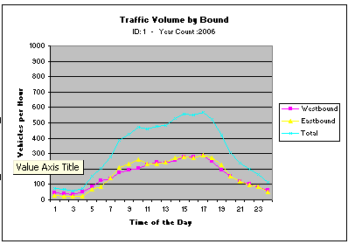

Figure 13. Sample 24 hour Traffic Count

Restructuring Traffic Engineering Division Data - Mississippi Department of Transportation (MDOT)
The crash information received from the Traffic Engineering Division (shown in Figure 9 to 11) was restructured to six variables: Segment ID, Date, Crash type/description
Lighting conditions, Road conditions and Crash Injury Severity.

The variables Date was defined as “Ordinal” as previously described based on the variable data new variable named Construction Status was created and received a value between 0 and 2, where 0 was assigned to “During” (Construction), 1 was assigned to the “Before” (construction), and 2 was assigned to the “After” (Construction) as shown in Figure 14.

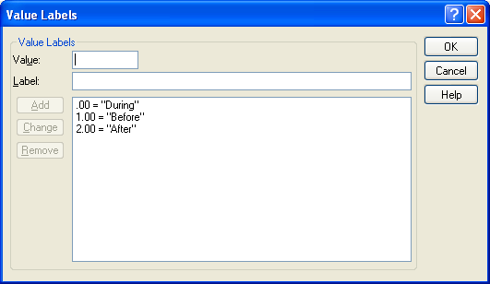

Figure 14. Construction Status for Statistical Analysis

The variable Crash type/description was defined as “Nominal” because the data values represented categories with no intrinsic order. The Crash type/description variable received a value between 1 and 4 for (Run Off Road and Overturn) as shown in Figure 15 and all other crash type/description received no value in this variable.

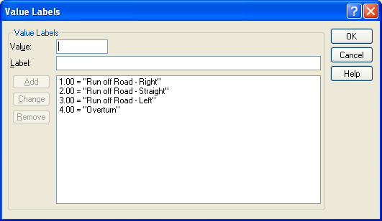

Figure 15. Crash Type/Description for Statistical Analysis

The lighting condition was defined as “Nominal” because the data values represented categories with no intrinsic order. This variable received a value between 1 and 5 as shown in Figure 16. The Road Conditions and Crash Injury Severity were also defined as “Nominal” with the value shown in Figure 17

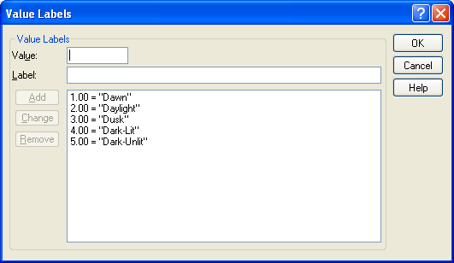

Figure 16. Lighting Conditions for Statistical Analysis

.
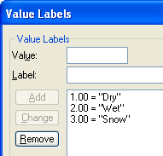 | 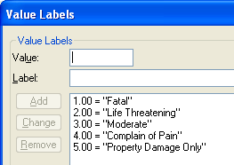

Figure-17. Road Conditions and Crash Injury Severity for Statistical Analysis

Consolidation of all the Data
After restructuring the information received from each divisions and districts, the next step was to consolidate (or integrate) all of the data sets into one master data file. The variables: “Segment ID” and “Date” were identified as the common field among all the data sets. The dashed arrows pointing in two directions, in Figure 18 show these two variables common among all the data sets. Therefore, “Segment ID” and “Date” were used as key fields and the data from all the data sets was copied into one master data set with the fields shown in Table 2. As a result of this consolidation, a total of 1564 records were integrated into the master data set as shown in Table 3.

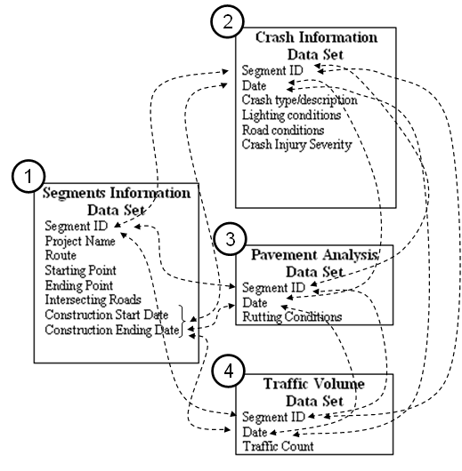
Figure 18. Data Set Consolidation
Table-2. Date Set Variables, Type of Variables and Value Codes

Variable | Type of Variable | Value Codes | Source
Segment ID | Nominal | Not Applicable | 1,2,3,4
Before Date | Ordinal | Not Applicable | 1
After Date | Ordinal | Not Applicable | 1
Accident Year | Ordinal | Not Applicable | Generated
Accident Month | Ordinal | 1: Jan → 12: Dec | Generated
Months Before | Scale | Not Applicable | Generated
Months After | Scale | Not Applicable | Generated
Crash Type/Description |  | 1: Run off Road – Right  2: Run off Road – Straight  3: Run off Road – Left  4: Overturn | 2
Lighting Conditions |  | 1: Dawn  2: Day Light  3: Dusk  4: Dark-Lit  5: Dark-UnLit | 2
Road Conditions | Nominal | 1: Dry  2: Wet  3: Snow | 2
Crash Injury Severity | Ordinal | 1: Fatal  2: Life Threatening  3: Moderate  4: Complain of Pain  5: Property Damage | 2
Traffic Count | Scale | Not Applicable | 4
Rutting Conditions | Scale | Not Applicable | 3
Construction Status | Ordinal | 0: During  1: Before  2: After | Generated

Table 3. Number of Records Restructured From the Data Sets

Source Records after Restructuring

Total Records in the Master Data Set 1564

Lessons Learned
The use of rumble stripes to improve the safety of drivers is of paramount importance for all the MDOT Divisions and Districts that graciously share their information with the research team. It is important to highlight that all Divisions and Districts were very willing to collaborate in the data consolidation process. However, collecting, archiving and retrieving information was not a main priority for any of these Divisions and Districts. Additionally, no general guidelines for data structuring was communicated among the Divisions and Districts. Therefore, it is evident that input into the data gathering process before the data is collected rather than after the fact, could greatly improve the process of accessing the impact of other safety programs currently implemented by MDOT. By defining the data to be collected, the method for collecting the data, the formatting of the data, the timeframes for collecting the data (before, during and after construction), all the participating Divisions and Districts would be able to share information and to demonstrate the impact of their performance to stakeholders. It was also learned that the restructuring of the data was of paramount importance for the consolidation of the data. Identifying the variable types and the possible values for each variable facilitated the comparison of variables to decide whether or not to use the same variable or to create a new variable for each data set. The identification of common data components among the data set was critical for the consolidation of all data sets. The use of the common data components to transfer data among data sets proved to be an effective way to complete the data sets with information from another data set (another agency). The research team was able to combine, reform, integrate and analyze the data to produce quantifiable results.

Finally, although each division and district participating in this project had a different mission and collected different data, it is possible to create a data structure that allow these divisions and districts to share common data for common purposes and reduce the cost of the data collection efforts.

Summary
Maintenance and construction programs are arguably one of the most important functions of States DOT (as represented by the percentage of the budget invested). MDOT through the Traffic Engineering Division is committed to improve Mississippi highway safety. MDOT has invested valuable resources to implement a series of safety improvement programs such as the “Rumble Stripes” program. Despite MDOT’s high commitment and efforts to improve highway safety, MDOT does not know the impact of the “Rumble Strip” program in reducing crashes. In other words, MDOT lacks quantifiable evidence that demonstrates the effectiveness of this program. This paper focused on the process implemented to structure the data obtained from multiple Divisions and Districts used to measure the effectiveness of the “Rumble Stripes” program. The content of this paper was then used as the foundation for the statistical analysis.

During the construction period, there are temporary traffic disruptions, which increase the number of accidents with associated deaths and injuring thousand of people every year. One of the special measures implemented in construction zones by several departments of transportation around the United States to reduce the number of crashes is the increase of law enforcement surveillance. This chapter focuses on the process implemented to structure the data obtained from multiple agencies to be able to measure the impact of law enforcement in construction zones. The content of this chapter was later used as the foundation for the statistical analysis.

The results presented in this chapter reveal that segmentation of the data and the structure of the data is a major barrier to assess the impact of law enforcement surveillance in construction zones. Due to the willingness of the Divisions and Districts to collaborate in the data consolidation process, it was possible to restructure and consolidate the data to perform statistical analysis. It is also expected that the restructuring process presented in this chapter could be used by other research teams to perform similar analysis of law enforcement surveillance or others methods implemented around the U.S. to reduce the deaths and injuries in road construction zones.
References
AASHTO (2003) “American Association of State Highway and Transportation Officials”, http://www.aashto.org, Last Visited: June 2003

ATSSA (2003) “American Traffic Safety Services Association”, http://www.atssa.com, Last Visited: June 2003

Breazeale, L, (2001), “Mississippi highways rank among the worst”, URL: http://msucares.com/news/print/commnews/cn01/011210.html. Last visited: May 2003.

FHWA (2003) “Federal Highway Administration”, http://www.fhwa.dot.gov/ Last Visited: June 2003

FHWA (2006) “FHWA Resource Center- SAFETY & DESIGN TEAM - Rumble Strips”, http://www.fhwa.dot.gov/resourcecenter/teams/safety/safe_8rum.cfm Last Visited: March 2006.

Lindly, J (2003) “Evaluation of Profile Pavement Markings”, UTCA Report Number 01465, November 13, 2003.

Jordan, T. (2005) “Rumble Stripe Projects in Mississippi”, MDOT, District 6, March 30, 2005.

NHTSA (2006) “National Highway Traffic Safety Administration”, http://www.nhtsa.dot.gov/ Last Visited: June 2006

MDOT (2006) “MDOT Mission Statement and Goals”, http://www.gomdot.com/facts/mission.htm, Last Visited: April 2006.

Associate Professor – School of Construction at the University of Southern Mississippi, Box 5138, Hattiesburg, MS, 39406. E-mail: Tulio.Sulbaran@usm.edu.
Professor – School of Construction at the University of Southern Mississippi, Box 5138, Hattiesburg, MS, 39406. E-mail: David.Marchman@usm.edu.

