KISMET: An Open Source Process for Faculty Participation in ABET Accreditation
Ravi Shankar , Ankur Agarwal
Abstract – A few ABET-experienced faculty members typically guide the ABET documentation process. Consequently, this becomes an abstract process that is of little concern to remainder of the faculty members. When one considers that ABET accreditation process can indeed provide an impetus for continuous improvement, which in turn, can make the next ABET accreditation cycle relatively smooth, the department’s wider community becomes an indispensable resource to involve and learn from. A typical department has many relevant on-going concurrent activities. Synergistic interactions among these can help address the overall goal of continuous improvement, and in turn secure ABET accreditation. KISMET (Keep It Simple and Measurable for Effective Teaching) takes a holistic approach to make ABET documentation a living document and to empower all faculty and staff members to participate, discuss, improve, and benefit from it. We have benefitted from the use of KISMET. We use OPM (object process methodology) to graphically present this in our paper.

Keywords: ABET, OPM, Continuous Improvement, Complex Systems, Open Source

Background
ABET accreditation visits are met with much trepidation at the host institution. Apprehension may arise out of ‘unforeseen’ and ‘unreasonable’ requests from the visiting ABET group. However, the host group may also have failed to anticipate such requests. This is possible because of the high stakes associated with the accreditation process. The tendency for the administrators would be to let a few ABET-experienced steady hands to steer the currents. It would be considered unwise and risky to involve a novice and to consider new initiatives. This prevents an open and constructive dialogue; and the ABET experienced faculty members may find it difficult to adapt to new expectations from ABET (for e.g., continuous improvement). The process in general stagnates because of lack of infusion of fresh ideas and initiatives. Interestingly, once one gains insight on the rationale behind ABET’s accreditation process, it becomes obvious how one could use the ABET process as a living document and reap benefits from it.
KISMET (Keep It Simple and Measurable for Effective Teaching) takes a holistic approach to make ABET documentation a living document and to empower all faculty and staff members to participate, discuss, improve, and benefit from it. It incorporates all the initiatives that faculty members and department committees would have had into an integrated open-source document. It helps one build a community of learners and teachers, who share each other’s knowledge and expertise. This helps the department to prosper as a whole. This formalization also helps build the documents that ABET group will need during their visits, with historical evidence. A more robust process with significant potential for continuous improvement will ensue.

KISMET sub-processes have existed informally in our department; we integrated and published them internally; this enhanced visibility, fostered discussion, and induced energetic participation and creative solutions. We will document the process and results in the paper.

The KISMET Model
We present the model with the aid of OPM (object process methodology) due to Dr. Dori [1]. OPM is an easy to learn and use modeling methodology that can be used to describe modern complex systems in a hierarchical manner from abstract to more detailed levels. The tool, called OPCAT, may be freely downloaded for academic purposes from [2]. OPM combines, unlike UML, objects and processes into one common diagram. We use it for conceptualizing the overall system, the interaction and behaviors of concurrent & synergistic activities, and the mapping of the ABET activities onto these activities, with the intent to seamlessly extract the needed ABET information and data from this integrated picture. Of course, anything that is not inherently available will become obvious, so measures can be undertaken to address such shortcomings. OPM provides both a graphical or visual representation which makes it easy for brainstorming sessions, and a textual representation which is in a natural language. Both are semantically equivalent. They appeal to two different parts of the brain, the visual and the lingual. Typically, in our department, a computer engineering undergraduate would prefer a visual representation, while a computer science undergraduate would prefer a textual representation. We would guess that to be true of our faculty members too, though a few tend to be ambidextrous. In our experience, the former is a good brainstorming tool, while the latter is a good portable format which is amenable to computer manipulation for automatic code generation at least at the skeleton level (if appropriate). Objects and processes are the two main building blocks that OPM uses to build models with. It also uses a third type of entity, States. Objects exist, and processes transform the objects by generating, consuming, or affecting them. States are used to describe objects, and are not stand-alone things. Thus, a student can be in one of the three states: Studying (that is, enrolled as an undergraduate student), Graduating (when the graduation check has been completed successfully), or Working (as an engineer). Objects for our example are the personnel involved (faculty member, student advisor, student records coordinator, student, etc.,), the committees involved, or the documents created/modified/updated (such as the course curriculum, student worksheet, etc.). We identify our main process as the Continuous Improvement process which is comprised of three sub-processes that are concurrent: Curriculum Improvement, Student Graduation, and Accreditation. Objects are represented by rectangles, while processes are depicted by ellipses.
Figure 1 represents the overall or the highest level model. We will present the model here, without discussing how we arrived there. That will be deferred to the Discussion section. Figure 1 shows the ‘Continuous Improvement Process’ interacting with several entities, by different types of links. The link from ‘Chair’ is called an agent link and has a filled circle at the end. It represents a required human object for the identified process to take place. There are several such agent links, from the following object entities: Student Advisor, Student Records Coordinator, Curriculum Committee, Faculty Member, Lab Coordinator, ABET Coordinator, and Company (which hires the coop student and/or the graduated engineer). This high level diagram also shows links with double arrows to four other object entities: Student Worksheet, University Catalog and Course Schedule, Student, and ABET Document. Some of these are physical entities, while others are informational objects. The informational objects are shown as dashed rectangles, while physical objects are shown as dashed rectangles with a shadow. The double arrow link implies that the process affects the object (process changes the state of the object in an unspecified manner). Thus, the ‘Student Worksheet’ is updated as the student moves through the junior and senior years in the engineering college. A ‘Student’ changes from ‘Studying’ state to ‘Graduating’ state, and of course, with a good ‘Continuous Improvement Process’ in place, would become a ‘Working’ engineer too. We did not intentionally label the links in Figure 1, but the labeling will be evident in the lower level diagrams.
Figure 2 is included to show the corresponding representation in OPL (object process language). Note the careful manner in which the language depicts the relationships. It is well suited for automated manipulation in a very non-domain specific manner. This is very helpful in requirements capture and automatic translation to a specification document. Domain specific translation, via XML, becomes easy.
Figures 3 shows the three underlying processes (at one level below the highest level depicted in Figure 1). Note how the links are now directly connected to the underlying processes. The Student Worksheet object is shown connected to Accreditation with an instrument link with an open circle, indicating that the object is a non-human entity, but is required for the Accreditation process. The lightning type of arrow links between processes is an activation link. Thus the Accreditation process activates or facilitates the Student Graduation process, as does the Curriculum Improvement process. The latter also facilitates the Accreditation process. We do not show some of the labels to reduce the clutter and to enhance legibility. The ones not shown have been discussed earlier.
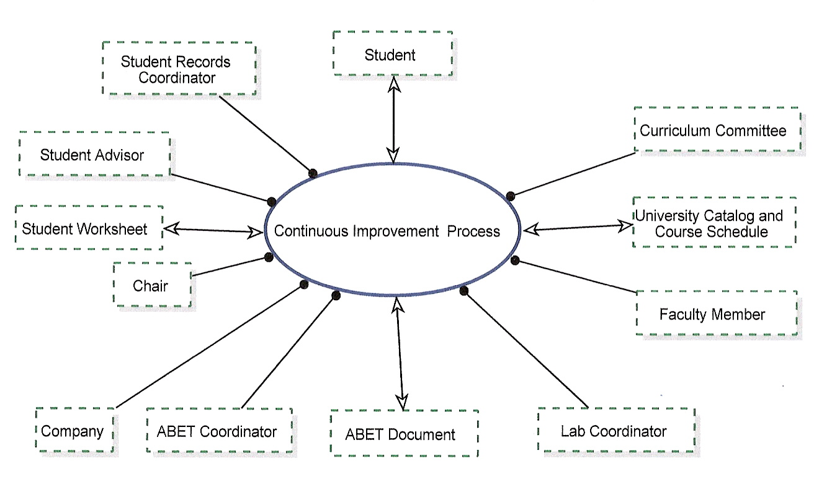

Figure 1: OPD Model for the top Level of the KISMET Process

Results
Our POPC (Program Outcome and corresponding Program Criteria) form for the CE (computer engineering) program is available at our website: www.cse.fau.edu. The 6 program outcomes (POs) that we evaluate our graduating students on are: 1. Proficiency in the area of electronics, computer architecture, and computer design; 2. Proficiency in the areas of software design and development, data structures, and operating systems; 3. An ability to plan and execute an engineering design to meet an identified need; 4. Proficiency in the mathematical and scientific principles relevant to computer engineering; 5. An ability to communicate effectively and to function in multi-disciplinary teams; and 6. An understanding of the overall context in which engineering and computing activities take place. Each of these POs has 4 to 6 program criteria defined, any combination of which is considered to have met the PO.
We followed the OPM modeling process to lower levels of hierarchy, to its logical conclusion, that is, the generation of the various tables required for ABET accreditation. These included certain overarching forms, such as POPC that we expect all our graduates to satisfy, mapping of ABET Criterion 3 [3] to our POPC, mapping of POs to all of our courses, and mapping of ABET criterion 3 (a – k) to all of our courses. Each course had several forms to be filled out by the faculty member that included information on student performance against the POPC, comments on student evaluation on whether ABET course objectives were met, and steps to improve the course to better meet those objectives in the next offering. There were also forms that collected statistics by semester, on how well the course offerings that semester met the POs. We also collected survey results from our working graduates and companies where our students had done Coop. Some of the faculty members each semester also collected assignments, etc., to assemble course display document for that course.
When there is so much information to collect, collate, and analyze, it is easy to lose track of the big picture. Having the overall picture helped us identify many missing and useful links. For example, we realized that ABET team would benefit from the ultimate proof – that all our ‘graduating’ students met the 6 POs across all the courses that they took, and that our ‘studying’ students (those who are still in the program) were making adequate progress towards meeting the 6 POs. We evolved an ABET student worksheet that added 6 columns for the POs on the right side of a typical transcript sheet, next to the columns for credits for the courses taken, semester when the course was taken, and the grade received. We filled this form out for all our graduating students and for an equal number of students still in the program. We provided this document as an appendix in the ABET report. Another area was in cross-learning. Earlier all the faculty members returned their course forms directly to the ABET coordinator, as per a template sent to them by the ABET coordinator. We found that faculty members interpreted the template differently. So, we assembled all the CE faculty members, agreed on the interpretations, and evolved improved forms to use. Further, we posted them on an internal hard disk that all had access to. Thus, cross-learning was facilitated. Next, we decided to encourage the CE faculty members to provide PDF documents of their course displays. This had several advantages: ABET reviewers could be given a CD with all the course displays, which could be reviewed prior to the site visit; the faculty members could review each others’ documentation and improve their own, or make suggestions to improve those of others; and finally, these documents would now be available on the internal hard disk for other professors who might wish to teach the course. Our faculty members use Blackboard website to receive assignments. Some had to scan exams and class quizzes to build the course display, but conversion to PDF was easy.

Discussion
When we were assigned the job of assembling ABET documents and preparing the ABET report earlier this year, we decided to first define a rubric. This is shown in Table 1 below. We identified each Evaluator, the Evaluated, Relevant Metric, and Objective. After review of the role pairs, we decided to exclude the Student-Professor pair.

Evaluator | Evaluated | Metric (Relevant) | Objective
ABET | CE Program | Criterion 3 / ABET | CE Program Accreditation
Student | Course | Student Comment Form | Course Improvement
Student | Professor | Student Percept of Teaching (SPOT) Form | Annual Academic Evaluation of the Professor
Professor | Student | Student Work | Student Course Grade
Curriculum Committee | Courses | Continuous Improvement Form | Curriculum Updates and New Courses
Advisor | Student | Student Worksheet | Advising, Progress and Graduation Checks
ABET Coordinator | The Overall Process | ABET Documentation, Surveys, and Student Graduation | CE Program Assessment, Verification, and Continuous Improvement
Alumni/ Supervisor | CE Program | Alumni and Coop Surveys | Continuous Improvement

Table 1: List of Evaluator Vs Evaluated for our Rubric

Student Advisor is environmental and physical.
Student Advisor handles Continuous Improvement Process.
Student Records Coordinator is environmental and physical.
Student Records Coordinator handles Continuous Improvement Process.
Faculty Member is environmental and physical.
Faculty Member handles Continuous Improvement Process.
ABET Coordinator is environmental and physical.
ABET Coordinator handles Continuous Improvement Process.
Curriculum Committee is environmental and physical.
Curriculum Committee handles Continuous Improvement Process.
Lab Coordinator is environmental and physical.
Lab Coordinator handles Continuous Improvement Process.
ABET Document is environmental.
University Catalog and Course Schedule is environmental.
Student is environmental and physical.
Company is environmental and physical.
Company handles Continuous Improvement Process.
Student Worksheet is environmental.
Chair is environmental and physical.
Chair handles Continuous Improvement Process.
Continuous Improvement Process affects ABET Document, University Catalog and Course Schedule, Student, and Student Worksheet.

Figure 2: OPL representation of Figure 1.
Table 1 helped us see the big picture and evolve the OPD model to better understand the interactions. Once we had done that, it was clear that the Accreditation process was strongly interlinked with the Student Graduation process and the Curriculum Improvement process. One of us (first author) fortunately had been the director of the Curriculum Committee for the past few years and had a very active group of members who pushed for making many changes to the curriculum. This was done without any strategic guidance, vis-à-vis ABET accreditation, merely as a necessary activity for the sake of the CE students, and in response to complaints we had heard in classes and elsewhere. Thus, we were able to document our work of the previous few years and show real continuous improvement in the curriculum. The model also showed us that ABET required that our students graduate only after having met all the 6 POs and in turn, all the ABET Criterion 3 (a – k). We thus documented the above cited ABET

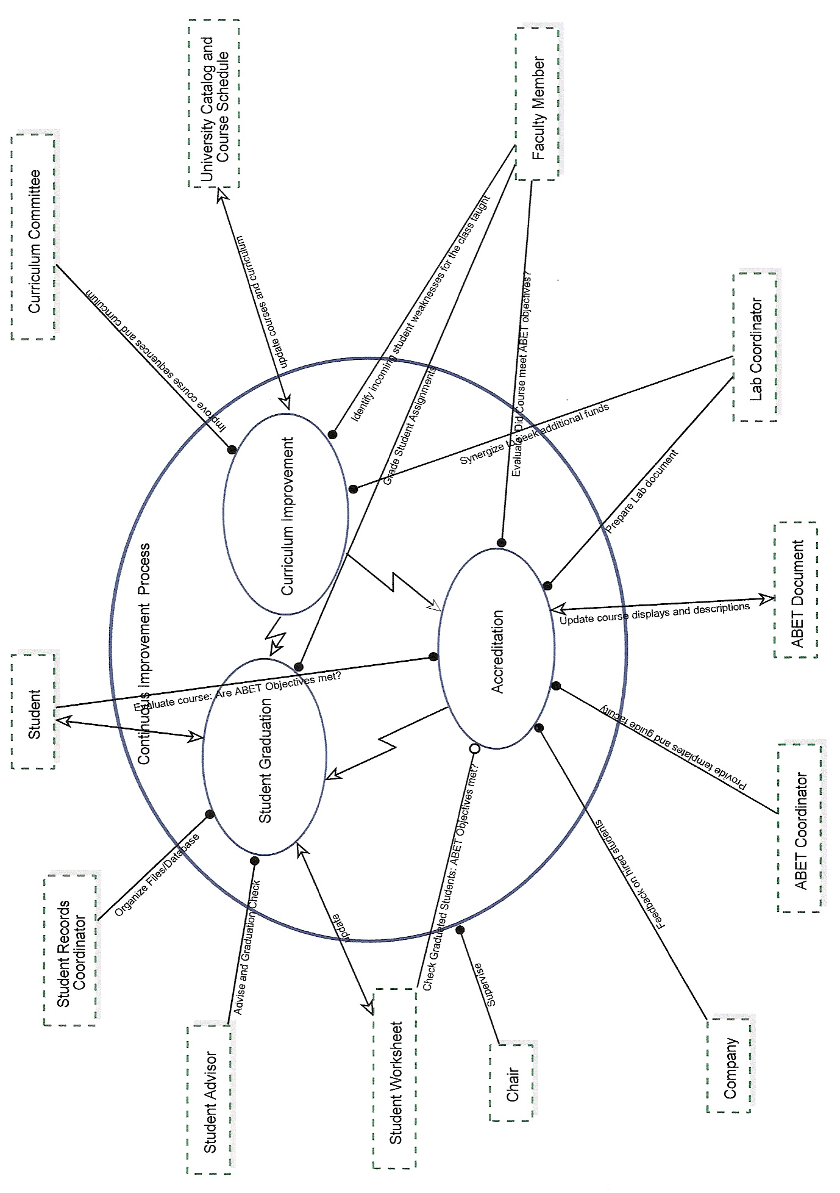

Figure 3: Lower Level OPD Diagram
student worksheet for all the graduating seniors and an equal number of students still in the program. We had also worked with a colleague, who had unofficially taken on the responsibility of lab coordination, in raising funds over the years to better equip the labs. We asked him to document his work for one of ABET document appendices, and gave him credit for preparing the document. This turned out to be a truly comprehensive and detailed document.
We have used both OPM and UML in our ABET accreditation effort. Once the big picture, as derived with OPD, was clear, we proceeded to accelerate the process of data collection with the use of standard templates for all the ABET forms and the appendices. Because of time limitations, this effort was conducted manually. However, in another related paper, we provide an UML based design flow that we plan to incorporate so the ABET data collection process can become automated, distributed, transparent, self-learning, and incremental [4]. In another paper at this conference, we document our use of UML in student design projects [5]. In fact the ABET design proposed in [4] will be a student project in spring 2009. We intend to implement it with .NET and web services software.
Our ABET site visit went without a hitch. Our program that was reviewed in fall ’08 has already been accredited, the only one to achieve this distinction amongst all the engineering programs at our university up for accreditation. Of course, many deserve credit. Also, by merely addressing issues at the level of our committees on undergraduate curriculum and on lab & equipment, we had laid a good foundation for this. We are now better prepared to face the next accreditation visit that will come in six years. With the model and the mechanisms in place for continuous improvement, it will have department wide responsibility and the ensuing document will be robust and complete. Further, by storing the course displays (in PDF form) and the ABET course and other forms in a common place (on an internal hard disk), we have facilitated departmental level learning and transparency.
We had initially described the KISMET process in the background section of the ABET Self-Study Report. However, we had to remove it from the submitted ABET Self-Study Report, as the college wanted all the reports to follow the same format. This was not a major loss, since it had served its purpose in flagging us to include better documentation on student achievement (with regard to ABET Criterion 3) and lab resources. We included the former as 19 additional sheets in Appendix E, one each for the students (9 graduates of spring ’08 and 10 undergraduates still in the program as of spring ’08). This seems to have triggered ABET reviewers’ request for similar proof for other undergraduate programs at our college. The latter was included in Appendix C.
We also had to remove some of the personalization we provided in the report. Such personalization would have shown proof of a department-wide effort with many stake holders. This was our effort to give credit where due. However, once again, due to the need to keep uniformity across all the reports, we had to curtail our additions there. We also had included video clips of student design projects as part of our soft-copy course display documentation for our engineering design courses. We discarded them to keep to the traditional hard bound copies of ABET Course Displays. We hope the ABET committee will read this paper and publish guidelines encouraging such additions which can make the process more enjoyable for faculty members and make the review process more tolerable for the ABET reviewers. Availability of the data in soft-copy format would also allow the reviewers to review such material ahead of time (more easily on a PC) and invest more time in meeting with students, faculty members, and administrators, during their site visit. Finally, note that ABET Self-Study Report requires documentation on 9 different criteria. We have centered our discussion above around ABET Criterion 3; however, the discussion is equally valid for other criteria as well; further, some of this information gets documented under other criteria as well.

Conclusion
We have used OPD (Object Process Diagram) to document the continuous improvement process in our department. Much of it had existed in the department, but not as part of a holistic process with clear identification of synergies and challenges to address across committee domains and individual responsibilities. Development of this OPD model earlier this year helped us visualize all the critical dependencies and provide appropriate documentations to ABET. This has also provided us a pathway to incrementally add documentations semester by semester, course by course, at a central location within the department, so the ABET process does not become a daunting and major undertaking six to twelve months before the ABET visit, but becomes a routine undertaking in the background. The open source process will also help with cross-learning and empower all the faculty members and interested staff members to participate much more vigorously.

References
[1] Dori, Dov, Object-Process Methodology: A Holistic Systems Paradigm, Springer, Berlin, 2002
[2] https://www.opcat.com/downloads/trial/
[3] http://www.abet.org/Linked%20Documents-UPDATE/Criteria%20and%20PP/E001%2008-09%20EAC%20Criteria%2012-04-07.pdf
[4] Shankar, R., A productive self-learning and self-documenting infrastructure for successful ABET accreditation, submitted to 2009 ASEE Annual Conference & Exposition, Austin, TX, June 2009.
[5] Shankar, R., Preparing Systems Engineers of Tomorrow, submitted to 2009 ASEE Southeastern Section Annual Conference, Marietta, GA, April 2009

Ravi Shankar
Ravi Shankar is a professor in the computer science and engineering department at Florida Atlantic University (FAU). He is the director of a college-wide center on systems integration. He holds a PhD from the University of Wisconsin, Madison, WI, and an MBA from FAU. He is a registered PE and a Fellow of AHA. Over the past six years, he has coordinated the efforts of a large group of faculty members and students from computer engineering, computer science, and electrical engineering, to address Motorola’s goal to radically increase their engineering design productivity. Motorola has provided $1.1 M in grants towards this goal. Significant progress has been made. Most of the publications are available at the center’s website: www.csi.fau.edu. He has now started applying principles learnt in the research project to model and improve other complex processes.
Ankur Agarwal
Ankur Agarwal received his PhD from the computer science and engineering department at Florida Atlantic University (FAU), where he is currently an assistant professor. His doctoral dissertation was on the NOC (network on chip) architecture, which allows for concurrent execution of multiple applications. He performed modeling studies for optimization of QOS (quality of service) metrics for such a system. This research was completed as part of a large Motorola grant to enhance engineering design productivity at Motorola. He is also the assistant director for the center of systems integration (www.csi.fau.edu). He was instrumental in developing our department’s BIET (Bachelors in Engineering Technology) program, which will undergo ABET accreditation in the near future.

Professor, Florida Atlantic University, Boca Raton, FL 33431, ravi@cse.fau.edu
Assistant Professor, Florida Atlantic University, Boca Raton, FL 33431, ankur@cse.fau.edu

