Introducing Freshmen Engineering Students to Function Modeling to Enhance Design
Cecelia M. Wigal
Abstract – At The University of Tennessee at Chattanooga (UTC) students are introduced to the design process and participate in a customer supported design project as a part of the first course in their engineering curriculum. Of particular emphasis in this course is the definition of functions, objectives and constraints that provide boundaries, guidelines, and clarification to project definition and design. During the emphasis on defining device functions students are introduced to two specific modeling techniques – Function Node Trees and an instructor modification of the Integrated Definition (IDEF0) function model used by the Systems Engineering community. This paper describes the modified IDEF0 model, the process of introducing the modified IDEF0 model to the students, and the outcomes from the modeling experience. An example of a student application of the IDEF0 model is also presented.
Keywords: IDEF0, Functional Decomposition, Function Node Tree, Design.

Introduction
The Engineering program at The University of Tennessee at Chattanooga (UTC) defines the design process as a systematic decision-making process that aids the engineer in generating and evaluating characteristics of an entity (physical or process) whose structure, function, and operation achieve specified objectives and constraints. The program describes the process as the application of the solid foundation of the basic sciences, mathematics, and engineering sciences to the abstractness, complexity, and solving of real world problems.
At UTC the elements of the design process are emphasized throughout the curriculum, beginning with the freshmen year. At the freshman year the Introduction to Engineering Design (IED) course uses project-based learning to address (1) problem definition, (2) attribute generation, (3) function, constraint and objective identification, (4) idea generation, and (5) simple decision-making as they apply to the design process. Of particular emphasis is the definition of functions, objectives and constraints that provide boundaries, guidelines, and clarification to project definition and design. The freshmen are introduced to project definition research involving customers and users to help them recognize project needs and requirements. The needs and requirements are transferred into project objectives, functions, and constraints using structured nomenclature and modeling techniques.

Often systems modeling and thus systems thinking is used to aid in identifying and developing design functions and objectives. Two specific systems function modeling techniques are the Function Node Tree and the Integrated Definition (IDEF0) model (used by the Systems Engineering community). This paper introduces systems thinking, the use of Function Node Trees to identify and categorize functions, and an instructor generated modified IDEF0 model to identify functional relationships. In addition, the paper describes the process of introducing the modified IDEF0 model to the students, the student learning outcomes from using the model, the student reactions to applying the model, and the implications of introducing the model at the freshmen level. An example of a student application of the IDEF0 model is also presented.

Freshmen Design
The goal of the UTC’s design curriculum is to graduate students who understand and can apply the steps of the design process to various interdisciplinary and discipline-based applications. The first step toward meeting this goal is to introduce the steps of the design process in UTC’s 3 credit hour freshman level course Introduction to Engineering Design (IED). The design process emphasized at UTC is shown in Figure 1.0.
The freshman IED course uses short lectures and hands-on design exercises to emphasize the body of the design process—problem definition, conceptual design, alternative selection, and preliminary design (see the shaded portions of Figure 1.0). Concurrent with the design methodology is graphics design practice on sketching and solids modeling necessary for communicating the design.

Client Need

Problem Definition
Conceptual Design
Preliminary Design
Detailed Design
Design Communication
Product
(Designed Object)
Final Design
(Fabrication Specs & Documents)
Validation
Alternative Selection

Verification

Figure 1.0: The Design Process (UTC Emphasis)
IED meets for 4 hours each week as two 2-hour class sessions. The first 2 weeks introduce the students to solids modeling and the concepts of graphical communication using a simple design project. The next 4.5 weeks introduces the students to the components of the design process especially system definition and understanding through a larger class project. Within the context of the class project the students are introduced to the concepts of functional analysis and functional decomposition as they apply to understanding what a device or system does.
The last 7.5 weeks are devoted to applying the design and graphical communication concepts the students learned to a small team project. The project culminates in a project prototype. The goal of the IED team project is to design a device for a specific customer. Since the fall of 2005 the projects consist of opportunities to support (1) community assistive technology projects, (2) UTC faculty research, and (3) upper level UTC student competition projects.

Systems Thinking
Engineers seek solutions for simple to very complex problems. They must understand the problems, needs, and relationships to develop the possible solutions. Visuals as well as state-of-the-art hardware and software enhance an engineer’s ability to effectively develop solutions.
Systems thinking is one means to aid problem understanding. Systems thinking is rooted in systems engineering which practices an interdisciplinary approach to evolve and verify an integrated set of product and process solutions that satisfy customer needs. Systems thinking begins with analysis—separating a study or entity into individual pieces—and emphasizes synthesis—looking at the relationships between parts to form new conclusions. Systems thinking aids the user to take into account a greater number of interactions as a study evolves and to categorize interactions as to level of affect on the final solution. The spirit of systems thinking makes it an effective tool in a variety of applications and levels of complex problems.
There appears to be no formal accepted definition of systems thinking. However, many advocates of “systems” and “systems theory,” and “systems analysis” agree that the aim of systems thinking is to spell out in detail what the whole system is, including its environment, its objectives, and how the objectives are supported by the activities of its parts.[1] Others promote that the whole system is not just the sum of the parts or subsystems; it is a system composed of interrelated subsystems.[2] These interactions should be studied with respect to their dynamic as well as static relationships. Thus, the subsystems of an entity should not be studied separately with the idea of putting the parts together into a whole. The starting point has to be with the total system and should consider feedback loops and dynamic interaction.
Systems Modeling
Problem solving is the essential motivation for systems thinking—the more we know, the better we can define, analyze, test, and deploy. Being able to decompose a phenomenon into components and understand interrelationships is necessary to effectively and efficiently define/redefine, control, and improve the phenomenon. Specifically, systems thinking directly influences problem definition, bounding, needs and constraint analysis, partitioning, structuring, alternative analysis.
Models—abstract representations of a phenomenon—are often used to define system boundaries and content and to guide system and process definition, design, and implementation. The initial consideration of a system uses models with a low degree of restriction—for example, input-output, input, output, functional, and process models. [3] In addition, as the system definition evolves, models allow for recognition and definition of detailed parts and their relationships.
IDEF0 Modeling
A proven methodology used to model systems is based on a standard established by the Integrated Computer Aided Manufacturing (ICAM) program of the United States Air Force. Integration Definition (IDEF0) function modeling was designed to provide better analysis and communication tools for improving manufacturing productivity. The IDEF family of models is based on the concepts of Structured Analysis and Design Technique (SADT) developed by Douglas T. Ross at SoftTech, Inc. [4] IDEF0 (Integration DEFinition language 0) focuses on the functional or process model of a system. IDEF0 is used to produce a structured representation of functions, activities, or processes within a system of interest.
As illustrated in Figure 2.0, the main components of IDEF0 models are functions (represented as boxes in the model), and inputs, outputs, constraints, and mechanisms (ICOMs). The functions are actions or transformations, and are described as verb-noun phrases. ICOMs, are represented as labeled arrows. Input arrows represent data or objects being transformed by the function and terminate on the left side of the function box. Output arrows represent data or objects produced by the function and initiate at the right side of the function box. Control arrows represent conditions or guidance required to produce the desired output. They terminate at the top of the function box. Mechanism arrows represents the supporting means (physical resources) used to perform the function and terminate at the bottom of the function box.
The power of the IDEF0 model is its ability to illustrate functions and subfunctions as layers of hierarchical diagrams that introduce levels of increasing functional detail. The hierarchical diagrams (see Figure 3.0) consist of an external system diagram, a context diagram, a top-level function diagram (level 0), and often between three and six sub-function decomposition diagrams. The context diagram contains the top-level or primary function (the parent) and the ICOMs that enter from, and exit to, the environment external to the modeled system. The level 0 diagram illustrates the high-level relationship between the major system sub-functions (the children) as well as the associated ICOMs defined in the context diagram. The hierarchy of diagrams continues as higher level subfunctions are decomposed into their more specific associated lower level subfunctions. [7]
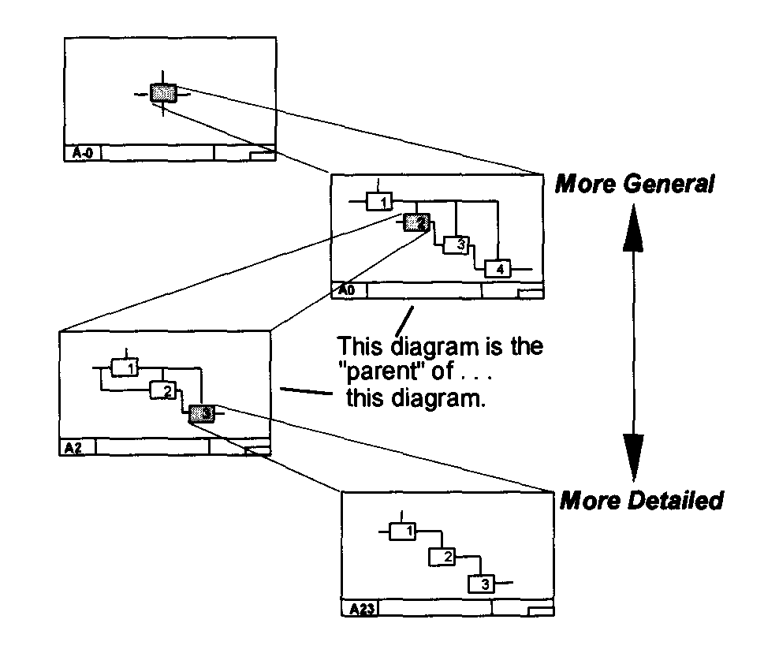
Figure 3.0: IDEF0 Decomposition [6]

Systems Modeling for Freshmen
The modeling method defined above is rather complicated for freshmen engineering students. Thus, the proven IDEF0 functional decomposition model is simplified for introduction to the freshmen. Specifically, since the identification of functions and their relationship to each other and the environment are the course emphasis, the identification of mechanisms and controls on the diagrams is deleted. In addition, for freshmen, the initial IDEF0 diagram is the context diagram, not the external system diagram. The freshmen are simply asked to identify the main or primary function and its associated inputs and outputs. It is emphasized that inputs always enter the left side of a function box and outputs exit from the right side. For the freshman inputs are defined as “things” that the function transforms into new “things”. Things are considered nouns.
Students are introduced to Function Node Trees to help them identify the primary function of a system or entity. Function Node Trees identify an entity’s functional structure as having two main function types – primary and secondary.[8] In most cases there is a single primary function. This is the function defined by the context diagram. An entity can have numerous secondary functions. These functions are categorized as required, supplemental, and unwanted. The structure of the Function Node Tree for designing a means to encourage recycling is shown in Figure 4.0.
Figure 4.0: Sample Function Node Tree for Encouraging Recycling
Specific Systems Modeling Instruction
Students are introduced to function modeling during the class project. During the needs identification phase of the design process, the class, led by the instructor, works together to develop a list of functions the device should do to meet the customers’ needs. From this list the instructor, with class participation, develops the Function Node Tree so that the primary function of the device is identified. This exercise generally adds a few functions to the function list as the students identify additional supplemental functions and unwanted functions.
After the students identify a list of possible device functions and structure them in the Function Node Tree, they develop, with instructor prompting, the IDEF0 Context Diagram based on the identified primary function. They first clearly identify the primary function by ensuring it is structured as a specific verb-noun phrase. They then identify the outputs they want the function to achieve. For example, if the primary function is to “encourage recycling,” the expected outputs may be “cans”, “paper”, and “plastic.” (See Figure 5.0). The students then identify the inputs that are transformed by the primary function into the identified outputs. Sometimes, identifying inputs results in identifying additional outputs. For example, the students identify that used material is the input to the Encourage Recycling function. They then identify that not all used material is labeled as “cans,” “paper,” or “plastic.” Thus, as shown in Figure 6.0, they label the remaining material as an output titled “garbage.”
Then the next hierarchical diagram of the IDEF0 family of diagrams (Level 0) is developed. The students consider the secondary functions shown on the Function Node Tree and determine how these functions may identify “like” categories. What is important is that the students identify 3 to 6 “subfunctions” that, at a high level, define the functional decomposition of the primary function. The subfunction names may exist in the list of secondary functions or the students may have to develop additional verb-noun phrases to identify the categories of similar functions. Then the destination and origins of inputs and outputs are identified to show functional transformations and relationships. To help students complete the diagrams, students are told that miracles (function boxes with outputs and no input(s)) and black holes (functions with inputs and no output(s)) can not occur. A sample Level 0 diagram for the “encourage recycling” function is shown in Figure 7.0.
Figure 7.0: Level 0 Diagram for Encourage Recycling
What one should notice in Figure 7.0 is that the output “Garbage” has been clarified as having two types – loose and contained. Since both types of garbage are shown as outputs on the Level 0 diagram they must also be shown as outputs on the Context Diagram. Thus, the Context Diagram should be updated as shown in Figure 8.0.
Once the Level 0 diagram is identified, the students, in like manner, decompose each Level 0 subfunction into a Level 1 diagram to illustrate its subfunctions and relationships. If new inputs and outputs are identified, the student should update the previous drawings to illustrate the impact on the upper level functions. Doing this helps the students iteratively define and understand the functions, their transformations, and their required inputs and resultant outputs.
A sample Level 1 diagram for the “Collect Recyclables” function is shown in Figure 9.0. The updated Level 0 diagram follows in Figure 10.0. The Context Diagram should also be updated to now include the input “Possible Recycler” which is transformed by the Advertise Recycling subfunction.
Figure 9.0: Level 1 Diagram for Collect Recyclables

Figure 10.0: Updated Level 0 Diagram following A1 Subfunction Identification.

The Student Functional Modeling Experience – One Example
Students use the experience of function modeling developed during the class project to help them understand and identify the device functions for their team project during the last 7.5 weeks of the course. The models produced by the students indicate that they identify and structure functions (as verb-noun phrases) rather easily. They also find Function Node Trees easy to construct and helpful when defining the primary function (see Figure 11.0 for a sample student generated Function Node Tree).
The task of developing the IDEF0 Functional Decomposition models, however, is more difficult for the students. The concept of breaking functions into meaningful and applicable subfunctions requires a process of thinking that many have not yet practiced. During the in-class IDEF0 model development only a few students participate in the model building. However, the questions generated during the development are inquisitive and revealing. The students identify the iterative development and benefit of the IDEF0 hierarchy of diagrams. They recognized that identifying a new input or output in a level 0, 1, or 2 diagram requires that it be added to the appropriate upper level functions in the previous diagrams. They also recognize that through this iteration the functions and their roles and relationships are more thoroughly defined. However, the ability to group functions in categories that encompass subfunctions and illustrate the relationships between the subfunctions comes only with practice.
Figure 11.0: Function Node Tree for Fall 08 Vertical Moving Whiteboard Project
For example, Figure 12.0 illustrates that the primary function of the Vertical Moving Whiteboard (VMW) is to provide productive instruction. The VMW is designed for a primary classroom where there is minimal wall space for mounting a white board at the children’s height. The VMW must be mounted above wall flushed lockers but lowered for use for instruction at the children’s height. The context diagram illustrates that students, materials, and teachers are converted by the “provide productive instruction” function to the outputs of “productive circle time” and “productive class time.”
Figure 12.0: Vertically Moving White Board Context Diagram

The students determined that there are four main subfunctions that support the VMW primary function. These are “moves vertically,” “holds materials,” “provides bulletin space,” and “provides writing space,” Figure 13.0 illustrates that there are relationships between these subfunctions. For example, “holds materials” converts materials to outputs that are used as inputs by the “provides bulletin space” and “provides writing surface” functions to create the main outputs. About half of the project teams are able to recognize that these relationships exist.

The students further decomposed the “moves vertically” function into three subfunctions (see Figure 14.0). The Level 1.0 diagram balances with the level 0 diagram in that there is one input to the “moves vertically” function and two outputs. The students successfully illustrate that the two outputs are internal and not external to the system by indicating they go to other subfunctions. Again, about half of the project teams successfully distinguish between internal and external output flows and successfully balance their hierarchical diagrams.
Figure 13.0: Vertically Moving White Board Level 0 Diagram
Figure 14.0: Vertically Moving White Board Level 1 Diagram (Moves Vertically)

Discussion
The provided student generated IDEF0 diagrams illustrate the level of decomposition detail expected of freshmen students. At this level the students identify sufficient subfunctions and relationships to help them understand the functional requirements of a device. For example, as seen in Figure 14.0, the level 1.0 diagram helped the students recognize that the VMW must not only slide into position, but also lock into position. In addition, they recognized that to complete these two functions, some type of force is required.
When students use simple lists of functions they tend not to recognize this level of detail or to identify functional relationships. Use of the Function Node Tree also does not result in identifying functional depth and relationships. The IDEF0 modeling forces students to think about functional relationships and thus to take a systemic view of a situation. Thus, the IDEF0 diagrams provide a vital role for developing students’ systems thinking skills. However, developing these skills does not come quickly or easily to the students. There is much interaction with the instructor to confirm the iterative growth of the diagrams. Students have a tendency to develop broad based functions and not to recognize the specific supporting functions. Feedback is needed from the instructor to ensure depth of detail.
During IDEF0 model development students are quick to note that there are many different versions of decomposition diagrams for the same device or project. They specifically recognize that team members identify different functions and relationships depending on their personal view of the project. This leads to their understanding the benefits of using a team or multiple viewpoints to develop the IDEF0 diagrams.

Conclusion
It is possible for the students to design their customer supported project devices without clearly defining device functions. In fact, many student teams drift this direction once introduced to their projects. However, most teams recognize they must take the time to walk through the function modeling process to identify the functions necessary for meeting many of their customer’s requirements.
As mentioned previously, functional decomposition modeling does not come easy to the students. Identifying functions as verb-nouns phrases comes quickly to them, and creating a list of possible functions is rather straight forward. However, the concept of categorizing functions to identify subfunctions requires more in depth processing. This instructor has found that creating the Function Node Tree prior to introducing the functional decomposition (IDEF0) models increases student understanding of decomposition and systems thinking. Also, having the students participate in creating the hierarchy of decomposition diagrams as a class activity and ensuring visible reference between the various diagrams as they are built increases understanding.
Does function modeling improve the designs created by freshmen students? The author would like to give an emphatic “yes”, but this is difficult to prove. However, the author witnessed that the practice of function modeling requires students to consider and discuss what a device must do to meet customer needs prior to developing the design. It also identifies how one function may interface with another function so that device function activities are not considered as isolated events. This increases the opportunities for and success of device design solutions.
Accreditation agencies and industry emphasize the need for engineering graduates to have the ability to understand the relationships within and between devices and processes. In other words, they want graduates to analyze in a systems sense. Introducing students to function modeling and functional decomposition and providing them opportunities to practice modeling is one means to help students develop this systems thinking. As shown by the activities in UTC’s IED course, emphasizing these practices at the freshmen year can be done and can be successful.

References
[1] Churchman, C. West (1968), The Systems Approach, Dell Publishing Co., Inc.
[2] Kast, F. W. and J. El Rosenzweig (1972), “The Modern View: A systems Approach,” Systems Behaviour, John Beishon and Geoff Peters (Eds.), Harper & Row, pp. 14 – 28.
[3] Thompson, Charles W. N. and Gustave J. Rath (1973) “Making Your Health System Work: A Systems Analysis Approach,” Annual Meeting of the Americana Academy of Pediatrics, Chicago, Illinois, October 20 – 24, Revised 1976.
[4] Buede, Dennis M. (1999) “Functional Analysis” Handbook of Systems Engineering and Management, A. P. Sage and W. B. rouse (Eds.), John Wiley & Sons, Inc., New York, pp. 997 – 1035.
[5] Whitman, Larry, Brian Huff, and Adrien Presley, “Structured Models and Dynamic Systems Analysis: The Integration of the IDEF0/IDEF3 Modeling Methods and Discrete Event Simulation,” Proceedings of the 1997 Winter Simulation Conference, ed. S. Andradottir, K. J. Healy, D. H. Withers, and B. L. Nelson, pp. 518 – 524.
[6] Presley, Adrien and Donald H. Liles, “The use of IDEF0 for the Design and Specification of Methodologies,” www2.truman.edu/~apresley/ierc95.pdf. Accessed 12-4-08.
[7] Tipton, J. Darrell and Cecelia Wigal, “Development of Systems and Process Models – Private Landfills Application,” Proceedings of the Second World Conference on POM and 15th Annual POM Conference, Cancun, Mexico, April 30 – May 3, 2004.
[8] Hyman, Barry, Fundamental of Engineering Design, second edition, Pearson Education, Inc., New Jersey, 2003.
Cecelia M. Wigal
Cecelia M. Wigal received her Ph.D. in 1998 from Northwestern University and is presently a professor of engineering at the University of Tennessee at Chattanooga (UTC). Her primary areas of interest and expertise include complex process and system analysis, quality process analysis with respect to nontraditional applications such as patient safety, and information system analysis with respect to usability and effectiveness. Dr. Wigal is also interested in engineering education reform to address present and future student and national and international needs.

The University of Tennessee at Chattanooga, 615 McCallie Ave Chattanooga TN 37403, Cecelia-wigal@utc.edu

