Auburn University Robotics and Computer Literacy K-12 Engineering Camps: A Success Story
Daniela Marghitu, Michael Fuller1, Taha Ben Brahim1, Eliza Banu
Abstract - Two K12 engineering outreach programs for typical and special needs children have been established at Auburn University: Computer Literacy Academy and Robo Camp, to enhance students’ knowledge in computing and robotics fields, and to offer graduate students a hands-on experience in working with school aged population. Programs for typical children included Lego Mindstorms/NXT and Lego RIS, Carnegie Mellon University’s Alice, Prentice Hall MyITLab tutorials for Internet, WWW and Microsoft Office applications, interactive educational games like Microsoft Flight Simulator X. Computer tasks for the special needs children included Internet, WWW, Microsoft Office applications and specialized computer programs like Acorn’s Tree House Vocabulary; No Glamour Grammar; Understanding and Following Directions. Feedback obtained from instructors, participants and participants' parents, reinforced by the results of the pre and post program evaluations, clearly indicated both programs as a success.
Keywords: K12 engineering outreach, education and assistive technology, robotics, broadening participation in engineering.
INTRODUCTION
It is becoming increasingly imperative that everyone should be able to use a computer and providing children will gain these technical skills at an early age increases their chances of being successful adults. Laws concerning education, inclusion and outreach for special needs students, such as Individuals with Disabilities Education Act (IDEA), are pushing towards a change in the structure and design of the traditional classrooms. Therefore educators from all academic levels are likely to have students from a variety of backgrounds. In this case the preparation programs for educators need to ensure that candidates are familiar with special needs pedagogy and assistive technologies [Cavanaugh, 1]. Teaming students from diverse disciplines is one step closer in making this possible. IDEA further states children with special needs must receive services in the least restrictive environment. Learning objectives developed for children with special needs should be integrated into the regular classroom setting with their peers so that the new skills will better generalize. Additionally, peer modeling can occur in an inclusion setting, allowing students to learn from one another [Haynes, 3].
Two Auburn University K12 engineering outreach programs have been established, Computer Literacy Academy (Comp Camp) for typical and special needs students ages seven to eighteen and Robo Camp, a robotics program for advanced students ages ten to eighteen (http://eng.auburn.edu/outreach/k-12/index.html), see Fig.1. Curriculum was designed toward enabling children to become computer literate while also increasing communication skills. Programs for typical children included Lego Mindstorms and Lego Robotics Invention System (RIS), Lego Mindstorms NXT and Microsoft Robotics, Alice (the 3D authoring system created at Carnegie Mellon University providing a direct manipulation graphical user interface which allows students to address the mechanical barriers of programming). Tutorials available through the Prentice Hall MyITLab training and assessment web-based application (http://www.myitlab.com) assist students through the keystrokes needed to master the Internet, World Wide Web, and Microsoft’s Office suite of applications. Zoo Tycoon, Age of Empires II, Rise of Nations, and Microsoft Flight Simulator X are four interactive educational games developed by Microsoft that are helping students to improve their computer operating skills while, as well, increasing their knowledge on economics, history, and geography. Computers are conducive to learning for all children, particularly children with special needs, because the pace can be adapted to the children’s response level [Ward, 9]. Computer tasks for the special needs children included traditional computer programs (Microsoft Word, Excel, and Power Point and a variety of software and hardware Educational and Assistive Technology Applications (EATA) including programs such as Acorn’s Tree House Vocabulary; No Glamour Language and Reasoning; Understanding and Following Directions; Webber Interactive WH Questions, Autism & PDD Adolescent Social Skills Lessons, and Dell Touch Screen E157FPT 15-inch. In this manner children with special needs will improve communication, cognitive and social skills using state of the art computer technology.
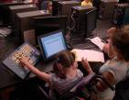 | 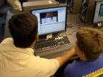 | 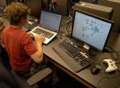 | 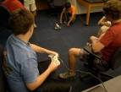
Figure 1: Students working with EATA, Alice, Microsoft Robotics and Lego Mindstorms NXT robots
Teaming graduate students from diverse engineering disciplines such as mechanical and computer science and engineering as well as communication disorders helps ensure that typical and special needs students are introduced and motivated to a variety of engineering aspects. Teaming graduate students from different disciplines enables them to share knowledge and information from their discipline while gaining knowledge and information from their peers. Teaming students from different disciplines encourages them to assume leadership. CMDS (Communication Disorders) students take a leadership role in teaching CSSE (Computer Science and Software Engineering) students to work with children with special needs. In return, CSSE students assist CMDS students with incorporating computer technology into their clinical goals and take a leadership role in teaching and improving the learning process for typical children. CSSE students gain more insight into the types of concepts that may be needed in developing computer programs for typical and special needs children. Both CSSE and CMDS will have hands-on experience with naïve users of common and popular applications therefore help them to identify the problems and concerns of those users. In the same time graduate students that are interested in a teaching career will improve their pedagogical skills by being exposed to typical and special needs children. The CMDS students become more technologically advanced as a response to the challenges that our society becomes more technology-dependent; therefore speech language pathologists with computer skills will be in demand [Power-de Fur, 8].
METHODOLOGY
Pre and post program surveys (see Fig. 2 and Fig. 3) were compared to determine areas in which the most significant amount of learning occurred. Participating children completed a computer background surveys indicating their academic grade, interest and knowledge in computers, previous usage of computers and goals they wanted to achieve. Children’s progress was evaluated after each class allowing instructors to adjust the lesson and teaching methods to enhance learning. Instructors also used this evaluation period to: identify children that were having difficulty following directions and attending to tasks; evaluate children’s strengths and weaknesses; and determine how children’s individual interest could be used to encourage an aptitude for computer literacy.
For Comp Camp, the CSSE and CMDS students were assigned to the program based on their interest in working with school-aged children, and their interest in evaluating, designing and developing educational interactive applications. The CMDS students improved their clinical skills by: 1) Maximizing their ability to work as a member of a team with CSSE peers 2) Learning to incorporate computer technology with communication goals and 3) Becoming familiar with working in an inclusion setting. The CSSE students improved their skills as future educators and educational applications developers by: 1) Having the opportunity to work with typical and special needs children as a member of a team 2) Better understanding the computer strengths and special needs of school-aged children in order to develop appropriate educational computer programs and 3) Further improving their pedagogical skills.
Figure 2: Results of the children’s 2006 and 2007 Comp Camp survey
Children’s Responses –: Y = Yes; N = No; VI = Very Interested; I = Interested; N = Don’t Know; UI = Uninterested.
Figure 3: Results of the children’s 2006 and 2007 Comp Camp end of program evaluation
Children’s Responses – Key: LTIH = Less than Hoped; AMAIH = As much as I hoped; MTIH = More than I hoped.
The effectiveness of the program was evaluated by measuring pre and post responses on a survey assessing the CSSE graduate students’ ability to work with peers from a different discipline (CMDS), knowledge of serving children from diverse linguistic and cultural backgrounds, knowledge of working with special needs children in an inclusive program, knowledge of the current level of effectiveness of educational computer programs and ways to further improve these educational computer applications both on a technological and pedagogical level.
For Robo Camp, the engineering students were assigned to the program based on their interest in working with school-aged children, and their interest in evaluating, designing and developing educational interactive applications. Engineering students improved their skills as future educators and educational applications developers by: 1) Having the opportunity to work with typical and special needs children as a member of a team 2) Better understanding the computer strengths and special needs of school-aged children in order to develop appropriate educational computer programs and 3) Further improving their pedagogical skills. Participating children completed pre computer background surveys indicating their academic grade, interest and knowledge in computers, previous usage of computers and goals they wanted to achieve and a post program evaluation survey. Pre and post program surveys were compared to determine areas in which the most significant amount of learning occurred.
COMPUTER LITERACY ACADEMY
The Auburn University Comp Camp has been offered starting summer 2005. The program was developed by faculty members from the Department of Computer Science and Software Engineering (CSSE) in cooperation with Communication Disorders (CMDS). The main objectives lined for this project were designed as follows:
- Provide an opportunity for graduate students from different disciplines to work together as a team, providing specialized services for each different group of children.
- Provide a computer literacy camp designed for children in an inclusion setting.
- Provide an opportunity for children with disabilities to improve communication, cognitive and social skills using state of the art computer technology in an inclusive environment.
This program has been a success since its early introduction, [Marghitu, 5], [Marghitu, 6]. In the last edition of 2008, based on the feedback obtained from children in previous years, see Fig. 1, program directors have defined extra objectives that characterize the progression of the program. Here are the new objectives added to the latest syllabus:
- Introduce new assistive technologies (Software and Hardware).
- Evaluate usability and adaptability of new software (Microsoft Windows Vista, Microsoft Office 2007) with respect to young age users.
- Introduce all typical students to basics of computing and programming robots through Alice and Lego Mindstorms robots and RIS
- Identify students that could work with advanced computing concepts and skills using Alice, Lego Mindstorms NXT robots as well as Microsoft Robotics Platform.
The Comp Camp curriculum for typical children is structured into two major sections. The first is related to software usage through computer applications and software programming. The second category of this program is an introduction to robotic platforms and its programming. Through the upgraded Comp Camp curriculum, program directors aim new findings and extensive research results that will help determine the new directions of the future programs.
Computer Literacy Academy: Alice Programming
Alice (http://www.alice.org/) is a 3D authoring system created at Carnegie Mellon University providing a direct manipulation graphical user interface creating an easy to work with programming environment using methods, functions, variables, parameters, recursion, array, and events. In the same time, it allows students to work with objects that they can see and to address the mechanical barriers of programming (such as rules of syntax and correctly typing commands), therefore to more easily create programs. Through a huge library of predefined objects, actions or methods, Alice introduces the students to the concepts of Object Oriented Programming (OOP). Students become the director of a movie or the creator of a video game, by learning how to think about arranging sets of instructions in order for their 3D objects to carry out a task. Therefore they learned how to design a program.
On the first day designated for learning Alice, the children watched some of the programs created by other children of their own age from previous Comp Camp programs. Children became instantly interested in learning to make a penguin dance, or a shark to swim around an island [Dann, 2]. Next, children became acquainted with Alice user interface and they worked on the built-in tutorials. Then children worked on a hands-on exercise about creating, designing, implementing and testing a scenario. Children learned about key programming concepts and terms such as method, parameters, loops, if/else statements, do together, do in order and practice using them in appropriate exercises. Students completed three main categories of assignments using Alice presented in Table 1. Fig. 4 shows an example of an Alice program developed by students. Two categories of problems for the children to complete were proposed:
  - Problems with very clear requirements and instructions on how to complete the assignment aiming also building good “follow directions” skills;
  - Problems with very clear requirements and no instructions on how to complete the assignment aiming also to simulate children’s creativity.

Categories | Assignments
Alice Basics | - Three tutorials from Carnegie Mellon teaching children how to Add Objects and Methods, Create Worlds and Methods, and Move Objects and Cameras  - Hands on exercise reinforcing the five Areas of the Alice Interface  - Exercises from the Learning to Program in Alice book to reinforce positions of objects in 3D world  - Exercises to demonstrate knowledge but allowing the children to be creative and implement the program various ways as long as certain criteria were met
Control Structures | - View and modify an Example Program as a group  - Learn how to only effect parts of an object (such as the robots head, upper left leg)  - Definitions of Control Structures and exercises to reinforce when and why to use each of these structures  - Relational operators and a matching exercise to reinforce the concepts  - Learn about Alice methods and testing knowledge by completing exercises from the book
Key Programming Terms | - Learn about terms such as classes, objects, methods (world and class level), parameters and why we need each of these  - Practice Exercises from the book to implement these concepts
Table 1: Alice Assignments for Comp Camp

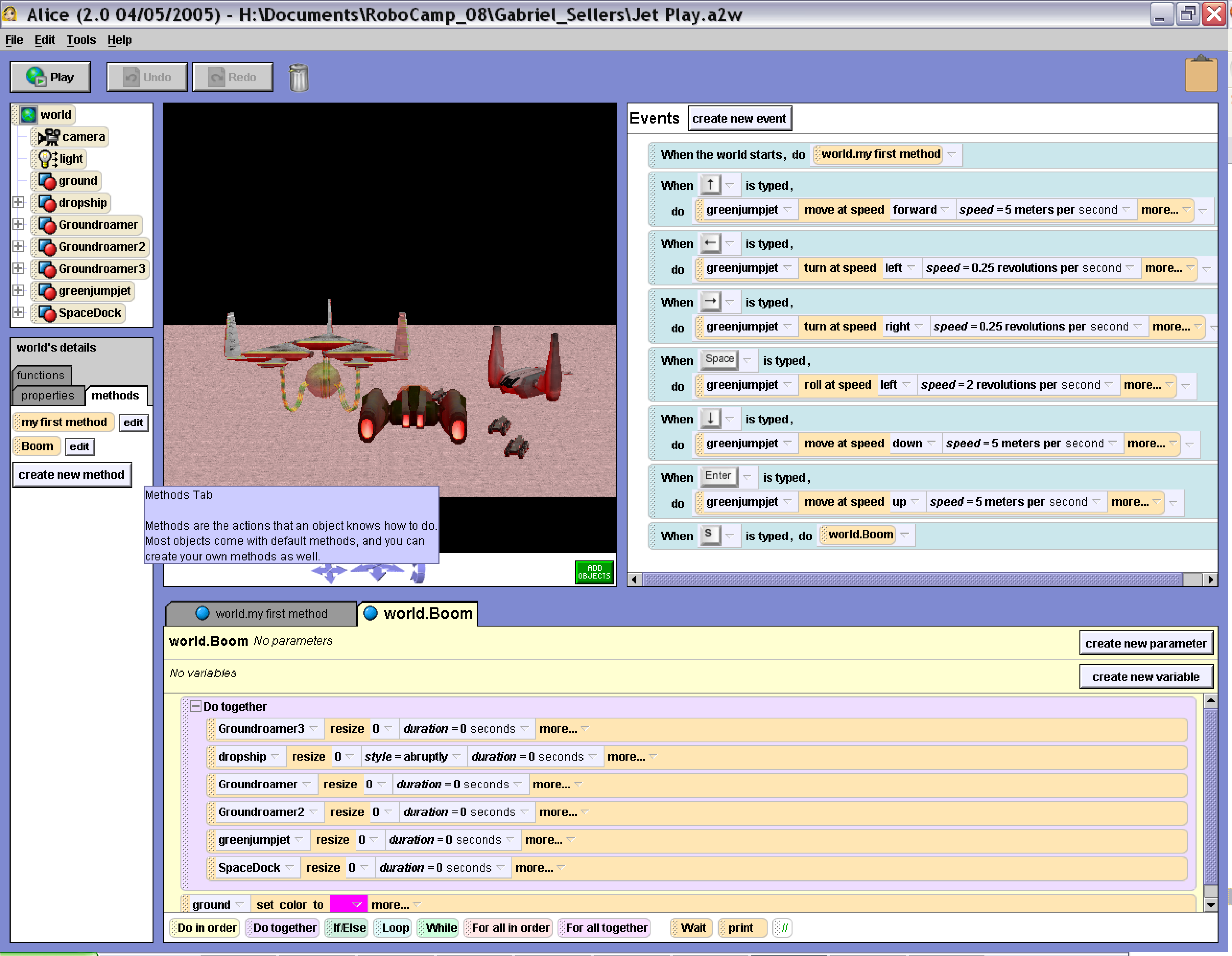
Figure 4: Alice beginner program students’ sample

Computer Literacy Academy: Lego Mindstorms Robots and Microsoft Robotics Platform
The second part of Comp Camp included Lego Mindstorms system, this system was created through a partnership between Lego and M.I.T. Media Laboratory in an effort to create a simple, child-friendly introduction to robotics (http://mindstorms.lego.com/eng/default_ris.asp). Children were introduced to the basic components of the Mindstorms robot: the brick (CPU), the sensors (touch and infrared), and the effectors (motors, display, and sound). Once children were comfortable with the capabilities of the robot, the Robotics Invention System 2.0 (RIS) was introduced. This is the visual programming language created specifically for programming Lego Mindstorms robots. Programs may be created on a desktop computer using RIS, and they are then transferred to the robot using a USB infrared tower. Programming and control structures are represented in RIS as Lego blocks, and their visual representations embrace the idea that form should follow function, see center image in Fig. 5. It was important to help children to realize that the “brick” was only capable of interacting with the world through the sensors and effectors. The younger children initially had a difficult time understanding this concept, so an interactive demonstration was devised in which the children were given tasks to perform but were not allowed to use some of their sensors (e.g., eyes) or effectors (e.g., hands). For example, center image in Fig. 5 displays a simple program in which the robot moves randomly on the ground while avoiding obstacles. The basic control structures (branching, looping, and sub-procedures) were discussed as needed during the given assignments (Tab. 2).
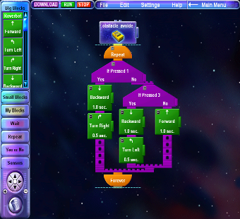
Figure 5: RIS program students’ sample
Assignment | Description
Robot moves forward in a square and turning without touching the delimiters. | A form of competition was organized where the winner is the robot that will make the fastest turn around the square without hitting any delimiter. This assignment required children to familiarize themselves with basic motor controls and timing aspects that relate to robotics. A square track was created using 4 delimiters on each square corner.
Robot moves randomly while avoiding obstacles. | Required children to consult touch sensors placed on the front of the robot. Based on the sensors’ states, the appropriate action could be taken (based on the first assignment). This assignment led to two different approaches – one using sensor polling (i.e., an event loop) and the other using multithreading.
Robot follows a thick black line on a white background. | Required children to consult the single infrared light sensor placed on the front of the robot. Based on the intensity of the reflected light (low for a black line and high for a white background), the robot could turn accordingly to keep it on the line.
Robot always moves toward the brightest spot in front of it. | For this assignment, the robot was given two separate light sensors, so it was possible for students to use the disparity between the eyes to discover the appropriate turning direction. Each light sensor was a simple “home-brewed” sensor created using photo resistors purchased from a local electronics store. Sensors registered the incoming light intensity and were used to ascertain the direction of the light. Children were then able to take the appropriate actions based on the sensor values.
Table 2: Lego Mindstroms Robots and RIS Assignments for Comp Camp
In this way, children learned concepts when those concepts became the most relevant. For instance, during a task in which the robot needed to do two things at once, children often attempted to solve the problem by using an iterative approach akin to an event loop. It is important to remember that children discovered this solution on their own. However, they often felt unsatisfied with the approach because the robot was not as responsive as they wanted. Children would inquire if there were some other way to solve the problem. The instructor could then go into a very relevant discussion of process threading. For each assignment, each team of 2 participants was given a USB tower and a robot. Team members often initially took several minutes to discuss their solutions. When the team reached a consensus, one of the members would begin to drag-and-drop the control blocks into the RIS program. The other team members would watch and make comments and suggestions as the solution took shape. Once a proposed solution was completed, the team would transfer the program to the robot and test it. This typically led to further refinement of the program and further testing.
A group of gifted 2008 Comp Camp students were also introduced, via shorts lectures and hands-on demos, to the latest generation of Lego robots, the Mindstorms NXT robots and the Microsoft Robotics Platform (MRP). The feedback obtained from these hands-on demos helped us further improve the Robotics curriculum for the 2009 Robo Camp and Comp Camp.
ROBO CAMP PROGRAM
As Kelleher points out, “Given the broad impact of computer science, it is critical that we ensure that computer science continues to attract bright minds that will enable the field to continue to make forward progress and support progress in other fields…there has been a dramatic drop in the numbers of students interested in studying computer science at both the college and high school levels…AP computer science exams dropped by 6%, 2004 to 2005.” [Kelleher, 4]. Robo Camp is an advanced program designed by CSSE faculty members for gifted children. Robo Camp aim is to select gifted children from Comp Camp that have shown substantial motivation and progress, and to introduce them to more advanced programming and Robotics concepts and skills, using programming environments such as Alice and Microsoft Robotics Platform.
Robo Camp: Alice Programming
Alice was used to create more challenging assignments such as developing movies and interactive worlds. Children that were new in Alice were asked to go through the three tutorials provided with the software, while children that worked with Alice before, received a simple assignment in order reinforce the basic concepts of the program. Hands-on exercise helped children new in Alice with understanding and implementing the main parts of creating a program (creating a scenario, design, implement and test), as well as learning terms such as method, parameters, loops, if/else statements, do together, do in order. Specific exercises were used with different levels of difficulty for each group of children to help them use and to stimulate their creativity while implementing the terms learn as well as new ones like creating their own methods, functions, and events, see Fig. 6.
Children learned how to group a set of instructions for a single object into a method. They used world-level methods as well as class-level methods and learned how to call the methods created. World-level methods were created so that more than one object is used. This allows children to reuse parts of the program every time that their storyboard requires it, in order to be more organized. Class-level methods are used to coordinate actions for a single object. Children created their own class-level methods for objects that didn’t have a build-in movement that the user would like to have. Children learned as well to communicate with a method using parameters such as Number, Boolean, Object, or Other (i.e. color, sound). Children’s favorite part was learning to use events and create interactive programs, see Fig. 6. Using a hands-on exercise, children learned about the control flow of an interactive program, events, event handling methods and testing. After practicing these terms on a “firefighter rescue mission”, children were asked to apply their skills in exercises such as “landing a helicopter”. During the last sessions, children completed a final project. The requirement for the project was to write their own story, and create a program for it using new methods, parameters and at least one event.
Robo Camp: Lego Mindstorms Robots and Microsoft Robotics Platform
The Robo Camp curriculum includes applications with the last two generations of Lego Mindstorms Robots. The older Lego RCX robots are a good place for new/beginner level students to start learning the basics of robots programming, see Figure 5, whereas the new generation of Lego NXT robots enables intermediate and advanced level students to further enhance their robot programming knowledge and skills.
Microsoft Robotics Platform (MRP) is also used in Robo Camp for students that have shown exceptional skills while working with the Lego NXT robots. MRP allows students to quickly program robots using a visual development environment, or directly by using a complex C# programming language. When working with MRP students have the option to program the real NXT robots or simulated robots in a virtual space. Programming virtual robots are a nice way to experiment on different simulated terrains.
In the 2008 Robo Camp, students started to experiment, using the simulated environment, creating a specialized robot, see Figure 1. Then, using input devices, such as Microsoft X-BOX 360 wired controller, they implemented wireless controlled robots race.
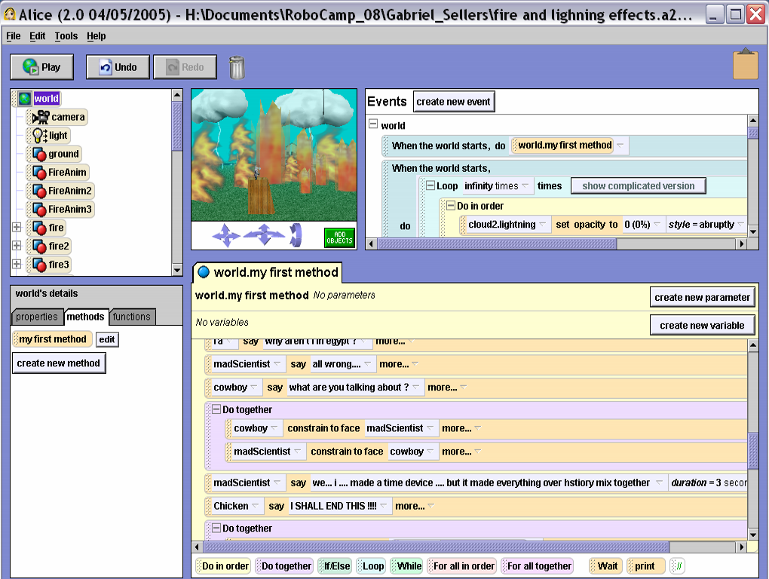
Figure 6: Alice advance program students’ sample
FINDINGS AND RESULTS
The 2008 Comp Camp and Robo Camp programs were a successful continuation of the previous years’ editions. Children's end of program evaluations show that the overwhelming majority of children felt that they had accomplished as much or more than they hoped from program goals, see Fig. 7. The major achievement of the 2008 program was the outstanding results obtained in introducing children to more advanced computer programming and robotics as well as software and hardware EATA specially designed for children with special needs. Very often children would make their parents wait after class in order to finish their assignments. Unlike some college age students, computers did not intimidate children. They have embraced with enthusiast this learning opportunity. Alice and Mindstorms equally appealed to girls and boys and encouraged children to become more involved in computers and programming. With the decrease of engineering college students' enrollment (especially women) over the past few years, we believe that getting children, especially girls, more involved in K 12 engineering outreach programs from an early age will increase the likelihood of young people enrolling in engineering and women in non-traditional fields [NSF, 7].

Figure 7: Results of the children’s 2008 Comp Camp end of program evaluation
CONCLUSIONS
For the past four year, COMP CAMP, based on the program evolution results, program was deemed successful. All children were excited about engaging and completing computer projects, especially in a college computer lab and surrounded by graduate students. Despite hard work, children had a lot of fun using Alice in learning the basics of programming; they were thrilled to receive their Alice books, at the end of the camp, and to be able to learn and work more with Alice even after the camp. Children exposed to Lego Mindstorms Robots displayed an increased interest in technology, due to their newfound understanding of concepts they once believed to be difficult. Younger children were more enthusiastic about Mindstorms than the oldest children. This can probably be attributed to the toy-like appearance of the robots. Younger children typically showed amazing creativity in their solutions to the assignments, and several of them stated that they would like to work more with robotics in the future. Children with special needs enjoyed using the computers to work on their targeted communication goals and they not only increased their computer skills, but also improved their communication skills. Total increase was 24% for all targeted goals. One extra benefit is that some of the children were able to independently answer questions on the computer. This increased independence also leads to increased self esteem.
Overall, CSSE graduate students were truly impressed by the eagerness, hard work and progress made by children toward becoming someday true computer wizards. At the end of the program, CSEE graduate students felt better prepared as future educators and developers of educational computer applications. CMDS graduate students reported working with CSSE peers was an effective way to increase their computer skills and that use of computers was an effective way to increase children’s learning of speech and language goals. CMDS students reported an increase in understanding how to incorporate speech and language goals along with computer technology and increased knowledge in working effectively with children from a variety of multicultural backgrounds.
FUTURE WORK
Comp Camp and Robo Camp program directors will continue to offer these successful K12 engineering outreach programs during subsequent years. Specialized EATA were used to successfully target 71% of the objectives included in the curriculum for the typical children, hence, program directors will make an effort to continue evaluate a multitude of cutting edge interactive EATA that will give children with special needs the support they need to be equally successful in COMP CAMP, their future life and career. The educational applications and environments for introducing children to more advanced computer concepts were successfully integrated in the curriculum and program directors will continue to evaluate these types of applications and select those that should be a good addition to programs' curriculum. Programs directors are also planning on organizing follow-up workshops with students, parents and K12 teachers for a better understanding of the strategies that should be used for further enhancing these programs.
REFERENCES
- Cavanaugh, T., “Assistive Technology and its Relationship with Instructional/Educational Technology, “ retrieved from: http://www.unf.edu/~tcavanau/research/aet/index.htm., 2000.
- Dann, W., Cooper, S. and Pausch, R., Learning to Program with Alice: 1/e, Prentice Hall Publishing Co, NJ, 2006.
- Haynes, W.O., Moran, M. and Pindzola, R.H., Communication Disorders in the Classroom. (2nd ed.), Kendall/Hunt Publishing Company, Iowa, 1990.
- Kelleher, C., Motivating Programming: Using Storytelling to Make Computer Programming Attractive to More Middle School Girls. Carnegie Mellon University Ph.D. Dissertation, Sept. 2006, Chapter 1 & 2. www.cs.cmu.edu/~caitlin/kelleherThesis_CSD.pdf.
- Marghitu, D., Zylla_Jones, E., “Auburn University Computer Literacy Academy for Children (dealing with disabilities),” SIGCSE, ACM, Portland Oregon, March 2008.
- Marghitu, D., Zylla-Jones, E., “Educational and Technological Computer Literacy Program for Typical and Special Needs Children: An Auburn University Case Study,” SITE Conf, AACE, Orlando, FL, 2006.
- NSF, “Women, minorities and persons with disabilities in science and engineering” http://www.nsf.gov/statistics/wmpd/disability.htm
- Power-de Fur, L., Practicing the Future of Speech-Language Pathology in Public Schools. In B. Sutherland Cornett (Ed), Clinical Practice Management for Speech Language Pathologist, Aspen Publishers, Maryland, 1999, pg. 243-254.
- Ward, R., “Computer-Assisted Learning and Language-Impaired Children. Equal Access to Software and Information Technology and Disabilities,” E-Journal, ITD Vol. II, 1995.
Daniela Marghitu
Dr. Daniela Marghitu is a faculty in the Computer Science and Software Engineering Department at Auburn University where she teaches Object Oriented Programming, and Web Application Development courses, and coordinates the traditional and independent learning computer literacy courses since 1996. She is the founder and director of the Auburn University Computer Literacy Academy for children (dealing with disabilities), Robo Camp, and Auburn University Lab for Educational and Assistive Technologies. She published two books for the Prentice Hall Exploring Series, over 30 peer reviewed articles and international conference papers, and she gave numerous presentations at national and international professional events.
Michael Fuller
Mr. Michael Fuller is a graduate teaching assistant and graduate research assistant in the Computer Science and Software Engineering Department at Auburn University. His research is focused on new Web applications development technologies. He is also working as coordinator of the Auburn University Robo Camp and is a part of the MyITLab administration team at Auburn University.
Taha Ben Brahim
Mr. Ben Brahim is a PhD candidate in the Computer Science and Software Engineering Department at Auburn University. He is working on new wireless networks platforms. He is also working as coordinator of the Auburn University Computer Literacy Academy for children. Mr. Ben Brahim is a part of the MyITLab administration team at Auburn University.
Eliza Banu
Ms. Eliza Banu holds a MS in Electrical Engineering, and currently is a PhD candidate, graduate teaching assistant and graduate research assistant in the Mechanical Engineering Department at Auburn University. Her research is focused on new nonlinear dynamics. She is also working as coordinator of the Auburn University Computer Literacy Academy for children.
ACKNOWLEDGEMENTS
The development of the Comp Camp and Robo Camp would not have been possible without the dedicated work of Mrs. Elizabeth Zylla-Jones Associate Clinical Professor at CMDS, Dr. Wanda Dann from Carnegie Mellon University and many other wonderful professionals, gracious help and support from CSSE and CMDS graduate students that worked mostly as volunteer instructors, all our amazing partners and sponsors (https://fp.auburn.edu/comp1000/SummerOutreach).

Department of Computer Science and Software Engineering at Auburn University, daniela,fullemg,benbrah@eng.auburn.edu
Department of Mechanical Engineering at Auburn University, Banueli@auburn.edu

