Building Engineering Achievement Through Transportation (BEAT): A Traffic Engineering Program for High School Students
Dwayne Henclewood, Mshadoni Smith, Laurie Garrow, Angshuman Guin, Michael Hunter, Marion Usselman
Abstract – The BEAT the Traffic program was a week-long summer program conducted at Georgia Tech with support by the Federal Highway Administration. This highly interactive and flexible program introduced high school students to transportation engineering and helped them develop and prepare for success in science and engineering. The curriculum included, among other things, an overview of the transportation sector and fundamentals of developing appropriate signalized timing plans for signalized intersections. The curriculum culminated with a design challenge in which teams of students attempted to design the best signal timing plan for a series of two intersections. This paper will give details about the curriculum, evaluation results, and lessons learned about high school outreach.

Keywords: traffic engineering, design challenge, high school summer camp

Introduction and Background
To promote K-12 student engagement in science, technology, engineering and mathematics (STEM), it is imperative that science and math teachers effectively link their content material to issues of significance to the students. Transportation issues, in particular those that occur during times of such national emergencies as hurricanes, earthquakes, or war, have recently come to the forefront of national concern. People at all levels, from students in elementary schools to policy makers to research scientists and engineers, have all attempted to comprehend and to mitigate the human impact inflicted by disasters such as Katrina and 9/11. Many of the lessons learned directly concern the engineering and science communities. How do we develop effective plans for the evacuation of large populations of people from affected regions, or smaller populations from locales such as shopping malls and schools? Which parts of our vital transportation network are most susceptible to damage, and how do we develop transportation infrastructure systems that will better withstand earthquakes and hurricanes? The importance of these questions is easily comprehended and appreciated by most middle and high school students, and therefore are effective examples to use when teaching many topics, from middle school mathematics to high school physics.
The Building Engineering Achievement in Transportation (BEAT the Traffic) program, funded by the Federal Highway Administration through the Garrett A. Morgan Technology and Transportation Futures program, is a collaboration between the Fulton County School System and Georgia Institute of Technology (Georgia Tech) and is designed to promote STEM achievement in predominately African American schools in south Fulton County through student and teacher programming in the topic of transportation engineering.
As part of the BEAT grant, in summer of 2008 Georgia Tech offered two one-week summer programs for high school students. One camp was offered to students at Westlake High School, a magnet math and science school in Fulton County, Georgia, that is 98% African American. The second camp was open to all interested high school students in the Atlanta metropolitan area, although a priority was placed on recruiting women and minority students. These “BEAT the Traffic” camps introduced students to the field of transportation engineering, while honing and developing skills to prepare them for success in science and engineering. The curriculum was designed to be highly interactive and flexible so that it could be adapted to students at various grade levels, while retaining its fundamental goals and objectives. No equivalent type of summer program was located in the literature, nor was anything similar referenced in a recent review of P-12 engineering education programs by Brophy et.al.[]
There were several teaching modules organized into three lessons that were developed for this week-long camp. The first lesson provided a brief overview of the transportation sector and its evolution and introduced the process through which transportation projects are initiated and completed. The second lesson introduced students to the fundamentals of developing signal timing plans for a single signalized intersection. The final lesson introduced coordination concepts that are involved in programming multiple intersections.
The goal of these instructions was to enable the students to understand the impact of the interaction between intersections on traffic flow and then using this knowledge coordinate the flows and minimize the delay for a network of two signalized intersections. The students were first introduced to the impact of an intersection’s operation on neighboring intersections through the use of a time-space diagram. That knowledge was then reinforced and transferred with the use of VISSIM, a transportation simulation software application, and a series of exercises designed to allow a visualization of the impact of different timing patterns on traffic flows.
Lunch speakers drawn from local consultants who are actively engaged with the Institute of Transportation Engineers, the primary professional organization for transportation engineers, also helped to reinforce fundamental traffic engineering concepts and illustrated how concepts learned in lecture applied to practical engineering settings. A field trip to the Georgia Department of Transportation’s NaviGAtor real-time traffic control center also helped to achieve this objective.
The curriculum culminated with a design challenge. Students formed groups of four or five and were challenged to develop the optimal signal timing plan for a series of two intersections given corresponding volumes at the various approaches. Each group’s timing plans were then executed and presented to an audience of parents, graduate students, fellow classmates, and curious onlookers. The presentations of the solutions involved the use of a software program that was developed by the camp staff, traffic signal heads, a taped-off “traffic corridor” and individuals walking through the network at particular speeds to mimic vehicle behavior. This method of instructing and presenting a few of the fundamental principles of traffic engineering proved to be an excellent means of reinforcing the lessons learned and a fun way to demonstrate to others what was taught.
Given an overview of the week-long camp curriculum, the balance of this paper focuses on describing two activities related to single and multiple intersection control, and the final design challenge. This is followed by an evaluation of the effectiveness of the camp, lessons learned (that will be helpful to others considering similar camps), and conclusions.

Single Intersection Control – Intersection “Mumble Jumble”
As shown in Figure 1, students were introduced to fundamentals of single intersection control via an activity. First, students stood as if they were cars at a single intersection and ran freely through the intersection. After seeing the obvious confusion, students then suggested ways to improve operations. The instructors categorized student suggestions into the three standard levels of intersection control:
- Level I – Basic rules of the road
- Level II – Yield / stop signage
- Level III – Signalized intersection¹

Instructors then focused on constructing a signalized intersection while ensuring that each portion of the timing plan was introduced as a solution to a particular issue that was observed in the intersection mumble jumble.
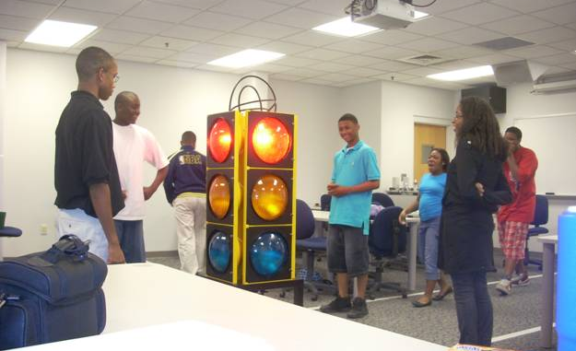
Figure 1: Intersection Mumble Jumble
INTERSECTION MUMBLE JUMBLE—CURRICULUM DETAILS
Learning Objectives
After this activity, students should be able to:
- Demonstrate the chaos and confusion that stems from a lack of any form of intersection control.
- Formulate a basic rule for “Level I” control which will be geared towards reflecting the official Level I control in traffic engineering
- Understand the primary purposes and fundamental concepts of an intersection.
- Comprehend the need to control traffic through an intersection.
- Recall the various ways of controlling the flow of vehicle through an intersection.
- Analyze traffic conditions at an intersection and select an appropriate method off controlling that intersection effectively and safely.
- Use “engineering judgment” to select the most appropriate means of controlling an intersection.
Materials List
- masking tape
- metronome
- stop watch
- make-shift stop signs
- poker chips
- make-shift signal light
- buckets

Background Concepts for Teachers: The Hierarchy of Intersection Control
Note that all of the material in this section describing levels of control draws heavily on reference [].
Level I Basic road rule - In the absence of control devices the driver on the left must yield to the driver on the right when the vehicle on the right is approaching in a manner that may create an impending hazard.¹
Level II Yield and Stop Control – If under Level I control the intersection is unsafe to traverse, some form of Level II control may be used to control the intersection. Forms of this level of intersection control include the use of yield signs, two-way stop control, and four-way stop control. Factors that may determine whether or not it is appropriate to use this level of control include whether the intersection:
- includes a high speed roadway
- has insufficient sight distance for Level I control
- has a history of large numbers of accidents that could be mitigated by Level II control
- includes a minor street entering a busy through highway or street
- includes a major road with presumed right-of-way
- has merges that require regulation to maintain safe operation ¹
Level III Traffic Control Signals – This form of traffic control assigns right-of-way to specific movements to eliminate or reduce the number of conflicting movements. In other words, traffic signals allot right-of-way for vehicles with conflicting movements over time and space. Factors that may determine whether or not it is appropriate to use this level of control include whether the intersection:
- has any of the factors from Level II, but is more severe
- has vehicle movements experiencing significant delays
- includes significant pedestrian traffic
- is near certain types of facilities such as schools or elderly homes
- has a history of large numbers of accidents that may be mitigated by Level III control
- is part of an organized road network with coordinated signalization
The potential advantages of Level-III control are that these intersections:
- provide orderly traffic movement
- increase traffic handling capacity of the intersection
- reduce the frequency and severity of certain types of crashes
- may potentially be coordinated to provide continuous or nearly continuous movement
- are used to interrupt heavy traffic at intervals to permit other traffic, vehicular or pedestrian, to cross or enter the traffic stream
The potential disadvantages of Level-III control are that these intersections
- can have excessive delay
- can promote excessive disobedience of the signal indications
- can increase use of less adequate routes
- can cause a significant increase in the frequency of rear-end collisions ¹
Overview of Traffic Mumble Jumble activity.
To achieve the aforementioned objectives, the following presents an exercise consisting of four scenarios that will be the medium through which the students will learn about intersection control. Each scenario will be centered on the “roadway” network configuration seen in Figure 2. This network may be outlined with the use of masking tape on the floor. Each approach should be at least 30ft in length and lanes 3ft wide.

Figure 2: Activity Layout – chip reservoirs
Students will traverse the network obeying the rule of the “road” in each scenario. The instructors will ensure that the students are discharged into the network with random headways. Once the students enter and re-enter the network they will take a chip. Each student should keep his or her chips throughout the duration of the exercise as these chips will be used to determine the primary measures of effectiveness (MOEs) that are used to evaluate the intersection operations. The MOEs that will be developed include:
- # of accidents (based on instructor observation) ● total # of chips
- # of chips collected by E-W approaches ● minimum # of chips collected by an individual
- # of chips collected by N-S approaches ● maximum # of chip collected by an individual
At the end of each scenario these MOEs will be tabulated to demonstrate how well each level of control serves demand. See Table 1:
Table: 1 Measures of Effectiveness for Each Scenario
Scenario | # Chips E-W | # Chips N-S | Tot. # Chip | Min. # Chips | Max. # Chips | # of Accidents
I
II
III
IV
Procedure –
Traffic Mumble Jumble Rules
- Movement is restricted by ticks from a metronome. Students are allowed to make only one step per metronome tick. This is the way in which walk / vehicle speed will be controlled. At this instance the instructors will ensure the connection between walk speed and vehicle speed is understood. The students should be able to relate their walk speeds to that of a real vehicle.
- If students touch or require evasive action to avoid touching each other during the exercise, that constitutes an accident. Once an accident occurs, the “police” (an instructor or an assigned student) will make a note and input the information at the end of the scenario.
- The duration of each scenario must be such that MOEs have sufficient magnitudes for comparison purposes. This will likely be on the order of a few minutes.
Activity Steps
At the beginning of each scenario, signaled by an instructor, students should: walk at the speed set by the metronome, maintain normal stride lengths, and not touch any other car/person (there will be police watching).
At the end of each scenario, again signaled by an instructor, students should: count the number of chips they collected, tally the chips on each approach, and report the numbers to the instructor for them to be recorded.

Scenarios
In Scenario I students will be given the basic instructions on how to traverse the intersection with no intersection rules, picking up chips in the process, at a various speeds set by the metronome. At the end of the scenario, MOEs will be recorded.
Scenario II will be a similar exercise to Scenario I with the central difference being the implementation of the basic rules of the road, drawn from students through a discussion with the instructors. It is anticipated that with the implementation of the basic rules for operations in the absence of control devices that the intersection performance will improve and that this will be reflected in the recorded MOEs. Despite the improvements to the intersection, inefficiencies are still expected to occur. As such, students will be asked to suggest ways to address those inefficiencies. Instructors will steer suggestions towards the implementation of a 4-way-stop control intersection.
The implementation of the 4-way-stop signs and students walking through this new intersection control will be Scenario III. Similar to the other scenarios, MOEs will be recorded. Again there should be an improvement in performance measures but students should still feel as if the intersection is not performing as efficiently as possible.
In attempting to make the intersection more efficient students will be invited to consider the implementation of a traffic signal. Using a traffic signal to control the intersection will be Scenario IV, which is the foundation of this lesson. As such a series of 3 sub-scenarios are planned to give a demonstration of a few of the key components of using a traffic signal to control an intersection.
Scenario IV-(a): In this scenario, volumes will be equally distributed on each approach and the signals will be timed so that each interval (i.e. length of a red, yellow, or green indication) is no more than 2 seconds long. Student will again walk through the intersection and at the end, MOEs recorded. This is meant to illustrate to the students that signal timing plans are well thought out before they are implemented. And with the implementation of poor signal timing plans the outcome is poor performance measures. Suggestions to improve this signal timing plan will be the basis for Scenario IV-(b).
Scenario IV-(b) will strive to have longer, more realistic intervals to increase the intersection’s performance. MOE’s for this scenario will once again be tabulated. It is anticipated that in this case the intersection will be operating rather optimally. To create another scenario there will be a shift in volumes, e.g. twice the volume E-W than N-S, while maintaining the same signal timing plan - this will be Scenario IV-(c).
At the end of all the scenarios, the MOEs from each will be compared to provide both a qualitative and quantitative measure of how different means of controlling an intersection perform. The instructors will emphasize the use of a traffic signal, and provide the take-home message that a traffic signal tries to share the right of way of an intersection in time and space.
Note that in the event that time is rather restrictive, the sub-scenarios of Scenario IV maybe substituted with a single scenario of a pre-determined set of signal timing plans that is intended to operate the intersection more efficiently than in the previous two scenarios.
Assessment
Pre-activity assessment includes soliciting from students predictions about how well each different intersection control method will work, and which they think will perform best. Activity-embedded assessments include asking students at the end of each scenario what some of the issues they faced when going through the intersection were and how these issues may be addressed. Post-activity assessment uses a completed table of MOEs. A discussion is also facilitated by the instructor(s) as to which method of control is the best and why is that the case. It is anticipated that there will not be a clear answer, given the MOEs, but what is noteworthy here is that, in this case, and often times in engineering, engineering judgment has to be used to select an approach. Such judgment will not only take into consideration the MOEs, but also the specifics of a situation, the intent of the solution amongst other external factors such as political influences, aesthetics etc.

Multiple Intersection Control - VISSIM
After the intersection mumble jumble exercise, two other activities were used to introduce fundamentals of intersection control, the components of a timing plan, and how to develop signal timing plans. These concepts were reinforced with “hands-on” labs that used VISSIM, a traffic simulation software package. The VISSIM representation of the two intersection network used in the design challenge is shown in Figure 3.
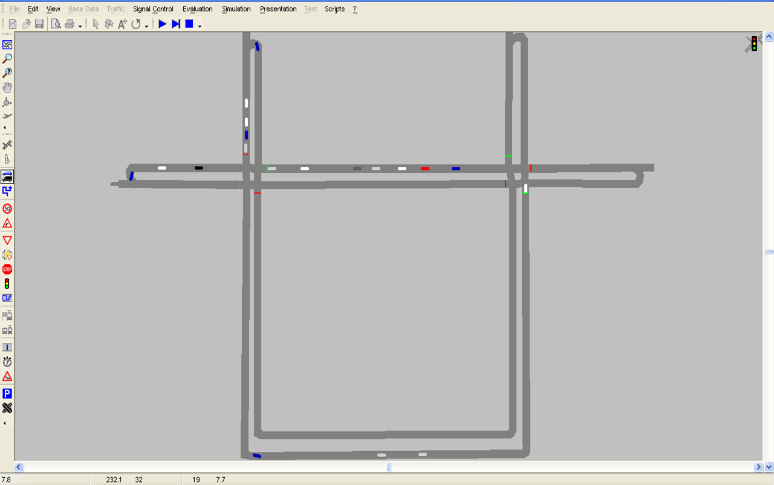
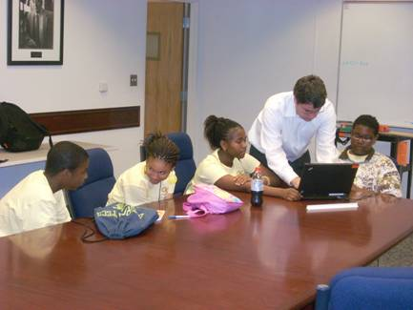
Figure 3: Using VISSIM for Multiple Intersection Control

The Design Challenge
The week-long camp culminated in a design challenge. The objective of the traffic challenge was to minimize total delay (one of the key measures of effectiveness used in design) through a corridor of two intersections by collecting the most poker chips. Each team was given different corridor characteristics, thereby requiring each team to design their own unique signal timing plans. Figure 4 illustrates the students executing their design challenges. This section outlines the main components of the design challenge. Note that the design challenge required students to integrate many of the traffic engineering concepts they learned throughout the week (that are not detailed in depth in this paper due to space constraints).

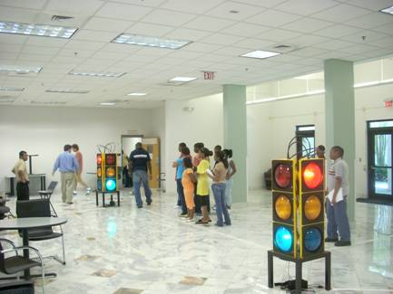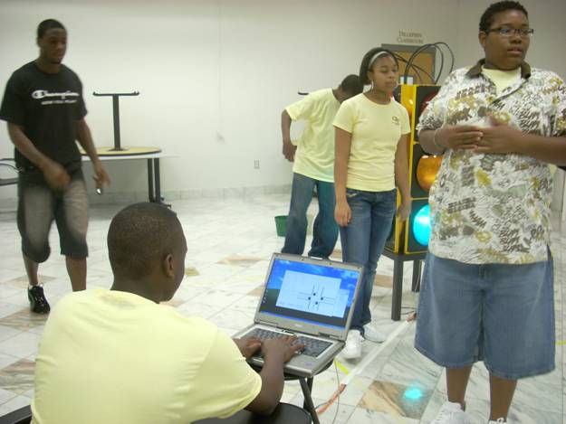
Figure 4: The Design Challenge
The objective of the design challenge was for students to minimize delay through their corridor, using the collection of poker chips as a means to estimate the delay. To perform the design challenge, students needed graph paper, a watch, scratch paper, and a calculator, as well as the metronome and poker chips, traffic signals and taped-off traffic corridors from the first activity. As part of the design challenge, students drew their corridors (including volumes, dimensions, and phasing) and developed timing plans for two signals, by selecting cycle lengths, green times, and an offset, to minimize vehicle delay.
There were several rules for the Design Challenge:
- No one may sabotage another group
- You may take only one poker chip per pass by a poker chip station
- You must allow cross-street time
- You may not touch another player and must be arms length away at all times
- Any traffic violations cost one chip
- Developed timing plans may not violate given minimum green, yellow, and red times
- You must stop at yellow
- You must use metronome speed limit

As shown in Figure 3, the design challenge used a network of two intersections 20 feet apart that had a corridor volume of x % traveling N-S and y % traveling E-W. All streets were one lane wide. Both streets had the same speed limit of z ft/s and there were no turns allowed. (The specific percentages and speed limits were team-specific). Teams were challenged to design signal timing plans that would minimize delay to all vehicles in the system.

Specific directions for the design challenge included the following:
- You will have 10 minutes to get as many “vehicles” through the system as possible.
- Each team will have different corridor characteristics, so what works for one team may not work for another team.
- Each team will set green and red times for suggested cycles.
- You must use minimum phase times:
Green = 2 second
Yellow = 4 seconds
All red = 1 second
- Delay will be measured for the entire corridor (this means that cross-street delay counts). Delay will be defined as the { # of chips / # of chips if ideal no delay }.
- Teams may use any method provided in class to determine and select the best timing plan.

Evaluation
A total of 32 students participated in the two camps; 72% were African American and 31% were women. Surveys were used to evaluate the four primary objectives of the camp: (1) to increase STEM and transportation engineering interest of high school students; (2) to involve students in advanced content traffic modeling activities including the use of traffic simulation software; (3) to expose students to transportation facilities; and (4) to expose students to transportation professionals as well as Georgia Tech faculty and graduate students as STEM role models. The results of the survey, filled out by 13 Westlake participants and 19 participants in the camp open to all interested students (defined as “everyone” in the legend) are summarized on the next page in Table 2.
There are several points of note in the table. The camp was very effective in increasing students’ awareness of transportation engineering (means across both camps increased from 2.05 to 3.89), helping students understand how transportation engineering research relates to the real world (mean=4.63), and helping students understand career opportunities in transportation engineering (mean=3.95). This is also revealed in comments from the students: “The Georgia Tech camp was an excellent experience for me. Now I have a better understanding of what civil engineering is. Now every time I’m at a traffic light, I will think about the engineers that work every day to make this possible.” However, overall, the course was not as effective in encouraging students to consider a career in transportation in college (mean=2.53). A closer inspection of one of the background questions reveals that this may be due in large part that the primary reason why students attended the camp was due to the fact that “my parents signed me up”: for example, 92% of the Westlake students responding to the survey indicated this was one of the primary reasons they attended the course, while only 46% of these students stated that they attended the course because they wanted to learn about transportation engineering.
Table 2: Evaluation of Effectiveness of Summer High School Camps
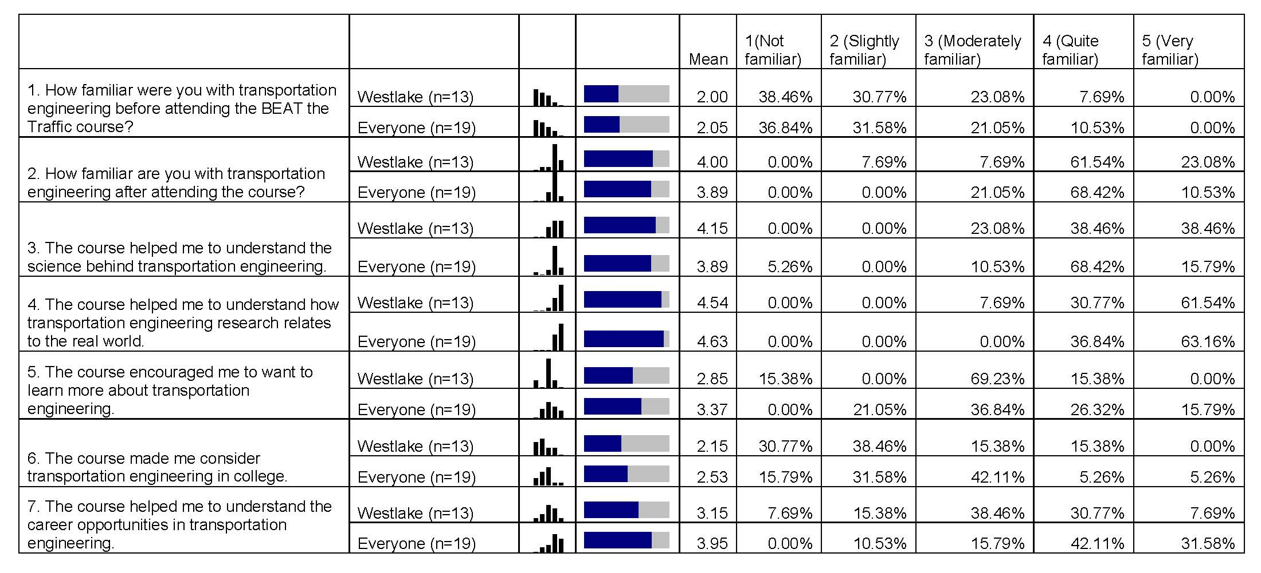

Lessons Learned
Most of the challenges and difficulties that were encountered in executing the camp’s curriculum can be categorized into two areas: (1) equipment (both hardware and software), and (2) scheduling.
The camp coordinators choose to provide hands-on experiences with as many real world applications as possible. This led to the use of field ready signal head assemblies, the centerpiece of the hands-on tutorials and applications, which mirrored those found in the real world – both in terms of appearance and operation. Though the implementation of this design was a success, numerous challenges were encountered in the process.
The first challenge was obtaining affordable and programmable signal head assemblies that would allow students the flexibility to input different signal timing plans given varying intersection characteristics. After several failed efforts in locating signal heads that could be used for the camp, the Georgia Department of Transportation generously loaned the coordinators eight new signal heads. However, to utilize these signal heads the coordinators had to construct a signal control system by purchasing a system of relay switches and developing a new software interface. Full field ready intersection controller cabinets and signal equipment could not be used due to the difficulty in moving such equipment, lack of an interface that would be intuitive to the students, and potential hazards to the students. Extensive effort was expended working with the relay systems to tailor it for the camp and, most importantly, to ensure that the relay system effectively communicated with the software interface with a high degree of reliability. The software interface allowed the students to input and adjust signal timing plans. What is noteworthy is that when designing the software interface with the signals, it was very important that it was designed with the curriculum in mind. This allowed the students to apply concepts they learned in lectures by successfully navigating the controls of the interface and implementing their signal timing plans.
Mounting the full size signal heads securely and portably was also a challenge. A stand was devised to hold four signal heads to control one intersection. Each signal head was bolted to the stand, which was a side table, with the relay system and battery mounted beneath. There were a number of wires and extension cords that were required to power the signal heads, as well as cables that connected the relay system to the laptop computers. And these had to be taped to the floor to minimize hazard to students.
Continuing along the lines of equipment challenges, the camp encountered a fair amount of challenges in using VISSIM, a traffic simulation tool. A part of curriculum was to have the students coordinate a corridor with two signalized intersections. To aid in this process the instructors employed the use of VISSIM to allow the students to model the signal timing plans before implementing them in the field. This was particularly challenging as the students had varying degrees of basic computer skills and as a result needed more supervision than originally anticipated. Additionally, VISSIM is a rather advance software package both in terms of its usage and the interpretation of its results. As such, supplementary assistance had to be solicited to not only teach student groups how to navigate VISSM but also to design a mechanism to easily obtain, read and interpret results from VISSIM.
The scheduling issues that were experienced were primarily related to the sequencing of lessons with hands-on activities, maintaining flexibility throughout the day and week, and reaching students at various levels of mathematical skill levels. The sequencing of lessons was the key challenge in order to build knowledge of signal timing and allow the students enough activities to apply the knowledge. The final group competition used all of the previous lessons and each of those lessons had to be applied prior to synthesizing for the final group competition. This was very difficult as some lessons were much more abstract and conceptual than others, and each day’s lessons were built upon those of the prior day which required the students to retain the previous lessons. Lastly, the mathematical base of knowledge and retention ability from rising 9th graders to 12th graders varies tremendously. Being responsive to the variance in student knowledge was a challenge.
The lessons the instructors learned were invaluable. The amount of time and planning to develop a new curriculum was much more extensive than they anticipated and the layout of the lessons was critical to achieving the end result of a knowledgeable student. Having a mixture of lectures, discussions and hands-on applications was critical to solidify new concepts and ideas. Additionally, in developing a curriculum for future summer camps, a series of assumptions will have to be made. These assumptions range from particular skill sets that students may have to how they will respond to the concepts that they will be introduced to. The assumptions are indeed necessary but what is equally as important is that these assumptions may be entirely incorrect and instructors must also be sufficiently prepared to deal with situations in which all assumptions are in fact incorrect. However, such preparations for coping with incorrect assumptions may be done via lesson plans with built-in flexibility while maintaining the necessary structure in order for the objective(s) of a lesson to be achieved.

Acknowledgements
The BEAT camps were sponsored by a Garret A. Morgan grant from the Federal Highways Administration. The authors are also grateful for the support of the Georgia Department of Transportation and Grice & Associates Transportation Consultants and for the efforts of numerous Georgia Tech students who volunteered to help with the camps.

Reference

Georgia Institute of Technology, School of Civil and Environmental Engineering, 790 Atlantic Drive, Atlanta, GA 30306 dhenclewood3@mail.gatech.edu,
Georgia Institute of Technology, School of Civil and Environmental Engineering, 790 Atlantic Drive, Atlanta, GA 30306 msmith3@ce.gatech.edu,
Georgia Institute of Technology, School of Civil and Environmental Engineering, 790 Atlantic Drive, Atlanta, GA 30306 laurie.garrow@ce.gatech.edu,
Georgia Institute of Technology, School of Civil and Environmental Engineering, 790 Atlantic Drive, Atlanta, GA 30306 guin@ce.gatech.edu.
Georgia Institute of Technology, School of Civil and Environmental Engineering, 790 Atlantic Drive, Atlanta, GA 30306 michael.hunter@ce.gatech.edu.
Georgia Institute of Technology, Center of Education Integrating Science, Mathematics, and Computing, 760 Spring Street, Atlanta, GA 30308, marion.usselman@ceismc.gatech.edu.
Brophy, S., Klein, S., Portsmore, M., Rogers, C. “Advancing Engineering Education in P-12 Classrooms”. Journal of Engineering Education, Vol 97, #3. July, 2008. Pp 369-380.
Roess, Roger P., Prassas, Elena S., and McShane, William R. Traffic Engineering, Third Edition. Pearson Prentice Hall. Upper Saddle River, NJ, 2004. 445-454 Biographical Information Dwayne Henclewood Mr. Dwayne Henclewood is a Ph.D. student at the Georgia Institute of Technology. His current research interest is in arterial performance evaluation and microscopic traffic simulation. Prior obtaining his M.S. in Civil Engineering from the University of Massachusetts Amherst (2007), he was a Mathematics and Science teacher at St. George’s College H.S., Kingston, Jamaica. Mshadoni Smith Ms. Mshadoni Smith is a Ph.D. student at the Georgia Institute of Technology. She has ten years of experience in Civil Engineering, seven in planning, design, management and operations of Intelligent Transportation Systems (ITS) with Federal Highway Administration. Laurie Garrow Dr. Laurie Garrow is an Assistant Professor in the School of Civil and Environmental Engineering at the Georgia Institute of Technology. Prior to joining the faculty, she worked for four years as a research analyst with United Air Lines and one year with a management consulting firm. Angshuman Guin Dr. Angshuman Guin is a Research Engineer in the School of Civil and Environmental Engineering at the Georgia Institute of Technology. He is a Transportation Engineer with 10 years of experience in the fields of Intelligent Transportation Systems (ITS), Transportation Safety, Incident Management and Freeway Operations. Michael Hunter Dr. Michael Hunter is an Assistant Professor in the School of Civil and Environmental Engineering at the Georgia Institute of Technology. He teaches undergraduate and graduate courses on transportation design, operations, and signal control. Dr. Hunter conducts research in the areas of transportation simulation, operations, and performance evaluations. Dr. Hunter as has several years experience as a traffic engineer with an engineering consulting firm. Marion Usselman Dr. Marion C. Usselman is a Senior Research Scientist at the Center for Education Integrating Science, Mathematics and Computing (CEISMC) at the Georgia Institute of Technology. Marion received her B.A. in biophysics from the University of California, San Diego, and her Ph.D. in biophysics from Johns Hopkins University. She focuses on K-12 educational reform, university-K-12 partnerships, and equity issues in education.

