Promoting Equity and Diversity in First Lego League

Marion Usselman, Jeffrey Rosen

Abstract—The Georgia First Lego League (FLL) tournament has grown from 16 teams registered with FLL in 2002 to 274 teams in 2008. As a consequence, Georgia now has a system of regional and super-regional qualifying competitions that ultimately lead to the State Tournament. To increase the quality of the experience for the largest number of students, we have assigned each team a “Power Rating” based on their prior experience and amount of time allotted to the activity. Teams are assigned to competitions partly based on their power rating to increase the likelihood that teams will compete against teams of similar strength and to help promote the success of urban public school FLL programs. The results from the 2008 tournament season show that there was a marked increase over 2007 in the number of public schools who were in the Top 10 list at the State Championship, from one team in 2007 to six teams in 2008.

Keywords: Robotics, First Lego League, K-12, Diversity

INTRODUCTION

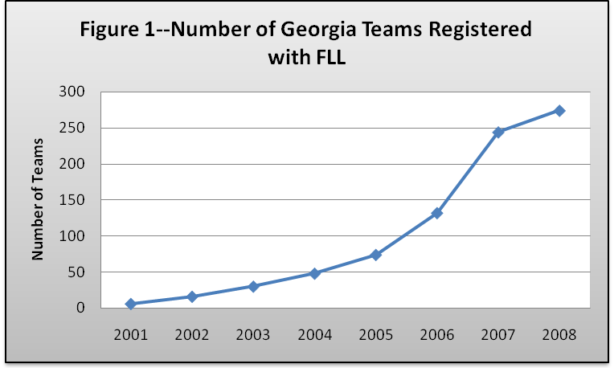
The FIRST LEGO League (FLL) competition is frequently promoted as an effective method of introducing middle school children to engineering problem solving and of increasing the pipeline of students into engineering and other STEM disciplines. The FLL program challenges students ages 9-14 to tackle a problem with a socially relevant theme and is designed to increase the students’ awareness of current affairs and possible engineering solutions. Each student team is required to build a robot that can perform 8-10 tasks that relate to the overarching theme, and to research the theme and develop a product or strategy to address the social issue. The tournament consists of the robot competition, presentation of the research projects, and an analysis of the technical and creative merits of the robot design. Historically, FLL has addressed issues such as climate connections (2008), alternative power sources and use of resources (2007), an exploration into the possibilities of nanotechnology (2006), the ocean resources and how we interact with them (2005) and making the world more accessible to the disabled (2004).

First Lego League has become a very popular program in Georgia; the number of Georgia teams registered with FLL increased from 48 in 2004 to 274 in 2008 (Figure 1) []. The number of student participants has increased from fewer than 400 in 2004, to over 1,600 in 2007 (Figure 2), necessitating two rounds of qualifying tournaments before the State Tournament. Clearly FLL is a highly successful program that provides a compelling experience to middle school students, and appeals to the parent, teacher, university and corporate volunteers necessary to coordinate the program.

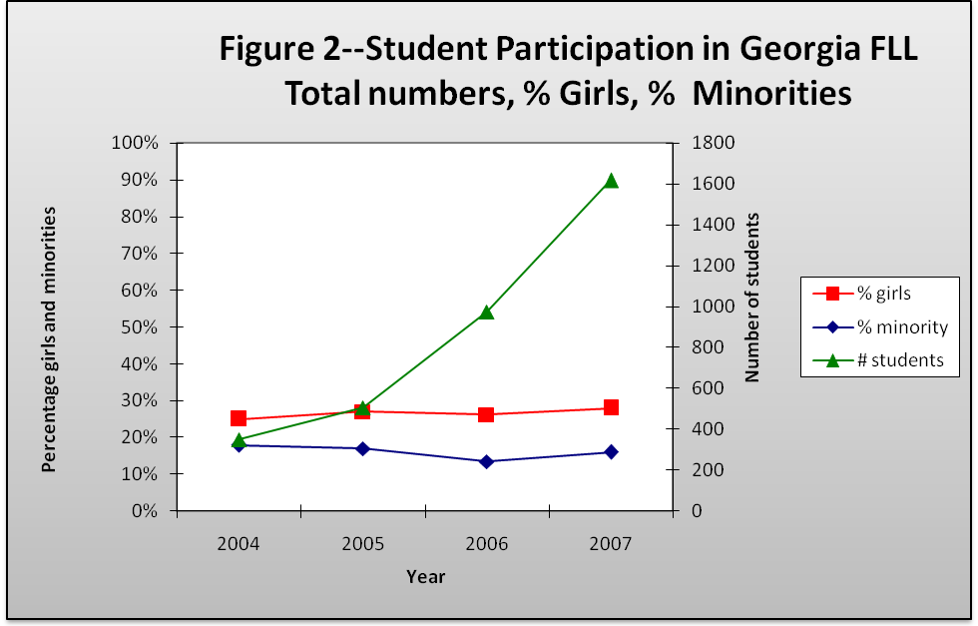
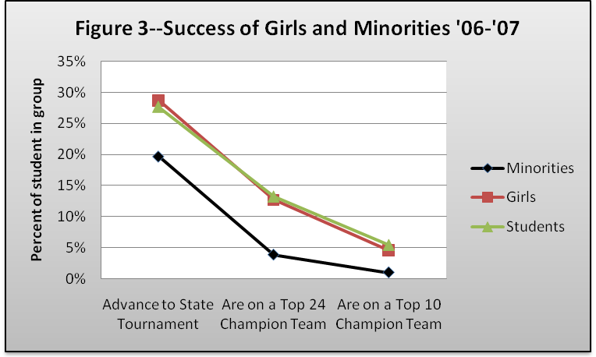
Since 2004, as the total number of students participating in the Georgia FLL program dramatically increased, the percentage of girls has remained essentially constant at approximately 25-27%, and the percentage of African American and Hispanic students has stayed in the 14-18% range (Figure 2). The girls in FLL succeed in the tournament in numbers comparable to the whole, but the minority students tend to be under-represented at the State Tournament, and in the top 24 teams (Figure 3). These differences in success rates can be attributed to differences in how experienced the coach and team members are, and to how many hours per week the students can dedicate to the task. Our goal, as coordinators of the Georgia FLL tournament, is to promote the best possible competition experiences for the largest number of children, a goal that requires that teams compete as frequently as possible against teams of approximately equal strength. To achieve this, we developed a method to rate the strength, or “power” of a team, and an infrastructural system that allows us to schedule teams to compete, at least in the early rounds, against teams of similar power. This paper presents our first attempt at such a rating system, and the effect it had on the 2008 FLL tournament. Over time we will modify our “Power Rating” to help maximize team success in the tournament, and will determine whether this method of scheduling increases the likelihood that more under-represented minority students progress past the first round of the tournament. We call this our “NCAA Basketball Tournament” model of competition-- where teams of all compositions and strengths get into the state tournament, and though the honest expectation is that teams from the “high power” qualifying rounds will ultimately come out on top, Cinderella teams are always possible and teams from a variety of backgrounds can experience the thrill of competing in the state tournament.
Figure 3 indicates the percent of each demographic group (minorities, girls, all students) that progress to each step of the tournament.

RESULTS

Determination of Power Rating

To determine a team’s “Power Rating”, we added questions to the required registration information form and collected data on how experienced the organization, coach, and students were, and how many hours per week the team had allotted for FLL activities. We assigned a score of 0-4 to each of four different factors (A, B, C & D) as explained in Table 1, and the Power Rating is the sum of those four scores.

Table 1--Determination of Power Rating Matrix
Power Rating=Sum of Team’s Power Scores (Power Score of A+B+C+D)
Power Score | A  (Prior Success of Organization) | B  (Prior Success of Coach) | C  (Returning Students Index) | D  (Time Allotted Index)
0 | Organization has not fielded a previous team | Coach has no prior FLL experience | Students are all new to FLL | Fewer than 2 hours/week allotted for FLL
1 | Organization fielded a team that only participated in the first-round qualifier. | Coach directed a team that only participated in the first-round qualifier. | 10-20% of students have prior experience with FLL | 2.0-3.5 hours/week allotted for FLL
2 | Organization fielded a team that participated in the State Tournament | Coach directed a team that participated in the State Tournament | 30-50% of students have prior experience with FLL
3 |  |  | Greater than 50% of students have prior experience with FLL | 4-6 hours/week allotted for FLL
4 | Organization fielded a team that won an award at the State Tournament | Coach directed a team that won an award at the State Tournament |  | Greater than 6 hours/week allotted for FLL

Analysis of Power Ratings for FLL Georgia Teams

During registration, all 242 teams that registered for the Georgia FLL tournament were assigned a power rating score that was taken into account when assigning teams to specific regional qualifying tournaments. Teams from programs that were predominantly African American and Hispanic had substantially lower power ratings than the majority white teams (Figure 4). Teams organized by public school had lower power ratings than other types of schools (private schools and home schools). The “independent” teams (i.e. neighborhood teams organized outside of a school setting, and teams coordinated by youth groups) had the highest power ratings as a group.
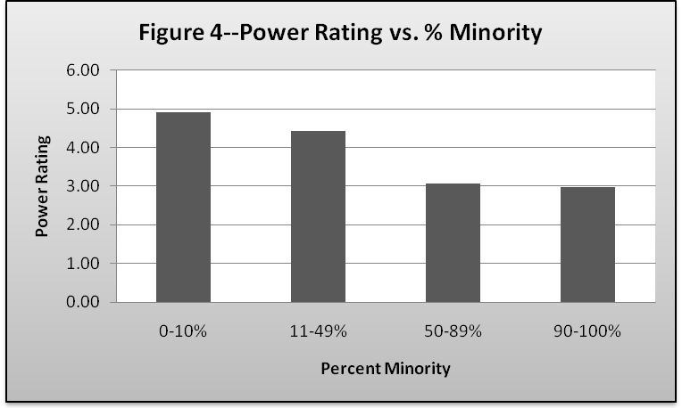
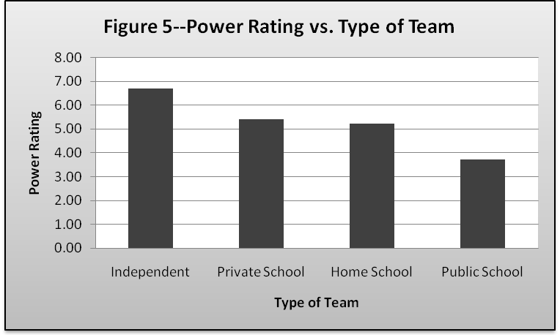

Tables 2 and 3 show the details of the power scores for teams, analyzed by the level of minority participation and the type of setting that the team operates in. Clearly at this point in time teams that consist primarily of minority students tend to be much less experienced in all dimensions than majority-white teams, and though white teams tend to have slightly more time allotted to the activity than do minority teams, this can be fully explained by differences in the type of team within which the students compete. We have reported previously [1] that independent and home school teams in Georgia are almost exclusively Caucasian, and as shown in Figure 3, these teams are able to devote many more hours per week to the task than the typical public or private school team. Private school teams, on average, had a higher power rating than the home school teams, which we found surprising since historically the home school teams have dominated the state-level FLL awards. This difference in scores is because the private schools that routinely participate in FLL now receive higher scores for “experience” than do home school groups that only participate as long as a particular group of students is of the proper age. The results of the 2008 tournament season show that home school and neighborhood teams still outperformed the private schools, regardless of the private schools’ greater experience, suggesting that the “Time Allotted Index” should be given more emphasis in the power rating.

Table 2--Power Rating Details of Schools with Different Minority Participation
Percent Minority | Number of Teams |  | Average Power Rating |  | Prior Success of Organization |  | Prior Success of Coach |  | Returning Students Index |  | Time Allotted Index
0-10% | 108 |  | 4.9 |  | 1.1 |  | 1.2 |  | 1.3 |  | 1.3
11-49% | 87 |  | 4.4 |  | 1.2 |  | 1.2 |  | 0.9 |  | 1.1
50-89% | 18 |  | 3.1 |  | 0.5 |  | 0.7 |  | 0.9 |  | 1.0
90-100% | 29 |  | 3.0 |  | 0.6 |  | 0.5 |  | 0.7 |  | 1.1
Table 3--Power Rating Details of Different Types of FLL Teams
Type of Team |  | Number of Teams |  | Average Power Rating |  | Prior Success of Organization |  | Prior Success of Coach |  | Returning Students Index |  | Time Allotted Index
Independent |  | 22 |  | 6.7 |  | 1.3 |  | 1.6 |  | 2.1 |  | 1.7
Private School |  | 37 |  | 5.4 |  | 1.5 |  | 1.4 |  | 1.5 |  | 1.0
Home School |  | 19 |  | 5.2 |  | 1.0 |  | 1.0 |  | 1.6 |  | 1.6
Public School |  | 164 |  | 3.7 |  | 0.9 |  | 0.9 |  | 0.7 |  | 1.1
Table 2-4 Legend-- |  | 0-1.0 |  | 1.1-1.5 |  | >1.5

Use of Power Ratings in Tournament Scheduling

The Georgia FLL 2008 tournament series consisted of nine regional qualifying competitions, two super-regional competitions, and a state tournament held at Georgia Tech in February, 2009. During registration, each team rank ordered their preference for which regional qualifier they wanted to participate in. Five of the qualifying competitions were planned and hosted by public schools, public school systems, or by partnering organizations for a particular school system. Teams within school systems that provided the resources and volunteers necessary to run a qualifying competition were given priority during registration for enrollment in that competition, though extra spots were given to other teams outside the school system. One competition was coordinated by a consortium of home school coaches, and home school and independent teams were given priority for that competition. Two competitions were completely open to any team, and one competition, in Savannah, was organized for that geographic region.

In 2007-2008, teams were assigned to competitions based on school system priorities, rank order requests, and geography. There was some dissatisfaction with the results when some high powered home school and independent teams, which spent enormous amounts of time on FLL, completely dominated tournaments that were being run by school systems for their own school teams. Because of this, we made the decision that when adding extra teams to school system competitions, the teams must be of the same general strength as the teams in that school system. The results for 2008-2009 are shown in Table 4. Each qualifier, labeled “A” through “I”, had an average power rating, ranging from a low of 2.6 for Qualifier A, to a high of 6.1 for Qualifier I. The range of ratings of teams in those two qualifiers is shown in Figure 6. Eleven of the 32 teams in Qualifier A had a power rating of 1, generally indicating a new after-school club at a rookie organization, with a rookie coach, inexperienced students, and a time allotment of 2-3.5 hours per week. On the other extreme, one team in the tournament has a power ranking of 14, indicating a team and coach that won a state-level award last year, has mostly returning students, and was allotting greater than 4 hours per week to the activity.

Table 4--Average Power Rating for Different Qualifying Competitions
Qual-ifier | Type of Qualifying Competition | Number of Teams | Average Power Rating | Prior Success of Organization | Prior Success of Coach | Returning Students Index | Time Allotted Index
A | School System | 32 | 2.6 | 0.4 | 0.4 | 0.8 | 1.0
B | School System | 34 | 3.0 | 0.6 | 0.5 | 0.7 | 1.3
C | School System | 34 | 3.8 | 1.2 | 1.2 | 0.4 | 0.9
D | Geographic | 7 | 3.9 | 1.1 | 1.1 | 1.0 | 0.6
E | School System | 27 | 4.1 | 1.0 | 1.0 | 0.9 | 1.1
F | School System | 32 | 5.1 | 1.3 | 1.3 | 1.3 | 1.2
G | Unaligned | 26 | 5.2 | 1.2 | 1.3 | 1.4 | 1.4
H | Open | 29 | 6.0 | 1.5 | 1.6 | 1.5 | 1.5
I | Open | 21 | 6.1 | 1.4 | 1.4 | 1.7 | 1.6
 | 0-1.0 | 1.1-1.5 | >1.5

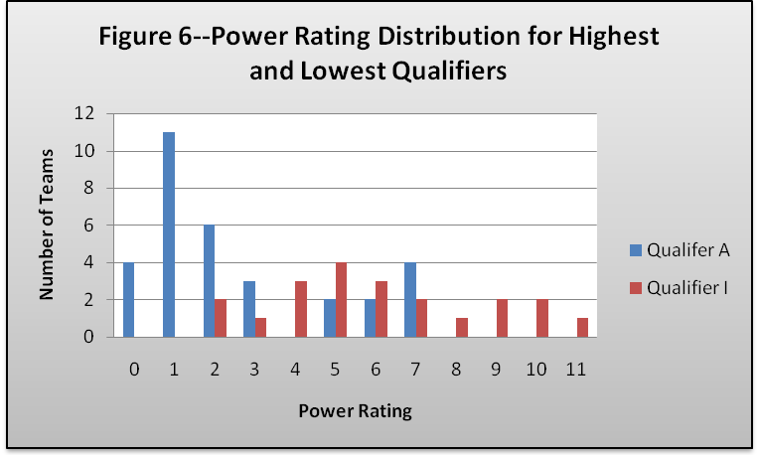
After the qualifying round of competitions, approximately 40% of the teams progressed to one of two super-regional qualifying competitions. Teams from the strongest qualifiers were more or less grouped in one super-regional qualifier, held in Dalton, GA and teams from the other competitions went to the other, in Warner Robbins, GA. Urban, inner city teams ended up being grouped together, giving them a chance to compete for a second round against similar teams. Over half of the teams from the super-regional qualifiers then progressed to the state tournament.

State Tournament Results

Super Regional #1 had a higher power rating than Super Regional #2 (6.3 vs. 4.1), and in that stronger competition, the most successful teams had the highest average power rating. Table 5 compares the average power

Table 5—Average Power Ratings of Most Successful Teams in 2008-2009 Tournament
Tournament | Number of teams attending | Tournament average power score | Top 5 teams average power | Top 10 teams average power | Top 24 teams average power
Super Regional 1 | 40 | 6.3 | 9.6 | 7.2 | 5.7
Super Regional 2 | 40 | 4.1 | 3.6 | 4.8 | 4.8
State Championship | 48 | 5.7 | 10.6 | 7.6 | 6.2
rating of the Top 5 teams in each of the Super Regional competitions and the State Championship, compared with the Top 10 teams, the Top 24 teams, and all of the teams in each tournament. Super Regional #2 showed a different profile than either Super Regional #1 or the State Championship, with the Top 5 teams having an average power rating below the average of that competition (3.6 vs. 4.1). This is because some very new teams, with no prior experience, did very well in one of the “weaker” first round qualifiers, and subsequently excelled in the Super Regional as well.

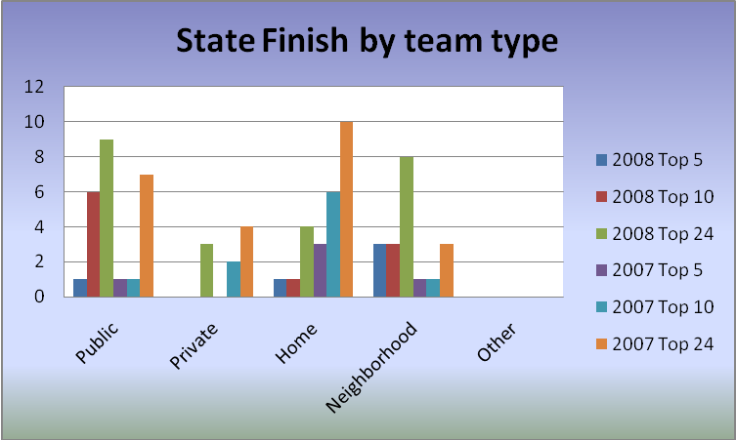
Figure 7—2008-2009 State Championship Results, by Team Location
Figure 7 shows which types of teams succeeded in the State Championship tournament in 2008 vs. in 2007. Four of the Top 5 teams were either home school or neighborhood teams in both years. (Some of the 2007 home school teams reclassified themselves as neighborhood teams in 2008 because they included a friend from a public school. Therefore it made sense to merge the two groups in this discussion.) The most striking change from 2007 to 2008 is that whereas in 2007 there was only one public school team in the Top 10, in 2008, six of the Top 10 were public school teams.

Conclusions

Public school teams were much more successful in the 2008 Georgia FLL tournament than they were the previous year, though non-school based teams (home school and neighborhood) continued to receive the top awards in the State Championship tournament. The increase in public school representation in the Top 10 was probably caused by a variety of factors, including:
- Public School FLL programs have become more experienced and competitive.
- The use of power ratings allowed the public school teams to be successful in the first round, giving them the time and competition experience required to perfect their robot and research project
- The implementation of the Super Regional round allowed more teams to progress out of the regional qualifier, giving the teams more experience.

We will now reassess the factors that are included in the Power Rating, determine which ones best predict success in FLL, and hopefully tease out some of the specific reasons for the 2008 results. We will then modify the model based on this data. We will also be able to analyze whether this system increases the representation by at-risk and minority students in the state tournament. We postulate that teams from those schools that experience success in the initial rounds of the tournament, rather than being completely dominated by well equipped, experienced and very dedicated independent teams, will be more likely to continue to nurture the program, providing engineering and robotics experiences to students who would most likely never otherwise participate in this type of activity.

Center for Education Integrating Science, Mathematics and Computing (CEISMC), Georgia Tech, Atlanta, GA 30332-0282, marion.usselman@ceismc.gatech.edu
Center for Education Integrating Science, Mathematics and Computing (CEISMC), Georgia Tech, Atlanta, GA 30332-0282, jeff.rosen@ceismc.gatech.edu
Usselman, M., Davis, J., Rosen, J. “Diversifying Participation in First Lego League”. Proceedings of the 2008 American Society for Engineering Education Annual Conference & Exposition. Marion Usselman Dr. Marion C. Usselman is a Senior Research Scientist at the Center for Education Integrating Science, Mathematics and Computing (CEISMC) at the Georgia Institute of Technology. Marion received her B.A. in biophysics from the University of California, San Diego, and her Ph.D. in biophysics from Johns Hopkins University. She focuses on K-12 educational reform, university-K-12 partnerships, and equity issues in education. Jeffrey Rosen Jeff Rosen is a Program Director in Georgia Tech's Center for Education Integrating Science, Math and Computing (CEISMC), leading up K-12 student activities in technology. Before arriving at Georgia Tech, Jeff was a veteran high school mathematics and technology teacher at Wheeler High School in Cobb County, Georgia, and organized the school's extensive robotics program.

