Creating A Positive Work Ethic in Civil Engineering Students: A Case for Attribution Theory and Scaffolding
Thomas R. Dion and Kevin C. Bower
Abstract

Influencing a student’s mindset can be challenging especially when students have had negative learning experiences. How a student rationalizes success or failure is called “attribution theory”. Their attribution, or explanation, centers on either an external or internal force causing their performance. As an example of external attribution, a student who thinks he or she has a poor teacher and a poorly written textbook can use those thoughts to rationalize the 62% test grade they received. If on the other hand, a test indicates a 95% achievement level, then the student may feel internally that superior intellect and intelligence played a part. Once an attribution has been asserted, it reflects the mindset of the student until another attribution is asserted. One means of trying to improve average and less than average student performance, is to intervene in this cycle where students want to change their mindset. The desired focus of a student’s rationalization should be ‘effort drive,’ because, that is the only condition a student can control.

This paper examines some possible ways for instructors to intervene where students want to create and possess a positive work ethic. This will allow them to perform their required functions in a manner that draws from their best efforts. In addition, the process of “scaffolding” will be discussed where students provide a solution to an open ended design problem. If the solution is less than satisfactory, the instructor provides guidance as to where the student erred, and the student then reworks the solution. If the reworked solution is still lacking, the process is repeated until a workable solution is achieved. Scaffolding provides a means for students to have a chance to complete their work in a satisfactory manner, while discarding the notion that they failed on the first try, and therefore there is no incentive to try to learn how to do the problem correctly. By using this approach, hopefully students will change their attribution assertion to a positive outlook, where those who never complete their work in a satisfactory manner have no reason to blame others on their performance except themselves for the lack of effort. An example is shared that involves the design of a highway as part of a junior level course where comments made by participating students indicate in their end of semester course evaluation the achievement of positive learning experiences.

Keywords: Work ethic, Attribution Theory, Scaffolding, student learning

Introduction
There are many different approaches used by teachers to impart knowledge to students, as well as many approaches used by students to accomplish learning. Well structured courses offer an environment that enhances teaching and learning where most students can be successful. As an example, Fink [1] offers some principles that if followed, will help promote effective learning in the classroom. These principles include challenging students through active learning where meaningful feedback is provided. In addition, Fink stresses that a structured variation in teaching techniques coupled with a fair student performance assessment system must also be included.
In most engineering undergraduate curricula, coursework required by degree seeking students includes taking courses that are sequenced to form a knowledge based thread that runs throughout the program of study. Typically enrollment in these courses is controlled by the use of pre-requisites and co-requisites. For example, in the Civil and Environmental Engineering Curriculum at The Citadel, there are several knowledge based threads that provide students with increasing difficult subject matter and skill sets in the areas of Environmental Engineering [2], Transportation Engineering [3], Structural Engineering [4], Geotechnical Engineering, and Site Engineering [5]. The basis for this curriculum organization is founded on the premise that freshmen students need to start with the basics, and then build their knowledge and skill sets by mastering increasing difficult material while dealing with increasingly more complex and ill-structured applications of the subject matter.
Some students possess a keen desire to learn, and therefore possess excellent skills in participating in the learning process. However, it is fairly safe to say that every student will not learn and master 100% of the material in each course as they progress through the various curriculum knowledge based threads; however, students need to gain a certain amount of acceptable proficiency if they expect to be able to protect the health, welfare, and well-being of the pubic when practicing engineering after graduation. Along with this premise is the understood obligation that each student will develop a motivation to actively engage in solving problems as well as aspire to the high ideal that producing the “best” workable solution is always the ultimate goal. And, therein lies one of the major challenges facing educators---specifically motivating average students and less than average students with low performance levels to achieve an acceptable level of proficiency in their coursework.
When an instructor teaching mid to upper level courses tries to invoke student learning at a higher level through creative/critical thinking and decision making, it often becomes apparent that some students have allowed the accumulation of “gaps” in their knowledge based threads. This is because they did not acquire previous skills or information while enrolled in lower level courses that provide the foundation upon which higher levels of learning emerge. As a result these students are unable to recall some of the foundational material, or lack the skill set for its application which often results in poor performance, lack of interest, and the continuation of a ‘laissez-faire’ approach to learning. This situation could possibly be attributed to what has been termed “attribution theory”.
Attribution Theory
Influencing a student’s mindset can be challenging especially when students have had negative learning experiences. Often these students rationalize why their levels of performance are low and their reasons. This process is called “attribution theory”. Their attribution, or explanation, centers on either an external or internal force causing the poor performance. According to Alderman [4], their beliefs affect a person’s expectations as well as their behavior. Often a student feels that he or she does not have the aptitude to accomplish the task. Others feel that what is being asked of them is too difficult to achieve, and if they do achieve it, nothing but luck was involved. One way for an instructor to address these low expectations is through scaffolding.
Scaffolding Theory
Scaffolding is the process where students are engaged by their instructor in a manner that leads them to comprehend the process of how to solve a problem through the use of examples that rely on using small incremental steps [4]. This process is a way to provide students with a bridge to overcome low-expectations and minimize their feelings of being overwhelmed. Students who perform poorly in college often have a history that allows them to be comfortable with their low level of performance. Should they do well on a test or assignment, they often look at that performance as a fluke, while allowing that opportunity to start building positive momentum pass them bye. Scaffolding is a way to help build student self-confidence that is needed to break the cycle of low expectations. In the end, if an instructor engages in scaffolding a student, and that student does not respond in a positive manner, then the resulting failure falls squarely on the shoulders of that student because of the lack of motivation.

Example Civil Engineering Course That Addresses Attribution Theory Through Scaffolding Techniques
A junior level Civil Engineering Course offered at The Citadel as part of the Transportation Engineering knowledge based thread includes Civil 302 Highway Engineering— which meets three times a week. This is a three credit hour course that includes an out-of-class highway design project as part of its scope. The open-ended highway design project is an opportunity for students to familiarize themselves with the principal plans made for road construction jobs, as well as an opportunity for students to apply previously studied design principles and techniques to a typical small road job. This problem also affords students an opportunity to use their graphical communication skills to express their design concepts in a form that can be recognized and followed by the construction industry. An example site is shown in Figure 1 where students are charged with designing a connector road between the two existing highways on either side of the site. A number of existing site features including houses, power lines, property lines, and out-buildings are part of what are involved to create this open ended problem. Students are required to prepare and submit their designed project using a Plan and Profile sheet, Cross Section Sheet, Earthwork Computation Sheet, a Mass Diagram drawing and their computer generated hydrology analysis for culvert design. Part of the grade requires that students turn their work in on time. The progression of design activities take place over a six (6) week period, where each week students work on sequential aspects of the project. Students are given various parameters to guide them when designing the project including maximum design speed, various sight restrictions, intersection design parameters, maximum and minimum roadway grades, any conditions or problems with residents that could be impacted by the design, and soil conditions.
During the first week of the semester students begin work on their Plan View as shown in Figure 2. The reader can gain a better idea of the level of detail a student must consider during the design process when looking at the top half of this figure. Creating their Plan View requires them to decide where the best location exists to connect the two existing roads, and how to horizontally align this connector. Horizontal curve data and drainage features must initially be considered; however, closer to the end of the project students must also address safety features, sedimentation and erosion control and appropriate notations to fully complete the Plan View.
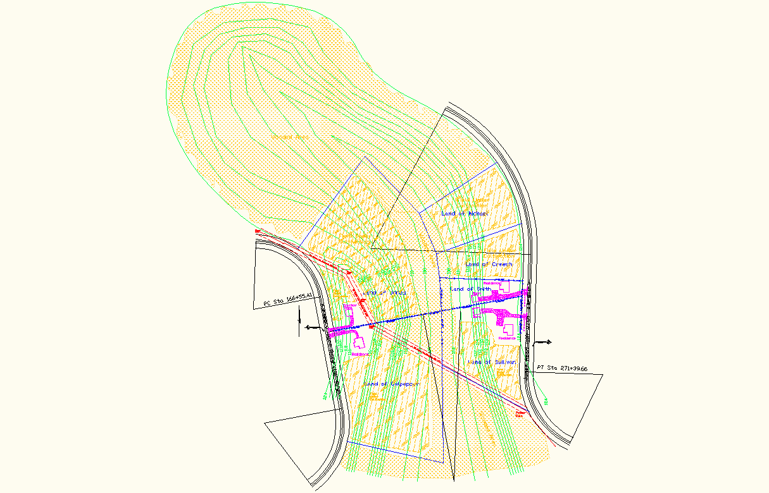

Figure 2 Road Project Site Topography
Figure 1 Example of Completed Plan and Profile ²

- Example student work by Kevin Hyskell, and undergraduate Civil Engineering student at The Citadel.

During the second week students begin working on their Profile View where they layout their existing ground profile and also their proposed road grades/vertical curves. Sight distances must be addressed as well as making sure adequate cover is provided over the crown of all culverts that they include.
Figure 3 Example Cross Section Sheet
Figure 4 Example Earthwork Mass Diagram

The third week is focused on students developing their cross sections as shown in Figure 3 by combining their existing ground cross section with their typical road cross section keyed to their designed centerline elevation. Students must also address any super-elevation requirements, and then determine their end areas.
The next week students spend computing their earthwork volumes and then their Mass Ordinates in order to complete their Mass Diagram as depicted in Figure 4. The Mass Diagram is used to graphically show the excess distribution of earthwork (cutting and filling) and where it occurs so that overhaul quantities can be determined. The goal is to balance the earthwork where the cut volumes equal the fill volumes (e.g. the contractor walks away from the completed site not looking for additional soil to fill remaining low areas, while also not having a mound of excess soil to waste). Students may find that they have large amounts of excess soil (Waste), or have large amounts of Borrow requirements, necessitating them to revise their proposed road grades to achieve a better balance of volumes. The closer students balance their earthwork, the better their grade on that part of the project.
The final week provides students time to complete their design, and make any revisions or additions to their drawings or calculations. At the end of this week, the projects are turned in for grading. Separate grades are assigned to the Plan and Profile Sheet, the Cross Section Sheet, Culvert Design, Earthwork Calculations, and the Mass Diagram Balance Sheet. When assigning a grade to each part, the instructor measures whether a contractor would be able to construct the road in a satisfactory manner based on the information provided. If that standard is met, then the student receives at least a “C”, or average grade on that part. If major mistakes are encountered, or the information provided would result in construction stoppages, unsafe conditions, or major errors/omissions, then the student fails that part.
During the six-week period when students are working on their individual projects, they are being encouraged to stay on schedule. Each week the instructor takes a few minutes of a lecture class to walk around the classroom and comment on their progress, while giving pointers as to things they might consider to improve their work. Students who did well in the end kept up with their weekly work schedule. Most of the other students did not consistently keep up, and often had excuses why they were unable to work on their project during the preceding week. These were the students who tried to do the minimum amount of work. Entry level engineers working at their first places of employment after graduation need to perform at a much higher level, because engineering firms do not knowingly turn out work that is marginal or incorrect. The bottom line for a consulting firm is for them to stay in business; therefore, their finished work must be correct. As a result, the instructor communicated to the class that for satisfactory completion of their project, their solution must be constructible even though it could contain minor errors and omissions. This was an effort to help instill a positive work ethic and encourage students to produce a quality driven end product (QDEP) [6].
Students were reminded that they could be successful with this large project if they kept making weekly progress. Students who were meeting expectations became positive role models for all. Poorly performing students were encouraged to work hard to achieve completion. It was pointed out that the instructor was available to help along the way but students needed to be making in progress in order to get help. The secret to success was effort driven. This idea was also couched in the notion of a good work ethic which was effective in reaching many of the students.

Specific Class Room Activities
Most recently there were thirty-three students enrolled in the class, where six of them were seniors who were behind in their class-work due to previous poor performance. Of the thirty-three students, sixteen submitted designs that contained major flaws. Interestingly enough all six seniors were among those falling into this category. In all cases the major flaws occurred on their Plan, Profile, and Cross Section Sheets. Things like errant horizontal control information (wrong scales, bearings, horizontal curve data, stationing), encroachments outside the allocated 100 foot right of way width, and other issues were found in their plan views. Major deficiencies occurring in their profiles included incorrect grades, slopes, vertical curves, and culvert placement. As part of the grading procedure, the instructor “marked-up” the student’s work with the correct information that could be used to correct his or her design, and then returned. Students who had major flaws were told to make the corrections, and then re-submit. Approximately half of these students successfully provided a workable solution during the second submission round. The remaining eight students still had significant problems, which were noted by the instructor and returned for re-submission. On the third submission, five of the students provided a workable solution. Two of the remaining three students never submitted again and ended up having to take the course again because they also performed poorly on their tests and final examination. The one remaining student continued the re-submission/review process until he finally corrected his major mistakes after six tries and ended up passing the course. In all, five of the six seniors were able to produce a workable solution.
The instructor, having previously taught all of the students in other classes, was familiar with the student’s motivation, ability, and demeanor at the beginning of the project. As a result, he tried to motivate everyone using the weekly walk-through discussion, as well as providing a scaffolding platform to encourage them to complete the project in a satisfactory manner. The discussions provide a forum where the instructor could address student attributions relating to their design (e.g. not applying proper graphic science language skills that should have been learned freshman year—but need to learn and apply now). The scaffolding incentive was for poor performing students to have an opportunity to receive a passing grade (D) on their project, rather than an automatic failure. The instructor felt that this approach would not penalize any students who initially submitted a satisfactory solution that contained minor errors or omissions resulting in an average grade.

Summary of Findings and Recommendations
With the exception of the two students who gave-up, every other poor-performing student was proud of their final work—regardless of their assigned grade. This was because they realized that they, in the end, had individually designed a workable solution as a result of their own efforts, while being guided through the steps by the instructor. It was hoped that this experience would help to build self-confidence, and break any cycle of helplessness.
Feedback provide by the students as part of their end of semester evaluation comments included the following:
- “…learned a lot…” Multiple times
- “…the challenge…” Multiple times
- “…unbelievable amount of work…” Multiple times
- “…(Project) brought everything I learned into a common goal…”
- Liked most: “…Highway design project—(Professor) is enthusiastic about the material- - definitely wants us prepared for when we graduate. I do believe he cares…”
- “…we should learn a little more about Civil 3D AutoCAD to help us on projects…”
- “…little guidance given concerning harnessing recent computer methods concerning roadway plans production…”
With an approximate average teacher performance rating assigned by the students at 4.6 out of a possible 5.0, the authors believe that the approach offered by this paper produced beneficial results
In summary, this paper focuses on students who are performing a low academic level, where their mindset must be challenged to evoke a change in their approach to learning. The authors have described one design course where the application of attribution intervention and scaffolding provided a platform for positive student performance. Not all students; however, responded positively, and as a result their failure was not linked to lack of opportunity, but lack of motivation on their part. What was discovered by the authors was that student learning improved.
A course assessment issue, that targets continuous improvement, centers on those students who failed to keep up with their weekly work schedule. Those students are also the ones who initially submitted poor design solutions. Armed with this knowledge, the instructor can use it to highlight the importance of students keeping up with their project schedule when the course is taught again. It is hoped that the reader will gain some new ideas on ways to motivate and improve the performance of students who are not doing well academically. Any success will not only benefit the student, but also improve the profession.

Future Recommendations
The authors feel that open ended design projects and ill-structured problems allow the instructor an opportunity to address student attributions in a positive way, if the students are low performing and have a feeling of academic hopelessness. In addition, by providing student scaffolding, these students have a mechanism to revise their attributions into positive outlooks, where a sense of accomplishment and achievement can be attained. The student, in the end, learns the necessary material, and accomplishes a task that provides a positive learning experience.
In order for an instructor to engage students in the manner described in this paper, adequate time must be set aside to meet with students, in some cases multiple times. This places an additional burden on the instructor; however, this additional effort shows great reward when students do finally demonstrate that they can perform in a satisfactory manner.
Finally, several students made comments in their course evaluations that they would like to learn more about the use of computer design applications (AutoCAD Civil 3D). This feedback for course improvement shows that the students are engaged and looking for ways to help make the course better, while demonstrating student-professor rapport which is critical in effective scaffolding.

References
[1] Fink, L. Dee. Creating Significant Learning Experiences—An Integrated Approach to Designing College Courses. New York: John Wiley & Sons, 2003, p. 28.
[2] Kevin C. Bower, Kenneth P. Brannan, and William J. Davis (2006). “Sequential Course Outcome Linkage: A New Look at Environmental Engineering Curriculum in a Civil Engineering Program.” ASEE National Conference – Environmental Engineering Division, Chicago, IL.
[3] William J. Davis, Timothy W. Mays, Kevin C. Bower (2005). “Implementation of a Course Assessment Process for Continuous Improvement and Outcomes Assessment.” ASEE Southeast Section Annual Conference, Chattanooga, TN.
[4] Mays, Timothy W. and Kevin C. Bower, William J. Davis. “Sequential Course Outcome Linkage: A New Look at the Structural Engineering Curriculum of a Civil Engineering Program”, Proceedings of the American Society for Engineering Education’s Southeastern Section Annual Conference, Louisville, KY. Washington: ASEE, 2007.
[5] Dion, Thomas R. and Kevin C. Bower. “Integrating Learning Outcomes Throughout the Civil Engineering Curriculum to Meet Site Engineering Prerequisite Needs”, Proceedings of the American Society for Engineering Education’s Southeastern Section Annual Conference, Louisville, KY. Washington: ASEE, 2007.
[6] Alderman, M. Kay. Motivation for Achievement—Possibilities for Teaching and Learning. New Jersey: Lawrence Erlbaum Associates, Publishers, 1999, p. 52-55.
[7] Dion, Thomas R. and Dennis J. Fallon. Bringing Reality into Senior Civil Engineering Design Projects Using The QDEP Approach”, Proceedings of the American Society for Engineering Education’s Southeastern Section Annual Conference, Macon, Georgia. Washington: ASEE, 2003.

Thomas R. Dion
COL. Dion graduated from The Citadel in 1968 with a BS degree in Civil Engineering. He earned an MS degree in Civil Engineering from Clemson University in 1973 and was registered as a professional engineer and land surveyor in the state of South Carolina in 1976. He became a full time faculty member of the Civil and Environmental Engineering Department at The Citadel 33 years ago when he began teaching undergraduate students. Part of his departmental duties includes being coordinator of the Civil and Environmental Engineering Department’s Capstone Design Course in Engineering Practice as well as the faculty member responsible for a senior level undergraduate site engineering course entitled Subdivision Planning and Design.. Col. Dion formerly served as President of the Section 2000-2001 and is currently serving as Campus Representatives Coordinator for the Southeastern Section of ASEE.

Kevin C. Bower
Dr. Bower is an Assistant Professor in the Department of Civil and Environmental Engineering at The Citadel in Charleston, SC. Prior to his employment at The Citadel, he worked as an environmental engineer in Akron, Ohio. He received a Ph.D. in Environmental Engineering from The University of Akron and specialized in modeling carcinogenic chemical production in the drinking water distribution system. Dr. Bower was the 2005 Most Outstanding New Faculty at the ASEE –SE Conference and a New Faculty Fellow at the 2004 Frontiers in Education Conference. Dr. Bower is currently pursuing research in ethical and moral development in the engineering profession and how that relates to student learning.

The Citadel, Department of Civil and Environmental Engineering Charleston, SC 29409, diont@citadel.edu kevin.bower@citadel.edu

