Use of Interactive Display Technology for Construction Education Applications
Javier Irizarry, Ph.D. Pavan Meadati, Ph.D.
Abstract – This paper discusses the results of experimental testing of an interactive display technology system being developed at the Virtual Construction Instructional Laboratory at Southern Polytechnic State University. The system facilitates the use of Building Information Modeling (BIM) to teach students about construction operations. The first phase consists of evaluating the usability implications of large format interactive displays for manipulation of building information models. The purpose of the evaluation is to compare the performance of students when using the standard desktop computer display versus the large format interactive display. Future phases of the project will test learning outcomes when the system is used to teach students about construction operations planning with the 4D-BIM. The technology being developed has the potential to greatly enhance the educational experience of students and will provide faculty with a tool that can facilitate teaching of construction concepts in a more visual and interactive way.
Keywords: Construction education, Building Information Modeling, BIM, interactive displays, visualization.

Introduction
Two-dimensional (2D) drawings are most widely used as pedagogical tools for teaching project management skills to Construction Management students. Some of these skills include estimation, developing and analyzing construction schedules, and safety analysis. The interpretation of 2D drawings by students varies based on their educational background and previous practical experience. Students are required to develop three-dimensional (3D) models mentally by visualizing the different components of the project. Students with little or no practical experience often face challenges and spend more time in developing 3D visual models. With increasing complexity of present-day projects, even experienced professionals can misinterpret the 2D drawings, which results in increased project cost and duration. The use of 3D models provides an opportunity to address the challenges faced by students and experienced professionals. Building Information Modeling (BIM) facilitates the usage of data-rich digital 3D models and enhances the student’s ability to understand the construction process.

Building information modeling
“BIM is an approach and not a technology” [Autodesk, 1]. In this approach, real world elements, such as walls, beams, doors, and windows, are represented as 3D objects to develop a 3D digital model. Attaching geometry and other information to these objects further enriches the 3D digital model. This data-rich 3D model serves as a repository of information and provides easy and anytime access to insert, extract, update, or modify digital data. BIM fosters a four-dimensional (4D) modeling framework by facilitating integration of 3D model with time. The 4D modeling provides a virtual reality environment and improves the ability of students to comprehend and learn the construction process. Virtual reality is defined as an experience in which a person is “surrounded by a three dimensional computer-generated representation, and is able to move around in the virtual world and see it from different angles, to reach into it, grab it, and reshape it” [Messner et al., 8].

Use of Graphical Representations and Visualization Tools in Construction Education
Previous research demonstrates that students learn more by engaging them actively “to explore, to question, to experiment and to formulate their own solutions” [Li and Liu, 7]. The teaching processes, which include sensory, visual, inductive and active aspects, provide effective learning methods to the engineering students [Felder and Silverman, 4]. Virtual reality provides the effective learning environment by mimicking the real world through 3D virtual models and actively engages students by immersing the user in this virtual world. The virtual reality experience can be further enhanced by providing interaction between the user and the model. The virtual reality systems are classified into four types, based on the communication of the user with the model [Novak-Marcincin, 9]: (1)Window on World Systems: It is also known as Desktop Virtual Reality, in which computer monitors are used for displaying the keyboard and mouse and are being used for interaction; (2) Video Mapping: In this, the user is embedded into the virtual 3D model by displaying the user as a 2D object; (3) Immersive Systems: In this system, the feeling of being in the virtual world is created to the user by using head-mounted displays; and (4) Telepresence: In this system, a high-speed network is used to create the feeling of being in the virtual world to the user. This facilitates remote access to the user to interact and change the model.
Researchers have successfully used desktop virtual reality systems for a variety of construction related analysis such as construction process simulation, interference analysis,, space conflict problem identification, and effective site utilization [Koo and Fischer, 6; Chau et al., 3]. Tanyer and Aouad [10] demonstrated the usefulness of desktop virtual reality in decision-making for owners, project engineers or managers. Haque [5] used desktop virtual reality to demonstrate the potential of visualization techniques in the construction education. Immersive Systems and Telepresence provide an extremely rich learning environment, compared to Desktop Virtual Reality and video mapping, since they add realism by providing a full-scale model to the viewer. CAVE, the first large scale immersive system, was developed by using three 10’x10’x10’ rear projection screens walls and one down projection screen for the floor. The interaction with the model is provided by tracking the movement of the user’s head and hand using electromagnetic sensors [Messner et al., 8].
The success of the virtual reality as pedagogical tool in disciplines, such as manufacturing, mechanical, and chemical engineering fields, showed a new direction in teaching in the construction discipline. However, the usage of virtual reality in construction education is limited due to the unavailability of low-cost virtual reality systems and lack of interoperability between CAD applications and immersive systems, [Messner et al., 8]. Partial immersive virtual reality system and BIM offers a cost-effective solution to address the above problems. A partial immersive virtual reality system can be simulated by using large format interactive display systems and this provides a viable and cost-effective solution compared to high-cost, full-immersion systems. The following sections present the methodology and results of the study by using a large format display system (SMARTBoard) to assess the benefits of this technology in the future development of cost-effective instructional systems for construction education.

Methodology
The experiment conducted for this study involved students interacting with a building information model using two different types of display technology. The facilities used to conduct the experiments were part of the Virtual Construction Instructional Laboratory (VCIL) at Southern Polytechnic State University in Marietta, Georgia. The VCIL was established with the goal of developing innovative approaches to teaching construction management students by integrating information technology and visualization tools in instructional delivery methods. The following sections describe the hardware and software used, the experiment development and execution, and the data collected during the experiment.

Hardware and Software Used in Experiment
The hardware used in the experiment included a rear projection SmartBoard display (Figure 1), a front projection SmartBoard display (Figure 2), and standard 22 in LCD desktop monitors (Figure 3). SmartBoard technology has been used to study the benefits of virtual reality applications in construction education [Messner et.al, 8]. In this study, the benefits of SmartBoard technology were evaluated in comparison with traditional means of digital information display. The software used in the experiment for development of the BIM and for students to perform the required task during the experiment was Autodesk Revit Architecture.
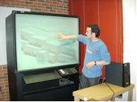 | 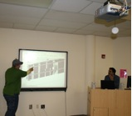
Figure 1 Rear Projection SmartBoard | Figure 2 Front Projection SmartBoard

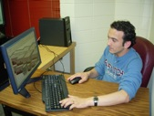

Figure 3 Desktop Computer with LCD Monitor

Experiment Development and Execution
Students were recruited from two sections of the CM3000 “Computer Applications in Construction” course of the Construction Management Department at SPSU. A total of 38 students participated in the experiment. Students were selected at random and were asked to perform the task of identifying discrepancies in the building information model, as shown in Table 1. Several changes were made to the model to introduce discrepancies in standard design conventions that can have an impact in the construction of the structure represented by the model. The discrepancies introduced are described in Table 2. Examples of discrepancies introduced are shown in Figure 4. Students received a short overview of the SMARTBoard and the functions they would use during the experiment. After the overview, students were allowed to practice using the SmartBoard for five minutes. The time allowed for students to perform the experiment was 15 minutes.

Table 1 Distribution of students by display technology
Display Technology | Number of Students
LCD Desktop Monitor | 38
SmartBoard Front Projection Display | 19
SmartBoard Rear Projection Display | 19

Table 2 Discrepancies introduced in the building information model
Discrepancies
- One of the rooms at the lower level has no access, the door has been removed.
- Access to the front deck has been blocked
- Stairs has been moved one foot away from its original place
- A railing has been put to block the access to the stairs
- One of the foundation walls have been replaced with a curtain wall.
- No roof for overhang portion
- Thickness of the lower level walls are 8 inches, thickness of the entry level walls are 12 inches.
- Lower and the entry level walls are not aligned
- Three windows were aligned to the bottom level
- Walls are not intersecting properly

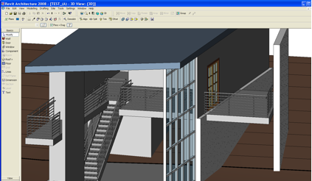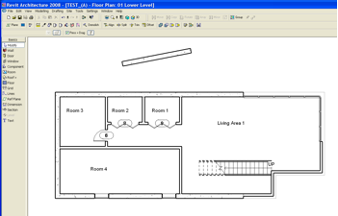
Figure 4 Example of discrepancies in building information model used in experiment: guardrail blocking access at top of stairs and door not present in room 4.

Limitations of the Study
Limitations that may affect the results obtained from the experiment conducted include a low sample size and the possibility of students not being familiar with the model. The main issue of the low sample size is in the lack of generalization of the results. In addition, a strong statistical analysis of the data is limited, since the low number of participants prevented the implementation of a fully randomized experimental design. This study can be considered a pilot test for a future study in which a larger sample size will be used. Student’s familiarity with the model is not considered in this study and may have had an effect on the performance of students in identifying discrepancies in the building information model provided. In future studies, several models will be used to reduce the possible effect of familiarity with the model.

Data Collection
Students were asked to find the discrepancies in the building information model using two different display technologies. The number of discrepancies found in the allowed time was recorded. After completing the task, students were asked to complete a questionnaire survey to assess their perceptions about using interactive displays, such as the SMARTBoard, for working with building information models. The discussion of the results of the survey is the focus of a separate paper.

Data Analysis

Age and Gender and Class Rank
Participants’ mean age was 22.58 years, with a standard deviation of 5.2 years (n=38) with a distribution shown in Figure 5. Over half of the participants (73.7%) were under the age of 25, which was expected from a population of college-level students. There was a small number of students over 25 years of age (n=10). These students were non-traditional students and certificate students who attend SPSU. The majority of experiment participants were male; 8% of participants are female. Figure 6 shows the distribution of participants by gender. Figure 7 shows the distribution of experiment participants by class rank. More than half of the students who participated in the experiment are in their junior (third) year or earlier (57.9%, n=38).

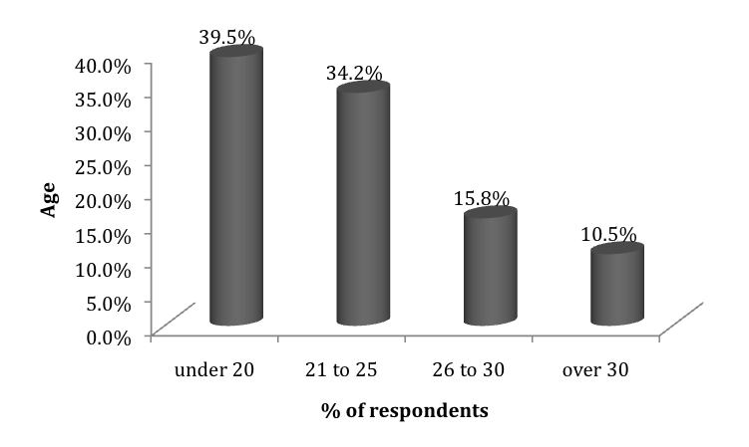 | 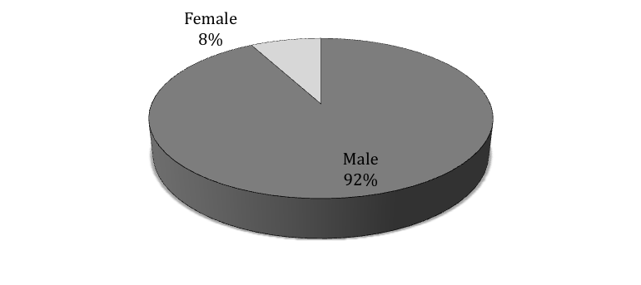
Figure 5 Age of experiment participants | Figure 6 Gender of experiment participants (n=38)

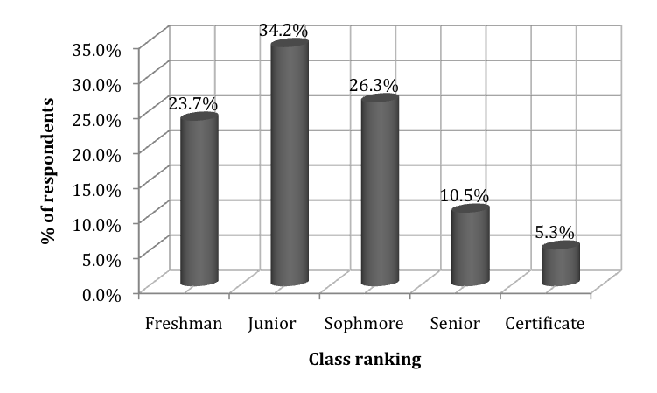

Figure 7 Class rank of experiment participants

Work Experience
There was an almost even distribution in the number of students with construction industry experience. As shown in Figure 8 fifty three percent (53%) of participants had some amount of construction industry experience. Of the students with industry experience, the majority had five years or less of experience (70%) with the distribution of participants with industry experience as shown in Figure 9.
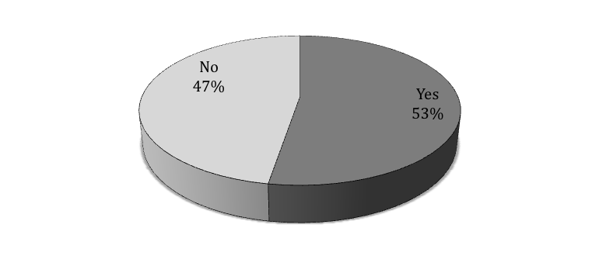 | 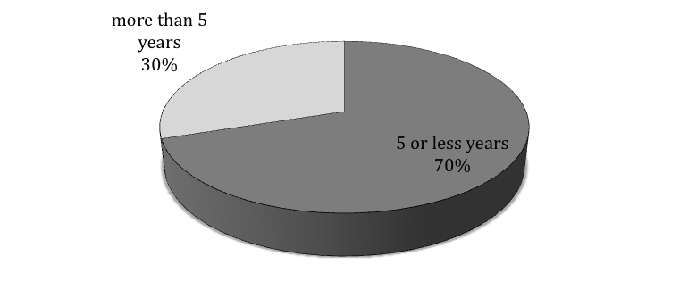
Figure 8 Students with industry experience | Figure 9 Amount of industry experience of experiment participants
Several of the characteristics of the experiment subject population were included in the data analysis to determine if they had any effect on the performance of students who performed the experiment. The next section discusses the results of the experiment.

Results from Experiment
The first analysis of the data collected was a basic ANOVA test to determine if any of the known variables about the sample population affected the task performance during the experiment. The results of the test showed that only the display type had a significant effect on the number of discrepancies found by students (F=2.397, p=0.017). Table 3 shows a summary of the ANOVA test results.

Table 3 Results of ANOVA test on subject-related variables
Variable | Total Sum of Squares | df | F | Sig. (p)
Display | 52.250 | 75 | 2.397 | .017
Age | 2030.526 | 75 | .608 | .801
Gender | 5.526 | 75 | .960 | .486
Rank | 94.158 | 75 | 1.173 | .325
Experience | 18.947 | 75 | .597 | .811

In order to determine the effect that the type of display used by students had on their performance during the experiment, two additional analyses were performed. The two analyses consisted of a comparison between the mean number of discrepancies found by students in the building information model provided when the different display types were used, and an analysis of students’ responses to survey questions about use of the SMARTBoard display technology. Data analysis was intended to determine if the use of interactive display technology, when working with the building information models, improved students’ understanding of the construction process. The results of the analysis of the survey data are included under a separate paper.

Difference between Displays Used
A comparison of the average number of discrepancies found by students was conducted from the data collected. Table 4 shows the average number of discrepancies found by students for each of the display configurations used. The results showed an average difference of 36.6% between the mean number of discrepancies found by students when they used the different display types (Table 4). This finding is further illustrated by Figure 10, which shows that better performance resulted when students used the SMARTBoard displays. For example, more than half (52.63%) of the students who found 8 to 10 discrepancies did so when using the front projection SMARTBoard.

Table 4 Average number of discrepancies found by display type
Desktop Monitor | SMARTBoard (Front Projector) | SMARTBoard (Rear Projector) | Average for SMARTBoard
4.974 | 6.842 | 6.737 | 6.789
% Difference with Desktop Monitor | 37.66 | 35.55 | 36.6

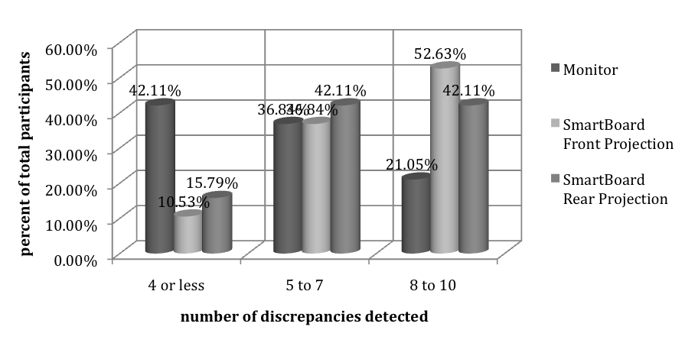

Figure 10 Discrepancies found by students by display technology

Conclusions and Future research
This paper presents the results of experimental testing of a large format interactive display teaching system being developed at the Virtual Construction Instructional Laboratory at Southern Polytechnic State University. The system allows faculty to use building information models to teach students several aspects of construction operations. The first phase of the development consists of evaluating the usability implications of large format interactive displays for manipulation of building information models. The purpose of the evaluation is to compare the performance of students when using the standard desktop computer display versus the large format interactive display (SMARTBoard). The results of the experiment clearly show improved performance when large format interactive display are used, as compared to desktop display unit, which indicates the potential of the technology to enhance the educational experience of construction management students.
As with any developing technology, usability must be considered. A follow-up paper will discuss the results of the post-experiment survey, which will address usability issues encountered by students during the experiment.
Future phases of the project will test learning outcomes when the system is used to teach students about construction operation planning with the 4D- building information model. The system being developed has the potential to greatly enhance the educational experience of students and will provide faculty with a tool that can facilitate teaching of construction concepts in a more visual and interactive way at a lower cost than the systems currently available. Other potential applications of this technology include interactive safety training to workers with language and other cognitive limitations.

Acknowledgements
The authors would like to acknowledge the work of Serkan Saglam, a graduate student in the Construction Management Department (CMD) at Southern Polytechnic State University. Also the resources provided by the CMD and the participation of CMD Students from the CM3000 course are greatly appreciated.

References
[1] Autodesk, “Building Information Modeling in Practice,” 2003, Retrieved July 25, 2006 from http://usa.autodesk.com/adsk/servlet/item?siteID=123112&id=8127972.
[2] Bell, J., and S. Fogler, "The Investigation and Application of Virtual Reality as an Educational Tool," Proceedings of the American Society for EngineeringEducation 1995 Annual Conference, Anaheim, CA. June, 1995, Retrieved November 11, 2008 from http://www.vrupl.evl.uic.edu/vrichel/Papers/aseepap2.pdf.
[3] Chau, K.W., M. Anson, and J.P. Zhang, “Four Dimensional Visualization of Construction Scheduling and Site Utilization,” Journal of Construction Engineering and Management, 2004, 130(4), pg. 598-606.
[4] Felder R.M. and L.K. Silverman, “Learning and Teaching Styles in Engineering Education,” Journal of Engineering Education, 1988, 78(7), 674-681. Retrieved November 11, 2008 from http://www4.ncsu.edu/unity/lockers/users/f/felder/public/Papers/LS-1988.pdf.
[5] Haque, M.E., “n-D Virtual Environment in Construction Education,” The 2nd International conference on Virtual Learning, ICVL 2007, Retrieved November 12, 2008 http://www.cniv.ro/2007/disc2/icvl/documente/pdf/met/2.pdf.
[6] Koo, B. and M. Fischer, “Feasibility Study of 4D CAD in Commercial Construction,” Journal of Construction Engineering and Management, 2000, 126(4), pp. 251-260.
[7] Li, S. G., and Q. Liu, “Interactive Ground Water (IGW): An Innovative Digital Laboratory for Groundwater Education and Research,” Computer Applications in Engineering Education, 2004, Retrieved November 11, 2008 from http://www.egr.msu.edu/%7Elishug/research/igw/igw%20courses/caee%20paper.pdf
[8] Messner, J. I., S. C. M. Yerrapathruni, V. E.Whisker, and A. J. Baratta, "Using Virtual Reality to Improve Construction Engineering Education." 2003 ASEE Annual Conference, Nashville, TN, 2003, Retrieved November 11, 2008 from http://www.engr.psu.edu/ae/cic/publications/Conference/Messner_2003_Using_Virtual_Reality.pdf.
[9] Novak-Marcincin, J., “Application of the Virtual Reality Modeling Language in Automated Technological Workplaces Design,” 2007, Retrieved November 11, 2008 from http://hrcak.srce.hr/file/41626.
[10] Tanyer, A.M., and G. Aoudad, “Moving Beyond the Fourth Dimension with an IFC-based Single Project Database,” Journal of Automation in Construction, 2005, 14, pg.15-32.

Javier Irizarry, Ph.D., P.E.
Dr. Irizarry has experience in the planning and construction of multiple types of infrastructure facilities including but not limited to PCC highways, bridges, and parking structures. Dr. Irizarry has conducted research in the areas of construction safety, constructability of transportation infrastructure, information technology applications for construction operations, and distance learning tools for construction. As faculty member in the Building Construction Program at the Georgia Tech, he directs the CONECTech Laboratory. He holds a BS in Civil Engineering from the University of Puerto Rico, a Masters in Engineering Management from the Polytechnic University of Puerto Rico and a PhD in Civil Engineering from Purdue University.
Pavan Meadati, Ph.D.
Dr. Meadati holds a BS in Civil Engineering, a Masters in Construction Engineering and Management from India and a PhD in Civil Engineering from University of Nebraska. Dr. Meadati is working as Assistant Professor in Construction Management at Southern Polytechnic State University. His areas of interest include building information modeling and application of information technologies in construction.

Assistant Professor, Building Construction Program, Georgia Institute of Technology, 280 Ferst Drive, 1st Floor, Atlanta, GA 30332-0680, Javier.irizarry@coa.gatech.edu
Assistant Professor, Construction Management Department, Southern Polytechnic State University, Room H-338 Academic Building, 1100 South Marietta Parkway Marietta, GA 30060-2896, pmeadati@spsu.edu

