The damaging impacts of hurricanes upon coastal structures

Dr. John Patterson Dr. George Ford
Abstract - This paper presents a discussion of the damage potential of a hurricane. Coastal regions in North Carolina are becoming more and more developed. There is a possibility that hurricanes may become more intense and more frequent with global warming. Every construction manger who performs work along coastal regions should be aware of the basic causes of structural damage due to hurricanes. This paper provides a detailed discussion of the potential damage a hurricane may cause to a structure due to the effects of wind pressure, storm surge, flooding, scour, hydrology, hydraulic pressures, tornadoes, topography and soils.

Keywords: hurricane damage, hurricane impact, coastal structures

Introduction
Damage is related to several factors; wind, surf or storm surge, tornados, flooding, flying debris and rip tides characterize the destructive power of the hurricane and the damage bands that results upon the structural environment. The structural environment includes all the elements that comprise the structure together with the external forces that impact the structure. The need to preserve the envelope of a structure throughout a major hurricane provides the construction industry with both a challenge and a responsibility. To fully understand the task of providing a lasting structure, the forces applied during a major hurricane must be evaluated to determine the effects on each element.
The exponential increase in damage is evident in the research conducted by Christopher W. Landsea (1993). Landsea reviewed the median damage levels from 1944 to 1990. During this period the trends showed the varying levels of damage; through this change in damage levels a damage multiplier was developed. The results of this research and the increasing reactions are presented in Table 2.2 indicating the relationship between the increased damage and the increase in the storms intensity. By examining the data in Table 2.2, the damage potential increase is in a quadratic relationship between the other categories as the storm increases.

Table 1: “Summary of United States tropical cyclone-spawned damage by intensity category of cyclone at United States landfall, averaged for years 1944-91 in millions of normalized 1991 dollars. The number of landfalls is shown in parentheses” (Source: Landsea, 1993, p. 1711).

Intensity (cases) | Median Damage | Potential Damage | Damage Percentage*
Tropical Storm (76) | < 1 | 0 | 9.8
Category One (34) | 25 | 1 | 11.2
Category Two (15) | 235 | 10 | 8.9
Category Three (26) | 1139 | 50 | 43.1
Category Four (6) | 2342 | 100 | 20.2
Category Five (1) | 6111 | 250 | 6.7
Structural systems and reactions

By maintaining a building’s envelope and integrity during a hurricane, property losses are minimized (Unanwa, 1997). The basic structural systems consist of the foundation, floor, wall and roof systems all forming the “structural envelope”. The structural envelope reacts differently as the various hurricane-induced loads are applied, due to the different material components and construction techniques. Properly designed and constructed structures prevent the forces applied by the hurricane from damaging the envelope. With the envelope in place, the interior components remain intact and the structures ability to resist both vertical and horizontal loads is maximized.
Structural designs must provide for both gravity and wind loads (Burleson, 1993) in addition to the horizontal and uplift loads by water as the storm impacts a structure. Normal gravity floor loads are 30 to 40 psf, but lateral and uplift loads imposed by winds can double the gravity loads (Burleson, 1994). The structural envelope is comprised of components that have individual properties inherent to the materials and connection methods selected. Each of these loads requires careful consideration during the design and construction phases. Meticulous observance of these loads will allow designers and construction professionals to provide a sustainable structure.
In the broadest definition, a structure is composed of components and joints. The components are jointed to form a complete unit. Units are then joined to independent components or other units to formulate a complete system constituting a structure. Failure of a single component part or a union can cause a unit to falter, thus causing a catastrophic failure of the system. Structural failures are normally located in two areas, the materials and/or the connections (Pilkey, 1983).
A material relies upon its strength to resist the loads and retaining the connecting device. Approved materials are provided in building codes. Materials are approved on the basis of scientific and engineering compliance testing (McDonald, 1994). The second factor is the strength of connections. Unforeseen factors that influence failures are hidden within pre-existing conditions that do not manifest themselves until the structure is impacted by the hurricane. The possibilities include the absence of quality construction through inadequate or non-existent construction inspections. A structure that has deteriorating conditions (e.g. roof leaks and moisture damage, corrosive deterioration) can lead to component failures, which weakens the system causing catastrophic failure (Bill Hanna, Personal Communication, 15 May 2002).

Wind pressure
When reviewing the damage potential of a hurricane, hurricane force winds cause the highest degree of damage to a structure (Ayscue, 1996). Wind will remove all loosely attached components of a structure and unsecured items surrounding the structure. In cases where various systems (i.e. roof and wall systems) of a building envelope are improperly attached they possess the possibility to become airborne (Barnes, 1998). The increased damage potential from flying debris impacts nearby structures that normally would have sustained minimal damage. The entire community is placed at risk from just a minimal number of improperly constructed buildings.
Wind is a formidable force imposed upon a structure. When determining the structural design of the building one of two things must happen; the wind must adjust to the structural conditions or the structural conditions must change to meet the wind conditions (Wills, 1994). The destructive power of the winds does not increase proportionately as the wind speeds increase, but instead they increase quadratically by the square of the speed increasing the destructive powers of the winds (Barnes, 1998).
Wind pressure behaves differently in varying conditions and has the potential to change from structure to structure and within the same structure. The condition that contributes to this effect is the density of the community and the manner in which the wind funnels through the buildings. Where the buildings are built closer together and taller, the wind is being forced through the gaps between the structures. Thus wind pressure, and therefore damage potential is increased (Figure 2.3). The confining, or funnelling, of the winds around the structure of the built environment, increases the pressure through the physical reaction presented in Bernoulli’s Law (Serway, 1992).

Figure 1: Bernoulli’s law effects on structures
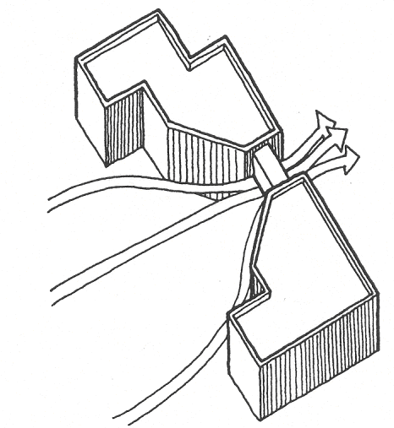

Source: Stein, 2000

To assist engineers in wind design loads, historical data is used to construct a map indicating the levels of probable wind speeds (Figure 2). This map indicates the mean average wind speed for the counties shown. Various areas or counties may reside in two different wind zones. When there is a discrepancy the higher of the two wind zones are applied to the entire area.

Figure 2: North Carolina wind map.
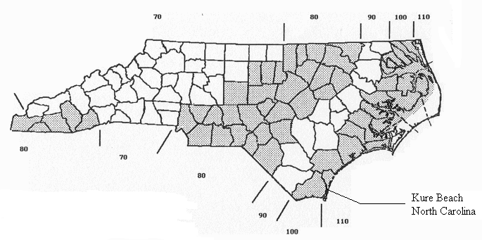
Source: North Carolina State Building Code, 1997

Wind pressures affecting residential structures are best described by viewing a simple rectangular structural model. As stated, the varying wind loadings are dependent upon construction materials and methods, and their connections. These elements combined determine the ability of the envelope to remain intact during a major hurricane. Once the envelope is penetrated the effects of the winds upon the structure changes dramatically. Window and door openings are an important consideration to safeguard the structure from damage as to prevent breaching the envelope. Structures that have storm shutters or were boarded up using plywood have a greater chance of surviving the storm by keeping the envelope intact. This protects the openings from flying debris impacts causing failures.
The wall that is directly impacted by the wind is known as the windward wall. The wall at the opposite end of the structure is known as the leeward wall. The other two walls, which are parallel to the wind flow, are known as sidewalls. As the wind force strikes the windward wall it applies an inward pressure.
In contrast the wind flows down the sidewalls and around the corner of the leeward wall, these three walls have an outward pressure applied (see Figure 3). The described pressures are as if pictured from above when looking at the model (NAHB, 1993).

Figure 3: Lateral structural wind pressures.
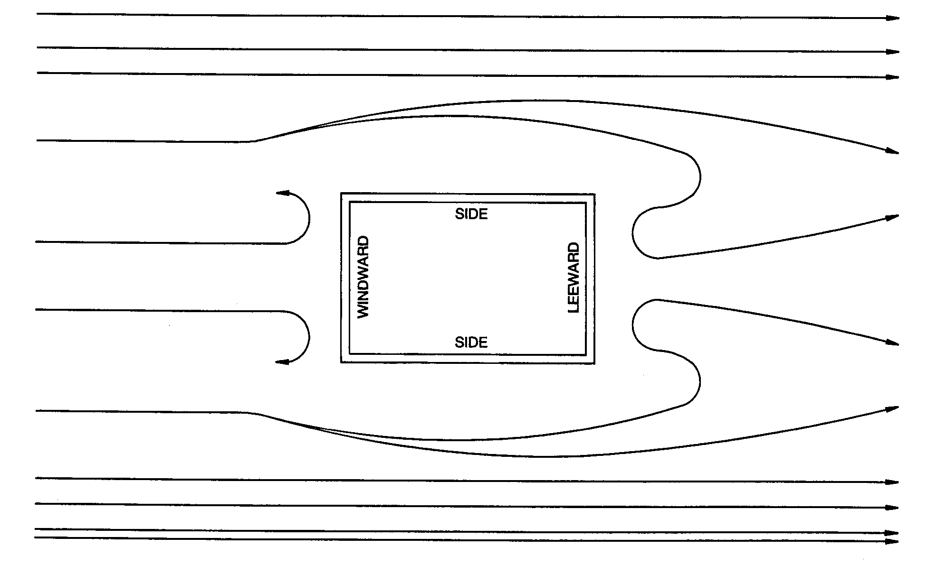
Source: SBCCI, 1997

As wind pressure or air-borne debris is exerted upon windows and doors, those unprotected or of poor design have a tendency to fail. When a window or door fails, the pressure effect on the structure undergoes a dramatic change. An opening on the windward wall allows the wind pressures into the interior of the structure exerting forces outward on all surfaces of the structure from its interior, but it should be noted that the magnitude of the wind pressure upon the interior faces increases due to the compression of air within the structure. Measurement of this pressure has indicated results that can be up to 1.6 times the normal wind pressure (Douglas,July 2001). An opening on the windward wall creates an internal pressure on all surfaces or a “balloon” effect swelling the walls outwards (Wills, 1994). Properly selected materials to withstand designed wind speeds; engineered connection devices and quality installation procedures are all a key elements in securing the structural integrity.
Additional structural impacts are imposed from the rotational winds of the hurricane. As the storm approaches, the structure, the winds strike the structure from one direction, but as the storm moves through, the winds at the back of the storm are reversed in direction. This applies lateral pressures in the opposite directions forcing the structure to resist reverse lateral loads (Committee on Natural Disasters, 1993) thus weakening the already battered structure.
When wind comes in contact with the windward wall of the structure the sidewalls are in a shearing action. The force at the top of the wall is forcing the wall to move in the direction of the wind. The base of the wall must resist the wind in the opposite direction. If the base connection is inadequate and this connection fails an overturning action is induced, this wall system is known as a shear wall (Jaafari, 1995), see Figure 4.

Figure 4: Wall diaphragm reactions.
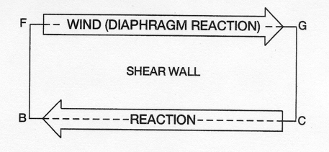
Source: SBCCI, 1997

The flat horizontal area of a floor/ceiling is designed to resist lateral loads creating the effects of a beam with the walls acting as the flanges of the beam (Keith, 1991). As the wind blows against the windward wall the roof diaphragms resists the action in the opposite direction with equal force (Figure 5). This creates a shearing action between the top of the shear wall or vertical diaphragm and the roof diaphragm. The integrity of the roof to wall connections determines the ability to resist total failure.

Figure 5: Roof diaphragm reactions.

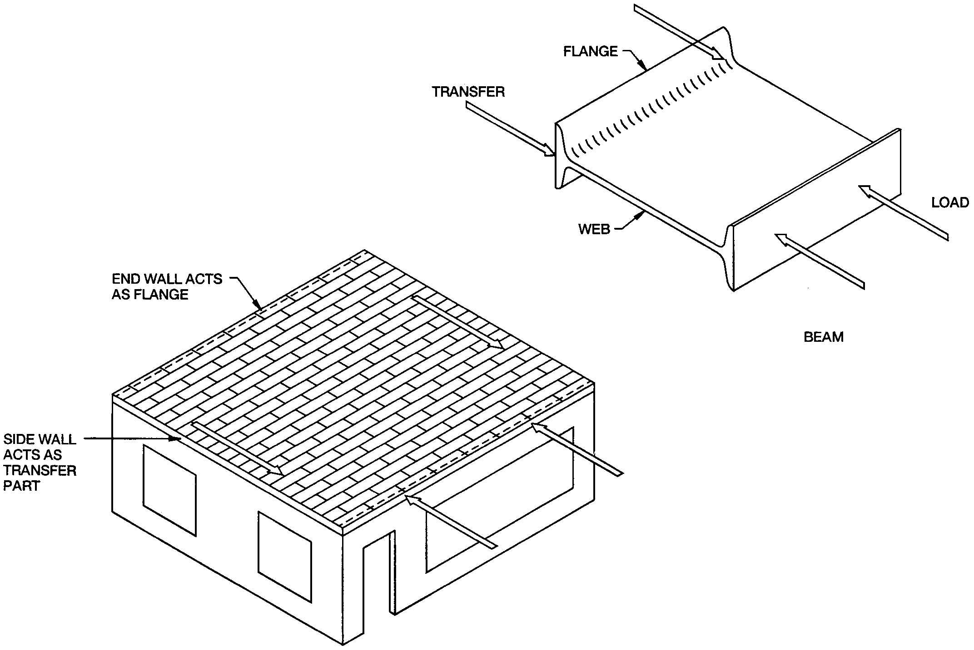
Source: SBCCI, 1997

As wind currents strike against a structure, winds not only transverse around the building, but also flow over the roof system. As they flow over the roof system the general loading is an uplift pressure on flat roofs and low-sloped gable roofs of less than a forty-degree slope, see Figure 6. When wind pressure is applied at a right angle to a roof system that is greater than a forty-degree slope, an inward pressure is caused on the windward side of the roof and an upward pressure on the leeward side of the roof (Jaafari, 1995). The roof system begins to react in the same manner as a wall.

Figure 6 Upward roof pressure.
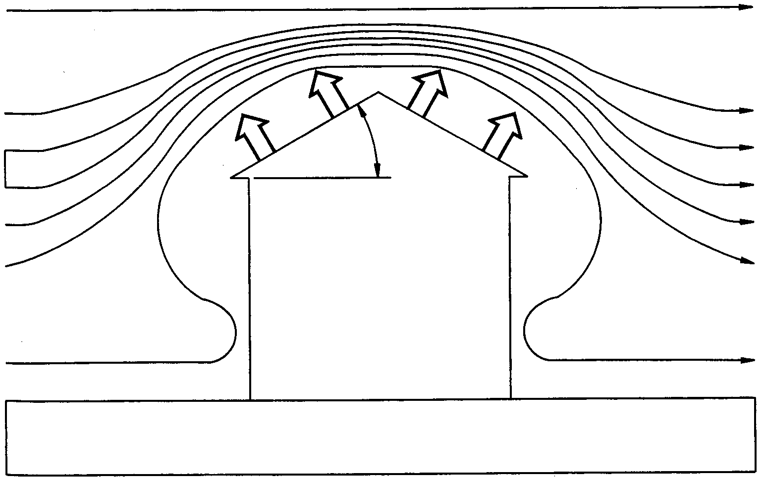
Source: SBCCI, 1997

Bill Hanna (Personal Communication, 5 May 2002), the building inspector for Kure Beach, NC, recommends for a durable design that a roof slope of greater than a twenty-three degrees (5 in 12 slope) and no greater than a thirty-four degrees (8 in 12 slope) be employed for maximum safety.
Any overhang on a roof receives an uplift pressure (Jaafari, 1995). The greater the overhang, the greater the uplift pressure that is exerted against the roof system. This places greater emphasis on the connecting devices and proper installation practices.
The combined loading of wind and water forces combines to make a destructive force that reacts adversely against structures. Individually they require extensive preplanning to ensure proper construction. A properly designed structure will resist the applied loads and properly transfer them into the ground. Structural members and connections are required to preserve the structural integrity of a building as wind loads are imposed to ensure that the envelope remains intact (Keith, 1991, p. 5-7).

Storm surge
Storm surge reaches the coast a day or two prior to the hurricane, in the form of larger waves and a rising tide. The rising tides are forced in front of the storm causing a massive wall of water moving to the coastline affecting several hundred miles of the coastline. The low pressure pushes down towards the sea floor causing a “dome” of water in front of the storm. This in turn produces the storm surge (Barnes, 1998; Pilkey, 1983). This condition is amplified if the storm makes landfall at high tide. The bathymetry of the ocean floor and the topography coastal shoreline determine the severity of the surge (US Department of Commerce, 1996). The storm surge can range from a few feet (0.61 meters) higher in a Category One hurricane to twenty-five feet higher (7.62 meters) in a Category Five storm; these differences are indicated on the Saffir-Simpson scale. The damage that the storm surge causes depends upon the size of the storm and the topography of the coastal area. Some storms have been known to stall and devastate one area and others have accelerated to as high as 60 mph (Barnes, 1995).
The damage potential is the highest in the right front quadrant of the hurricanes forward movement (Figure 7). The right front quadrant has devastating affects from four elements: the forward movement of the hurricane; the counter-clockwise rotation; the highest storm surges; and the highest winds located in the hurricane (Tannehill, 1938).
The counter clockwise rotation of a hurricane forces the waters to accumulate, or bank-up in the right front of the hurricane, increasing the storm surge height. The largest reported storm surge was in 1899 at Bathurst Bay, Australia of forty-two and two thirds feet (13 meters) high (FEMA, 2002).

Figure 7: Forward movement / right front quadrant
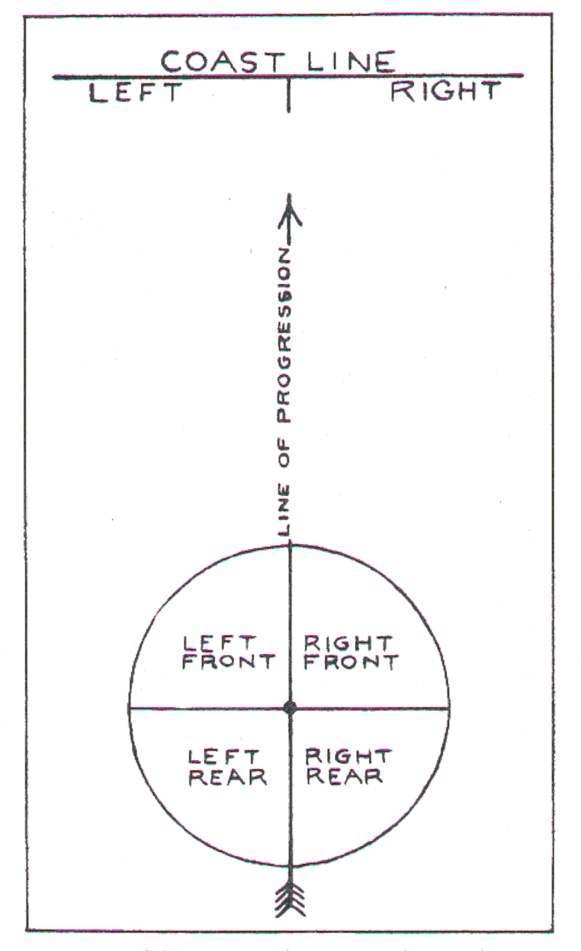
Source: Tannehill, I. R, 1938

Scour
The storm surge is accompanied by rip tides. The rip tides cause a “scouring” affect on the beachfronts inflicting massive erosion. The storm surge, upon making contact with the coastline, erodes the natural barriers that protect the environment. The dunes are developed naturally by depositing sand or manufactured in those areas that do not naturally possess the needed barrier. The dunes repel the surges of minor hurricanes, but during a major storm they can be overwhelmed by an elevated surge. The water trapped behind the dunes has a tendency to “blow out” an opening to allow the water to escape. This leaves the coast unprotected and creates a location that is prone to advanced erosion as more waves strike the coast. The storm surge striking the barrier islands creates an “overwash” by forcing the sand from ocean one side of the island to the landward side. As the surge strikes the seaward side of the island sand is eroded, picked up and deposited on the back side of the island, this moves the islands as the storm impacts the coastline (Watson, 1997), see Figure 8.

Figure 8: Overwash

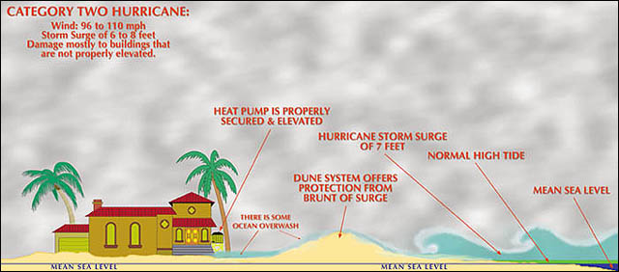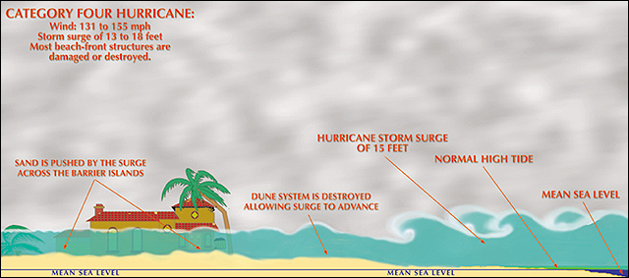
Source: Watson, 1997

Scour can loosen piled foundations, wash out poured slab and strip foundations and apply lateral forces to exposed grade beams (Ayscue, 1996). The rip tides cause a “scouring” which affects beachfronts creating an “undertow” pulling sand back out to sea, causing massive erosion. This erosion can undermine foundations of coastal structures causing failure of the structure (SBCCI, 1997). The circled areas in Figure 9 indicate the pre-hurricane sand levels and the damage inflected when the effects of scouring influence a foundation.

Figure 9: Scouring effects
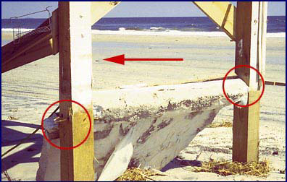
Source: BPAT, 2001

The scouring effect usually affects only the first row of structures (beachfont) and will not generally erode below sea level, but scour levels in extreme cases have been recorded up to twenty feet deep (6.1 meters). These conditions are normally due to the constructed environment trapping or diverting water. As water strikes the surface of a structure the flow of the water is altered causing deepening erosion. Grade beams parallel to the wave direction are known to cause turbulence in the water as it flows back out to sea. This swirling turbulence behind the grade beams leads to severe scouring (SBCCI, 1997).
Scour can lead to premature failure of structural foundations. In some instances, soil erosion caused by the scouring effect caused a depletion of the soil surrounding the piling. The scouring of the retaining soil can occur at the rate of 1.5 times the diameter of the pilings, leaving the piling foundations weakened (BPAT, 2001). The incident of scouring and the depletion of the soil surrounding piles creates a condition that influences the probability that the storm surge will force the structure over, causing a catastrophic failure of the piling system (Figure 10).

Figure 10: Erosion – failure and success
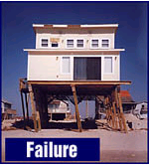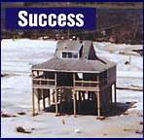

Source: BPAT, 2001

Hydraulic pressures
As the storm approaches, high volumes of precipitation saturate the land loosening the ground and making it easer for the accompanying wind to blow over trees, shrubs and signs. The rains that accompany the hurricane will saturate the land. As the storm approaches the coast, it can easily provide six to twelve inches (15.24 to 30.48 centimeters) of rain. Water exerts hydraulic pressures upon structures in three manners; surge, waves and scour. The wave action caused by a hurricane increase the storm surge height producing forces that can exceed 1000 psf (Burleson, 1993). This can cause a structure to float off the foundation, increasing the pressures on the envelope of the structure and/or producing severe impact and drag forces on pilings in the direction of the water flow. As structures become damaged, debris is produced. Debris combined with the wave action causes a heightened collision impact with other structures in their path (FEMA, 1986). Debris moving in the waves will become lodged against the foundation of the structures in its wake. As the debris becomes lodged it in essence creates a dam thus further increasing the hydraulic pressures against the structures (FEMA, 1986).
The hydrostatic uplift pressures of the waves can remove a structure from its foundation. This problem is amplified if the pilings are not driven properly and scouring removes the soil they are driven into. To protect a structure from surge damage, reference is made to the Base Flood Elevation (BFE). The BFE is determined by calculating the 100-year flood zone plus the average wave height (Pilkey, 1983). The BFE is measured to the bottom of the floor system along the coast and to the top of the first floor system inland. The BFE is indicated on Flood Insurance Rate Maps (FIRM) is published by the Federal Emergency Management Agency (FEMA). Some of these maps show the average wave height in conjunction with the flood zone elevation. The elevation of the BFE is in relation to a National Geodetic Vertical Datum point (NGVD). All new structures are required to conform to regulations to receive federal flood insurance for proper verification of the BFE. A licensed surveyor documents conformity. The ground elevation, elevation of the floor system and the flood zone that the property is located within must be indicated upon the deed (SBCCI, 1997).
To prevent unnecessary lateral pressures upon the foundation by hydrostatic and hydrodynamic forces (i.e. water velocity and wave action respectively), the area from the ground to the BFE should not be obstructed. However, limited bracing of the pilings is acceptable. The preference is to have a piling system designed to be self-supporting. Walls constructed in or around the pilings must be designed to breakaway under pressure or not obstruct the flow of water. Breakaway walls must withstand at least 10 psf, but must breakaway with no more than 20 psf. Even with breakaway walls, debris from these walls can cause additional damage as it collides with other structural elements (SCBBI, 1997).

Tornados
Cyclonic rotation of a hurricane can also spawn tornadoes. These are generally located in the fringes of the hurricane and not near the eye wall of the hurricane (Bryant, 1991). Tornados’ winds can easily top 200 mph. Doppler radar can indicate the presence of tornados in conjunction with rain bands. Spawned tornadoes can contribute greatly to the damage caused by a hurricane. There have been instances where spawned tornadoes have caused more damage than the hurricane (Barnes, 1998). Most hurricane spawned tornados form within 100 nautical miles (n mi) of the coastline (Novlan, 1973).
The standard for rating tornados is the Fajita intensity scale or the “F” scale. Of the tornados detected during a certain hurricane study, thirteen were F0, nineteen were rated at an F1 and six were classified as an F2, with the largest percentage of them being F1 (Edwards, 1998). Edwards (1998) determined from the available data from previous hurricanes that thirty-eight tornados were produced during recent hurricanes and all were an F2 or less.

Topography
The topography of a coastal area can be a safe haven or an increased risk to a residential structure. A structure that is on higher ground and at a further distance from the coast will escape the damaging effects of the surge and scouring. The effects upon a structure are different in relation to wind. Wind flow over a land mass produces uplift pressures that are specific to an individual structure and are subject to change as the surrounding conditions change; this is known as the Bernoulli Flow Effect (NAHB, 1993). As the topography increases in elevation, two effects on a structure are possible. First the overhang has greater exposure to uplift. Secondly, the uplift suction effect on the roof system is increased (FEMA, 1986). Wind fields created are called tertiary air circulations and are regulated in part by the local topography (Bryant, 1991).

Soils
The soil is an important aspect of the design of a foundation. Determination of the type of soil or rock to support the pilings and other types of foundation systems is directly related to the sustainability of the structure. Sand is the primary coastal soil, although clays are found in certain areas. Clays have a greater resistance to scour compared to sand. Clay soils require less penetration of the pilings. Piles driven into sandy soils require greater depth to circumvent the scour and subsequent loss of sand. If rock is encountered then boring is required to penetrate the rock to pour a socketed foundation (FEMA-55, 1986).

Summary
This discussion reviewed hurricane forces and the associated damage potential of these forces. The chapter began by examining the manner in which residential structures are understood to respond to the various forces that are imposed when hurricanes strike them. The natural environment can contribute to the damage levels by increasing the wind pressures as the topographical elevations changes or the differing soil conditions which may lead to soil erosion and an inability to retain pilings properly.
What this paper reveals is that much is known and understood about how the various damage causing attributes, or damage mechanisms, that affect residential structures. For example, McAlister (2002) reveals that there is a strong interaction between wind pressure and the pitch of the roof. This is helpful to identify a set of variables that are important in seeking to determine how total damage results to a structure as differing storm conditions react upon a structural system. The discussion presented causal natural factors that contribute to the damage levels of residential structures from a hurricane.

References
- [1] Ayscue, J. K. (November 1996). Hurricane Damage to Residential Structures: Risk and Mitigation. Natural Hazards Research and Applications Information Center, University of Colorado: Bolder, Colorado
- Barnes, J. (1998). Florida’s Hurricane History. The University of North Carolina Press: Chapel Hill, N.C.
- BPAT (Building Performance Assessment Team). (2001). Building Performance: Hurricane Fran in North Carolina. FEMA: Washington DC.
- Bryant, B. (1991). Natural Hazards. Cambridge University Press: Cambridge, MA.
- Burleson, J. (November/December1993). Hurricane Elements: Building Interaction. Southern Building. SBCCI: Birmingham, AL. pp. 16-17.
- Burleson, J. (March/April1994). Hurricane Elements: Building Interaction.
- Committee on Natural Disasters. (1993). Wind and the Built Environment: U.S. Needs in Wind Engineering and Hazard Mitigation. Panel on the Assessment of Wind Engineering Issues in the United States. National Academy Press: Washington D.C.
- Douglas, B. K. (July 2001). Considerations in Wind Design of Wood Structures. American Forest and Paper Association, American Wood Council: Washington D.C.
- Edwards, R. (1998). Tornado Production by Exiting Tropical Cyclones. 23rd AMS Conference on Hurricanes and Tropical Meteorology, Dallas, 11-15 January 1998. http://www.spc.ncep.noaa.gov/publications/edwards/exittors.htm
- FEMA. (1986). Coastal Construction Manual – FEMA-55. Federal Emergency Management Agency: Washington D.C.
- FEMA-55. (2002). (3rd Ed.). Coastal Construction Manual – FEMA-55. Federal Emergency Management Agency: Washington D.C.
- Flood Hazard Mapping. (4 October 2002). FEMA: Washington, D.C. http://www.fema.gov/mit/tsd/fq_q3.htm [Accessed, 17 November 2002].
- Jaafari, M. (1995). Wind Damage to Wood-Frame Houses With Gable Roof: Analysis of Failure, Building Code and Cost. (Doctorial Dissertation, University of Missouri-Columbia, 1995).
- Keith, E. (January/February, 1991). Design for Lateral Load Due to Wind. Southern Building. SBCCI: Birmingham, AL. Keith, 1991, p. 5-8 NOTE this page number is in reference to the SBCCI book not the article.
- Landsea, C. (June 1993). A Climatology of Intense (or Major) Atlantic Hurricanes. Monthly Weather Review. 121(93) pp.1703-1713.
- McDonald, J. R. (November/December, 1994). Building in Harms Way. Southern Building. SBCCI: Birmingham, AL. pp. 4-5.
- NAHB. (1993). Assessment of Damage to Single-Family Homes Caused by Hurricanes Andrew and Iniki. NAHB Research Center: Upper Marlboro, MD.
- NFIP. About the NFIP. (12 September 2002). FEMA: Washington, D.C. http://www.fema.gov/nfip/whonfip.htm [Accessed, 2 September 2002].
- North Carolina State Building Code. (1997). North Carolina Building Code Council: Raleigh, NC.
- Novlan, D. J. (1973). Hurricane Spawned Tornados. Department of Atmospheric Science, Colorado State University: Fort Collins, CO.
- Pielke, R. (1990). The Hurricane. Rutledge: London, Great Britain.
- Pilkey, O. H. Sr., Pilkey, O. H. Jr., Pilkey, W. D.; Neal, W. J. (1983). Coastal Design: A Guide for Builders, Planners, and Home Owners. Van Nostrand Reinhold Company: New York, NY.
- SBCCI. (1997). A Manual For Hurricane Resistant Residential Construction. Southern Building Code Congress International, Inc.: Birmingham, Al.
- Serway, R. A., Faughn, J. S. (1992). College Physics. Saunders College Publishing: London.
- Tannehill, I. R. (1938). Hurricanes, Their Nature and History. Princeton University Press: Princeton.
- US Department of Commerce. (1996). Hurricanes... Unleashing Nature’s Fury. US Department of Commerce: Washington, D.C.
- Unanwa, C. O. (1997). A Model for Maximum Loss in Hurricanes. Dissertation Texas Tech University December, 1997
- Watson, C. C. (2002). Using Integrated Multihazard Numerical Models in Coastal Storm Hazard Planning. In Ewing, L., Wallendorf, L. (Ed.). Solutions to Coastal Disasters ‘02. Conference Proceedings. (p.p. 172-177). American Society of Civil Engineers.
- Wills, R. (November/December 1994). On Wind Engineering. Southern Building. SBCCI: Birmingham, AL pp. 12-18

Authors

Dr. John E. Patterson is an Assistant Professor in the Kimmel School of Construction Management and Technology at Western Carolina University. Dr. Patterson holds a B.S. Degree in Industrial Education, an M.S. Degree in Construction Management from Clemson University and a Ph.D. degree from Heriot-Watt University, Edinburgh, Scotland in the University’s School of Built Environment. Dr. Patterson accepted an appointment as an associate professor in the Department of Construction Management at Western Carolina University in the fall of 2007. Dr. Patterson’s research interests are in the areas of quality systems for construction firms, sustainability of residential structures in hurricanes, and construction education.

Dr. George Ford, P.E. is an Assistant Professor in the Kimmel School of Construction Management and Technology at Western Carolina University. Dr. Ford holds a B.S. in Mechanical Engineering from Clemson University, an M.B.A. from Clemson University, a Master of Engineering degree in Environmental and Civil Engineering from the University of South Carolina, and an Ed D from Western Carolina University. Dr. Ford is a licensed professional engineer in both North Carolina and South Carolina. He worked for over fifteen years in the corporate world in plant engineering and environmental engineering positions and for four years at Spartanburg Technical College before joining Western Carolina University in 2004.

Western Carolina University, Belk 211, Cullowhee, NC 28779. jpatterson@wcu.edu
Western Carolina University, Belk 211, Cullowhee, NC 28779. gford@wcu.edu

