Traffic Study for UT Martin Campus and Surroundings
Mohammad Obadat , Stephanie Kissell , William Anderson , Matt Kee
Abstract – The University of Tennessee at Martin is in need of solutions to some problems that are related to traffic and parking on its campus. A group of civil engineering undergraduate students are willing to face the challenge of the traffic problems as part of their senior design project. The traffic study is intended to cover intersection analysis for signalized and un-signalized intersections, evaluate levels of service, conduct speed studies, and perform parking effectiveness studies. The duties of the students are to collect data using standardized forms, run suitable analysis using appropriate manuals and professional software, communicate with local transportation agencies such as Tennessee Department of Transportation (TDOT), and design solutions for major problems found in the studies. This hands-on experience is an excellent opportunity for our undergraduate students to get engaged in the practical and professional engineering world. This paper intends to describe the work done in the study and the learned experience, challenges, and benefits.

Keywords: traffic, speed, delay, studies, intersections, parking, signals

introduction
Some of the challenges that the undergraduate students have are translating the theories and concepts they learn in class to the hands on applications in the real world. It becomes evident that once the students establish this link that they become more engaged in learning the theory and concept behind the engineering designs and systems. This is considered an excellent way for preparing the engineers for tomorrow.
The senior students in the engineering department at the University of Tennessee at Martin are required to take a senior design project as part of their course work degree requirements. The intended projects are established to cover a set of criteria and objectives that stimulates the students’ thinking in terms of engineering analysis and design. ENGR 410 is the first half of the project activities and ENGR 411 is the other half for completion of the design project. This paper summarizes the project’s goals and activities involved in ENGR 410.
The University of Tennessee at Martin is located in West Tennessee and is established on a 250 acre campus. The university’s campus and surroundings are in need of a comprehensive traffic study to identify potentially conflicting areas and sections. There are numerous claims regarding delays at some intersections, overfilled parking lots, and speeding commuters at some corridors. The high traffic areas are focused on the center of the campus and its feeding corridors around it. The borders of the study area are shown in Figure 1 including main roads and intersections on the university’s campus and surroundings.
The traffic analysis component of the project is based on the following traffic studies: spot speed zoning, intersection volume count, intersection delay and level of service (LOS), parking, and vehicle occupancy study. These studies are conducted based on the standard procedures and formatting adopted from the following manuals:

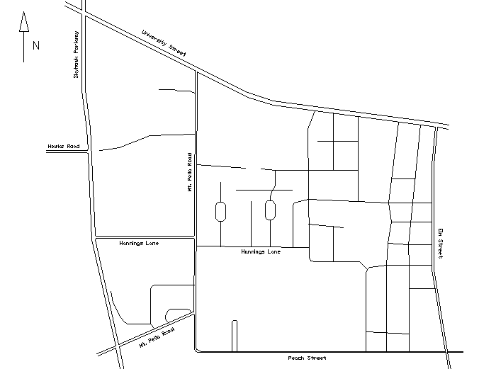

Figure 1. Traffic study area

AASHTO: A Policy on Geometric Design of Highways and Streets; Manual on Uniform Traffic Control Devices for Streets and Highways, 2003 edition; Highway Capacity Manual 2000. Some of the data collected overlapped with the studies performed in the transportation engineering course. The following sections describe a summary of the effort made in collecting data, analyzing data, getting results, interpreting results, making conclusions and describing future work.

Traffic Studies
Traffic studies are conducted to cover various traffic aspects related to the study area. The following is a summary of the methodology, data collection, and results related to each study.
Spot Speed Zoning
Spot speed studies are used to measure factors needed in the design and analysis of the highway system. The highlighted sections of corridors in the study area in Figure 2 are evaluated. The collection of data represents the speeds of vehicles during off-peak times. Collection of data was conducted using a radar gun pointed at the targeted vehicles in both directions of the section. The measurements of speeds are done such that the drivers are unaware of the radar location so that it will not affect the real speed trends.
Results
The analysis of the results of seven corridors in the study area is presented in forms of distribution curves and histograms, cumulative distribution, mode, median and 85th percentile speeds. An example of the results is shown in Figures 3 through 5. Table 1 is an example of a tabulated summary of the data and results. Similar data collection and analysis are made for a total of 14 sets. Also, an AutoCAD drawing representing the corridor and its geometric features is represented in Figure 6. Below is an illustration of the results. Table 2 shows a summary of the 85th percentile speeds found in the maximum direction on each corridor.
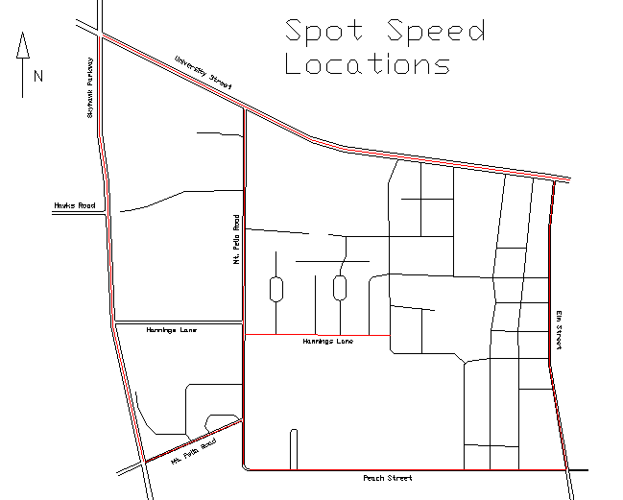
Figure 2. Spot speed locations in interest in the traffic study area
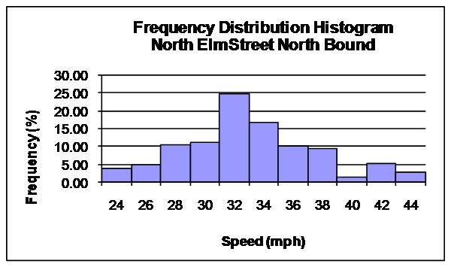
Figure 3. Frequency distribution histogram for North Elm Street, north bound
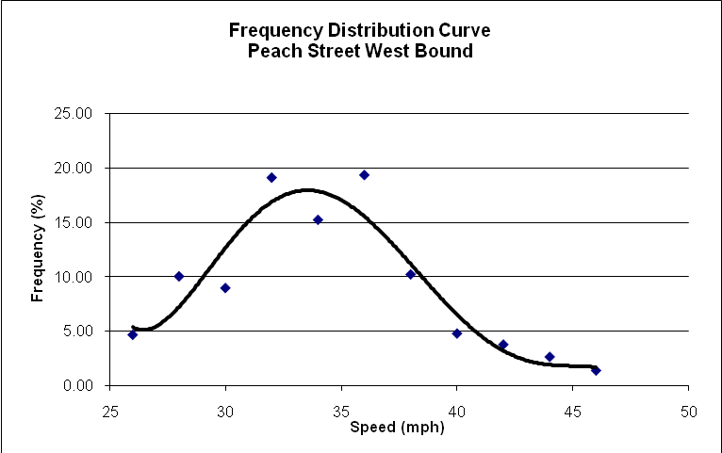
Figure 4. Frequency distribution curve for Peach Street, west bound
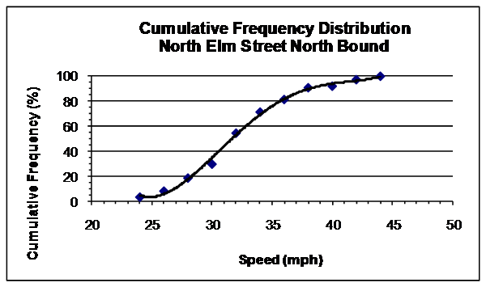
85th Percentile
Figure 5. Cumulative distribution curve for North Elm Street, north bound
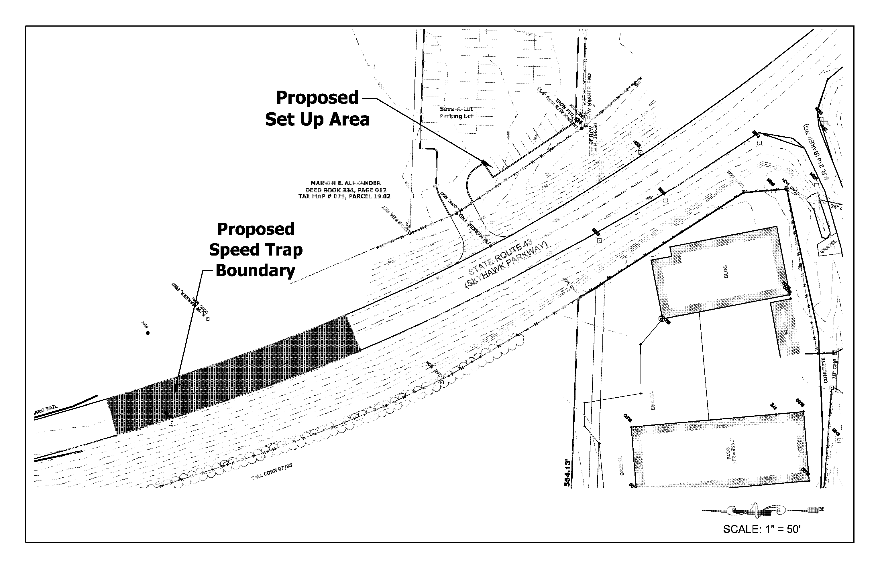
Figure 6. AutoCAD drawing for Skyhawk Parkway
Table 1. Example of summary of data and results for a spot speed study for Peach Street, west bound
Table 2. Summary of 85th percentile speed (maximum direction) for each corridor
Corridor | 85th percentile speed, mph | Design Speed, mph
Hannings Lane | 34 | 30
Mt. Pelia (near Hospital) | 36 | 30
Mt. Pelia Road | 34 | 30
Elm Street | 38 | 30
Skyhawk Parkway | 47 | 45
Peach Street | 39 | 30
South Skyhawk Parkway | 49 | 45
University Street | 40 | 30
Intersections Traffic Volume
The quality of the traffic in a certain area is highly dependent on the intersections’ performance for that area. If the intersections are handling traffic in a high level of service, that will influence the rest of the network. Turning movements and volume data are collected for the targeted intersections in the study marked in Figure 7. The collection of data included the number of vehicles and the directional movements on each approach during the peak hour. A summary of the results is shown in the results section.
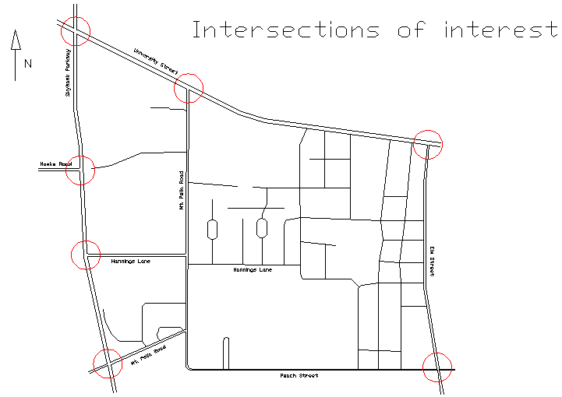
Figure 7. Intersections of interest in the traffic study area
Results
The results are presented in Figure 8 as a graphical representation for volume and directional movements. Also the peak hour factors were calculated for each intersection.
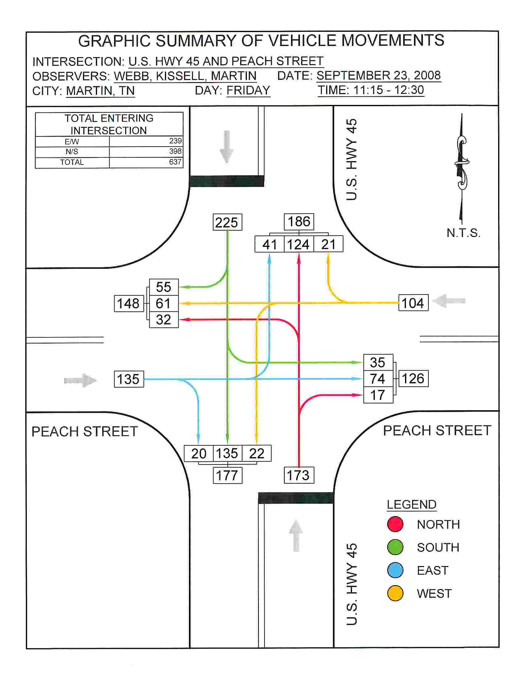
Figure 8. Graphical representation of the turning movement counts on Peach Street and US HWY 45

Intersections Delay

The intersection level of service and delay were measured using the HCS 2000 software. The software follows the procedures of the Highway Capacity Manual 2000. All necessary input was collected from the intersection information with regard to the signalization effectiveness.

Results
A summary of the intersections’ levels of service is shown in Table 3.

Table 3. Summary of LOS and delay for selected intersections
Intersection | Delay sec/veh | LOS | PHF
Elm/University | 13.9 | B | 0.85
Skyhawk/Mt. Pelia | 70.8 | E | 0.9
Skyhawk/University | 27.6 | C | 0.9
Skyhawk /University | 7.2 | A | 0.9
University/Mt. Pelia | 12.7 | B | 0.91
Hwy 45 (Elm)/ Peach | 10.3 | B | 0.93

Parking
The parking on campus is distributed at different locations and some of the parking lots are designated for specific users such as staff and administration. There are several parking complaints especially during late morning and early afternoon hours when parking is at its highest demand. The parking study is initiated at different locations around campus to assess the level of the problem. The collection of data is done for two hours for some parking lots during the working day. Within a parking lot, individual spaces are monitored, and data collection of the usage is tabulated and many results are dictated as well. A layout for one of the parking lots is shown in Figure 9.
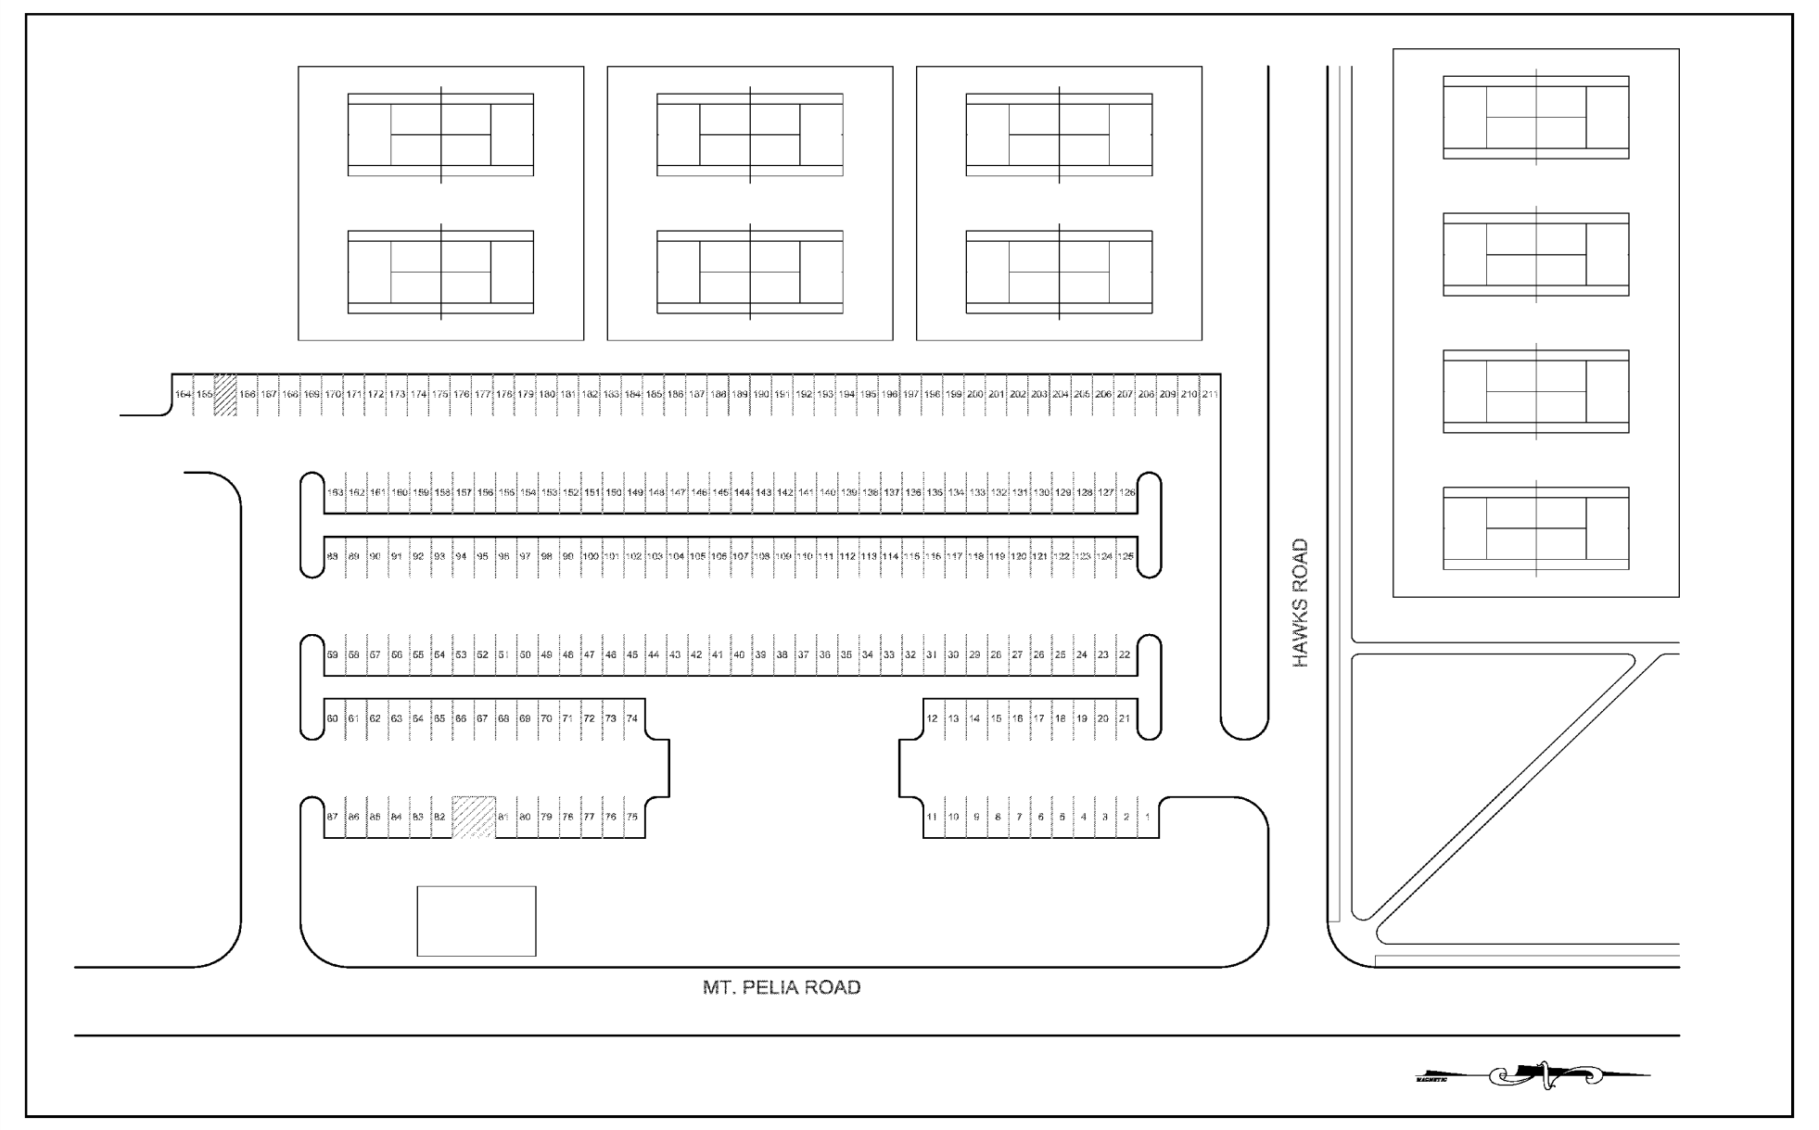
Figure 9. Layout of parking lot 2

Results
The results of the parking study are described by the following parameters:
Parking Volume =Vehicles Parked / number of hours, Turnover =Total # of Vehicles Observed / # spaces, Duration =Total Vehicle-min parked / Total Vehicles, Load =Used space min / Available space min, Accumulation =Total number of vehicles using the spaces at a particular time (shown as a graphical representation). Also some of the questions that were raised to evaluate the condition of each parking lot include the following: Is the parking area fully utilized? Does the parking demand appear to be satisfied? What does the turnover rate indicate? Does the duration indicate that employees are using the area most close to campus? Would relocation of the access drives better utilize the parking area? Is there one time period that exhibits a higher demand than others? Except for construction of new spaces what can be done to improve parking at this location? How can video monitoring or mobile video-taping equipment be used to improve the data collection process?
The parameters were calculated and questions were answered appropriately for some of the targeted parking lots. Figure 9 below shows an example of the parking accumulation during a two hour peak period.

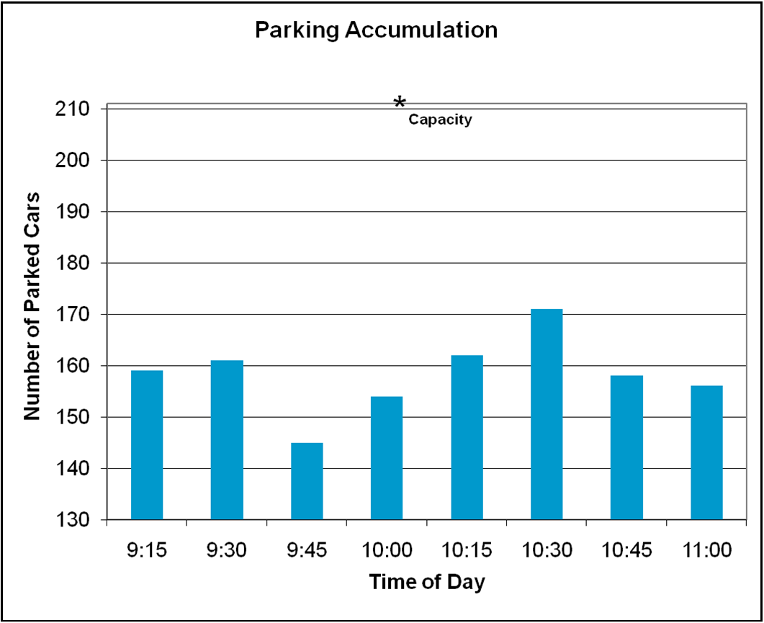
Figure 10. Parking study assessment for lot 31

Vehicle Occupancy
The vehicle occupancy study aims to assess the level of awareness for car pooling in the study area. The methodology done to collect the data is to count the number of people occupying each vehicle along a certain section of the road. The number of occupants per vehicle is summarized as a frequency distribution. The data collection process excluded the big trucks (semitrailers) and transits since they would skew the data. A sample of data was collected for a continuous one hour period at different locations in the study area.

Results
An example of the results of the occupancy study is shown in Figure 11.

Figure 11 Frequency for number of occupant

FUTURE WORK
This portion of the senior design project describes the diagnostic stage for the potentially conflicted traffic related locations. Although the collection of data is not yet completed, there were quite a few locations that require immediate attention. The spot speed zoning at different locations of the study area concluded that most drivers view the posted speed as lower than it should be. The intersections’ levels of service for some of the intersections are very low and a need for a redesign of such high delay service is in necessitate. The future work is to finish the traffic studies at all targeted locations as planned and carry on with any design needs to solve conflicted traffic areas.

LEARNING EXPERIENCES
The students learned that time management was of utmost importance when performing traffic studies. Data collection was one of the most time consuming portions of the project. The traffic studies had to be performed at certain times of the day, and all studies had to be performed during the work week. This sometimes conflicted with the students’ class schedules, so the importance of planning was realized from the beginning. Also, the students learned to collect and organize useful data through the interpretation of manuals and the use of professional software such as HCS 2000. In some instances, the students had to repeat studies because once data was entered into the software; errors were shown in the results. Through writing memos and reports, as well as a poster presentation, the students gained experience in effectively and visually communicating their results and ideas with an audience.

CONCLUSIONS
The traffic study was found to be more exhaustive than it appeared at the beginning of the work. The traffic study for the UT Martin campus and surrounding areas was initiated to identify potential traffic related conflicts. Some locations were diagnosed to have potential traffic problems especially in the intersections that had low levels of service. Also it was found that many corridors experienced high speeds above the designed speeds. That trend was found for the 85th percentile speed at different sections. At the moment, no serious parking problems are identified based on the analysis of data collected (but this is based on few limited studies of some parking lots). The vehicle occupancy study revealed the fact that most riders drive alone. Car pooling has to be encouraged by means of educating the campus community of its benefits and needs. These benefits include traffic and environmental quality of the campus. Since there will be more data to be collected in the future work there might be locations with some parking related problems. The traffic problems identified in this study require attention and solutions, as discussed in the future design section. ENGR 411 will cover the design and suggested solution for the aforementioned conflicts. A traffic signal redesign will be done for the intersections with low levels of service. The main benefits that the students experienced in this paper are the hands on experience with the data collection, professional formatting, professional software implementations, interpreting results, making design (re-design) decisions, manual usage and following standardized procedures. Also, the students submitted bi-weekly memos that described the work done. They also presented their work in group meetings. The students gained communication experience by contacting local professionals such as the TDOT traffic division and the parking and traffic administrators on campus.

REFERENCES
[1] Currin, Thomas R. Introduction to Traffic Engineering: A Manual for Data Collection and Analysis. Pacific Grove, CA: Brooks/Cole, 2001.
[2] Garber, Nicholas J., and Lester A. Hoel. Traffic and Highway Engineering. 3rd ed. Pacific Grove, CA: Brooks/Cole, 2002.
[3] Robertson, H. D., Joseph E. Hummer and Donna C. Nelson, eds. Manual of Transportation Engineering Studies. Institute of Transportation Engineers. Englewood Cliffs, N.J.: Prentice Hall, 2000.
[4] AASHTO: A Policy on Geometric Design of Highways and Streets, 4th ed. AASHTO, 2001.
[5] Manual on Uniform Traffic Control Devices for Streets and Highways, 2003 edition.
[6] Highway Capacity Manual: 2000. Transportation Research Board, 2000.

Mohammad Obadat
Assistant professor of civil engineering at the University of Tennessee at Martin. Instructor of the following courses: Transportation engineering, pavement design and analysis, geotechnical engineering, elementary surveying, and statics. PhD in civil engineering in August 2003 at the University of Iowa specializing in transportation.
Stephanie Kissell
Undergraduate student in the department of engineering at The University of Tennessee at Martin. Concentration in civil engineering. Expected to graduate May, 2009.
William Anderson
Undergraduate student in the department of engineering at The University of Tennessee at Martin. Concentration in civil engineering. Expected to graduate December, 2009.
Matt Kee
Undergraduate student in the department of engineering at The University of Tennessee at Martin. Concentration in civil engineering. Expected to graduate December, 2009.

Assistant Professor, 124 D EPS Bldg, Department of Engineering, The University of Tennessee at Martin, Martin, TN 38238, mobadat@utm.edu.
Undergraduate student, EPS Bldg, Department of Engineering, The University of Tennessee at Martin, Martin, TN 38238, stenpaul@utm.edu.
Undergraduate student, EPS Bldg, Department of Engineering, The University of Tennessee at Martin, Martin, TN 38238, wiltande@utm.edu.
Undergraduate student, EPS Bldg, Department of Engineering, The University of Tennessee at Martin, Martin, TN 38238, matdkee@utm.edu.

