A Low Cost Environmental Test Chamber for Teaching Engineering and Technology Students

Aaron K. Ball, Frank Miceli, & Chip Ferguson

Abstract - Environmental test chambers are used in a variety of ways in supporting the development of new products and processes and can provide an excellent means to expose students to standardized testing procedures as well as offer opportunities to effectively supplement the teaching of control systems and instrumentation. Using LabViewTM for data acquisition and control, a relative low cost but effective chamber was developed by Western Carolina University and Asheville-Buncombe Technical Community College through a joint partnership. This paper will present a logical approach to developing such a system and describe how applications have been integrated into curricula at both the two-year and university level. Educational merit and approaches will be described relative to respective educational levels.

Keywords: instrumentation, test chamber, environmental test chamber, control methods, engaged learning.

BACKGROUND

Western Carolina University is committed to supporting economic development through scholarly engagement and partnerships. The university established a campus-wide mandate for engagement with regional business and industry and has provided for engagement activities that focus on sustaining economic development and boosting entrepreneurial startups through innovative and creative projects, particularly those that develop intellectual capital and technology transfer [Bardo, 1 & 2; Snellenberger, 6] The development of new products demonstrating significant potential for reducing energy cost coupled with technology transfer resulting in increasing employment in western North Carolina is of particular concern in light of the significant number of displaced workers in the region [Klein, 3; U.S. Department of Labor, 8].

The Engineering and Technology Department was awarded a contract through the Department of Energy (DOE) and sponsored by the Education and Research Consortium of the Western Carolinas. Teaming with Asheville-Buncombe Technical Community College, a local manufacturer, and Oak Ridge National Laboratory, a collaborative effort to develop energy efficient technologies for residential water heating was undertaken from 2004-2007.
Based on previous work of engineers, scientists, and technologists at Oak Ridge National Laboratory, 18 percent of residential energy utilization is consumed by water heating [Murphy, 4]. Laboratory results have shown the efficiency ratings of test units to be approximately 90 percent of the maximum achievable operating efficiency [Zogg, 9]. Further research conducted by the national laboratory suggested that substantial improvement could be made by implementing a heat pump type unit for supplementing a standard electric water heater. The heat pump water heater (HPWH) field tests have demonstrated that the overall energy costs of heating water can be reduced by 50 percent [Murphy, 4]. The project discussed in this paper addressed the monitoring, development, and testing needed to prototype a similar product with added dehumidification capability. Thus, the project focused on developing a hybrid Water Heater and Dehumidifier (WHD) product. Two viable prototypes demonstrating proof of concept were presented as deliverables in Phase I. During Phase II of the project, a controlled environmental test chamber was needed to validate the design and performance prior to field testing. This need led to the development of an environmental test chamber and control system described in the following section.

ENVIRONMENTAL TEST CHAMBER AND SYSTEM DESIGN

Companies such as Cincinnati Sub-Zero and Teney produced commercial environmental chambers with controllers that may have met the technical specifications necessary for the WHD project. However, due to budget and time constraints, alternative options had to be considered.
WCU and ABTCC worked collaboratively in the development of an environmental test chamber at the AB Tech WHD laboratory test site. After receiving quotes for test chambers of adequate capacity and size for testing WHD units, the decision to purchase a chamber was abandoned due to costs. A more workable option was identified by relocating and refurbishing a unit previously used by BASF. The BASF facility had recently been transferred to AB-Tech and was located on the ABTCC-Enka campus. This unit consisted of foam filled panels assembled to form a 14' x 8' x 8' structure. Temperature and humidity had been provided by steam piped into the structure from the physical plant; however no corresponding utilities were available at the AB-Tech WHD laboratory test site.
The foam panels were easily disassembled and reconfigured due to the cam locking mechanism integrated into each unit. It should be noted that these panels are readily available from companies such as CrownTonka and a quick internet search revealed numerous 8' X 8' walk-in coolers in the $4,000 through $7,000 price range. Using the panels, the test chamber was reconfigured into an 8 x 8 x 8 unit in the Mechanical Engineering Technology Laboratory on AB-Techs campus by faculty and students. Photographs showing the chamber structure at the AB-Tech laboratory are shown in Figure 1.

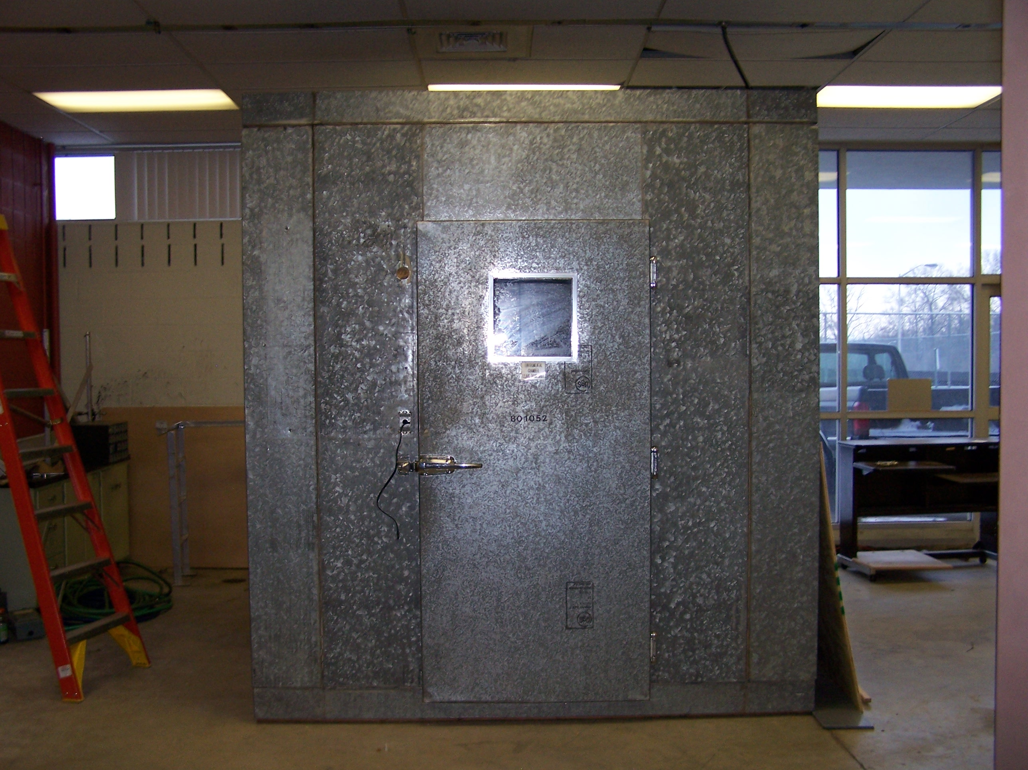
Figure 1: Test Chamber at new WHD Test location.
SYSTEM SPECIFICATIONS AND REDESIGN
A redesign of both the physical size of the chamber and utilities was required since no steam was available at the new site. Additionally, it was desired to create a system with local control and readily compatible with existing plumbing and electrical utilities. A conceptual model was initially developed (shown in Figure 2), and required systems were identified to meet the testing requirements for WHD prototypes. Load calculations were completed based on the specifications required by the federal test for water heating and dehumidification devices along with the added heat load of the units under test.
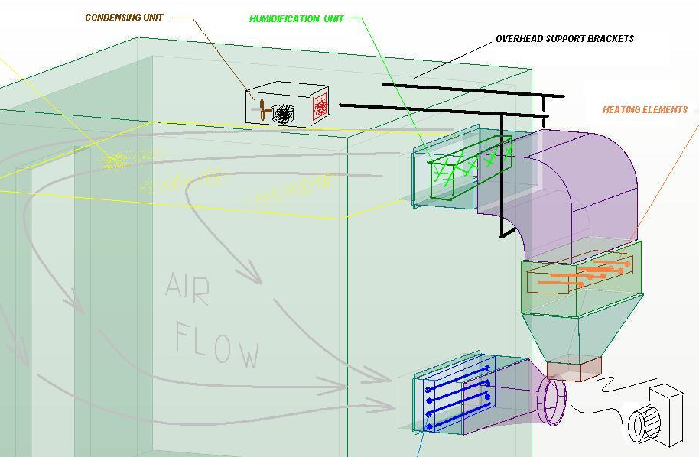
Figure 2: Conceptual Environmental Chamber Model
LOAD CALCULATIONS
As summarized by Sigma Systems of San Diego, California, “The capability of maintaining desired temperature within the chamber was affected by the mass and materials of the Unit Under Test (UUT), the chamber walls, and components such as blowers and ducting [Sigma Systems, 5]. Further heat generating capabilities and energy losses must be at a minimum. Energy required to change the temperature of an object can be calculated if the mass and specific heat of the object and the temperature range that the object is subjected are given. From basic thermodynamics, specific heat is defined as the amount of heat required to produce a desired temperature change in an exact amount of any substance and is expressed in J/(⁰C-g) or BTU/(F-Lbm). The mass of an object is the product of the volume and the density [Sigma Systems, 5].
Heating Loads
Heating Loads were estimated using the following formulae.
Mass Calculation:
Linear Mass = ρ x volume
= ρ x (thickness x area)
Energy Calculations:
Energy = Mass x Specific Heat x Temperature Change

Cooling Load
Mechanical refrigeration was ideally suited for the chamber since a completely self-contained system could be fabricated using a Copeland condensing unit and an appropriately sized evaporator. Both of these units were readily available from HVAC suppliers and required only electrical connections to operate.

Test Chamber Cooling Requirements

An environmental test chamber operating below ambient temperature requires refrigeration to compensate for the following factors.
- The heat energy flowing into the chamber through the walls
- The heat generated by lamps, fans and blowers within the chamber
- The heat generated from active loads
Heat flow through chamber walls can be calculated by Q = A x Delta T / R
. Where:
- Q is the heat transfer in BTUs/hour
- A is the total surface area of the test volume in square feet
- Delta T is the maximum required temperature difference
- R is the heat resistance of the insulating material per inch thickness

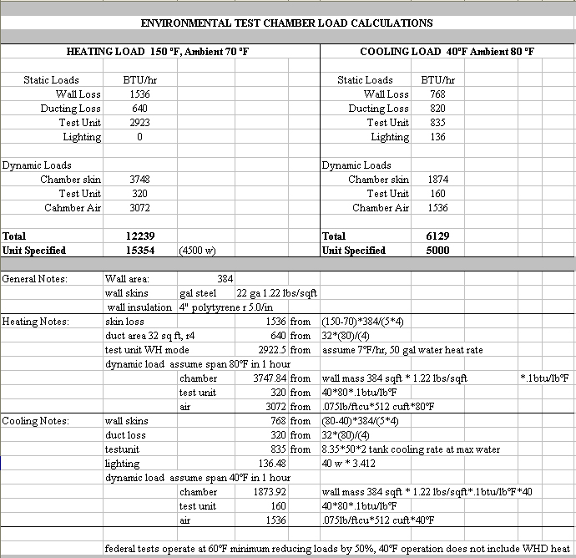
Table 1: Summary of Heating and Cooling Load Calculations.
COMPONENT SELECTION AND METHODS OF CONTROL
The objective of the environmental chamber project was to satisfy the requirements of testing WHD units and serve as a general purpose testing and teaching facility. Based on estimated load calculations and desired range of environmental control, systems were identified to meet the required specifications for refrigeration, heating, and humidification for the test chamber. The method of control and selected input/output components are shown in the Table 2.
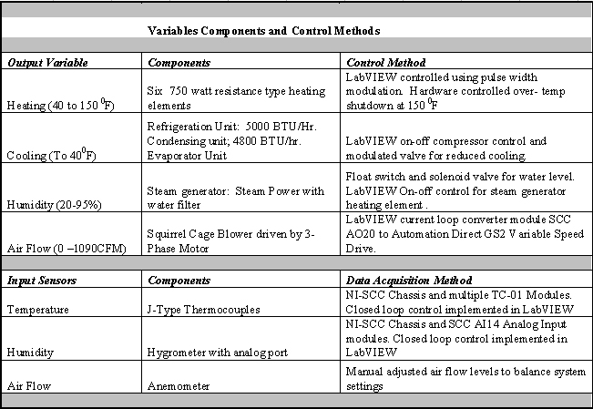
Table 2: Variables Components and Control Methods

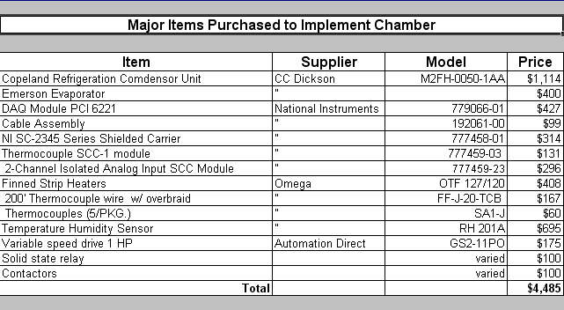
Table 3: Major Items Purchased to Implement Chamber
A bill of materials is shown in Table 3 and selected components were procured and installed as shown in Figure 3. Students were involved in all phases of the project including design, fabrication, and installation under the supervision of faculty. AB-Tech students participated in HVAC system fabrication and testing, electrical controls, and assembly. Graduate students at WCU were responsible for all sheet metal design, layout and fabrication of sheet metal ductwork. Pro-EngineerTM sheet metal module was used to design air ducts, and CNC programs were developed for a HAAS Z-500 laser machining center. Sections of the ducting system were fabricated and assembled on the WCU campus then delivered to the AB-Tech test facility for installation.

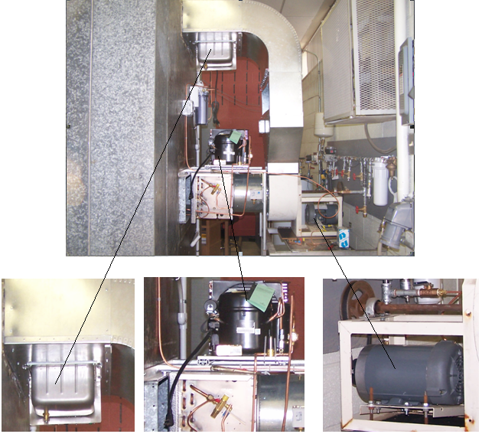
Honeywell Steam Generator Condensing and Evaporator Units Three Phase Motor
Figure 3: Environmental Chamber Installed Components
LabViewTM was selected as the primary method for data acquisition and control due to the capabilities for data acquisition, control and analysis. LabViewTM is a sophisticated graphical language very suitable for science and engineering applications requiring data acquisition, control and analysis. Further, LabViewTM has become more popular with local industries, and a need exists for skills and experience using the software. Primary Virtual Instruments (VIs) and sub-Vis were written to monitor and control the environmental chamber through feedback control using the constraints as shown in Table1.The developed LabViewTM front panel and block diagrams are shown in Figures 4 and 5.
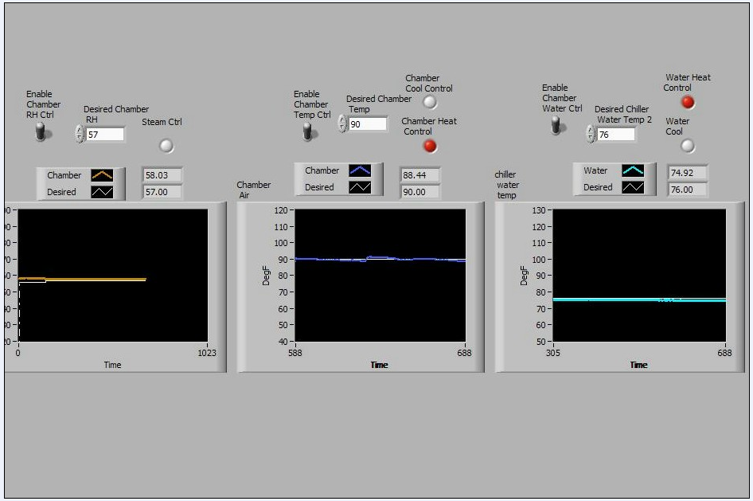
Figure 4: LabVIEWTM Front Panel Chamber Control
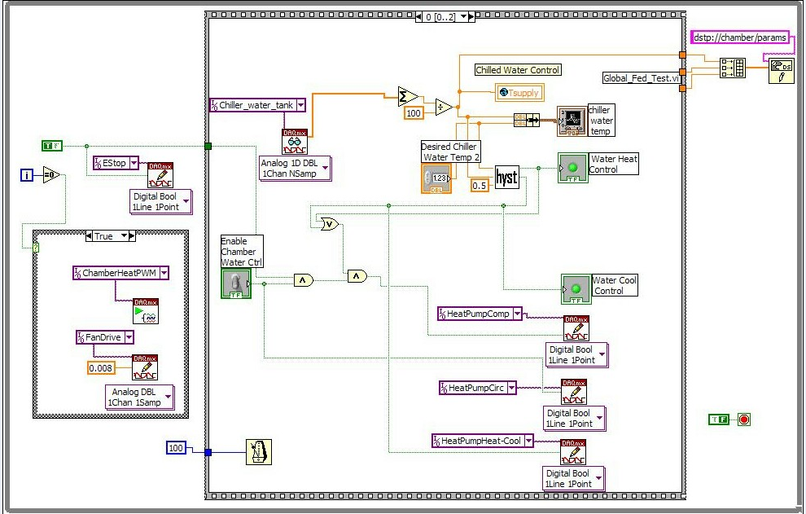
Figure 5: LabViewTM Block Diagram of Environmental Chamber Control

EDUCATIONAL GOALS

The WHD project presented a challenging opportunity for integrating the development and application of an environmental test chamber into engineering technology courses. Specifically, the educational goals of the WHD project were the professional and technical development of faculty and students, engineering project work for students, and developing laboratory equipment to support research and courses in control systems and instrumentation.

FACULTY INVOLVEMENT

Faculty members from Western Carolina University and Asheville-Buncombe Technical Community College were involved in numerous activities throughout the project. This close partnership was strengthened through total team participation between the two institutions. Although the principal investigator served as project coordinator and community college faculty were initially charged with the responsibility for control development and testing, all faculty were committed to making the project a success. Both institutions freely exchanged support in the form of test site development, instrumentation and control, and testing. As a result of this cooperative team effort, an environmental test chamber was developed to support both research and teaching for both two-year and four-year institutions.

STUDENT INVOLVEMENT

Snellenberger and his colleagues emphasized the need for students to attain higher technical skills and practical engineering experience to reinforce a stronger U.S. engineering workforce [Snellenberger, 6]. Aside from technical skills, practical engineering experience, and progressive professional skills from industry, advisors often urge that graduates must be made aware of skills such as planning, communications, and safety. The comments from industrial advisory board members have had a major influence on the engineering technology programs. Under their guidance, the curricula for each of the engineering technology programs were designed to provide flexibility and accommodate two general categories of students. For students seeking to transfer for a bachelor’s degree, electives in math and science are made available. However, for those students seeking immediate employment with an associate’s degree, project classes are recommended to establish workplace experience. Project classes are the college’s vehicles for allowing the student to integrate the technical and non-technical skills. The WHD project, with challenges in many disciplines, was well suited for this very type of student experience. This project was in essence the experience that the industrial advisory board desired.
Students from both institutions made important contributions and support to the project. Western Carolina University students were primarily involved with engineering documentation and modeling, rapid prototyping, component machining, and sheet metal fabrication. Graduate students also conducted design of experiments and data analysis on UUTs. Two-year college student involvement included site development work, instrumentation, controls, and testing. The follow section provides more specifics on student activities throughout the project.

USE OF THE TEST CHAMBER TO SUPPORT AN INSTRUMENTATION COURSE

Engineering Technology strives to provide students with a balance of theory and applications. Similarly a balance of instruction in mathematics and sciences fundamentals with practical applications was carried for an undergraduate instrumentation course. Attempts were made to show the operational characteristics of the test chamber by explanations of basic science and engineering fundamentals.

The environmental chamber has proven its value by supporting experiments that are relevant to students’ personal and career interests. Recent experiments were conducted relative to sustainable energy by carrying out tests on a Hydrogen Oxygen Generator. Teams were assigned to monitor the gas output of a generator at different electrolyte concentrations. Currently the chamber is being used to validate the efficiency of a new generation of HID and florescent lighting products.

As LabViewTM gains more acceptance in local manufacturing community, more emphasis will be placed on providing necessary skills in LabViewTM “G” programming and Data AcQuisition (DAQ). LabViewTM instruction is provided throughout the undergraduate instrumentation course, and the chamber provides an opportunity for students to reinforcing theory through practical application. Unlike the classroom environment, students set the requirements of the DAQ system and proceed with the implementation using a variety of DAQ hardware and sensors.

Two separate systems are in place for integrating the chamber into the instrumentation class. One system is fixed and used solely for controlling environmental conditions inside the chamber. The second system is used to host students’ applications alloying individual students to design their own application, configure the chamber environment, operate the unit under test, record the desired data, and finally analyze the data.

The most recent project for the instrumentation class involved efforts to validate and enhance the capabilities of the environmental test chamber. This was achieved by adding sensors to detect an excessive temperature gradient in the chamber. Students defined inputs, processing requirements and outputs prior to developing a new sub-VI. Five new thermocouples were installed and configured prior to testing the VI and analyzing the effects of chamber performance.

OVERALL BENEFITS OF THE PROJECT

In addition to the educational benefits, a win-win situation has been developed and fostered through the non-competitive and collaborative efforts of each educational institution. It is widely recognized that technology transfer has the potential to enhance the competitiveness of small businesses, which in turn spurs regional economic development and job growth. As a result of this project, an industrial caliber test chamber is now available to support such initiatives. Additionally the central missions of Western Carolina University and Asheville-Buncombe Technical Community College have been complimented through efforts in providing new technology and modern engineering support. Oak Ridge National Laboratory gained the potential to expand the body of knowledge and demonstrate concepts of viable alternative energy saving appliances through validated environmental chamber testing.

CONCLUSION

Western Carolina University and Asheville-Buncombe Technical Community College contributed resources and support for the design, fabrication, and testing of a fully instrumented environmental test chamber. This creative and applied engineering project provided each institution with the opportunity to integrate applications of theoretical concepts into course and laboratory exercises as well as supporting research. The test chamber provides multiple learning and research opportunities for community college students, university undergraduate and graduate students, and faculty from both institutions. Faculty have gained and strengthened their technical knowledge of subjects that may have otherwise remained uncultivated. Further, students were provided opportunities to solve real design problems and gain experience in fabrication, system control, and testing. The knowledge and experience gained will prove to be valuable in the enhancement of engineering technology curricula and support of future engagement projects.

REFERENCES
1. Bardo, J. (2000). Western Carolina University's Commitment to Regional Economic and Community
Development. Rural Economic Development Conference, November 2000, Retrieved October 17, 2004,
from Western Carolina University, Office of the Chancellor Web site: http://www.wcu.edu/chancellor/
2. Bardo, J. (2003). Meeting Western North Carolina’s Needs through Higher Education. Regional Summit,
February 2003, Retrieved October 17, 2004, from Western Carolina University, Office of the Chancellor Web
site: http://www.wcu.edu/chancellor/Presentations/presentations.htm
3. Klein, Jean C., Chris Beachum and Catherine Moga. (2002). Manufacturing Layoffs: Hard Times for Rural
Factories, Workers and Communities, The Rural Center, Number 11, April 2002, Retrieved November 30,
2004, from http://www.ncruralcenter.org/pubs/mfglayoffs.pdf
4. Murphy, R. Tomlinson, J. (2002). Field Tests of a “Drop-In” Residential Heat Pump Water Heater.
Final Report. Oak Ridge National Laboratory, September, 2002.
5. Sigma Systems Incorporated. (2006). Thermal Test Chamber Construction, Considerations and Constraints, retrieved September, 2006 from http://www.sigmasystems.com/Techdoc/Chamber%20Size%20Discussion.pdf
6. Snellenberger, J. M., D. H. Quick, I. T. Davis, J. P. Tidwell, J. O’Brien, R. M. Haynes, et al.(2004)
Enabling the U.S. Engineering Workforce to Perform: Recognizing the Importance of Industrial Engagement
In Professional Graduate Engineering Education. Proceedings of American Society for Engineering Education
7. Taylor, C. (2004). Environmental test chamber for the support of learning and teaching in intelligent control. International Journal of Electrical Engineering Education.
8. US Department of Labor, Bureau of Labor Statistics, Local Area Unemployment Statistics, Retrieved
November 30, 2004, from http://stats.bls.gov/lau/home.htm
9. Zogg, R.A. and Murphy, W.J. (2004). California Field-Test Data And Analysis. Technical Report. California Energy Commission. April, 2004.

Biographical Information

AARON K. BALL
Aaron K. Ball is a Full Professor and serves as the Graduate Program Director in Engineering and Technology at Western Carolina University in Cullowhee, North Carolina. He holds a B.S. and an M.S. from Appalachian State University, and earned his doctorate from Virginia Polytechnic Institute and State University. His areas of interests include fluid power, advanced machining, prototyping systems, and applied research.

FRANK MICELI
Mr. Frank Miceli is currently the Department Chair for ECET at ABTCC, Asheville, North Carolina. Mr. Miceli holds a B.S. in Electrical Engineering and an M.S. from Western Carolina University. He has worked with advanced navigation systems used aboard the Trident Submarine and served as Engineering Section Head for Telephonics Corporation. His interests are in automation and controls using LabVIEW and .NET applications.

Chip W. Ferguson
Chip W. Ferguson is an Assistant Professor of Engineering Technology at Western Carolina University in Cullowhee, North Carolina. He also serves as the Coordinator of Engineering Technology. Professor Ferguson earned his B.S and M.S. at the University of Southern Mississippi and is currently in ABD status at Western Carolina University. Prior to his arrival at Western Carolina University, Professor Ferguson gained five years of industrial experience working in mechanical and fluid power systems.

