Undergraduate Distributed Collaborative Engineering Project using CAD, CAE and PLM tools
Tord W. Dennis, Robert E. Fulton1

Abstract
Just as many corporations have retired “business-as-usual” in favor of lean business practices (i.e. Just-In-Time, Total Quality Management, etc.) coupled with cutting edge Information Technology to become more competitive, universities must change the way they do business (train engineers) or go the way of the dinosaurs. We must continuously strive to improve the quality of education we provide to our engineering students in order to prepare them to be successful in the workforce. The best way to do this is to study industry trends and create a similar (or superior) environment in academia. At Georgia Tech we have successfully implemented many new tools into our curriculum and developed new teaching paradigms that have made our students the most sought after recruits in the market. In this paper we share our experiences implementing distributed collaborative engineering projects in an undergraduate setting and invite others to join us in defining the future of engineering education.

Introduction
Every corporation is part of a grand supply-chain network of corporations collaborating to produce quality products quickly at low cost. To make such an enterprise system effective, corporate entities have retired “business-as-usual” in favor of lean business practices (i.e. Just-In-Time, Total Quality Management, etc.) coupled with cutting edge Information Technology. Computer Aided Design (CAD) and Computer Aided Engineering (CAE) tools enable engineers to efficiently and quickly realize and simulate concepts virtually, reducing the need for expensive prototyping and testing. Computer Aided Manufacturing (CAM) enables manufacturers to directly utilize information generated by designers to prepare for and manufacture parts. Product Lifecycle Management (PLM) ties all of these innovations together tracking mountains of data, allowing all parties involved in the lifecycle of a product to share information in real-time over the Internet.
Universities are the feeder mechanism for Industry and thus are charged with imparting upon students the skills necessary to be productive in the supply-chain network. Therefore we must continuously strive to improve the quality of education we provide to our engineering students by studying industry trends and creating a similar (or superior) environment in Academia. Engineering curricula traditionally emphasize individual learning steeped in gaining theoretical knowledge over applied knowledge, however the days of the individual contributor in industry is gone. Today’s work environment demands multidisciplinary teamwork among individuals that may be geographically dispersed. Employees must be concerned and familiar with all aspects of the lifecycle of a product and all operating facets of the corporation. Industry and Academia must collaborate to broaden the experience and education of the engineering student or else Industry will bear the costs of “retraining” them in the field.
In 2002 Georgia Tech and PTC of Needham, MA founded the PLM Center of Excellence at Georgia Tech to develop a paradigm of fostering multidisciplinary product development in an academic curriculum. The crown jewel of this Center is a “Grand Experiment” involving students from multiple schools and many disciplines collaborating virtually to deliver a product design over a two-year period. The Distributed Collaborative Product Development (DCPD) project documented in this paper is a pilot program conducted by students and faculty at Georgia Tech and the University of Maryland College Park during the spring semester of 2003 to identify and explore potential issues relating to the “Grand Experiment.”

Historical Perspective of ME4041 – Computer Aided Design
At Georgia Tech we have always believed that effective engineering communication involves more than technical writing skills. An engineer must be proficient in describing the intent of a design using both words and technical drawings. Our ME 1770 course, Introduction to Engineering Graphics, is cross listed with the schools of Aerospace, Mechanical and Civil engineering and is required of all freshmen. The students are introduced to technical communication using paper drawings and Computer Aided Design (both 2D and 3D) software through a 3-hour lecture and 2-hour lab per week.
The ME 4041 course (Interactive Computer Graphics and Computer-Aided Design) at Georgia Tech is targeted at junior and senior level students of the George W. Woodruff School of Mechanical Engineering. The objective of this course is to provide hands-on exposure to computer-based modeling, design, and analysis techniques in addition to theoretical formulations. Three hours of lectures every week introduce them to the principles of geometric modeling and the finite element method. Two hours of weekly laboratory gives them practical applications using the I-DEAS Master Series suite of CAD/CAE/CAM tools by EDS-PLM Solutions or Pro\Engineer suite of tools by PTC of Needham, MA. The students demonstrate their learning with a group design project involving CAD and CAE applications in thermal and mechanical design. A Product Data Management (PDM) system was implemented in the computing environment to support the design projects and foster teamwork.
The PDM databases and related files are setup on a SUN workstation in the A. French building of the College of Engineering. The CAD/CAE executable files are loaded locally on:
- 22 personal computers in the MRDC building of the School of Mechanical Engineering running Windows 2000
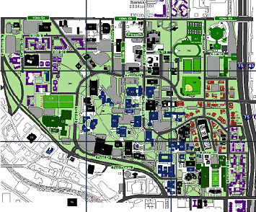
- 25 SUN workstations in the A. French building running UNIX
A French bld
MRDC bld
West dorms
Figure 1. Computing Environment at GT
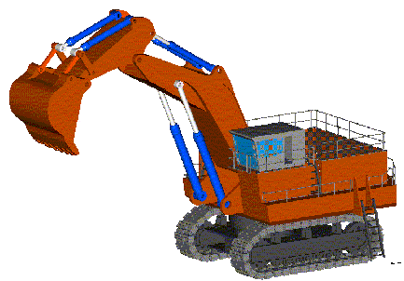
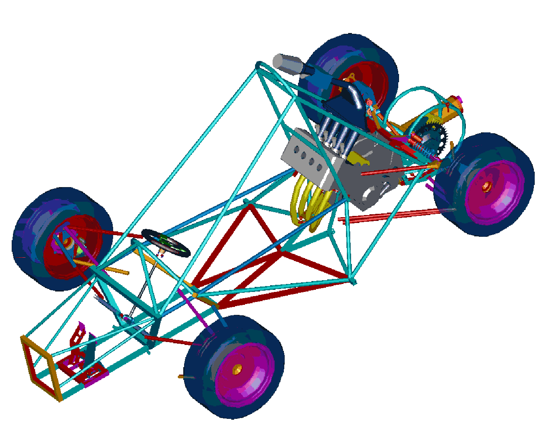
All of these facilities (see Figure 1), including the student dormitories located on the west campus are connected via a T1 ethernet network. This gives students access to their data from any computer on campus via a web browser or locally installed software. The PDM handles the data conversion processes (from UNIX to NT and vice-versa) and file locking. As students build parts, others can conduct the assembly process and other tasks (e.g. finite element analysis) working on referenced parts with read-only privileges. Working in this environment, 2 students designed and analyzed the excavator shown in Figure 2 during the spring semester of 2003 and 18 students collaborated to virtually build the mini-Formula racecar for the GT Motorsports club shown in Figure 3.
Figure 2. Excavator
Figure 3. mini-Formula racecar

Distributed Collaboration Paradigm
Just as it was a logical decision to move from paper drawings to CAD, our current state of distributed collaborative projects is the next logical step in the evolutionary progression of engineering education. Typical computer supported engineering involves a linear design process involving rework and many iterations (see Figure 4). After the requirements are formed, the geometry is modeled and analyzed. If changes are necessary, the design is reworked and reanalyzed until the design specifications are satisfied. Then a prototype is built and tested and the results documented. Sometimes the prototype sparks rework in the modeling arena and the process loops until a satisfactory design is achieved.
Figure 4. Linear CAx design process with rework
Define
Requirements
Model
Geometry
Analyze
Design
Build
Prototype
Document
Results
CAE
CAD
In a competitive development environment, a linear design process such as this can be very costly. It is generally accepted as fact that the revenue generated by the average product in the first 2 years accounts for 35 to 50% of its lifelong income potential so being first-to-market is crucial to recouping R&D expenditure. It is also accepted as fact that 80% of the costs of a product are committed during the first 20% of the product development cycle. Poor decision making during the conceptual phase causes not only a waste of resources but also is a major cause of rework and fixing problems late in the development cycle can increase costs exponentially. For these reasons, corporations are turning from a linear or sequential development cycle to a parallel cycle in which all participants in a product’s development work collaboratively throughout the entire lifecycle. The key to making this work effectively is product lifecycle management, making information available at all times to all participants.
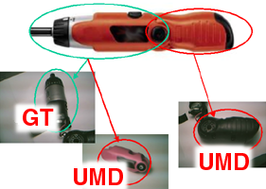
To introduce product lifecycle management into our curriculum, we decided to conduct a distributed collaborative engineering project with colleagues at the University of Maryland - College Park. The decision was made to reverse engineer an existing product that could be readily obtained by both schools from the local home improvement store. We planned for the project to proceed as follows: GT would function as the OEM building CAD models of the mechanical gear components of a cordless screwdriver using Pro/Engineer. UMD would function as the design team; UMD team 1 (UMD1) would rebuild the handle assembly of the existing model in CAD, and UMD team 2 (UMD2) would create a completely new handle assembly. The division of responsibilities can be seen in Figure 5. All documents would be shared using a PTC ProjectLink PLM server installed at Georgia Tech. A weekly teleconference would be conducted every Friday to assess the project's progress and decide on future work. Collaboration using ProductView, a lightweight viewer component of ProjectLink, would also be done as appropriate.
Figure 5. Division of labor
We decided that this would be a great platform for developing the engineering education of the future. Through this project we could:
- Facilitate real time sharing of pertinent design information
- Address barriers to effective teamwork and communication
- Understand prime-supplier relationship in product development
- Incorporate more IT in undergraduate and graduate courses
- Deploy latest CAx/PxM technology at universities
- Study aggregate project management
- Understand team interdependence
- Explore top-down and bottom-up design issues
- Understand barriers to integrating different technology
- Explore standards to facilitate information exchange (STEP)
- Understand security issues relating to data management
- Develop guidelines/best practices for integrating PLM into the design process

Hardware & Software Infrastructure
The collaboration server was installed at Georgia Tech and its address was registered with the Georgia Tech DNS as ptc.cad.gatech.edu making it accessible via the Internet. Due to limited funds, the ProjectLink server was actually a triad of hand built machines: each PC had a 1GHz Pentium III CPU with 1 Gig of RAM running Windows 2000 SP3.
The first PC was loaded with:
- Windchill ProjectLink 6.2 DSU3
- Apache 1.3
- Tomcat 3.2.3
- Aphelion Directory 2001
The second PC was setup as the database with Oracle 8i Server Enterprise Edition.
The third PC was setup as the CAD visualization server with Pro/Engineer 2001.
Pro/E 2001 was loaded locally on workstations for each team to use. A CAD client was downloaded from the ProjectLink server and installed onto each machine to facilitate the uploading and downloading of parts and assemblies directly from within Pro/E. Other documents such as reports and presentations were uploaded via a web browser.
The server triad was simultaneously utilized by 40 students at GT sharing CAD data in ME4041.

Participants
GT - extension of ME4041 (Interactive Computer Graphics and Computer-Aided Design)
- one faculty advisor and one student engineer/project leader
UMD1 – project in ENME414 (Computer Aided Design)
- one faculty advisor and two student engineers
UMD2 - special problems course
- one faculty advisor and one student engineer

Schedule
The master schedule was created as a PowerPoint document and uploaded to the ProjectLink server along with meeting notes so that project members could revise it as needed. Typically this was done following the weekly Friday teleconference. At the initial meeting it was decided that the project proceed in the following order:
1. GT begin modeling interface components and UMD1 begin modeling lower handle components
2. UMD1 begin modeling intermediate components when GT completes interface components
3. GT complete upper parts and assembly
4. GT begin working on complete assembly adding intermediate components and lower assembly from UMD1
5. Design review
6. UMD2 begin work on lower assembly
7. Design review

Collaboration
The GT group purchased two identical power screwdrivers and mailed one to UMD. With the server in place, all participants were emailed a username and password to access the ProjectLink site. The GT team disassembled a cordless screwdriver, took digital pictures of each component, and compiled a PowerPoint document detailing which pieces were to be built by which teams. The initial meeting was held via teleconference on Friday February 14. The semester progressed as follows:
Feb 17-21 Initial team meeting to discuss schedule and division of work.
24-28 Seed geometry from GT built and uploaded along with pictures of parts outlining responsibilities.
March 03-07 UMD1 built CAD components of the bottom black handle assembly
GT: Spring break.
10-14 UMD1 completed and uploaded CAD components of the bottom black handle and uploaded a list of the components created (in Word format). GT modeled motor for the casing assembly.
17-21 UMD1 completed CAD components of the top orange handle assembly. GT completed all components.
24-28 UMD: Spring break. GT completed assembly of gear components.
April 31-04 UMD1 completed CAD components of the top orange handle and uploaded a list of components.
UMD1 completed bottom black handle assembly.
GT: Completed assembly of motor and motor casing to the gear component assembly.
07-11 UMD1 completed top orange handle assembly.
GT completed the assembly of the upper and lower handles with the gear assembly.
14-18 Design modifications and enhancements of both the bottom and top handle assemblies.
GT: Finalized additional assembling and worked on animation.
21-25 Phase 1 completed, review phase 2 started.
May 28-09 UMD2 built new handle assembly and components using GT assemblies.
12-16 Phase 2 completed.

Results and Summary
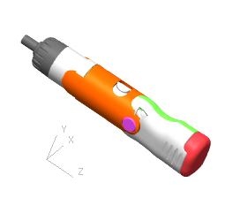
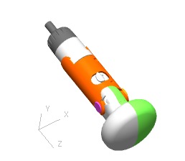
The Distributed Collaborative Product Development (DCPD) was a resounding success. Two different configurations of the screwdriver product were successfully developed integrating components and assemblies created collaboratively by distributed teams (see Figures 6 and 7). Team members who never met face-to-face shared CAD files in real-time using ProjectLink. Using ProductView team members conducted virtual design reviews in collaborative sessions and formed a shared mental model of the project landscape. Assemblies were built and checked for tolerance and fit; parts were sectioned and measured for accurateness. Professors extended the reach of their influence and experience to students beyond the walls of their schools. We successfully spanned the distance barrier and overcame the two-week difference in our academic schedules. We developed new paradigms for fostering collaborative product development in an academic environment.
Figure 6. GT-UMD1 Assembly
Figure 7. GT-UMD2 Assembly
We successfully integrated PLM into a traditional engineering course (ME4041) to promote teamwork and collaborative design. Eight student project groups in were trained on cutting-edge design methodology putting them heads above the competition for industry positions. They learned to use CAD and CAE systems in an integrated team environment and collaborate with students in other courses most notable or ME4182 Capstone Design course. Many students linked their home machines to the laboratory equipment through ProjectLink and the student edition of ProE. Utilizing the server the students realized increased productivity from the ability to work anywhere, anytime sharing data and collaborating virtually.
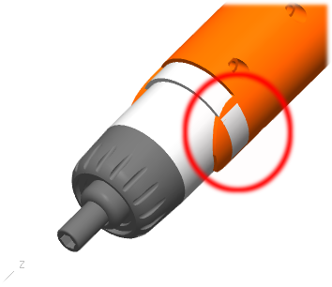
Despite our successes, the following issues were noted:
Figure 8. Interference
Due to a lack of technical resources, UMD1 was unable to successfully utilize ProductView to conduct design reviews during the weekly teleconference. Some of the issues were related to unsupported hardware and software; untested versions of Windows, and Java conflicts. As a result, a lot of time was spent verbally describing problem areas of the design.
Formal training to use core software is essential. ProductView does not share the same user interface with Pro/E and essentially is a very different software package. It can be seen in Figure 8 that despite both teams having access to the data and there were problems with part dimensions and fit. The functions of PLM are also not intuitive. Many people are uncomfortable with setting file access permissions and also tend to save multiple copies of files as backup in ProjectLink and locally.
True virtual presentations were not conducted with non-CAD files. Aside from the ProductView collaboration, PowerPoint and Word documents were downloaded from ProjectLink by each team and references were made to “look at page X” with each team locally manipulating a copy.
The true functionally of PLM was not exercised: no milestones were used, no workflows were used, and no progressions of object states were made. This was mostly due to us being untrained with using those functions in ProjectLink and they were viewed as being overkill for the size and scope of this project.
No engineering change orders (ECO) were used partly because design reviews were done virtually with all parties present and participants were uncomfortable using the redlining features of ProductView.
A mechanism for recording and storing audio and video of meetings is needed.

Conclusion
The GT-UMD DCE project was a resounding success. We demonstrated that a Distributed Collaborative Engineering project could be conducted with virtual teams sharing CAD information in real time as part of a traditional semester engineering course. Design reviews were conducted virtually utilizing a variety of software and hardware tools. The server was successfully battle-tested under a mixed full load and it was demonstrated that commercial PLM tools could be successfully implemented to enhance the academic environment. We will spend the next semester reviewing the problems encountered and developing preventative measures for future endeavors. Procedures and methodologies for conducting distributed collaborative engineering projects will be developed and transferred to other universities through “the Grand Experiment” and conferences. This is just the beginning of an exciting chapter of discovery that will enable us enrich the student experience and shape the engineer of the future.

Acknowledgements
The authors would like to acknowledge the contribution to this paper of the many faculty and students at Georgia Tech in the Engineering Information Systems (EIS) Laboratory and the Engineering Computing Services Department (ECS) Department. Their on going work provides the basis for the thoughts included herein. Thanks also go to the faculty and students at UMD for their hard work in making this project possible, and to our associates at PTC for their guidance and support.

References
PTC - http://www.ptc.com/
DCPD homepage at Georgia Tech - http://ptc.cad.gatech.edu/
ME4041 homepage at Georgia Tech - http://www.cad.gatech.edu/courses/me4041.html

Tord W. Dennis
Tord W. Dennis is working towards a Ph.D. in the School of Industrial and Systems Engineering and works as a Research Engineer with the College of Engineering at the Georgia Institute of Technology. Mr. Dennis earned a B.S. degree in Mechanical Engineering from West Virginia University and an M.S. degree in Mechanical Engineering from the Georgia Institute of Technology. His current research interests are in Computed Aided Engineering Design and Product Lifecycle Management. He has professional experience as an Applications Development Engineer with GE Plastics and professional affiliations with the American Society for Engineering Education, the American Society of Mechanical Engineers, and the Society of Automotive Engineers.

Robert E. Fulton
Dr. Robert E. Fulton is Professor of Mechanical Engineering and Co-Director of the CAE/CAD Laboratory at the Georgia Institute of Technology. Dr. Fulton received a B.S. degree in Civil Engineering from Auburn University in 1953, and M.S. and Ph.D. degrees in Civil Engineering from the University of Illinois in 1958 and 1960, respectively. He joined the NASA Langley Research Center in 1962, where, until 1984, he conducted or directed research in a broad range of engineering analysis design and manufacturing. He is the author of over 200 technical publications on the use of computers for technical and business needs. He has also served on the faculties of the George Washington Univ., Old Dominion, North Carolina State University, University of Illinois and VPI&SU. His professional society affiliations include membership and active leadership roles in the National Computer Graphics Association, the American Society of Civil Engineers, the American Society of Mechanical Engineers (Fellow), the American Society for Engineering Education, the American Academy of Mechanics, and the American Institute of Aeronautics and Astronautics (Associate Fellow).

The Georgia Institute of Technology, Atlanta, GA.

