Using LEGO® Group Projects to Increase Student Understanding of Constraint-Based Solid Modeling and Other Engineering Graphics Concepts
Theodore J. Branoff

Abstract
One of the most challenging tasks for engineering graphics educators teaching introductory courses with constraint-based solid modeling tools is trying to develop a student’s understanding of the software over the course of a semester. Students not only have to learn basic solid modeling construction techniques such as selecting appropriate construction planes, sketching profiles, extruding, and revolving, but they also must learn how individual models can be revised and how those revisions influence part functionality in an assembly. In addition, educators continually look for ways to integrate other engineering graphics topics into the course. This paper outlines a small group project conducted at North Carolina State University during the summer of 2003 which was created to develop students’ group communication skills while increasing their understanding of constraint-based solid modeling and engineering graphics concepts. Students were given LEGO® kits consisting of 16-30 pieces and asked to distribute the parts equally among the group members (3-4 students), sketch multiviews and pictorials of all pieces, reverse engineer and dimension each piece in the project, model each piece, design several new pieces, construct an assembly of the parts, create technical drawings of the new pieces, and give a short presentation describing the group’s project. Examples of student projects as well as student feedback will be presented.

Introduction
Engineering graphics educators have used a variety of very creative activities in the classroom to make learning more meaningful and fun for students. Recent activities include project-centered education¹, interactive 3D animation², dynamic modeling assignments³, and reverse engineering activities⁴. Activities not only should be fun, but they must address the objectives of the curriculum and prepare students for the future. Modeling assignments that are problem-solving oriented and demand dynamic manipulation of models allow students and instructors to experience model behaviors in real-time⁵. Since industry is looking for students who are proficient with assembly modeling and constraint-based modeling, students who are familiar with different modeling strategies and who have had experience preparing multiview drawings will be more marketable. Industry is looking for well-prepared students who can collaborate with others (especially online), identify and fix problems with 3D geometry, and be flexible enough to do design and development work⁶. The focus of this project is more on design than on documentation. It is important for students to realize that the 3D database is critical when using constraint-based modeling tools and that documentation is a byproduct of the 3D modeling processes⁷.
During the summer of 2003, a small group project was implemented in selected sections of the introductory engineering graphics course at North Carolina State University in order to give students an enjoyable experience learning engineering graphics concepts. Since students come into the classroom with varying levels of academic, haptic, and visualization abilities, Study recommends using physical objects in the classroom to supplement instruction⁸. Using the sense of touch to interact with the environment is a principal contributor to high level, integrated perceptual functions. For this project, students were given LEGO® kits to reverse engineer, model, revise, and document. This not only gave them the opportunity to work with real objects, but objects with which they were familiar.
A small group project was selected for several reasons. Small group projects allow for the synthesis of content since students have to discuss things together, share ideas, and solve problems together. This type of environment helps students develop listening and oral expression skills. It gives more able learners the chance to develop their learning by explaining things to other learners. Instructors can evaluate the effectiveness of the project by carefully listening in on a group’s discussions and progress. In general, the activity promotes active learning and helps to develop social skills. Instructors must carefully plan and manage the composition of the groups to ensure that all students participate. Instructors have to be careful when using small group instruction since students are typically not trained as instructors and may not know how to function effectively in this type of environment. It is also recommended that the group work not replace other forms of instruction to ensure that course content is covered⁹. Software demonstrations, discussions, and lecture were used to supplement the small group work for this project.

Project Description
Students were given the following instructions at the beginning of the semester:
You are new members of a design team responsible for coming up with new and exciting LEGO® designs. Your first responsibility is to become familiar with standard LEGO® pieces by putting together an existing model, creating technical sketches of several pieces (including dimensions), discussing standards for dimensions with your group, and modeling several pieces in SolidWorks. As a group you will assemble the pieces in SolidWorks per the existing design. The final step of the project is to come up with at least 4 modifications of the existing design. Each modification must include at least one new piece designed by the group. The group will then create four new assemblies incorporating the new pieces.
The purpose of this project is to develop team communication skills, develop multiview and pictorial sketching skills, reinforce the concepts of 2D & 3D geometry, dimensioning, and working drawings, develop a further understanding of SolidWorks, and practice presentation skills.
After completing the project, each person should be able to:
1. Demonstrate team communication skills by effectively working with three classmates on the project.
2. Correctly sketch multiviews and pictorials of several LEGO® pieces.
3. Recognize elements of 2D & 3D geometry in LEGO pieces.
4. Correctly reverse engineer and dimension each piece in the project.
5. Demonstrate good modeling techniques in SolidWorks.
6. Demonstrate correct techniques for creating technical drawings in SolidWorks.
7. Put together a professional document describing the new designs.
8. Give a short presentation describing the group’s project.
Step 1 – Become Familiar with the LEGO® Design. Divide into groups. Select a LEGO® assembly. Put the model together per the instructions provided. Take the model apart. Examine each piece. Categorize the pieces by level of difficulty for sketching and modeling. Divide the pieces equitably among the group members. Select a spokesperson for the group (the instructor will be communicating with this person regarding the progress of the group).
Step 2 – Sketching. Create multiview sketches of each part. Determine which views of the pieces are necessary to describe the shape. Also, think about the dimensions necessary to describe the size and location of features on each piece. As you do this, think about what dimensions are critical.
Step 3 – Reverse Engineering. Use your calipers to determine the correct dimensions for each piece. Demonstrate correct dimensioning technique when adding the dimensions to the sketches. Revise your sketches as needed. Compare your dimensions with others in the group (or with other groups).
Step 4 – Solid Modeling. Model each piece in the design. Begin by planning your modeling procedure. Think about where your origin should be on each piece. Think about the orientation of each piece relative to the other pieces. Discuss this with your group members. Can you take advantage of the piece’s symmetry by mirroring or patterning features? Take advantage of color or materials to make the pieces as close to the original color as possible.
Step 5 – Assembly. As a group, create an assembly in SolidWorks by putting together the individual pieces of the LEGO® design.
Step 6 – Design New Pieces. As a group, brainstorm new designs. Create design sketches describing the modifications to the assembly. Create technical sketches of the new pieces. Model the new pieces. Divide the work equitably among group members.
Step 7 – New Assemblies. Create 4 new assemblies in SolidWorks.
Step 8 – Detail Drawings of the New Designs. Create detail drawings in SolidWorks of only the new pieces. Select an appropriate drawing scale for each piece. Demonstrate correct ANSI practices for dimensioning the pieces. Print each drawing out at 100%.
Step 9 – Document the New Designs. Put together a professional document that describes the work your group did on the project. Divide the work equitably. The document should include the following:
• Title page with a rendered image of the original design.
• Table of Contents.
• Page with a short biography of each group member.
• Technical sketches of all the original pieces in the design.
• A rendered assembly of the original design.
• Technical sketches of the new pieces.
• Written descriptions of the new designs. Be creative. How are the new pieces different from the existing pieces? How are they similar? Look at existing LEGO® documentation to get ideas. This could take on the look of an advertisement or more of a press release. Talk about the age appropriateness of the new designs and how they fit into the existing product line.
• Rendered assemblies of the new designs.
Step 10 – Presentation. Prepare a PowerPoint presentation to introduce the class to your new designs. Describe the new features and how they fit into the existing product line. Give examples of story lines kids might come up with as they play with the new designs.
Students were given instructions and a rubric for how the projects steps would be evaluated. The rubric included due dates for each step of the project.

Sketching and Reverse Engineering
During the class period when the projects were introduced, students were asked to form groups of 3-4 people. The groups then proceeded to the front of the classroom to select a LEGO® kit. Each kit was labeled by the name of the product and the number of pieces included (see Figure 1). Most kits included just the pieces and assembly instructions. Some kits included story booklets. After selecting a kit, each group put the parts together, took them apart, and then divided the parts equitably among the members (see Figure 2). Each person was allowed to take their parts with them to begin the process of reverse engineering.
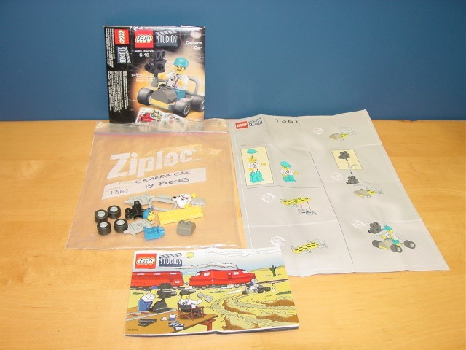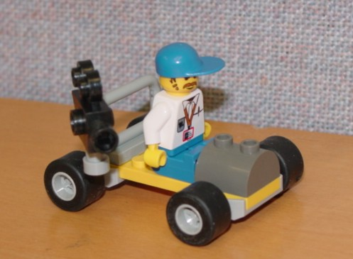
Figure 1. LEGO® Kit. Figure 2. Assembled LEGO® Kit.
Students were asked to make multiview sketches of each LEGO® piece and then use calipers to determine the correct sizes for each piece. Students were encouraged to compare their dimensions with other students in their group as well as with other students in class and discuss the issue of standards for products. Since the projects were assigned at the beginning of the semester, most students had little experience with sketching or dimensioning. The quality of their sketches was generally acceptable, but their lack of knowledge related to standard practices for dimensioning was evident. Flexibility was granted with initial sketches as students reverse engineered their pieces. All students were asked to submit new sketches at the end of the semester after content related to multiviews, sectional views, and dimensioning was covered. Figure 3 is an example of a sketch completed at the beginning of the semester.
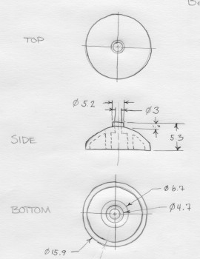
Figure 3. Student’s Sketch of a LEGO® Part.

Modeling the LEGO® Pieces
By far the most challenging part of the project, for both the instructor and the students, was modeling the individual LEGO® pieces. Some of the pieces were fairly easy to model and required little help from the instructor. Most students were able to complete pieces similar to the one in Figure 4 after a few sessions with SolidWorks. Early in the semester students were introduced to basic boss-extrudes and cut-extrudes, linear and circular patterning, and the best location for the origin to take advantage of the software’s ability to incorporate design intent into each model. It was made clear to the students that all models had to be fully constrained in order to receive full credit for the project.
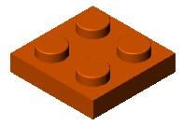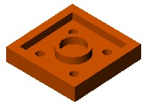
Figure 4. Simple LEGO® Piece.
It was evident early in the project that modeling some of the pieces was going to require advanced techniques. Some pieces like the one in Figure 5 required lofting. Modeling other pieces required sweeping along nonlinear paths, advanced shell commands, or advanced filleting. Since no prerequisite knowledge or experience in solid modeling was required for the course, the instructor had to take time to give advice on modeling strategies when students could not figure out how to model a particular piece. This help came in the form of one-on-one conversations with students or quick demonstrations of advanced concepts for the entire class.
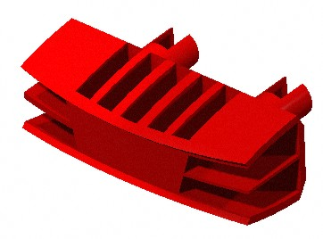
Figure 5. Complex LEGO® Piece Requiring a Loft.

Assemblies
One of the most rewarding parts of the project for students was putting the individual pieces together to make assemblies. An advantage of having students model entire assemblies of parts was that they experienced how the parts functioned together. Dimensioning errors in parts were evident when students took their pieces and began mating them within the assembly. They discovered the importance of building design intent into their models when dimensions had to be modified to correct errors. When good modeling technique was used initially, features moved in a predictable fashion. When poor technique was used, students had to spend quite a bit more time revising SolidWorks’ sketches and features.
In addition to putting the pieces together, students were required to make their projects look as close as possible to the finished product by rendering the assemblies using PhotoWorks. Students were given some basic instruction on applying materials, setting up an initial scene, modifying the lighting, and orienting bases and sides to their assembly. Figure 6 illustrates a rendered assembly of one group’s project.
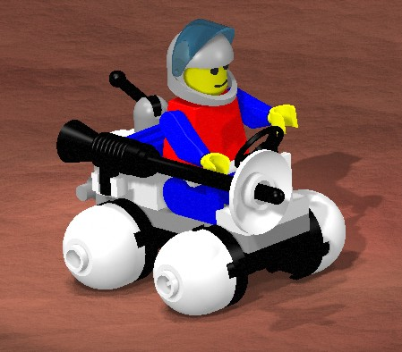
Figure 6. Rendering of the Original Mars Rover.

Designing and Documenting New Pieces
To integrate creativity into the project, students were required to design several new LEGO® pieces that fit into the theme of their kit. After modeling these new pieces, students were required to document their parts by creating standard engineering drawings. At this point in the semester most of the engineering graphics concepts related to drawings had been covered. Students were familiar with multiview drawings, sectional views, dimensioning, and basic manufacturing processes. A typical drawing is shown in Figure 7.
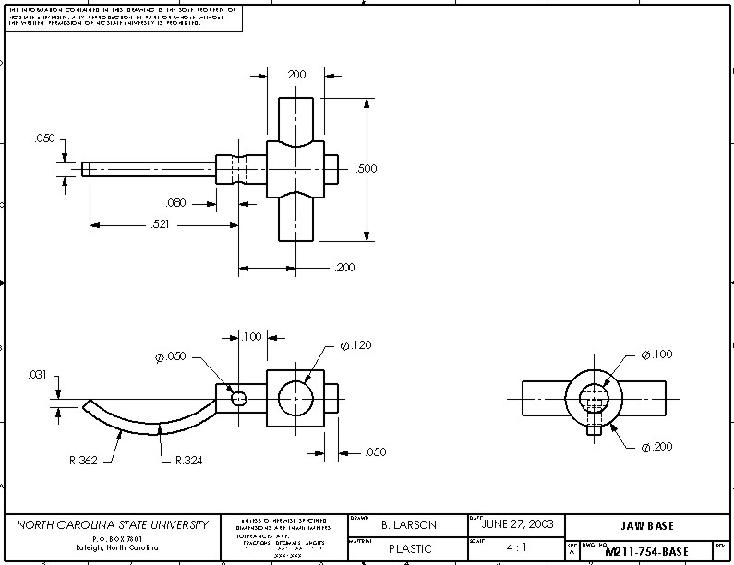
Figure 7. Drawing of a New LEGO® Piece.

Presentations
The presentations gave students an opportunity to be creative in addition to practicing their writing skills. Each group was asked to present their new designs in the form of a new product release and to give examples of story lines or scenarios in which children might play with the toys. For example, the Mars Rover group had the following description of their new design shown in Figure 8:
This model requires quite a few duplicates of existing pieces that were included in the Mars Rover model. These pieces include another chassis, a small antennae assembly, a bumper, many black wheel pieces, and one bumper piece. When assembled this model has a stunning appearance. It was originally designed to transport oxygen tanks or water tanks.

Another group took a more commercial approach in their product description (Figure 9):
The camera man, aboard his newly upgraded Camera Car, is now better equipped to catch every moment of action than ever before. The new 2003 model Camera Car has three new features which include a megaphone, an umbrella, and a spotlight. Never again will the camera man be left to weather the elements or yell until it hurts. He can stay comfortable and dry under his big umbrella, which will also protect him from the damaging rays of the sun on those bright summer days. Communicating with those stubborn actors at a distance will no longer be a hassle with his new and powerful megaphone. Need some extra lighting for those outdoor night scenes? Well, the camera man’s got that too! With his new spotlight, he won’t have to worry about being left in the dark ever again. This LEGO® model is best suited for children ages 6-16.
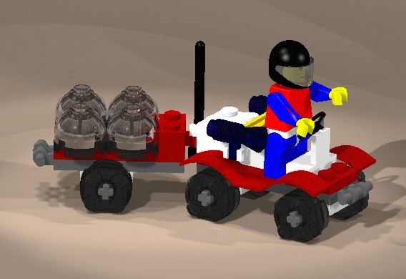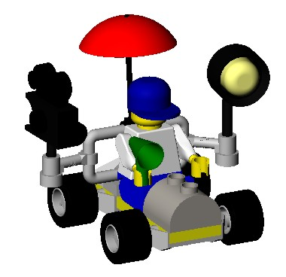
Figure 8. Modification of the Mars Rover. Figure 9. The New Camera Car.

Student Evaluations
At the end of the semester, students were asked to anonymously respond to a 10-item Likert scale questionnaire. They were asked if they strongly agreed, agreed, were neutral, disagreed, or strongly disagreed with the following statements:
- My project group functioned well together
2. The group members generally did their fair share of the group project.
3. I enjoyed the group project.
4. The group project was a valuable component of the course.
5. Designing a new component was a useful part of the project.
6. The presentation was a valuable part of the project.
7. I enjoyed using SolidWorks this semester.
8. I was surprised at the types of things SolidWorks could do.
9. I will use SolidWorks again after this semester.
10. I am satisfied with what I have accomplished this semester.
Table 1 presents the data for the 33 students in the summer semester who responded to each question. Overall, students agreed that their group members functioned well together, members did their fair share of work, they enjoyed the project, the project was an important part of the course, designing the new components was a useful part of the project, they enjoyed using SolidWorks, they were surprised by what could be done in SolidWorks, and they were satisfied with what they personally accomplished during the semester. In general, students were not sure that the project presentation was a valuable component of the project or whether they would use SolidWorks in the future.
Table 1. Student Questionnaire Results (N=33).
Question | MEAN | Std Dev | Min | Max
1 | 4.182 | 0.917 | 1 | 5
2 | 4.152 | 0.838 | 2 | 5
3 | 4.091 | 0.879 | 1 | 5
4 | 4.364 | 0.783 | 2 | 5
5 | 4.182 | 0.769 | 2 | 5
6 | 3.606 | 0.864 | 1 | 5
7 | 4.545 | 0.666 | 3 | 5
8 | 4.333 | 0.924 | 2 | 5
9 | 3.697 | 0.984 | 1 | 5
10 | 4.303 | 0.585 | 3 | 5

Discussion and Conclusions
The evaluations revealed that students thought the project was a valuable and meaningful experience with the possible exception of the presentation. The instructor noted that their lack of satisfaction with the project presentation generally had to do with not knowing how to present their projects. This problem could have been alleviated by showing students examples of past presentations or giving them more detailed instructions on what was expected.
Several other observations were made during the semester. Since students were asked to make technical sketches of pieces before they knew much about engineering graphics concepts, most of the initial sketches were poor. Providing students with examples of technical sketches at the beginning of the semester might have eliminated some of the errors on their sketches.
Another observation was that this type of project requires a great deal of instructor support when students begin modeling pieces. Instructors must be patient with students and comfortable enough with the software to help novice users move from modeling simple widgets to building design intent into complex parts.
As with any type of group project, there is a chance that one person may not complete their fair share of the project work. At the beginning of the project instructors must be clear about how groups and individuals will be evaluated and be flexible enough during the project to put a group at ease if one of their fellow students elects not to participate.
The LEGO® kits used for this project were purchased through a university grant, so the instructor did not have to worry about students buying the appropriate kits. Since students were allowed to keep the pieces for the duration of the project, some problems did occur. Some pieces and instruction sets were not returned or were lost. Students should be made aware of the consequences for losing items at the beginning of the semester so that the instructor is not left with the burden of finding replacement items for the next semester.
Overall, this project met the goals of the course while giving students a challenging and enjoyable project. Based on student feedback and instructor observations, making the project presentation expectations clearer and providing more examples of detail drawings at the beginning of the semester are changes that should be made to improve the project.

References
1. Barr, R. E., Krueger, T. J., Aanstoos, T. A., Horan, J, & Moore, J. (October, 2002). Industry-sponsored design projects for freshmen engineering graphics students. Proceedings of the 57th Midyear Meeting of the Engineering Design Graphics Division of the American Society for Engineering Education, Indianapolis, Indiana, October 27-30, 2002.
2. Kovac, K. (October, 2002). Leveraging product visualization with interactive 3D animation. Proceedings of the 57th Midyear Meeting of the Engineering Design Graphics Division of the American Society for Engineering Education, Indianapolis, Indiana, October 27-30, 2002.
3. Wiebe, E. N., Branoff, T. J., & Hartman, N. W. (2003). Teaching geometry through dynamic modeling in introductory engineering graphics. Engineering Design Graphics Journal, 67 (2), 12-20.
4. Branoff, T. J., Hartman, N. W. & Wiebe, E. N. (October, 2002a). Applications of dynamic modeling in introductory engineering graphics classes. Proceedings of the 57th Midyear Meeting of the Engineering Design Graphics Division of the American Society for Engineering Education, Indianapolis, Indiana, October 27-30, 2002.
5. See Ref. 3
6. Branoff, T. J., Hartman, N. W., & Wiebe, E. N. (2003). Constraint-based, solid modeling: What do employers want our students to know? The Engineering Design Graphics Journal, 67 (1), 6-11.
7. Branoff, T. J., Hartman, N. W., & Wiebe, E. N. (2002b). Constraint-based, three-dimensional solid modeling in an introductory engineering graphics course: Re-examining the curriculum. The Engineering Design Graphics Journal, 66 (1), 5-10.
8. Study, N. E. (October, 2002). The haptic visualization tendencies of freshman engineering students and their implication on testing and instruction. Proceedings of the 57th Midyear Meeting of the Engineering Design Graphics Division of the American Society for Engineering Education, Indianapolis, Indiana, October 27-30, 2002.
9. Morrison, G. R., Ross, S. M., & Kemp, J. E. (2004). Designing effective instruction. (4th ed.). Hoboken, NJ: Wiley.

Theodore J. Branoff
Ted is an assistant professor of Graphic Communications at North Carolina State University and has been an ASEE member since 1987. He has taught courses in introductory engineering graphics, computer-aided design, descriptive geometry, instructional design and course design. Ted has a bachelor of science in Technical Education, a master of science in Occupational Education, and a Ph.D. in Curriculum and Instruction. His current academic interests include spatial visualization ability, geometric dimensioning and tolerancing, constraint-based modeling, and online instruction for preparing community college educators.

North Carolina State University, Department of Mathematics, Science and Technology Education, Graphic Communications Program, Raleigh, North Carolina 27695-7801.

