Teaching Chemical Engineering Courses with Workbook Strategy

Yaşar Demirel*

Abstract

Often mismatches between the learning and teaching styles arise because students are in majority visual and sensing learners, and yet most instructors are intuitive learners. Besides that, textbooks have their own style too, and their contents, depth of coverage of materials, and organization may affect the teaching and learning styles. As the learning preferences are characteristics, and students in majority lack the skills of problem solving and transferring knowledge in higher order or across courses, instructors have to improve the effectiveness of their teaching. For this purpose, a new approach called the workbook strategy has been developed and implemented in teaching some of the engineering courses in the Department of Chemical Engineering at Virginia Polytechnic Institute and State University. The workbook strategy integrates the following four elements: (i) assessing students learning preferences, (ii) using workbook in lecturing, (iii) implementing group work, and (iv) using ‘blackboard’ as information technology aided tool for education and communication. The workbook combines the visual elements, such as figures, tables, charts, with the verbal elements, like definitions and analysis in an organized way to help the students to extract, learn and follow the course material easily, and relate the fundamentals to applications. An ideal workbook may reduce the mismatches between learning and teaching styles, and leads to active learning and effective teaching. Most of the students who have taken the courses taught with the new strategy have found it very effective learning tool.

Introduction

All institutions of higher education give high priority to developing learning and teaching strategies with focus on the promotion of students’ subject-specific skills, knowledge, understanding, and intellectual curiosity. Some of the strategies are active and cooperative learning [Bean, 3; Felder & Brent, 14,15,19; McGowan, 30], problem or case based learning [Kulonda, 29; Fogler & Leblanc, 21], teaching through inquiry [Buch & Wolf, 5], and the colloquial approach, in which students are at the center of the learning [Arce, 1,2]. Majority of faculty acknowledge the necessity for active and cooperative learning strategies, and use it in varying degrees [Felder & Brent, 15; Gokhale, 22; Haller, 24; Morell et al., 31]. Effective teaching incorporates forms of creativity to analyze, synthesize, and present knowledge in new and effective ways [Kennedy, 28], while students must participate in analysis, synthesis and problem solving in active learning [Bean, 3].

The following issues are widely acknowledged in engineering education. (i) There is often a mismatch between the learning styles of students and the teaching styles of instructors; most instructors are intuitive learners, and yet students are in majority visual and sensing learners [Felder & Silverman 13; Felder & Brent 15; Zwyno 39]; textbooks also have their own styles in providing the theory and applications, and their contents, depth of coverage of materials, and organization may affect the teaching and learning styles, (ii) Students usually learn problem solving using cook-book procedures instead of learning how to solve problems by understanding the concepts [Elger et al. 8; Zwyno 39,40], (iii) Students mainly lack the skill of transferring and synthesizing knowledge in higher order within a course or across courses [Ellis et al., 9; Schneck 33], and (iv) Student’s native ability, background, and the match between the learning and teaching styles determine the level of learning [Felder & Brent, 15; Felder et al., 17; Fitch & Kirby, 20]; as the learning styles are characteristics, instructors have to improve the effectiveness of their teaching [Felder & Brent, 14; Felder, 10,11,16].

* Department of Chemical Engineering, Virginia Polytechnic Institute and State University, Blacksburg, VA 24060.

ASEE Southeast Section Conference 2004
With these issues in mind, two workbooks were prepared and used previously in teaching two chemical engineering courses on thermodynamics and simulation at Virginia Polytechnic Institute and State University [Demirel, 6]. After the positive feed back from the students and faculty, the workbook strategy is improved further, and integrated with the following four elements: (i) assessing students learning preferences, (ii) using workbook in lecturing, (iii) implementing group work with in-class and out-class parts, and (iv) using ‘blackboard’ as information aided tool for learning/teaching and communication. This study presents the workbook strategy implemented in the separation course, and aims to share the preliminary assessment of its effectiveness in effective teaching and active learning with other engineering departments across the Nation.

Learning and Teaching Styles

Learning styles involve verbal or visual input modality, sensing or intuitive perception, active or reflective processing, and sequential or global understanding of a course material, while teaching styles involve instructor’s emphasis on factual or theoretical information, visual or verbal presentation mode, active or reflective student participation, and sequential or global perspective [Felder, 12; Felder & Silverman, 13; Felder & Brent, 15]. The learning and teaching styles are summarized in Table 1. However, as Felder and Silverman [13] emphasize, the dimensions of learning and teaching styles are neither unique nor comprehensive. Learning styles may vary among students and depend on the field of study and background. For example, a student may be both sensing and intuitive learner with a certain degree, or one of these may be dominant. Obviously, students will learn more when instructional approach targets their preferred styles [Fitch & Kirby, 20; Felder et al., 17; Gosser & Roth, 23].

Table 1. Learning and teaching styles [Felder, 12; Felder & Silverman, 13; Felder & Brent, 15].

Learning Styles |  | Teaching Styles
Input  Modality | Visual: Prefer to see graphs, diagrams, flow charts, plots, and schematics. | Presentation | Visual: Figures, charts,  Diagrams, flowsheet.
Input  Modality | Verbal: Prefer written or oral explanations, discussions. | Presentation | Verbal: Definitions, analysis, discussion.
Perception | Sensing: Focus on sensory input, detail work, facts and data methodical, observant. | Contents | Concrete: Factual, experiments, data..
Perception | Intuitive: Focus on imaginative and conceptual work, theory and models. | Contents | Abstract: Conceptual, theoretical.
Processing | Active: Process actively, think out loudly, and like working in groups. | Student  Participation | Active: Students talk and discuss.
Processing | Reflective: Process introspectively, like thinking and working solo or in pairs. | Student  Participation | Passive: Students watch and listen.
Understanding | Sequential: Function in continual steps and steady progress, like analysis. | Perspective | Sequential: Step-by-step progression.
Understanding | Global: Need whole picture to function, initially slow, then major steps, like synthesis. | Perspective | Global: Context and relevance.

Active Learning and Effective Teaching

Engineering students are encouraged to work with clear course material, real-world applications, pictures, diagrams, demonstrations, and experiments beside theory and analysis [Arce 1,2; Bell & Fogler, 4; Hesketh 25; Felder 16]. An effective teaching strategy should engage students fully, stimulate a sense of enquiry, and facilitate active and collaborative learning [Felder & Brent, 14,15; Gokhale, 22; Buch & Wolf, 5; Haller et al., 24; Felder, 11]. Consequently, students should be able to transfer knowledge from lower to higher levels within a course and across courses [Ellis et al., 9; Schneck 33;]. For that, students need time to follow the lecture and exercise critical thinking besides taking notes. Therefore, institutions should promote educational innovations for effective teaching by developing classroom strategies and hands-on practices [Felder, 10,11; Gokhale, 22; Raju & Cooney, 32; Kaufman et al., 27; Streveler, 35; Stice et al., 36; NRC, 37]. In-class group work, which is widely recommended [Arce 1,2; Bean, 3; Felder, 10-12], promotes problem-based learning and active learning. Edgar [7] reported that students retain up to 90 % of what they learn through active participation.

ASEE Southeast Section Conference 2004
Preparing and Implementing the Workbook Strategy

The workbook strategy integrates the following four basic elements: (1) assessing students learning preferences, (2) preparing and using workbook in lecturing, (3) implementing in-class and out-class group work, and (4) using ‘blackboard’ as information technology aided tool. These elements are described briefly as follows.

(1) Learning preferences: The index of learning styles (ILS) can be used to assess the learning preferences of students [Felder & Soloman, 18; Zwyno, 39,40; Zwanenberg et al., 41]. The ILS consists of eleven questions in each learning style dimension, and student answers (a) or (b) category. A score is obtained by subtracting the smaller from the larger category. A score on a scale of 1-3 shows that student is well balanced; a ‘3a’ in the sensing(a)/intuitive(b) category indicates a mild preference for sensing learning. A score on a scale of 5-7 shows a moderate preference, while 9-11 shows that student has strong preference for one of the categories. Table 2 shows the learning preferences for the students taking the separation course; the learning styles are somewhat distributed except for the visual/verbal, for which 85 % of the students scored on a scale of 3-11 corresponding to mild to strong preferences; about half of them appeared as active learners by scoring on a scale of 3-11.

Table 2. Student learning preferences obtained from the (ILS) [Felder & Soloman, 18].

Learning Style Dimensions
 | Active(a)/Reflective(b)  /Preference | Sensing(a)/Intuitive(b)  /Preference | Visual(a)/Verbal(b)  /Preference | Sequential(a)/Global(b)  /Preference
1 | 7b - 4a = 3b | 7a - 4b = 3a | 7a – 4b = 3a | 6a – 5b = 1a
2 | 7b - 4a = 3b | 7b – 4a = 3b | 9a – 2b = 7a | 6a – 5b = 1a
3 | 7b - 4a = 3b | 6a - 5b = 1a | 8a – 3b = 5a | 6b – 5a = 1b
4 | 10a – 1b = 9a | 9a - 2b = 7a | 7a – 4b = 3a | 10a – 1b = 9a
5 | 8b - 3a = 5b | 8a - 3b = 5a | 9a – 2b = 7a | 8b – 3a = 5b
6 | 10a – 1b = 9a | 7a - 4b = 3a | 10a – 1b = 9a | 7a – 4b = 3a
7 | 9a – 2b = 7a | 6b – 5a = 1b | 9a – 2b = 7a | 7a – 4b = 3a
8 | 8a – 3b = 5a | 8a - 3b = 5a | 9a – 2b = 7a | 9a – 2b = 7a
9 | 8b - 3a = 5b | 7b – 4a = 3b | 7a – 4b = 3a | 6b – 5a = 1b
10 | 6a – 5b = 1a | 7a - 4b = 3a | 8a – 3b = 5a | 9a – 2b = 7a
11 | 6a – 5b = 1a | 6a - 5b = 1a | 8a – 3b = 5a | 7b – 4a = 3b
12 | 10a – 1b = 9a | 9a - 2b = 7a | 9a – 2b = 7a | 8a – 3b = 5a
13 | 7b - 4a = 3b | 10a - 1b = 9a | 11a – 0b = 11a | 11a – 0b = 11a
14 | 8a – 3b = 5a | 6b – 5a = 1b | 7a – 4b = 3a | 7b - 4a = 3b
15 | 6a – 5b = 1a | 8a - 3b = 5a | 7a – 4b = 3a | 7b – 4a = 3b
16 | 8b - 3a = 5b | 8a - 3b = 5a | 9a – 2b = 7a | 7a – 4b = 3a
17 | 6a – 5b = 1a | 10a - 1b = 9a | 6b – 5a = 1b | 6b – 5a = 1b
18 | 7a – 4b = 3a | 10a - 1b = 9a | 7a – 4b = 3a | 9a – 2b = 7a
19 | 8b - 3a = 5b | 6b – 5a = 1b | 10a – 1b = 9a | 6b – 5a = 1b
20 | 11a – 0b = 11a | 11a - 0b = 11a | 6a – 5b = 1a | 9a – 2b = 7a
21 | 7b - 4a = 3b | 8a - 3b = 5a | 8a – 3b = 5a | 5a – 6b = 1b
22 | 9a – 2b = 7a | 9a - 2b = 7a | 8a – 3b = 5a | 7a – 4b = 3a
23 | 7a – 4b = 3a | 7a - 4b = 3a | 10a – 1b = 9a | 5a – 6b = 1b
24 | 8a – 3b = 5a | 4a - 7b = 3b | 8a – 3b = 5a | 7a – 4b = 3a
25 | 5a – 6b = 1b | 11a - 0 = 11a | 6a – 5b = 1a | 6a – 5b = 1a
26 | 10a - b = 9a | 8a - 3b = 5a | 7a – 4b = 3a | 6b – 5a = 1b
27 | 7b - 4a = 3b | 8a - 3b = 5a | 7a – 4b = 3a | 6b – 5a = 1b
28 | 6a – 5b = 1a | 8a - 3b = 5a | 9b – 2a = 7b | 6a – 5b = 1a
29 | 10b - 1a = 9b | 4a - 7b = 3b | 8a – 3b = 5a | 6a – 5b = 1a
30 | 7a – 4b = 3a | 10a - 1b = 9a | 11a – 0b = 11a | 7b – 4a = 3b
31 | 10a – 1b = 9a | 7a - 4b = 3a | 7a – 4b = 3a | 8a – 3b = 5a
32 | 6b - 5a = 1b | 11b – 0a = 11b | 11b – 0a = 11b | 11b – 0a = 11b
33 | 8a – 3b = 5a | 8b - 3a = 5b | 11a – 0b = 11a | 8b – 3a = 5b

ASEE Southeast Section Conference 2004

(2) Workbook: A properly prepared workbook presents the contents of a textbook more visible and extractable, and relates fundamentals to applications. Instructor prepares the workbook with a detailed course syllabus and all the essential verbal and visual learning elements mainly by using the designated textbook, reference books, and publisher’s Web sites, as well as feedbacks from other instructors within the department. The verbal elements include all the fundamentals, analysis, and synthesis. The visual elements consist of most of the related graphs, diagrams, schemes, configurations, process flow diagrams and streams, algorithms, flowcharts, tables, pictures, figures, schematics, plots, analogies, and data. All the related verbal and visual elements are presented to support each other, and hence to stimulate: (i) understanding and following the lectures effectively, (ii) relating the concepts to applications. One of the important features of workbook is that some of the visual and verbal elements are deliberately left incomplete or missing. All the predetermined example problems and homework assignments appear in the workbook. The best format and size of a workbook mainly depends on the experience of instructor, organization of textbook, level of course, and feedback from students.

Instructor delivers the lectures with an overhead projector using the transparencies of workbook, and completes the missing verbal and visual elements jointly with the students. Problems solving practices are performed on the blank spaces allocated within the workbook. Before assigning, homework questions are briefly discussed and related to the analysis after each chapter.

Previously two trial workbooks were prepared and used for the courses on thermodynamics and simulations mainly for the sophomore students [Demirel, 6]. The new 118-page workbook is for the textbook “Equilibrium Staged Separations by Wankat [38]. This course is offered for 39 mainly junior students. Figures 1 to 4 show some completed pages of the workbook. In Figure 1, an experimental isobaric vapor liquid equilibrium data in table form for the ethanol-water system is elaborated. Using the data, degrees of freedom are explained, and the azeotropic point was underlined. Underneath the data table, T-x-y and x-y equilibrium diagrams are supplied. To show the use of the T-x-y diagram, a feed located at point ‘a’ is heated, and the evolution of the system has been explored by obtaining the compositions of the system at various temperatures and regions. This information is spread out in the textbook; therefore the students may need more time and effort to understand fully. Following this, a group work is assigned to obtain the boiling and dew point temperatures of a mixture; all the groups worked on their group packages, which contain the T-x-y diagram for about 8 to 10 minutes.

Figure 2 introduces the iterative calculations of bubble-point and dew point temperatures using the flow diagram and step-by-step algorithms provided within the allocated boxes. After discussing the reference component, and a convergence criterion, the variables known and the ones to be found are clearly separated for each type of the calculations. This enables the students to compare the calculations while they are following and learning the material. After a short time (one-minute break) of group discussions, groups perform a short group work (about ten minutes) to calculate the bubble-and-dew-points of a ternary mixture with specified compositions by using the DePriester charts.

Figure 3 starts with some background information on multicomponent flash calculations by expressing equilibrium relations and mass balance equations, which are used to derive the liquid and vapor phase compositions x_{i} and y_{i}, respectively. After that, the objective function of Rachford-Rice equation is derived and used in the Newtonian method to obtain the root that is V/F by iterative calculations. The initial value of V/F, the steps, and the iterations are discussed. The example 3.2 from the textbook is used as an application of the multicomponent flash calculations, and is solved by the instructor and the students jointly on the next page.

Figure 4 shows incorporating an application for the topic introduced previously by solving the example problem 11.2 on the multistage batch distillation from the textbook. Since McCabe-Thiele diagram is provided, the procedure is explained step by step in order to construct the plot of $\left(1/(x_{D}−x_{W})\right)$ versus x_{W} by using the changing values of x_{D} on the y-x equilibrium diagram. The area underneath the curve is calculated using Simpson’s rule to find the final amount of liquid W_{F}, the total distillate D, and the average distillate composition x_{D,av}. Diagrams inside the box are useful to visualize the analysis to locate the function values in Simpson’s rule for numerical analysis or graphical integration. The solution is provided on the same page with all the related analysis, whereas the solution may be spread out in various pages in some textbooks.

ASEE Southeast Section Conference 2004

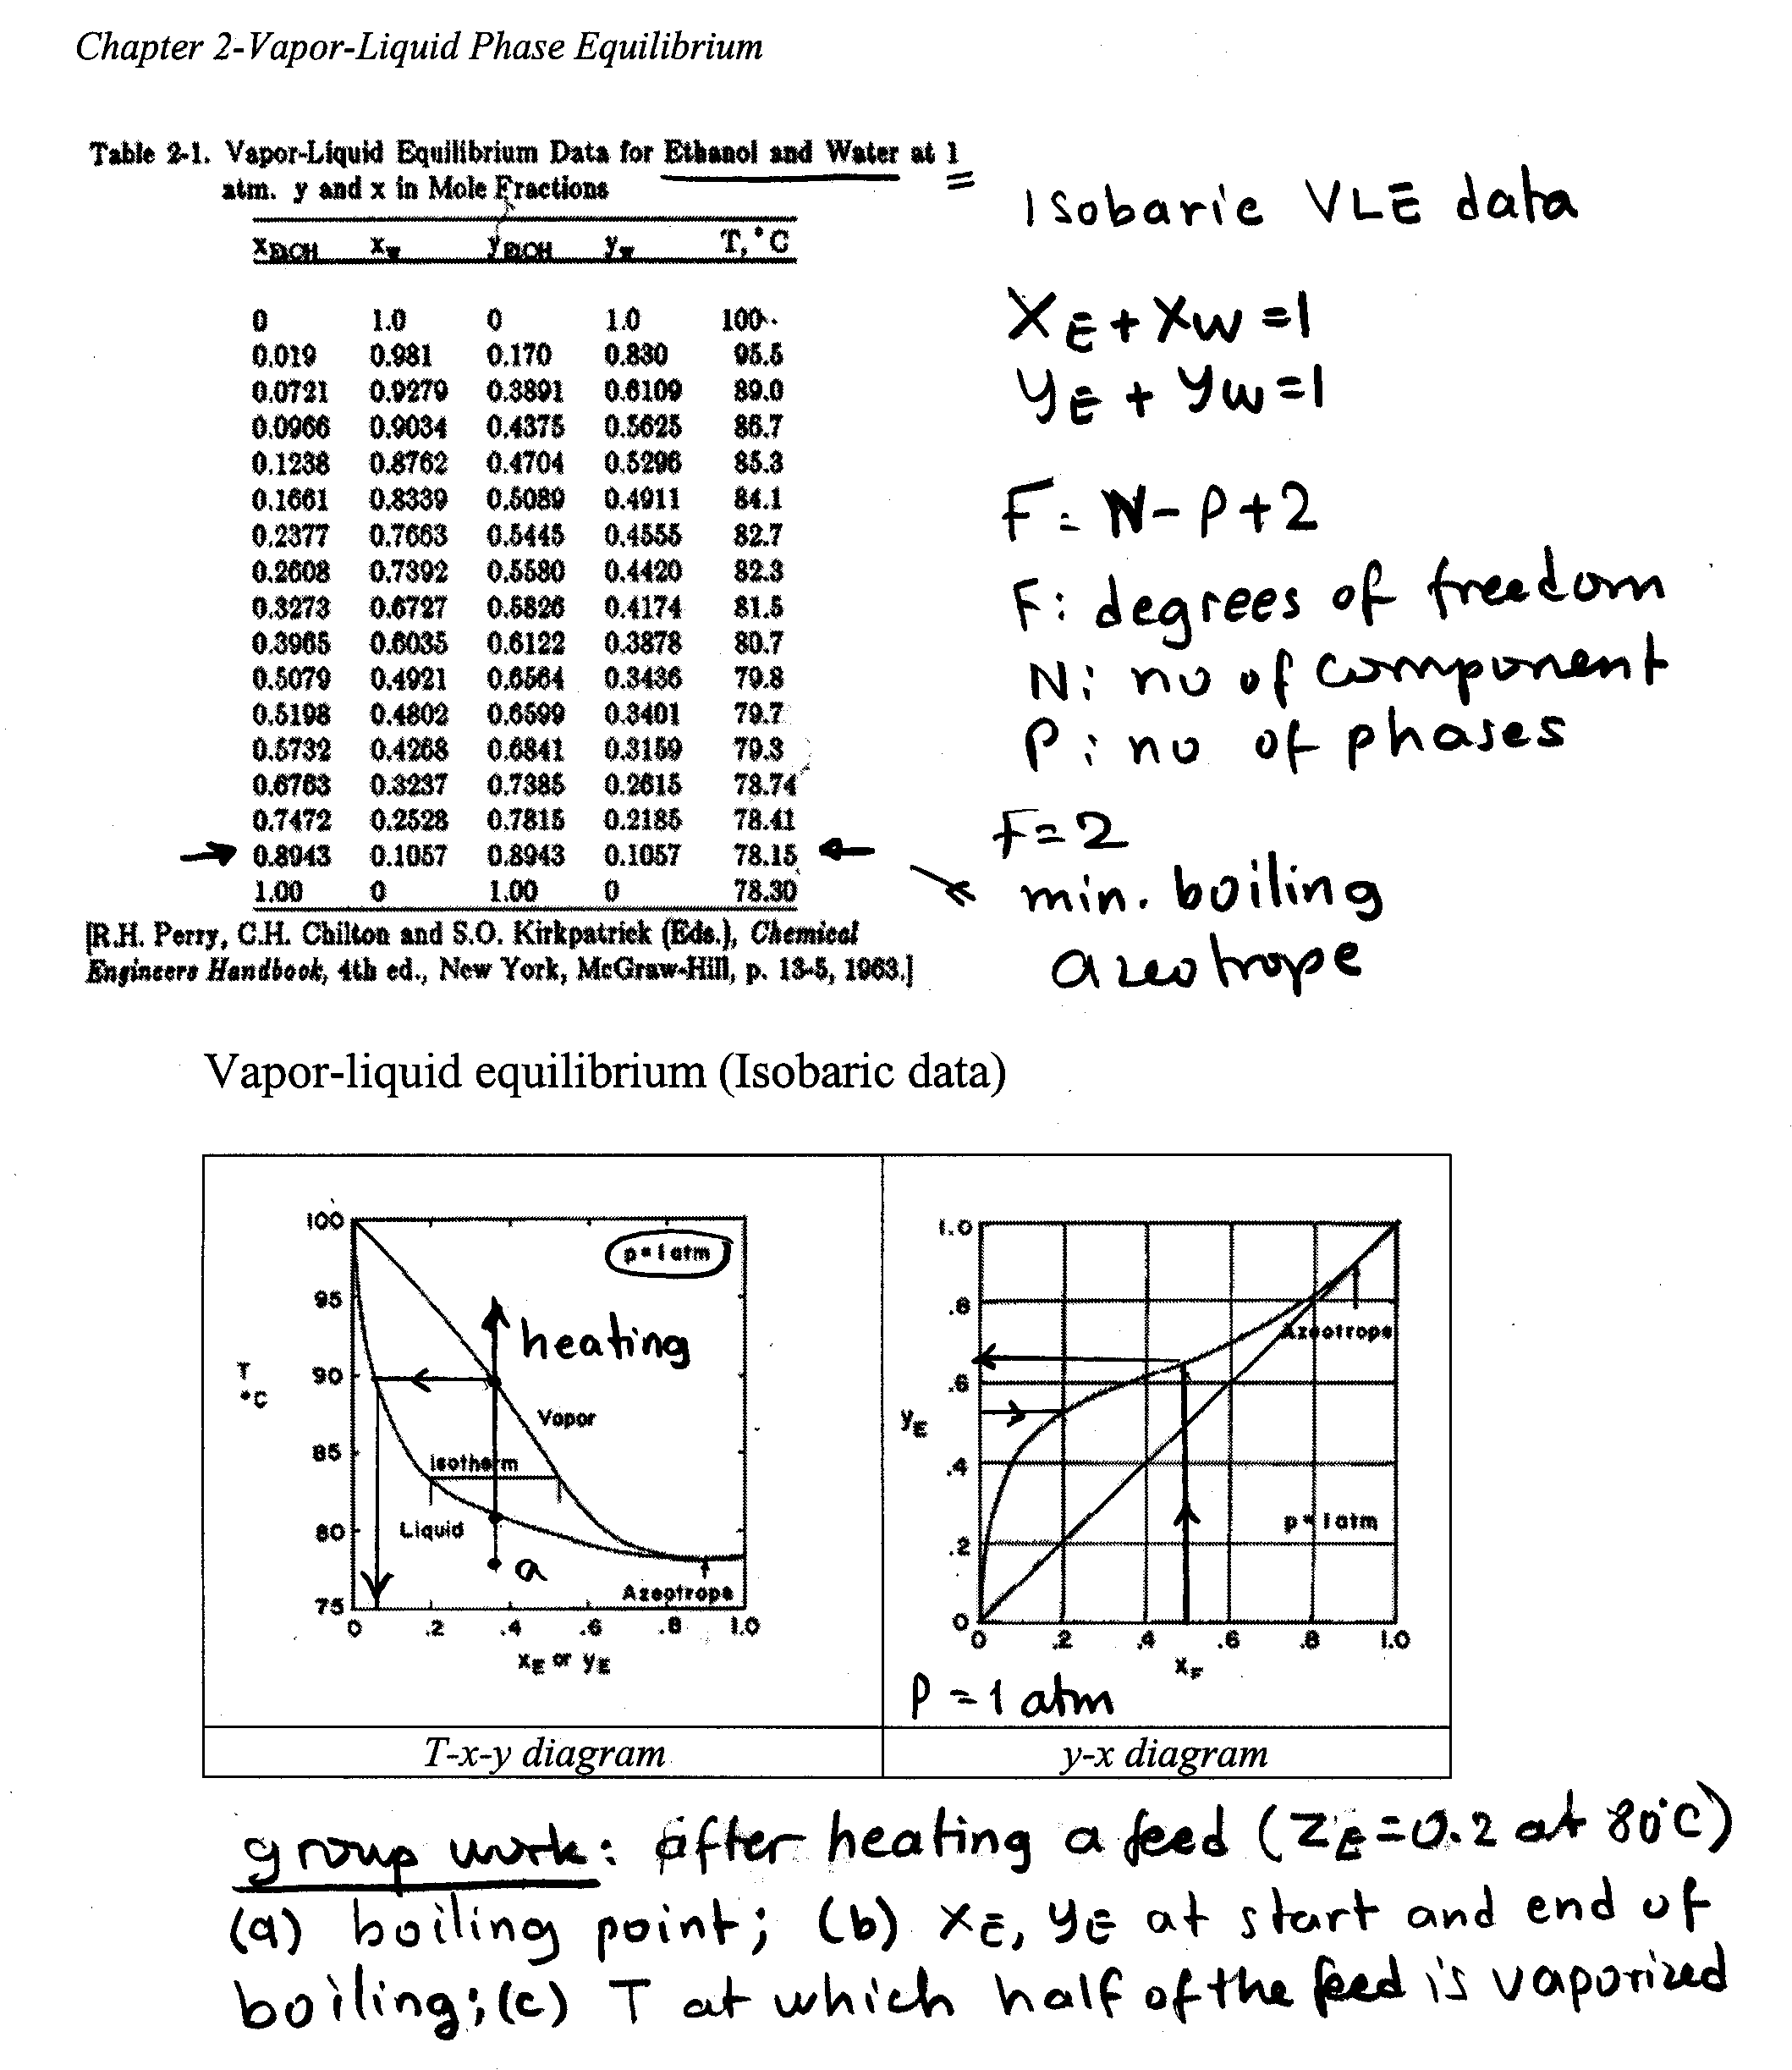 | . | 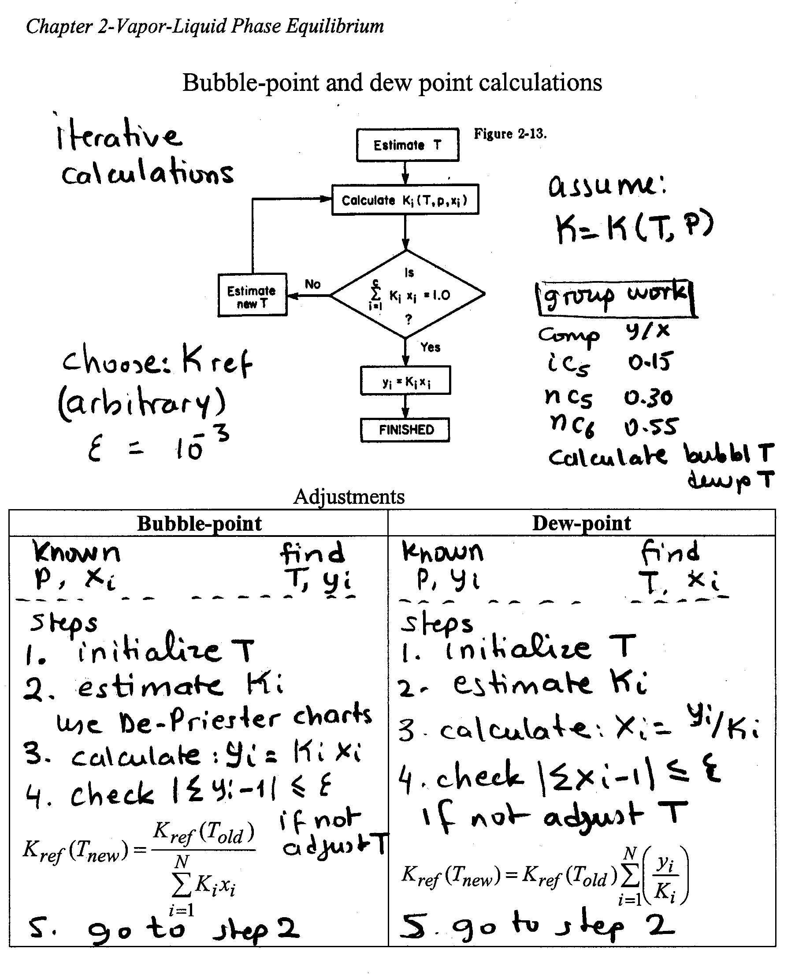
Figure 1. A typical, completed workbook page for the isobaric vapor-liquid equilibrium data in the form of table, T-x-y and y-x diagrams with group work |  | Figure 2. A typical, completed workbook page for the bubble and dew point iterative temperature calculations with group work for ternary mixture.

(3) Group work: The students are advised to establish groups with two students with different learning preferences, so that they may teach one another. After that, group packages containing some of the graphs, diagrams, and data that are to be used in their in-class group work are distributed. In-class group-work activity, two or three students can apply a newly learned concept in solving a short problem. Some time, the groups solve a homework problem. The group work is checked and returned with a feedback within the next class meeting. This follow up is crucial for the success of the group work. Also, the group members, in one-minute breaks, discuss the analysis with each other, and assess what they are doing and learning. Occasionally, they prepare short essays, or answer questions, such as “what are the three most important key words in the last chapter.” In out-class group work, students prepare two projects by exercising team effort and responsibility. These projects take about two to four weeks, and are mostly presented in the classroom. Group work stimulates active participation, teamwork, and cooperative learning [Johnson, 26].

(4) Blackboard: ‘Blackboard’ multi-user teaching/learning platform is incorporated with the workbook to provide students with the supplemental course material, assignments, useful sites, test objectives, test solutions, announcements, and communications by email.

Some of the anticipated and observed benefits of the workbook strategy are:

(i) The workbook provides the students with detailed syllabus, objective and vision statements, main definitions, graphs, diagrams, data, examples and problems in a more apparent and categorized way. It presents the course material as a package of fundamentals and related application, and helps to reach the students with various learning styles.

ASEE Southeast Section Conference 2004

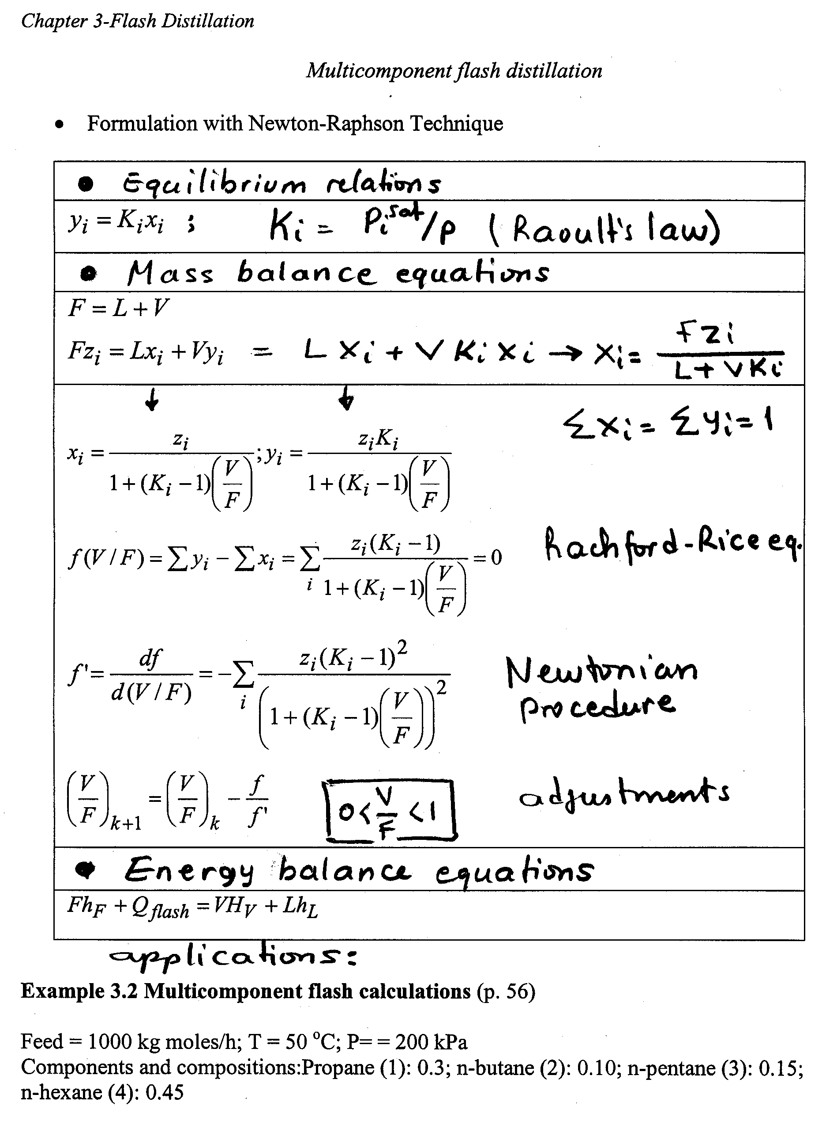 | . | 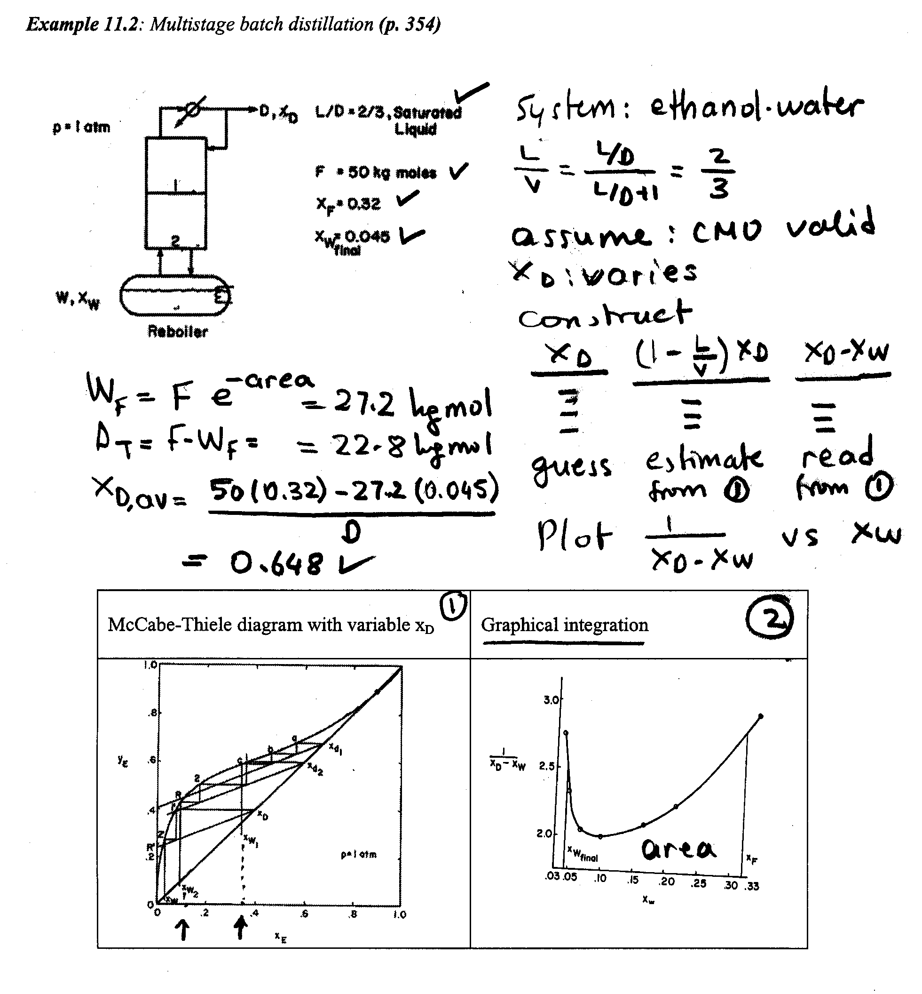
Figure 3. A typical workbook-page format for the multicomponent flash calculation using Newtonian method and the Rachford-Rice equation, and following the example problem as application, which is continued on the next page. |  | Figure 4. A typical workbook-page format for the example problem practice for the multistage batch distillation using the equilibrium graph and the curve for graphical integration or numerical integration by Simpson’s rule.

(ii) The workbook and group work reduce the mismatches among the styles of the instructor, textbook and students, and hence stimulates effective teaching and active learning.

(iii) As the instructor and students complete the missing elements in the workbook during the lecturing, students fully engage with the analysis and applications and have better interactions with the instructor. This leads to effective note taking, learning and reviewing the course material.

(iv) The workbook provides the homework assignments with brief descriptions to relate them to the fundaments.

(v) Group work promotes the problem based learning and collaborative learning.

(vi) “Blackboard” information technology provides the students with additional course information, documents, assignments, test objectives, and effective, announcements, and communications by email.

Preliminary Assessment of the Workbook Strategy

Proper assessment of the workbook strategy is essential for measuring its true level of effectiveness in improving the learning and teaching for a particular course. Therefore the strategy will gain a level of maturity after it is tried and assessed properly. It is the author’s intention to seek the support for a true effectiveness assessment of the strategy from organizations such as Center for Excellence in Undergraduate Teaching and Center for Survey Research at Virginia Tech through a research proposal to be submitted shortly. Some colleges prepare course learning objectives, which portray an assessment of student learning [Somerton 34].

ASEE Southeast Section Conference 2004
Table 3 displays the preliminary questionnaire prepared by the author, and responses in percentages for the course on separation processes. The questionnaire was processed after 12 weeks with the workbook, and 36 students responded. About 83 % of the students used the workbook strategy within the previous semester in the thermodynamic course [Demirel, 6]. The questions were treated with the same weight. The following responses might deserve reviewing:

(i) Around 90% of the students agree and tend to agree that workbook strategy reduces mismatches between the learning and teaching styles, and may be helpful for the students with various learning preferences.

(ii) Around 92% of them agree and tend to agree that the workbook strategy enhances problem-based learning, subject-specific skills, and deep understanding.

(iii) Around 92% of them agree and tend to agree that workbook strategy stimulates active and collaborative learning.

(iv) Around 95% of them agree and tend to agree that overall, the workbook strategy is an effective teaching tool, and beneficial in effective learning.

Table 3. A preliminary assessment of the workbook strategy for the separation processes course.
(1-disagree; 2- tend to disagree; 3- tend to agree; 4- agree; 5- not applicable)

Questionnaire |  | Student responses %
 |  | 1 | 2 | 3 | 4 | 5
1 | You have used WB in previous courses. | 17 | - | - | 83 | -
2 | WB contains a detailed syllabus. | - | - | - | 98 | -
3 | WB contains subject schedule from the textbook. | - | - | 11 | 89 | -
4 | WB provides objective, mission, and vision statements. | - | - | 17 | 83 | -
5 | WB provides subject-related examples and homework problems. | - | - | 19 | 81 | -
6 | WB provides concepts, definitions, and working equations. | - | - | 14 | 86 | -
7 | WB enhances problem-based learning. | - | 2 | 14 | 84 | -
8 | WB enhances subject-specific skills & deep understanding. | 2 | - | 34 | 64 | -
9 | WB enhances problem-solving skills. | 2 | - | 31 | 67 | -
10 | WB makes it easy to locate subjects, definitions, and applications. | - | - | 17 | 83 | -
11 | WB relates analysis to data, tables, diagrams and figures. | - | - | 11 | 89 | -
12 | WB shortens the time for note taking. | - | 2 | 17 | 81 | -
13 | WB facilitates effective review of subjects and related problems. | - | 2 | 12 | 86 | -
14 | WB reduces mismatches between learning and teaching styles. | 2 | - | 35 | 61 | 2
15 | WB reduces mismatches between textbook and instructor styles. | 2 | 2 | 31 | 67 | -
16 | WB offers a balanced teaching for various learning styles. | - | 2 | 28 | 70 | -
17 | WB stimulates active learning. | 2 | - | 26 | 72 | -
18 | WB stimulates group work, and hence collaborative learning. | 2 | 8 | 29 | 61 | -
19 | WB facilitates higher grades from tests & assignments. | 6 | 8 | 33 | 53 | -
20 | WB stimulates the effective use of the textbook. | 8 | 8 | 55 | 39 | -
21 | WB contains enough visual material (figures graphs, data, picture). | - | 6 | 19 | 75 | -
22 | WB contains enough verbal material (definitions, analysis). | 6 | 11 | 22 | 61 | -
23 | WB presents visual and verbal elements in an organized way. | 2 | 2 | 38 | 58 | -
24 | WB provides equal access to learning material for each student. | - | - | 30 | 70 | -
25 | WB is an effective teaching tool for instructor. | 2 | - | 12 | 86 | -
26 | Overall, WB is beneficial in effective learning. | 2 | - | 15 | 83 | -

ASEE Southeast Section Conference 2004
The followings are examples of written comments that were made on the assessment questionnaire [Demirel, 6]:

“I do not have any suggestions but I think the workbook is an excellent idea. It helps a great deal in truncating and starting all the information in each chapter.”

“I do not have suggestions because I highly approve of the use of workbook. It gives the students time to reflect on what is going on in the class instead of just blindly copying down notes. I encourage all teachers to adopt the workbook which causes positive interactions between student and teacher.”

“Workbook allows instructor to go over topics very quickly because notes are already in front of you. I think it would be more useful to go over each concept in detail and make sure everyone understands. The workbook also closely mirrors the book. If you don’t understand the book, you probably will not understand the workbook.“

“I really like the workbook. It makes the information a lot more clear and cuts out all the messy derivations and extraneous information, so we can understand the concepts then go back to look at it.”

“The workbook is a good idea and excellent study tool.”

“The workbook is amazing! It condenses textbook into more meaningful and useful notes; makes more difficult concepts easier to understand. You can tell instructor cares about the student learning and appreciation of the subject matter. Needs no improvements, love the workbook!”

“I really like the workbook. It helped me greatly in the course and I wish more teachers would use it. I understand more and have learned a lot.”

“Workbook helps keep me organized, and allows me to pay attention in class and actively interact with what is going on. It motivates learning, reviewing and comprehension. I wish workbook would be used in all of my classes.”

Preliminary Assessment of the In-Class Group Work

Elger et al. [8] underlined the importance of formative assessment practice, and developed criteria for assessing the performance in problem solving in engineering analysis. Table 4 shows the preliminary assessment of the in-class group work on the separation processes course. The questions are prepared by the author, and are not scientific. As Table 4 shows that, around 90% of the students agree and tend to agree that they have learned from each other most of the time during their group work, which is acknowledged as an active-learning tool.

Table 4. A preliminary assessment of the in-class group work for the separation processes course.
(1-disagree; 2- tend to disagree; 3- tend to agree; 4- agree; 5- not applicable)

Questionnaire |  | Student responses %
 |  | 1 | 2 | 3 | 4 | 5
1 | You understood the group assignment fully most of the time. | 6 | 11 | 61 | 22 | -
2 | You participated actively most of the time. | - | 11 | 6 | 83 | -
3 | You learned from each other most of the time | 2 | 2 | 41 | 53 | 2
4 | You contributed ideas and information most of the time. | - | 6 | 16 | 78 | -
5 | You listened closely to each other most of the time. | - | 8 | 29 | 61 | 2
6 | You completed the group work most of the time. | 2 | 19 | 37 | 42 | -
7 | Group work helped to solve homework problems. | - | 2 | 23 | 75 | -
8 | You had useful feed back from the instructor on your group work. | 8 | 17 | 25 | 50 | -
9 | The workbook helped you to understand and complete your group work. | - | - | 39 | 69 | 2
10 | The group work has been an active-learning tool. | - | 6 | 20 | 72 | 2

ASEE Southeast Section Conference 2004
Conclusions

Preparation and implementation of the workbook strategy for the separation processes course, and the preliminary assessments are presented. The preliminary assessment studies indicate that the workbook strategy may reduce the mismatches between teaching and learning styles, and improves active and collaborative learning; it also increases interactions between students and faculty, and is an effective teaching and learning tool. Most of the engineering students who took the course taught with the workbook strategy have found the strategy highly beneficial in learning. However, the workbook strategy as a whole needs a true and coordinated assessment in order to measure its true level of effectiveness in engineering education.

Acknowledgements

The author thanks the students of the separation processes course (CHE 3134) who participated in the preliminary assessment studies.

Note

The workbook examples for the chemical engineering courses on thermodynamics, simulation and separation processes are available upon request from the author: ydemirel@vt.edu

References

1. Arce, P. E. (1994) “A Colloquial Approach: An Active Learning Technique,” J. Sci. Ed. Tech., 3(3), 145.
2. Arce, P.E. (2000) “Principal Objects of Knowledge (POK’s) In Colloquial Approach Environment,” Proceedings of 2000 ASEE Annual Conference and Exposition, Session 3413, St Louis, MO.
3. Bean, J.C. (2001) Engaging Idea. The Professor’s Guide to Integrating Writing, Critical Thinking, and Active Learning in the Classroom, Jossey-Bass Publishers, San Francisco, CA.
- Bell, J.T., Fogler, H.S. (1998) “Virtual Reality in the Chemical Engineering Classroom,” Proceedings of 1998 North Central Sectional ASEE Conference, Session 3513, University of Detroit Mercy, MI.
- Buch, N.J., Wolf, T.F. (2000) “Classroom Teaching Through Inquiry,” J. Profess. Issues Eng. Ed. Practice, 126(3), 105.
6. Demirel, Y. (2004) “Teaching Engineering Courses with Workbooks,” Chem. Eng. Ed., 38(1), 74.
7. Edgar, D. (1969) Audio-Visual Methods in Teaching, 3rd ed., Holt, Rinehart, and Winston.
8. Elger, D., Beller, J., Beyerlin, S., Williams, B. (2003) “Performance Criteria for Quality in Problem Solving, ” Proceedings of 2003 ASEE Annual Conference and Exposition, Session 2230, Nashville, TN.
9 Ellis, G.W., Mikic, B., Rudnitsky, A.N. (2003) ‘Getting the “Big Picture” in Engineering: Using Narratives and Conceptual Maps,” Proceedings of 2003 ASEE Annual Conference and Exposition, Session 2531, Nashville, TN.
10. Felder, R.M. (1991) “It Goes Without Saying,” Chem. Eng. Ed., 25(3), 132.
11. Felder, R.M. (1992) “How About a Quick One?” Chem. Eng. Ed., 26(1), 18.
12. Felder, R.M. (1993) “Reaching the Second Tier: Learning and Teaching Styles in College Science Education,” J. College Sci. Teach., 23, 286.
13. Felder, R.M., Silverman, L.K. (1988) “Learning and Teaching Styles in Engineering Education,” Eng. Ed., 78(7), 674.
14. Felder, R.M., Brent, R. (2001) “Effective Strategies for Cooperative Learning,” J. Coop. Collab. Coll. Teach., 10(2), 63.
15. Felder, R.M., Brent, R. (2001) Effective Teaching: A Workshop, Winona, MN, October 5-6.
16. Felder, R.M. (2002) “How to Survive Engineering School?” Chem. Eng. Ed., 36(3), 30.
17. Felder, R.M., Felder, G.N., Dietz, E.J. (2002) “The Effects of Personality Type on Engineering Student Performance and Attitudes,” J. Eng. Ed., 91(1), 3.
18. Felder, R.M., Soloman, B.A. Index of Learning Styles Questionnaire, North Carolina State University, (2001) Online at: http://polaris.umuc.edu/~rouellet/learning/felder.htm.
19. Felder, R.M., Brent, R. (2003) “Learning by Doing,” Chem. Eng. Ed., 37(4), 282.

ASEE Southeast Section Conference 2004
20. Fitch, B., Kirby, A. (2000) “Students’ Assumptions and Professors’ Presumptions: Creating a Learning Community for the Whole Student,” College Teaching., 48(2), 47.
21. Fogler, H.S., Leblanc, S.E. (1994) Strategies for Creative Problem-Solving, Prentice Hall, Engelwoods Cliffs, NJ.
22. Gokhale, A.A. (1995) “Collaborative Learning Enhances Critical Thinking,” J. Tech. Ed., 7(1), 23.
23. Gosser, D.G., Roth, V. (1998) “The Workshop Chemistry Project: Peer-led Team Learning,” J. Chem. Ed., 75(2), 185.
24. Haller, C.R., Gallagher, V.J., Weldon, T.L., Felder, R.M. (2000) “Dynamics of Peer Education in Cooperative Learning Workgroups,” J. Eng. Ed., 89(3), 285.
25. Hesketh, R.P., Farrel, S., Slater, C.S. (2003) “ The Role of Experiments in Inductive Learning,” Proceedings of 2003 ASEE Annual Conference and Exposition, Session 3613, Nashville, TN.
26. Johnson, D. (1991) Active learning: Cooperation in the College Classroom, Burgess Publishing Company, New York, NY.
27. Kaufman, D.B., Felder, R.M., Fuller, H. (2000) “Accounting for Individual Effort in Cooperative Learning Teams,” J. Eng. Ed., 89(2), 133.
28. Kennedy, D. (1999) Academic Duty, Harvard University Press, Cambridge, MA.
29. Kulonda, D.J. (2001) “Case Learning Strategy in Operations Engineering,” J. Eng. Ed., 90(3), 299.
30. McCowan, D.J. (2002) “An Integrated and Comprehensive Approach to Engineering Curricula, Part Two: Techniques,” Int. J. Eng. Ed., 18(6), 638.
31. Morell, L., Buxeda, R., Orengo, M., Sánchez, A. (2001) “After So Much Effort: Is Faculty Using Cooperative Learning in the Classroom?” J. Eng. Ed., 90(3), 357.
32. Raju, G.K., Cooney, C.L. (1998) “Active Learning From Process Data,” AICHE J., 44(10), 2199.
33 Schneck, D.J. (2001) “Integrated Learning: Paradigm for a Unified Approach,” J. Eng. Ed., 90(2), 213.
34. Somerton, C.W. (2003) “ Correlating Student’s Evaluation of their Learning with Class Performance”, Proceedings of 2003 ASEE Annual Conference and Exposition, Session 3530, Nashville, TN.
35. Streveler, R.A., Moskal, B.M., Miller, R.L. and Pavelich, M.J. (2001) “Center for Engineering Education: Colorado School of Mines,” J. Eng. Ed., 90(3), 381.
36. Stice, J.E., Felder, R.M., Woods, D.R., Rugarcia, A. (2000) “The future of Engineering Education IV. Learning How to Teach,” Chem. Eng. Ed., 34(2), 118.
37. Report of a Convocation (1996) “From Analysis to Action” Center for Science, Mathematics, and Engineering Education, National Research Council, National Academy Press, Washington, DC.
38. Wankat, P.C. (1988) Equilibrium Staged Separations, Prentice Hall, Englewood Cliffs, NJ.
39. Zwyno, M.S. (2003) “Engineering Faculty Teaching Styles and Attitudes toward Student-Centered and Teaching-Enabled Teaching Strategies,” Proceedings of 2003 ASEE Annual Conference and Exposition, Session 1122, Nashville, TN.
40. Zywno, M.S. (2003) “A contribution to Validation of Score Meaning for Felder-Soloman’s Index of Learning Styles, Proceedings of 2003 ASEE Annual Conference and Exposition, Session 2351, Nashville, TN.
41. Zwanenberg, N.V., Wilkinson, L.J., Anderson, A. (2000) “Felder and Silverman’s Index of Learning Styles and Honey and Mumford’s Learning Styles Questionnaire: How do they compare and do they predict academic performance?” Ed. Psychol., 20(3), 365.

ASEE Southeast Section Conference 2004
Yaşar Demirel

Dr. Demirel is a visiting professor in the Department of Chemical Engineering at Virginia Polytechnic Institute and State University. He received his Ph.D. from the University of Birmingham, UK, in chemical engineering. He teaches senior design, separation processes, thermodynamics, transport phenomena, and simulation. His long-term research focus is coupled physical and biological systems and stability analysis of transport and rate processes. He is the author of a book titled “Nonequilibrium Thermodynamics: Transport and Rate Processes in Physical and Biological Systems” published by Elsevier in 2002, and over 80 peer-reviewed publications.

