Polychlorinated Biphenyls (PCBs), A Case History of Environmental Contamination in Anniston, Alabama
P. S. Yeh, Ph.D.

Abstract
In 1825, the English physicist Michael Faraday discovered benzene. Benzene is an organic compound. The chemical representation of benzene is a hexagonal ring, with six carbon atoms and six hydrogen atoms (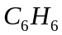). It is a colorless, volatile, and flammable toxic liquid. It is used as a solvent and as a motor fuel. More than one hundred years later, benzene was determined to be a carcinogenic substance. With the advancement of chemistry, a chemical compound called biphenyl was developed. A biphenyl molecule consists of two six-sided benzene rings. A single carbon-to-carbon bond connects the two rings together (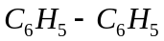). Further modifications of the biphenyl molecule were performed in the subsequent years. In the late nineteenth century, scientists discovered many new compounds by replacing one or more of the hydrogen atoms in the biphenyl molecule with the chlorine atoms. These new products are all classified as polychlorinated biphenyl, or PCBs.
PCBs were introduced into the industry of the United States on a large scale in 1929. They have been in use in most industrial nations of the world after that time. In the normal state, a PCB is a colorless, viscous, and oily liquid. It is relatively insoluble in water. It is chemically stable, resistance to heat, not easily combustible, can withstand high temperature without degradation, and has high electrical resistance. These characteristics make PCBs persistent in the environment. They are used primarily as a dielectric fluid in electrical equipment, such as transformers, capacitors, voltage regulators, etc. Once PCBs are discharged into the living world, they do not degrade and disappear for many decades. In the early 1960s, scientists determined that PCBs are toxic to humans and animals, and may be carcinogenic in humans. PCBs can cause chloracne, skin discoloration, liver dysfunction, reproductive effects, developmental toxicity and oncogenicity in humans. Some PCBs have the ability to alter reproductive processes in mammals. Prenatal exposure in animals can result in various degrees of developmentally toxic effects. Since PCBs are poisonous environmental pollutants, which tend to accumulate in animal tissues, their production has been restricted in the 1970s, and in 1979 a complete stoppage of production. Even though some of the possible sources of PCBs pollution are due to ruptured or burned electrical transformers and other equipment containing PCBs, one of the largest origin of pollution seems to be the manufacturer itself, in this case the Monsanto Company, or its spin-off company called Solutia, located in the city of Anniston, Alabama. In the United States, the Toxic Substance Control Act of 1976 prohibited the manufacture of PCBs in this country in 1979. The Monsanto Company produced PCBs from 1935 to 1971, and was one of only two companies in the United States which manufactured PCBs. Even today, a substantially high level of PCBs exists in the surrounding area of the Monsanto plant, in the creeks where the plant discharged its wastes more than thirty years ago, and in the tissue of fish which people catch in the creeks and lakes.
The PCBs contamination in Anniston occurred more than thirty years ago, however, the health of many people in the surrounding area has been and will be affected for many years to come. If the concepts of engineering ethic and environmental protection had been placed with much more emphasis years ago, then we could have avoided much of the sufferings and problems today.

History of PCBs
PCB is the acronym for polychlorinated biphenyl, which is a generic term for a family of 209 chlorinated isomers of biphenyl. In chemistry, isomers represent compounds that contain the same numbers of atoms of the same elements, but differ in structural arrangement of the atoms, and hence differ in the physical and chemical properties. Before the chlorine atoms are introduced into the compound, the compound itself is identified as the biphenyl molecule. Chemically, a biphenyl molecule can be depicted graphically by two six-sided rings (that is, two hexagonal rings. See Figure 1). A carbon atom is located at the intersection of each pair of adjacent two sides, and the two rings are connected by a single carbon-to-carbon bond. As a consequence, there are a total of 12 carbon atoms in such a structure. To complete the structure of the biphenyl molecule, a hydrogen atom is attached to each carbon atom, pointing outward from the rings. This requires a total of 10 atoms of hydrogen [1]. Note that no hydrogen atom is attached to either of the two carbon atoms bonding the two rings together. A single hexagonal ring, with six carbon atoms and six hydrogen atoms, is called a benzene ring (Figure 2) [2]. Benzene is an organic substance called aromatic compound, because of its fragrant and pleasant smell. Benzene was discovered by Michael Faraday (1791-1867), an English physicist, in 1825. People in the area of physical science remember that Professor Faraday has significant contributions in the field of electricity and magnetism. Benzene is a colorless, volatile, and flammable toxic liquid. It is used as a solvent and as a motor fuel (i.e., a major component of gasoline). It has been associated with significantly increased risks of leukemia
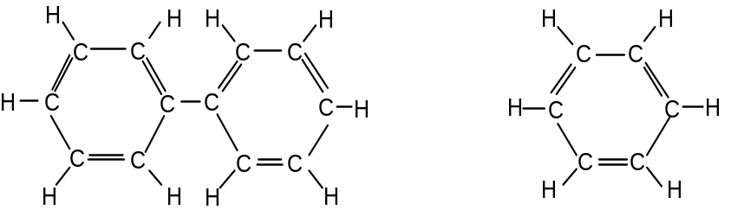
Figure 1. Biphenyl Molecule Figure 2. Benzene Ring

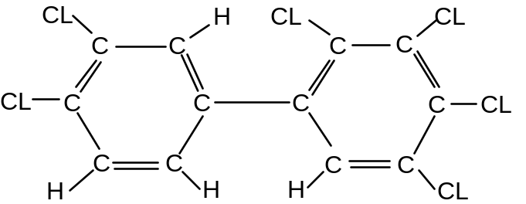
Figure 3. A Polychlorinated Biphenyl (PCB) with Six Chlorine Atoms
among industrial workers exposed to relatively large amounts of this chemical during their working careers. It is considered a carcinogenic substance.
PCBs were discovered in the late nineteenth century. They are created by replacing one or more of the hydrogen atoms in the biphenyl molecule by the chlorine atoms (Figure 3). Up to ten sites are possible for the chlorine atoms to join the biphenyl molecule. The resulting compounds are called polychlorinated biphenyls, or PCBs [3].
PCBs were introduced into the industry of the United States on a large scale in 1929. They have been in use in most industrial nations since that time. In the normal state, a PCB is a colorless, viscous, and oily liquid, and is relatively insoluble in water. It can also exist as a waxy solid. It vaporizes at 862 ºC (1584 ºF). It is chemically stable, resistance to heat, not easily combustible, can withstand high temperature without degradation, and has high resistance against the flow of electricity. These characteristics make PCBs persistent in the environment, and are used primarily as a dielectric fluid in electrical equipment, such as transformers, capacitors, voltage regulators, circuit breakers, switches, and electromagnets. In the United States, no electrical equipment produced since the 1980's contain PCBs. The trade name for a PCB mixture used in a pesticide is called aroclor, which probably means aromatic chlorine. Other commercial and industrial applications include plasticizers in paints, plastics and rubber products; in pigments and dyes; in heat transfer systems and hydraulic systems; and additives in lubricating and cutting oils. More than 1.5 billion pounds of PCBs were produced in the United States prior to its cession in 1979. The Random House Compact Unabridged Dictionary (1996) describes PCBs as "a family of highly toxic chemical compounds known to cause skin diseases and suspected of causing birth defects and cancer." PCBs accumulate in the bottom sediment and in fish, birds, ducks, and other animals on a steady diet of food contaminated with the chemical [4].
In the study of air pollution and water pollution, there are generally two ways to express the concentration of a pollutant. One representation is in micrograms (g) per cubic meter (m³), that is,g/m³ ; another representation is in parts per million, that is, ppm [5], [6]. Both methods are expressed by the ratio of two quantities. In the first method, the numerator, which is the amount of pollutant, is measured in terms of mass, which is in micrograms. One microgram is equal to one millionth of a gram. The denominator is the representative volume, which is in cubic meter. One cubic meter is equal to 264 gallons. This is more than ten times the volume of the gas tank of most cars. In the second method, both the numerator and the denominator are expressed in terms of volume. Thus, one ppm is the ratio of one volume of pollutant to one million total volume. For example, 2 ppm can be two cubic meters of pollutant divided by one million cubic meters of total volume, or it can be two cubic inches of pollutant divided by one million cubic inches of total volume. The two methods of expressing pollutant are mutually convertible. If the density of the pollutant is known, multiply the density by the value of ppm to get the corresponding value in micrograms per cubic meter. The density must be expressed in micrograms per cubic meter, while the volume is expressed in cubic meters. Another way for the conversion is to apply the ideal gas equation of state, especially when the variations in temperature and pressure are to be taken into account.
Some other units for mass and volume are sometimes in use. For example, the mass can be expressed in nanograms instead of micrograms. A nanogram is one thousandth of a microgram. A volume of deciliter can also be used. A deciliter is one-tenth of a liter, and one liter is one-thousandth of a cubic-meter.
The Occupational Safety and Health Administration (OSHA) has established an airborne exposure limit of from 0.5 mg/m³ for a 54% chlorine content PCB, to 1 mg/m³ for a 42% chlorine content PCB, as an 8-hour average [4]. The National Institute of Occupational Safety and Health (NIOSH) recommends that the airborne exposure to PCBs in the workplace be 1g/m³ or less [4]. The Food and Drug Administration (FDA) has established action levels for poisonous or deleterious substances in human food or animal feed. The action level is that limit at or above which the FDA will act to remove the product from the market [4]. The action level for PCBs in fish and shellfish is 2.0 ppm, for milk and dairy product is 1.5 ppm, for poultry is 3.0 ppm, for eggs is 0.3 ppm, and for beef and pork is 5.0 ppm. The Environmental Protection Agency (EPA) sets the Maximum Contaminant Level (MCL) of PCBs in drinking water to be 0.0005 mg/L [4], which is equivalent to 0.5 mg/m³ , or 0.5 g/L. The ultimate goal is to reduce this value to zero. The estimated percentage of the U.S. population with greater than 3 ppm of PCBs in their blood tissue was 2.7% in 1972, and less than 1% in 1981. The decrease in this value is primarily due to the stoppage of production of PCBs in 1979.
Some of the possible sources of PCBs are ruptured or burned electrical transformers and other equipment containing PCBs; PCB-contaminated air, food (such as fish) or drinking water containing PCBs, illegal dumping of liquids containing PCBs, etc.
PCBs can be disposed by several methods. A few of the more effective ways are thermal destruction, chemical neutralization, and micro-organic degradation.
In thermal destruction, the incineration of solid and liquid PCB materials is a highly efficient method. The operation temperature is above 1100 ºC (2000 ºF) for commercial incinerators. A 3% excess oxygen is used for 2 second of contact time. The final goal is the reduction of the waste to ash, vapor, carbon dioxide, and hydrogen chlorine. A rotary kiln incinerator has been in operation at the General Electric plan in Schenectady, New York, to burn PCBs since 1987.
In the chemical neutralization operation, PCB-contaminated liquids can be decontaminated by using a chemical reagent to replace the chlorinated molecule. A metal element, such as sodium, is used to remove the chlorine atoms from the biphenyl molecule. For the PCB contaminated soil, some research has been conducted toward chemical treatment by spraying the reagent on the soil. The effectiveness and the environmental consequences are still not clear.
Microbiological degradation of PCB-contaminated soils has been performed in the laboratory, however, no commercial-scale applications have been developed yet.
History of PCBs Pollution
PCBs were first manufactured by Swann Chemical Company in the early 1920s. The plant, which was located in Anniston, Alabama, was purchased by Monsanto Company in 1935, and Monsanto continued to produce PCBs in Anniston until 1971. Monsanto Company has been one of the leading chemical companies in the United States. Its headquarters is situated in St. Louis, Missouri [7]. The chemical plant is located in the western part of Anniston, Alabama, a city with a population of about 24,000 (Figure 4). Around 1987, the name of the plant was changed to Solutia. Solutia is a spin-off company of Monsanto. From 1952 to 1969, a production line in this plant used mercury and lead to produce the raw materials for PCBs. These raw materials were the biphenyl and chlorine. During this period, Monsanto was the only company in the United States which manufactured the PCBs. To supply chlorine gas to its PCB and insecticide manufacturing units, Monsanto used mercury cells filled with liquid mercury to produce chlorine (During the Monsanto trial in Anniston, it was revealed that insecticides were also produced by Monsanto). Chlorinated hydrocarbon insecticides, sometimes called organic chlorines, contain carbon, hydrogen, oxygen, and chlorine atoms. These insecticides are considered persistent, or long-lasting, because once used, they can affect the environment and living things for many years. From 1928 to 1961, Monsanto also used pots of molten lead to make biphenyl. Biphenyl is the building block of PCBs
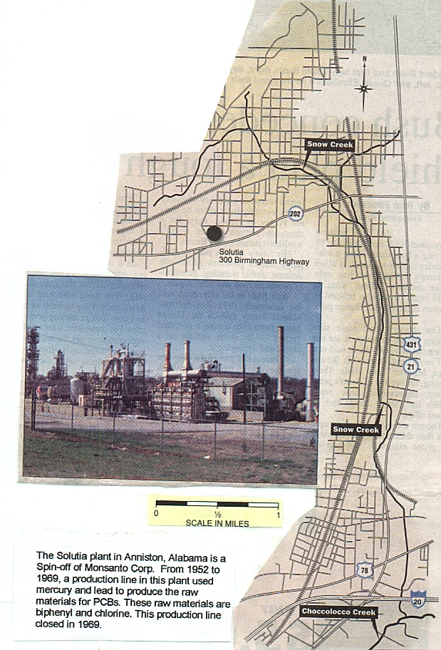
Figure 4. The Monsanto Chemical Plant in Anniston, Alabama

and many other chemical compounds. The pots of lead were used to provide heat for the production of biphenyl (the melting point of lead is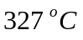, or 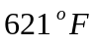).
Before the discovery of PCBs and lead pollution in the local ditches, streams, and low-income neighborhoods, the Monsanto plant in Anniston operated a sodium hydroxide (NaOH, also called caustic soda) and chlorine production line that discharged as much as 50 tons of liquid mercury during its 16 years of operation (this is an average of 521 pounds per month). Shortly before closing the chlorine plant in 1969, the maximum mercury waste stream from the Anniston plant was 570 pounds per month [7]. These data are based on the company record. Employees at the Monsanto plant swept spilled mercury into drainage ditches leading to the storm sewer, where traps recovered liquid mercury for reuse. However, some of these wastes, including mercury, chloride, and other chemicals, eventually went into the storm sewer and were not recovered. Employees at Monsanto periodically cleaned out the mercury ditches and traps. The recovery system was primitive and rudimentary at best. In 1967, two biologists from the Mississippi State University, Dr. Denzel Ferguson and Dr. George Murphy, loaded 10 healthy sunfish into a cage and lowered it into the cement-lined ditch carrying the effluent from Monsanto. This initial location was near the boundary of the plant, in one of the plant's drainage ditches leading to the Snow Creek. The liquid in the ditch looked clear, but the reaction to the fish was immediate. They went belly-up in 10 seconds, and died in five minutes. The two biologists placed more fish cages downstream and found that the lethal effects of the discharge extended into the Snow Creek and continued several hundred yards into its receiving stream, which is the Choccoloco Creek. The length of the Snow Creek is about 5 miles. The larger and longer Choccoloco Creek eventually flows into the Logan Martin Lake, which is more than 25 miles downstream and west of the Snow Creek and Choccoloco Creek confluence. Lab tests performed by Dr. Ferguson's team showed the effluent in the drainage ditches contained mercuric chloride (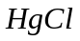), which was a byproduct of the chlorine plant. It is a poisonous chemical and a suspected carcinogen that can convert to methylmercury in aquatic environments. Also, the team discovered "massive" peaks of a mysterious compound on their equipment, which was later identified as PCBs.
Methylmercury (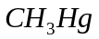) is a toxic compound of mercury. It is produced in inland waters by the action of microorganisms in the bottom mud on mercury, which may remain from prior discharge of waste mercury and mercury compounds. Methylmercury accumulates in animals – particularly in fish – and is especially dangerous for children and pregnant women. It can cause problems ranging from developmental delays to mental retardation, deafness and blindness. It attacks vital organs such as the liver and kidney. It concentrates in the fetus and can cause birth defects. Depending on the concentration and intake, methylmercury can cause unusual weakness, fatigue, and apathy followed by neurological disorders. Numbness around the mouth, loss of vision, poor coordination in speech and gait, tremors of hands, irritability, and depression are additional symptoms leading to possible blindness, paralysis, and death.
In 1970, after the chlorine plant was dismantled, Monsanto informed the Alabama Water Improvement Commission, which is the predecessor of the Alabama Department of Environmental Management (ADEM), about its PCB release in the previous operation. However, company records did not show any measurement of the amount of mercury spills, air emissions, or sludge generated in the production process. In the year 2000, lead contamination was found in ditches and residential soil near the now called Solutia plant. No records of the company show how the lead was disposed once it was rendered useless. Solutia's current director of environmental affairs, Dr. Robert Kaley, said some of the lead was probably dumped in the landfills or sold. In 2001, lead contamination was discovered when the Environmental Protection Agency (EPA) was testing for PCBs in the Western Anniston area. So far, 141 sites were identified as having high levels of lead in the soil. One residence had lead levels that peaked at 4,300 ppm. Using the Superfund, the EPA will focus on removing lead from 15 sites with the highest level of lead. Residents with lead levels higher than 1,200 ppm were given the first priority as they present the greatest risk to pregnant women and children. Workers remove contaminated soil from the residence and replace it with clean soil (Figure 5). They then place a layer of sod over the clean soil. The lead contamination problem in Anniston dates back to the 1860s and stems from the city's history as a hub for foundries, pipe fitters, and other industries. As of March 2002, EPA designated 23 properties in western Anniston for emergency PCB cleanup. These are homes with PCB soil levels higher than 10 ppm. Solutia agrees to remove 12 inches of dirt from each property (Figure 6).
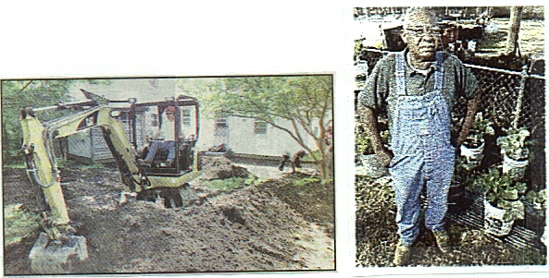
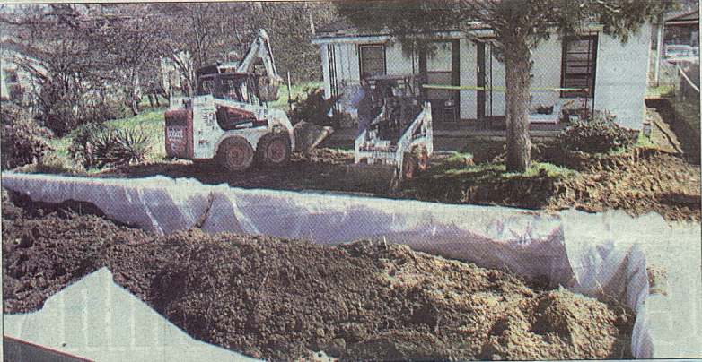
Figure 5. EPA Cleans Lead Contamination Figure 7. Resident Grows With Superfund Collard Greens in Buckets
Figure 6. Emergency PCB Cleanup in a Resident in Anniston, Alabama
Today, testings mandated by the state of Alabama show detectable levels of mercury in fish and sediment in both the Snow and Choccoloco creeks. The reports by ADEM show that, in addition to extremely high levels of PCBs previously recorded in Choccoloco fish, as recently as 1993, some creek fish downstream of Snow Creek also exceeded the 1 ppm advisory for mercury. For the immediate vicinity of the Monsanto plant, EPA advises residents not to consume any vegetables they grow in the yard (Figure 7) [8]. One of Monsanto's landfills nearby the plant contains 10 million pounds of PCBs. All of the sampling data indicate that the waterways, the air, the groundwater and Monsanto-owned land continue to be the sources for PCB contamination.
Legal Lawsuits and Legal Settlements
In 1996, after the state and federal health agencies found a PCB health hazard in the Sweet Valley-Cobbtown area (within one mile radius of the Solutia plant), Solutia bought 44 homes, 39 vacant residential properties, 14 commercial properties, and two churches in the western Anniston area.
Solutia has previously settled two PCB-related cases in the Anniston area: (1) The company gave Choccoloco Creek and Logan Martin Lake property owners $40 millions for contaminating the waterways and committed $21 millions to a Waterway investigation of PCBs. (2) Settled with 1,600 plaintiffs who had property and personal injury claims in western Anniston, giving them $45 millions.
In the year 2001, the claims of 6,600 residents and lake Martin property owners were settled out of court for more than $80 millions.
The legal case of Antonia Tobert versus Monsanto et al has been set for jury trial in February of 2003, in the Birmingham, Alabama federal courtroom of U. W. Clemon, the chief justice for the northern district of Alabama. This is not a class action lawsuit, but the case begins to grow rapidly.
The legal case of Arthur Bowie versus Monsanto et al involves 3,500 plaintiffs. These are current and former residents of the western Anniston area. The case went on jury trial in early January of 2002, in the city of Gadsden, Alabama, which is about 30 miles north of Anniston. The plaintiffs seek compensation for personal injuries, emotional distress, property damages, and cleanup under the federal Superfund statute. Bowie's yard contains PCB levels as high as 1,990 ppm. His blood contains a total of 35 ppm in PCBs. The average level of PCBs in the blood of 15 of the 17 plaintiffs is 47 ppm. On February 22, 2002 [9], after a five-hour deliberation over two days, the trial jury reached a verdict that Monsanto and Solutia are legally responsible for polluting the Anniston area and people's blood with PCBs. The jury's ruling are unanimous, and it contains six counts: negligence, wantonness, fraud, trespass, nuisance, and outrage. However, on March 22, 2002, Solutia filed a petition to the EPA and the U.S. Justice Department, to dismiss or defer the 3,500 Anniston plaintiffs request for a court-mandated PCB cleanup. On the same day, the EPA and the Justice Department announced their intention to file the investigation/cleanup consent decree with Solutia and Pharmacia (this is the company that owns Monsanto), in federal court in Birmingham on March 25, 2002. As a consequence, the court case has not been settled yet.
On October 23, 2002, the EPA and U.S. Department of Justice filed a partial consent decree, or new agreement, with Solutia, Monsanto and Pharmasia, in the U.S. District Court in Birmnigham, Alabama [10]. This decree is in place of a controversial proposed consent decree filed earlier in March of the same year. The new decree states that (a) the EPA, rather than Solutia, will perform a human health risk assessment; (b) penalties for non-compliance will be doubled as compared to previous amounts; (c) if Solutia is not fulfilling the agreement, it cannot challenge the EPA if the agency decides to have the federal government take over the site; (d) Solutia will begin to clean up properties with more than 1 ppm of PCBs far earlier than agreed to in the original decree. No health study is included in the agreement, but the Agency for Toxic Substances and Diseases Registry, a branch of the Centers for Disease Control, has committed to a comprehensive study of the Anniston area. EPA attorneys said the decree should not affect pending lawsuits against Solutia, unless court orders conflict directly with the agreement.
Summary
This paper studies the history of the chemical products PCBs, and the manufacturing procedure of PCBs by a chemical company. The study reveals the utmost importance of engineering ethic and environmental engineering. The emphasis of knowledge in these two engineering curricula has been enhanced by the engineering schools only in the last few decades. Engineering ethic is concerned with the good and bad aspects of any engineering project, and the moral duty and obligation of all engineers to their jobs. Environmental engineering deals with the application of science and engineering principles to minimize the adverse effects of human activity on the environment. When an engineer is possessed of knowledge and experience in these vital areas of engineering study, then much of the problems mentioned in the present paper can be eliminated.

References
1. Ray, Bill T. Environmental Engineering, 1995, page 131. PWS Publishing Company, Boston. MA.
- Robinson, Holtzclaw, College Chemistry, 1988, 8th ed. Page 876. D.C. Heath and Company, Lexington, MA.
- Miller, John A., Neuzil, E. F. Organic Chemistry, 1979, page 161. D.C. Heath and Company, Lexington, MA.
- Salvato, Joseph A. Environmental Engineering and Sanitation, 1992, 4th ed. Pages 236, 277, 278, 709, 928, 1222. John Wiley & Sons, Inc. New York, NY.
- Vesilind, P. Aarne, Pierce, J. Jeffrey, Weiner, Ruth F. Environmental Engineering, 1994, 3rd ed. Pages 358, 359. Butterworth-Heinemann, Boston, MA.
- McGraw-Hill Encyclopedia of Science & Technology, 1997, page 158, 159.
- The Anniston Star (a newspaper), Bluemink, Elizabeth. July 20, 2001.
- The New York Times (a newspaper), Sack, Kevin, and Langston, Jacob. January 27, 2002.
- The New York Times (a newspaper), Firestone, David. February 22, 2002. Also The Anniston Star, February 22, 2002.
10. The Anniston Star (a newspaper), Clemence, Sara. October 24,2002.

P. S. Yeh
P. S. Yeh received his B.S. degree from the National Taiwan University, in Taipei, Taiwan, the M.S. degree from the University of Illinois in Urbana-Champaign, Illinois, and the Ph.D. degree from Rutgers University in New Brunswick, New Jersey, all in Mechanical Engineering. He is a professor emeritus in engineering at Jacksonville State University, in Jacksonville, Alabama. His major areas of teaching and research are in fluid mechanics, thermodynamics, heat transfer, computer-aided design, computer programming, acoustics, and environmental engineering.

Professor Emeritus of Engineering, Jacksonville State University, 205 Macon Drive, Jacksonville, AL 36265. E-mail: psyeh@jsucc.jsu.edu

