Outcomes Assessment: Electronic Surveys Versus Paper-Based Surveys
Randy V. Bradley and Chetan S. Sankar

Abstract
The Accreditation Board for Engineering and Technology (ABET) requires engineering departments to have a system of on-going evaluation that demonstrates achievement of objectives and uses the results to improve the effectiveness of the program. An important tool in the evaluation process is the survey instrument that is given to students, faculty members, and alumni in order to receive their feedback. Instructors and assessors have the option of developing and using paper-based survey instruments versus electronic survey instruments. The purpose of this paper is to present some lessons learned while conducting assessment research for the Laboratory for Innovative Technology and Engineering Education (LITEE) case study project at several universities, in the southeastern United States, over a period of many years. This paper also presents five factors that must be considered when conducting an assessment study using both paper-based and electronic surveys, consistency, handling of null values, sociological factors, presentation (formatting and resolution), and version control (pairing the correct version of the survey with the responses). We discuss the factors in this paper and provide guidelines on developing and using paper-based and electronic surveys.

Introduction
The Accreditation Board for Engineering and Technology (ABET) requires engineering departments to have a system of on-going evaluation that demonstrates achievement of objectives and uses the results to improve the effectiveness of the program. An important tool in the evaluation process is the survey instrument that is given to students, faculty members, and alumni in order to receive their feedback. Instructors and assessors have the option of developing and using paper-based survey instruments versus electronic survey instruments.
For many years, faculty members and researchers have been trying to find ways to increase the response rate of their survey instruments, reduce the time it takes for a subject to respond, and minimize the burden of inputting and cleaning the data collected. In an effort to increase response rates, shorten response times, and reduce the burden of inputting and cleaning the data, more researchers have opted to turn to today's technology and employ the modern method of data collection--electronic surveys.
The purpose of this paper is to present some lessons learned while conducting assessment research for the Laboratory for Innovative Technology and Engineering Education (LITEE) case study project at several universities, in the southeastern United States, over a period of many years. The nature of the research project required development and use of a combination of paper-based surveys and electronic surveys for data collection purposes. During the process of inputting, cleansing, and analyzing the data, we had considerable problems and were able to identify five factors that must be considered when conducting an assessment study using both paper-based and electronic surveys. These five factors are: consistency, handling of null values, sociological factors, presentation (formatting and resolution), and version control (pairing the correct version of the survey with the responses). We discuss the factors in this paper and provide guidelines on developing and using paper-based and electronic surveys.

Literature Review

Paper-Based Surveys
Paper-based surveys, as a means of collecting data, have been in use for years (McCoy and Marks, 2001). Due to their sustained prominence in the research community, paper-based surveys have come to be readily accepted and understood by most scholars and research participants. This is not to say that paper-based surveys are without flaw and painless to use, rather just the opposite. Although the construction of the instrument may not be painstaking, the usage of paper-based surveys has many inherent problems that make this method of data collection difficult and time consuming. Inherent problems include, but are not limited to, low response rates (Fox et al., 1988), long response times, illegible and incomplete data, expensiveness (McCoy and Marks, 2001), and data entry errors. It is problems such as these that have prompted researchers to find a better or more convenient way in which to conduct their research. Some researchers have attempted to fax surveys hoping to curb some of the cost usually incurred when doing mass mailings. Others have attempted to use scantrons in an effort to minimize illegible data and eliminate data entry errors. Although there appears to be ways to circumvent some of the inherent problems with paper-based surveys (i.e. illegible data, expensiveness, data entry errors), the problems of low response rates, long response times, and incomplete data continue to be issues of major concern. It is the abovementioned concerns that researchers are hoping can be resolved by using electronic surveys.

Electronic Surveys
Electronic surveys include surveys that are both conducted and submitted electronically via some means of technology. The initial reason for employing technology to conduct research was to attempt to increase the response rates (Bachmann et al., 1999; Cobanoglu et al., 2001). In the past, most electronic surveys were conducted and submitted via email, but with growing popularity of the Internet, web-based surveys have emerged to be the methodology of choice by some researchers (Cobanoglu et al., 2001). This paper limits the discussion of electronic surveys to mean web-based surveys only. Dillman (2000) cited that not all members of a population have access to the Internet as a concern in using web-based surveys alone. While this may have been a valid concern in 2000, we don’t perceive this as being an issue today. However, research has shown that using more than one method of data collection can yield higher repose rates (Cobanoglu et al., 2001).

Mixed-Mode Surveys
Another method used is mixed-mode surveys, where both paper-based and electronic surveys are used. The use of mixed-mode surveys has the potential to open the door for measurement differences between modes, especially when the surveys are used for the same population (De Leeuw, 1992; Dillman, 2000). Although these problems could prove to be difficult to resolve in a research project, Dillman (2000) suggests that employing a unimodal design for the surveys can eliminate the problems associated with measurement differences between modes.

Research Questions
The purpose of this paper is to present lessons learned when conducting mixed-mode surveys, report our experiences with use of mixed-mode surveys and make recommendations about how to develop and conduct such research. Thus the research questions for this paper are as follows:
Question 1: What were the issues encountered when conducting research using mixed-mode surveys?
Question 2: How can researchers overcome the issues associated with conducting research using web-based and paper-based surveys?
Question 3: What recommendations can be made to aid researchers in conducting research experiments using web-based and paper-based surveys?

Research Experiment
The LITEE group at Auburn University led by Drs. P.K. Raju and Chetan S. Sankar has developed case studies that bring real-world issues into engineering classrooms. The case studies consisted of real world problems, which were presented to the students by representatives of the company using text, videos, and photos. In addition, competency material needed for the students to work on the case study was also provided using CD-ROMs (Raju and Sankar, 2002).
In order to assess how the use of these case studies impacted student learning, questionnaires were developed (Hingorani, et al., 1996; Mbarika, et al., 2002). The questionnaires were administered to engineering and business students at four major universities, University of Virginia (UVA), Mercer University, Louisiana State University (LSU), and Auburn University (AU). Due to the geographic separation of the participants in our studies, the usage of mixed-mode surveys was the methodology of choice. The two modes chosen for the study were paper-based and web-based.
In assessing the usefulness and relevance of the case studies and multimedia instructional materials, students at LSU, Mercer, and AU were provided both the paper-based and web-based surveys, whereas students at UVA were provided only one type of survey, paper-based. The authors received the completed surveys for the purpose of writing assessment reports that were sent back to the participating universities. It was during the analysis and writing of the reports that we encountered a few problems and discrepancies.
The electronic surveys were developed using Microsoft FrontPage and hosted on the web page of LITEE and are available at www.auburn.edu/research/litee. We provide examples of the survey instruments used in Appendices A and B.

Factors Identified in Developing and Implementing Questionnaires
When the data were analyzed, we identified five factors that need to be addressed before using mixed-mode surveys in research experiments. The five factors are: consistency, null values, sociological factors, presentation, and version control.
The first factor to be considered is consistency. Consistency refers to the oneness that exists between paper-based and web-based surveys. In order to accurately capture information, there should be no significant difference in the overall structure of the paper-based and web-based surveys. The second factor is the handling of null values. The research design should either be setup to prevent null values or robust enough to handle for null values. Thirdly, sociological factors should be considered. The researchers should be aware of the style and background of the participants in the experiment, and thus design the instruments to fit the experimental groups. The next factor needing consideration is presentation (formatting and resolution). Like the consistency factor, the presentation of each instrument should be done in a manner that would not cause others to wonder or be concerned with possible instrument bias. Finally, the fifth factor to be considered is version control. The researcher should be proactive and take every necessary precaution to ensure that he/she is able to pair the correct version of the survey with the correct responses.

Recommendations for Improvements to Research Design
Based on the experience gained in inputting, cleaning up, and analyzing the data (paper-based and web-based from AU, paper-based and web-based from LSU, paper-based and web-based from Mercer, and paper-based from UVA), we make recommendations about how to address the issues created.

Consistency Factor
While analyzing completed surveys, we noticed that the items on the web-based survey did not appear in the same order as the items on the paper-based survey. That is the order of the questions was changed in the web-based survey compared to the paper-based survey. In addition, the web version was changed a few times and there was no electronic record kept of the changes. This created issues in analyzing the data. In a paper-based questionnaire, this bias is non-existent since the final surveys are available along with the results and the researcher can verify the accuracy of the data. Since the answers to the electronic surveys are stored in a file away from the source of the data, issues arose as to which answers corresponded to which items.
This can become a major problem when trying to map survey items to various constructs or factors in the research model. The researcher must take care to avoid such a costly mistake, as it can prove to be damaging to the data analysis of the research project.

Null Value Factor
There is no sure fire way to prevent null values on paper-based surveys, but surveys to be conducted on websites should have the intelligence to prevent an individual from submitting an assessment in which items are not answered. We encountered situations where many of the questionnaire items were not answered. The frequency of this was much more than that found in the paper-based questionnaires.
If the nature of the research doesn’t require participants to answer all questions, it would be better to add a “no response” or “N/A” item to the scale. The web-based surveys we used required participants to submit survey 1 before proceeding to survey 2. This approach becomes a problem when and if participants choose not to complete both evaluations at the same time. When this occurs, the participants come back and submit evaluation 1 without selecting any items on the scale, thus submitting a blank evaluation, and then complete evaluation 2. This further complicates the cleaning of the data. To prevent this from happening, each evaluation should be listed on the website in a manner that would enable participants to access any given evaluation without going through another evaluation.

Sociological Factor
This factor assumes that the researcher has some knowledge about the participants in the research experiment. When considering the usage of web-based surveys for research projects, researchers must consider the sociological make-up of the participants. For instance, we noticed a difference in the way students recognized the reverse coding of items. It was apparent that when items were reverse coded, students appeared to not recognize the reverse coding of some items on the web-based surveys. Our experiences indicate that students were better able to accurately identify the reverse coded items on paper-based surveys in comparison to web-based surveys. We believe this bias existed since people might read questions on a web-based survey differently than the way in which they read a paper-based survey. The researcher must consider the way individuals read text on websites and decide whether or not it is a good idea to reverse code items on a web-based survey.

Presentation Factor
While analyzing completed surveys, we noticed that the web-based surveys were formatted differently than paper-based surveys. The items on the web-based surveys did not line up in the same manner as the items on the paper-based surveys. In other words, some items on the web-based survey wrapped to the next line, thus disrupting the appearance of the items listed below it. This happened since different participants used different systems to view the questionnaires. This problem does not happen in the paper-based survey since formatting is not an issue.
When designing surveys for a website, the research should take into consideration the screen sizes and resolutions that will be used by the participants to view the survey. A resolution and formatting scheme should be chosen that would accommodate different monitor sizes and Internet browsers.

Version Control Factor
We noticed that at times the web-based surveys would be revised to reflect changes in the factors being measured, but the database in which the information was being stored did not reflect the changes, in regards to the names of variables. Screen shots of the web-based survey should be taken prior to the collection of data, in order to be able to match the responses with the correct version of the web-based survey. Another solution would be to develop a website that is intelligent enough to capture the version number of the web-based survey and store it in the database along with the collected data. Another issue encountered was that the order of the columns in the database did not always match the order of the items on the electronic instrument, which presented a problem if one did not have immediate access to the instrument when analyzing the data. Special care must be taken to ensure that the structure of the repository used to store the data accurately reflects the structure and order of the items on the web-based survey. In regards to paper-based surveys, each survey should have a revision date printed on the first page. This will allow researchers to keep track of the changes to the survey that have occurred over time.

Future Research
Further research needs to be conducted using mixed-mode surveys. The completed surveys would then need to be investigated for errors and discrepancies associated with both types of surveys. A limitation of this study is that there are no quantitative estimates as to the number of errors or discrepancies encountered when using paper-based and web-based surveys. Finally, error counts from both types of surveys would need to be compared to determine which survey type is more efficient.

Summary and Conclusion
In this paper we discussed paper-based surveys, web-based surveys, and mixed-mode surveys. We also discussed how we used the various surveys to conduct assessment studies at four universities. This paper discussed the five factors that need to be considered when administering mixed-mode surveys that consist of paper-based and web-based surveys. Further research needs to be performed to provide statistically valid counts of the types of errors and processes to minimize those errors. This research on using paper-based and web-based surveys is of great interest to the academic community since it provides the means to increase response rates, decrease response times, minimize illegible data, and improve the accuracy of the data by reducing the burden of data entry.

References
Bachmann, D.P., Elfrink, J., and Vazzana, G. Email and Snail Mail Face Off in Rematch. Marketing Research (11:4), 1999.
Church, A. H. Estimating the Effect of Incentives on Mail Survey Response Rates: A Meta-analysis. Public Opinion Quarterly (57:1), 1993.
Cobanoglu, C., Warde, B., and Moreo, P.J. A Comparison of Mail, Fax, and Web-based Survey Methods. International Journal of Market Research (43:4), 2001.
De Leeuw, E.D. Data Quality in Mail, Telephone and Face-to-Face Surveys. Amsterdam: TT-Publikaties, 1993.
Dillman, D.A. Mail and Internet Surveys: The Tailored Design Method, 2nd Edition. New York: John Wiley and Sons, 2000.
Fox, R.J., Crask, M.R., and Kim, J. Mail Survey Response Rate: A Meta-Analysis of Selected Techniques For Inducing Response. Public Opinion Quarterly (52:4), 1988.
Mbarika, V., Sankar, C.S., Raju, P.K. (Forthcoming). Identification of Factors that Lead to Perceived Learning Improvements for Female Students. IEEE Transactions on Education (forthcoming)
McCoy, S., Marks, P.V. Using Electronic Surveys to Collect Data: Experiences from the Field. Proceedings of the Seventh Americas Conference on Information Systems, 2001.

Appendix A

Screens of web-based survey

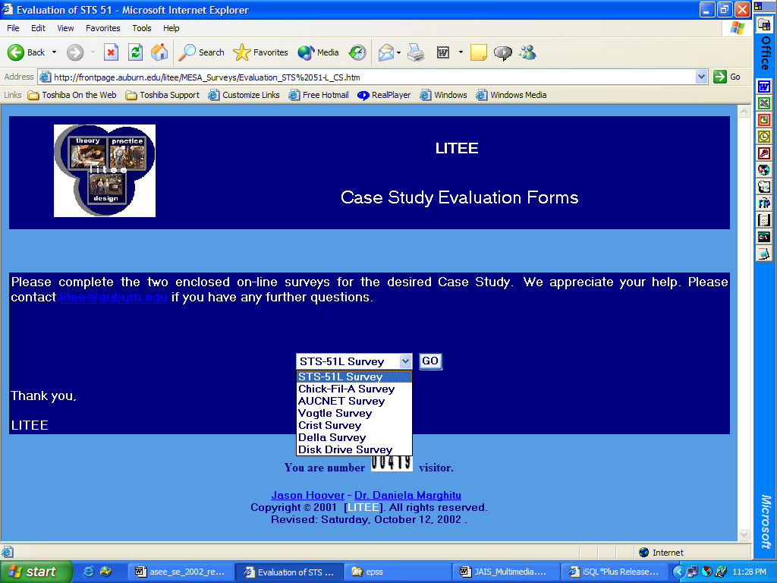



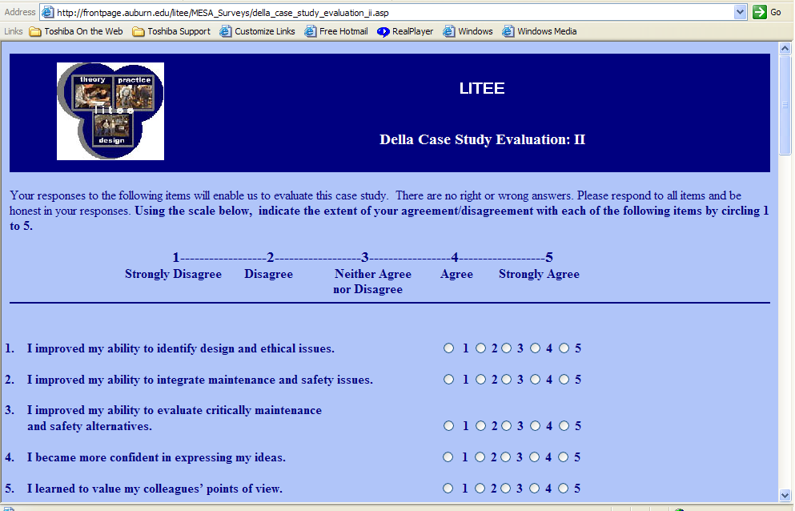

Appendix B

Examples of paper-based survey
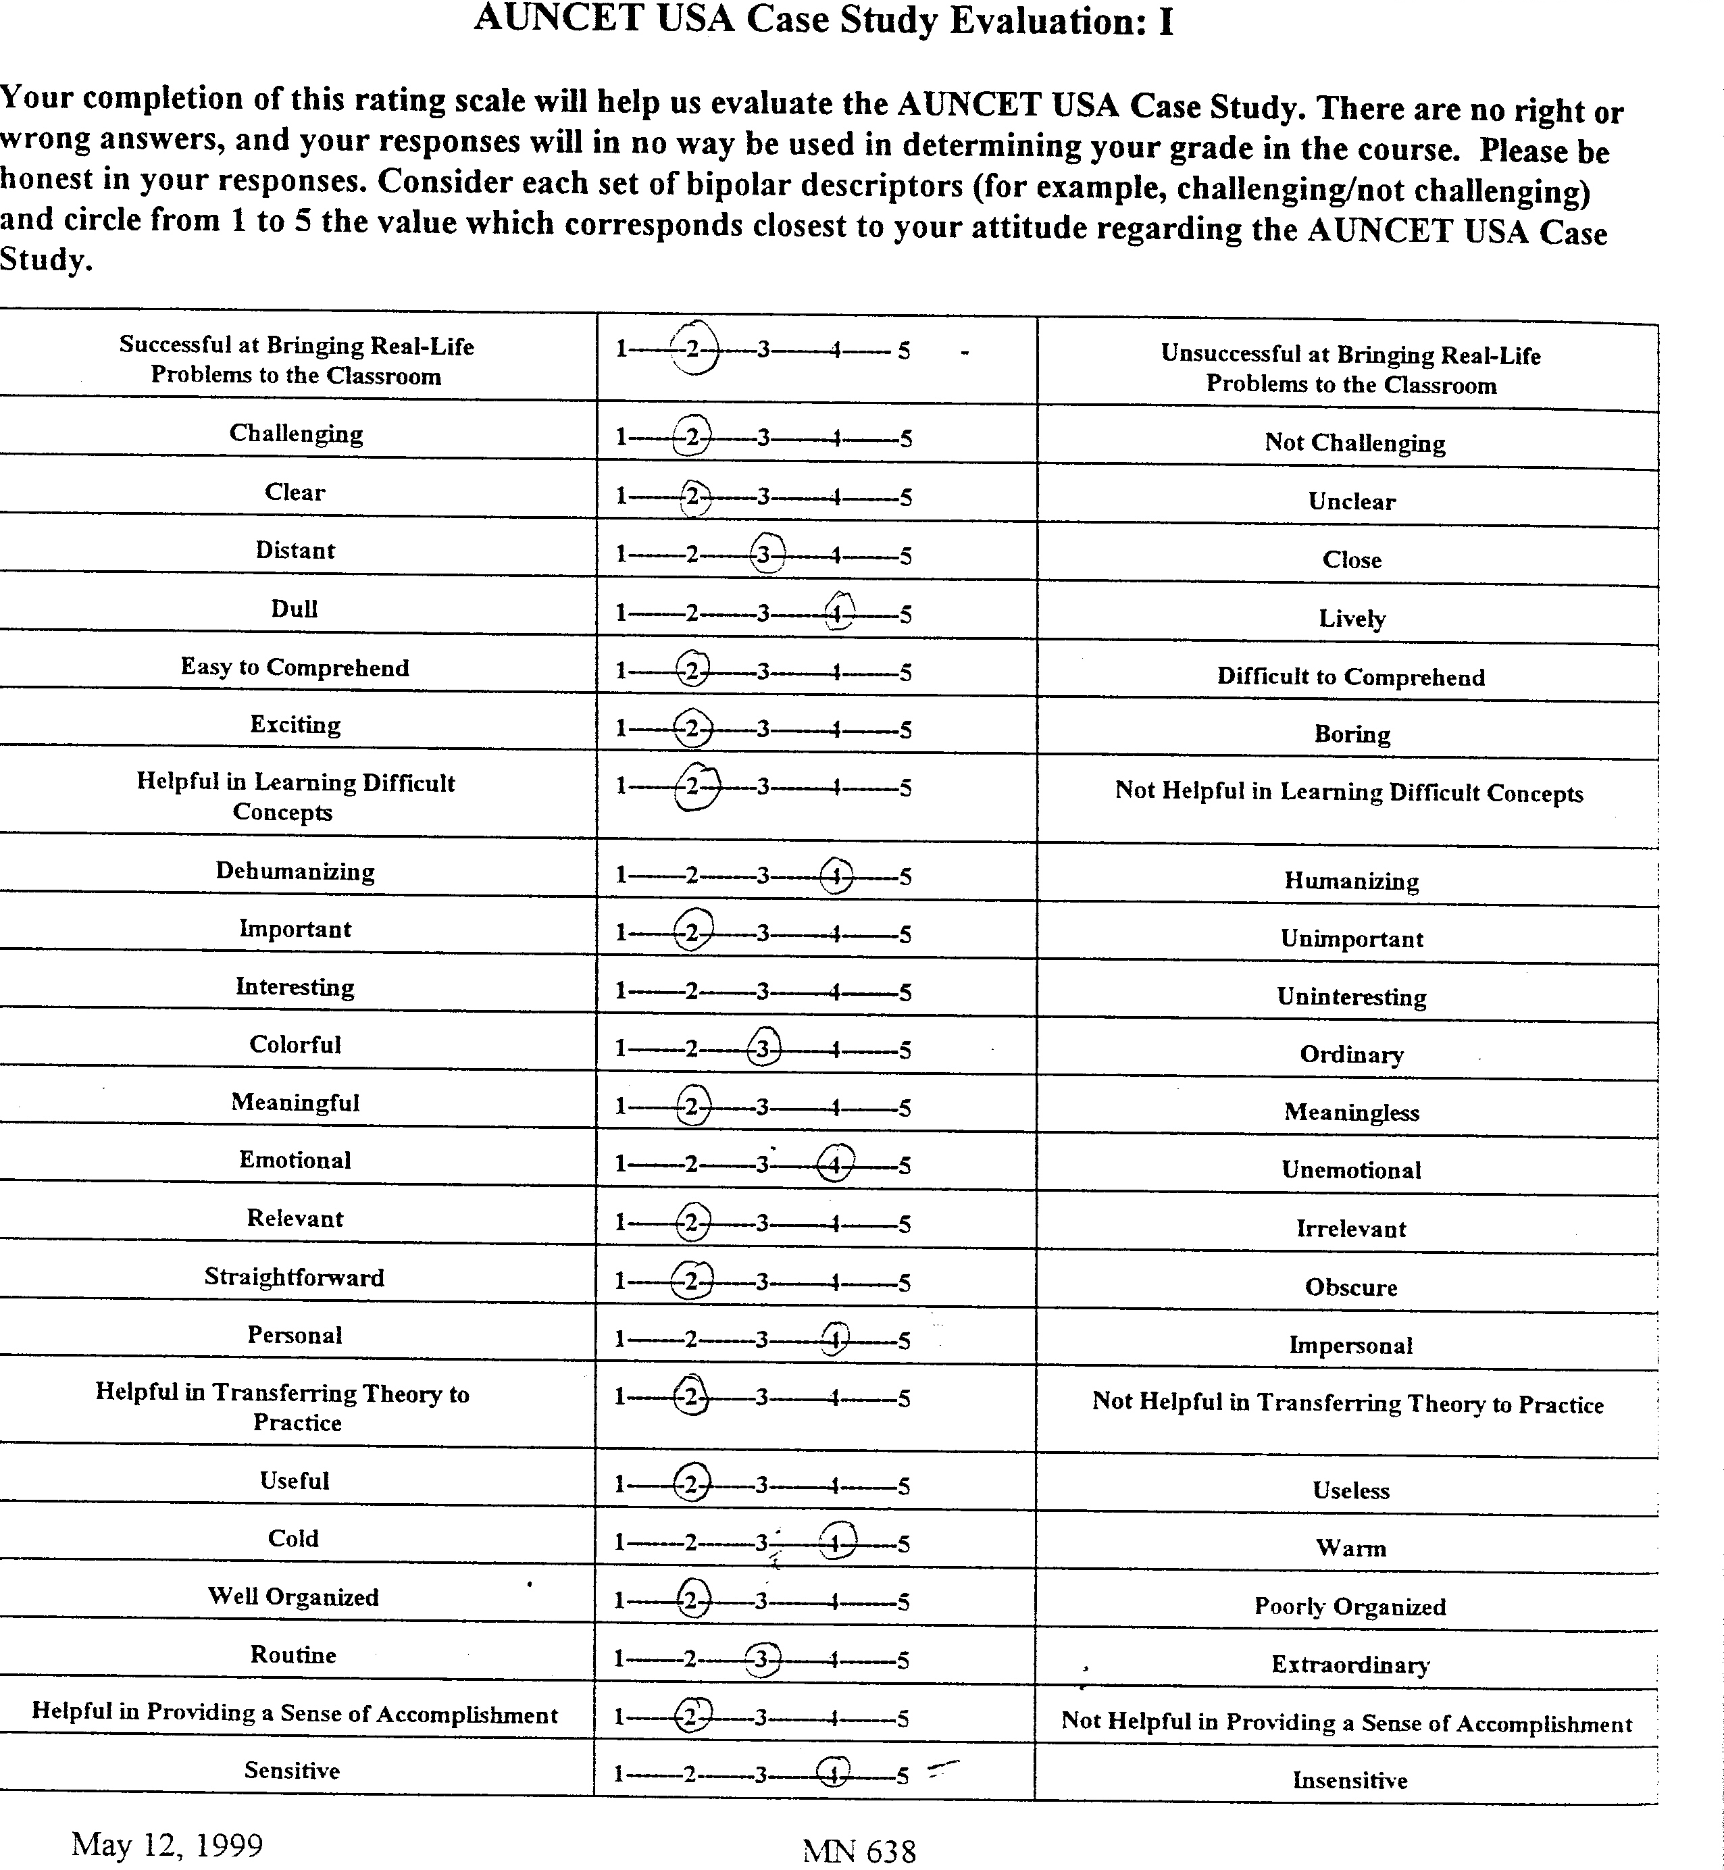
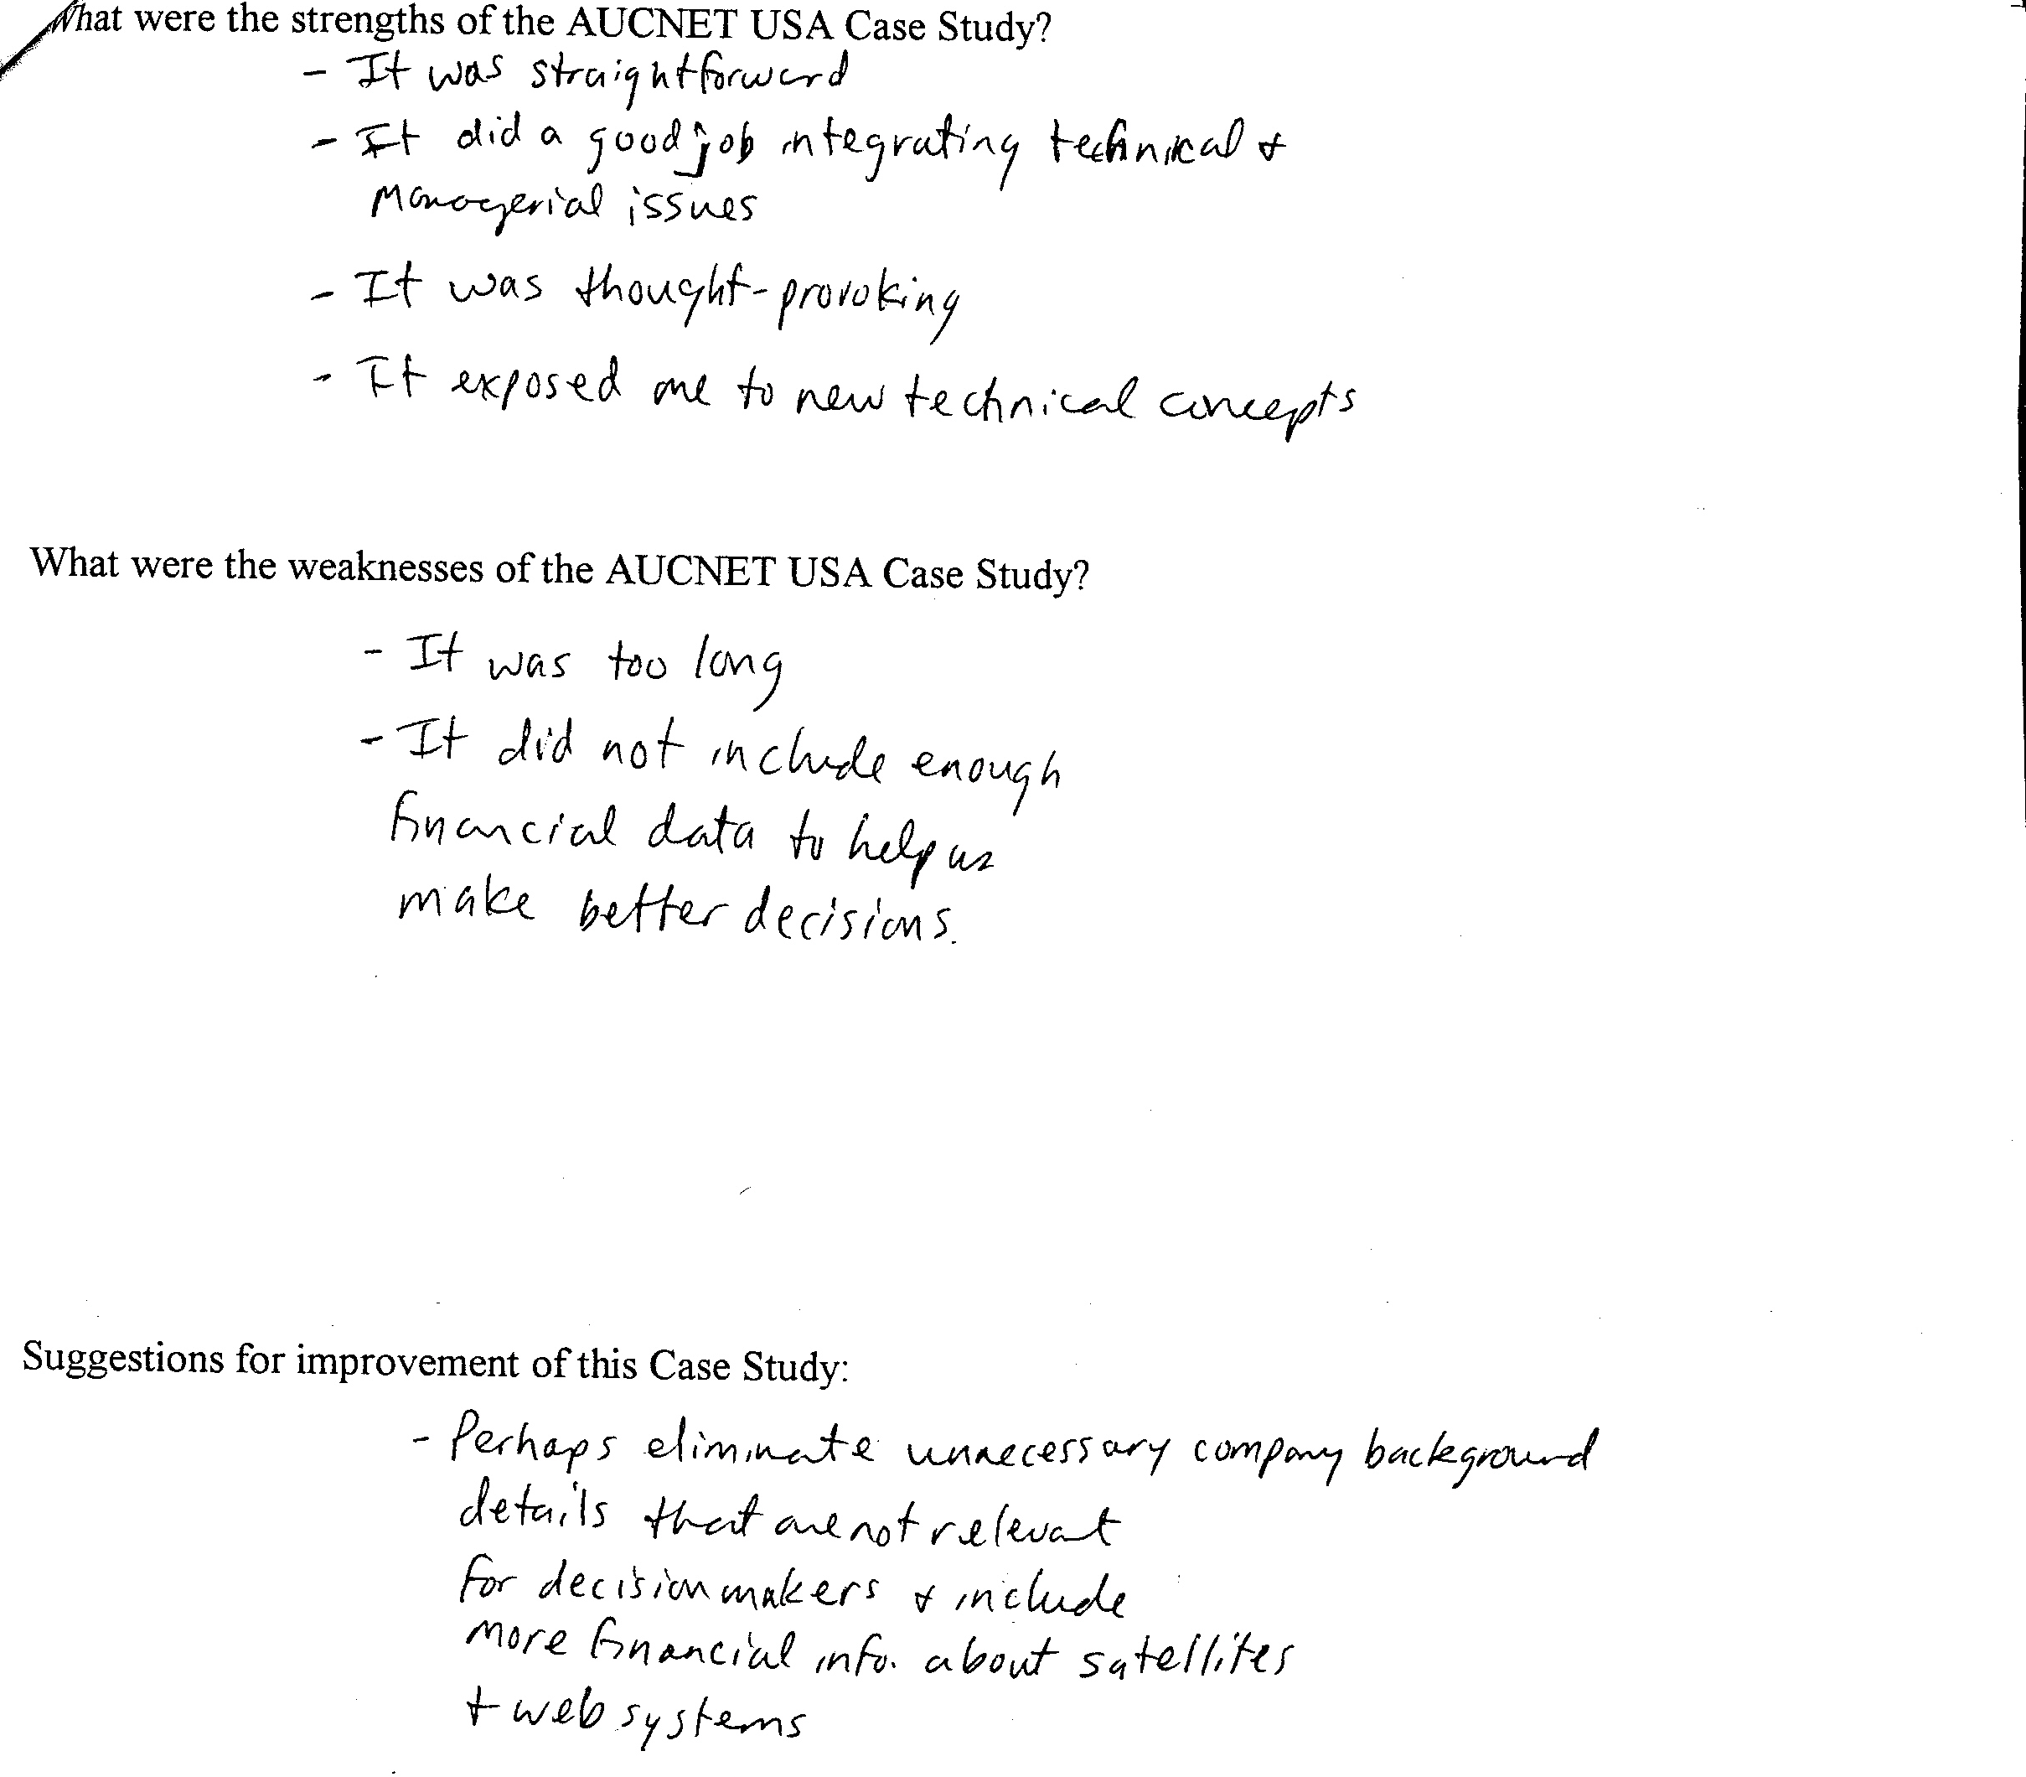
.

Randy V. Bradley
Randy Bradley received a B.S. degree in Computer Engineering from Auburn University in 1997. He received a M.S. degree in Management Information Systems (MIS) from Auburn University in 2001. He is currently a SREB Doctoral Scholar and Doctoral Candidate in MIS at Auburn University.

Chetan S. Sankar
Chetan S. Sankar is currently the Thomas Walter Professor of Management at Auburn University's College of Business. He received his Ph.D. from the Wharton School, University of Pennsylvania and has worked at Temple University and at AT&T Bell Laboratories. He is a Co-Principal Investigator of four National Science Foundation grants worth more than a million dollars. The objective of these grants is to develop exceptional instructional materials that bring real-world issues into classrooms and to improve the higher-level cognitive skills of students. These instructional materials have been published and made available as nine textbooks that include multimedia CD-ROM supplements. The case studies and supplements bring alive the issues faced by Southern Company, Powertel, Chick-fil-A, AUCNET USA, and other companies into the classrooms. In addition to his current research and teaching interests, Dr. Sankar has published more than 100 papers in journals, book chapters, and conference proceedings. He has won many awards for research and teaching from the Society for Information Management, NEEDS and John Wiley and Sons, Decision Sciences Institute, American Society for Engineering Education - Southeastern Section, American Society for Mechanical Engineering, Auburn University, and the Project Management Institute. In order to promote the research interests of other academicians who want to publish high-quality case studies and papers that integrate real-world issues with theories in science, mathematics, engineering, and technology (SMET) fields, he co-edits the Journal of SMET Education: Innovations and Research. Further information about Dr. Sankar’s research and teaching accomplishments could be obtained from the web site: www.auburn.edu/~sankacs.

Randy V. Bradley, SREB Doctoral Scholar, Department of Management, Auburn University, AL 36849, bradlrv@auburn.edu, Phone: 334-844-6483, Fax: 334-844-5159
Chetan S. Sankar, Thomas Walter Professor, Department of Management, Auburn University, AL 36849, sankar@business.auburn.edu, Phone: 334-844-6504, Fax: 334-844-5159

