Conference Site Planning Meeting
October 16, 2014 – 3pm – Microtel Inn & Suites – Atlanta GA
Preliminary Minutes

Attendance
Name | Position | Email Address | School
Aidan Browne | ENGINEERING TECHNOLOGY DIVISION Chair: | aidanbrowne@uncc.edu | UNC Charlotte
Amber Thompson | ADMINISTRATIVE DIVISION Secretary: | athompson@isothermal.edu | Isothermal Community College
Beth Todd | Following Year Conference Site Coordinator | btodd.eng@gmail.com | University of Alabama
Chuck Newhouse | CIVIL ENGINEERING DIVISION Chair: | NewhouseCD@VMI.edu | Virginia Military Institute
Daniel Kohn | SECTION OFFICER Secretary-Treasurer | dekohn@memphis.edu | University of Memphis
David Calamas | INSTRUCTIONAL DIVISION Secretary: | dcalamas@georgiasouthern.edu | Georgia Southern University
Hodge Jenkins | MECHANICAL ENGINEERING DIVISION Chair: | jenkins_he@mercer.edu | Mercer University
| | Last Year Conference Site Coordinator | jenkins_he@mercer.edu | Mercer University
Jerry Newman | ENGINEERING TECHNOLOGY DIVISION Vice Chair: | jdnewman@memphis.edu | University of Memphis
| | PROGRAM UNIT Vice President | jdnewman@memphis.edu | University of Memphis
John Abbitt | Upcoming Year Conference Site Coordinator | jda@ufl.edu | University of Florida
Ken Brannan | CIVIL ENGINEERING DIVISION Vice Chair: | Ken.Brannan@citadel.edu | The Citadel
| | SECTION OFFICER Newsletter Editor | Ken.Brannan@citadel.edu | The Citadel
Matthew Jensen | MECHANICAL ENGINEERING DIVISION Secretary: | mjensen@fit.edu | Florida Institute of Technology
Paul Palazolo | INSTRUCTIONAL DIVISION Chair: | ppalazol@memphis.edu | University of Memphis
| | SECTION OFFICER President Elect | ppalazol@memphis.edu | University of Memphis
| | AWARDS AND RECOGNITION Vice President | ppalazol@memphis.edu | University of Memphis
Priscilla Hill | SECTION OFFICER Past President | Phill@che.msstate.edu | Mississippi State University
Ruby Mawasha | Zone II Representative | ruby.mawasha@wright.edu | Write State University
Sally Pardue | K-12 DIVISION Chair: | spardue@tntech.edu | Tennessee Tech
Scott Schultz | INDUSTRIAL ENGINEERING DIVISION Vice Chair: | schultz_sr@mercer.edu | Mercer University
Tanya Kunberger | PROGRAM UNIT Vice Chair | tkunberg@fgcu.edu | Florida Gulf Coast University
Tim Wilson | ADMINISTRATIVE DIVISION Chair: | Timothy.Wilson@erau.edu | Embry-Riddle Aerou
| | AWARDS AND RECOGNITION Secretary | Timothy.Wilson@erau.edu | Embry-Riddle Aerou
Tulio Sulbaran | SECTION OFFICER President | Tulio.Sulbaran@usm.edu | University of Southern Mississippi
Tyson Hall | COMPUTER ENG & TECH DIVISION Vice Chair: | tyson@southern.edu | Southern Adventist University

- Meeting called to order at 2:55pm by Tulio Sulbaran.

- Welcome and Introductions

- Motion to approve edited meeting minutes from 2013 Conference Site Planning Meeting made by Tyson Hall, 2nd by Hodge Jenkins. Approved Unanimously.

- 2014 Conference Report (Hodge Jenkins)
  - 198 attendees last year (including 75 students). 96 papers and 46 poster presentations.
  - The Mercer conference made $13,478.90 .
  - Lessons learned
    - Used EventBrite for conference organization (since campus did not have a system for handling conference registration) It worked very well and is recommended for future use.
  - Suggest that all future sites get a meal count as part of the registration process (worked well).
  - Suggest a workshop coordinator (different than the Site coordinator)
  - Need to be clear with students on “poster Board”, “Poster” or tri-fold.
  - Need to think of how to organize posters (organize per how they are judged perhaps)

- 2015 Conference Report (John Abbitt)
  - Conference to be hosted by the University of Florida at the Hilton Conference Center.
  - Hotel has shuttles to/from airport.
  - There are three museums across the street. One will be the host for the reception (right now leaning towards the Florida Museum of Natural History).
  - Seven meeting rooms are reserved for sessions
  - Student poster session will be in the main hall (outside the meeting rooms) Breaks will also take place in this space.
  - Expect a large number of student posters. ASEE event corresponds to a student research event on campus.
  - Banquet will be on site.
  - Registration website ready to go (awaiting approval of budge before going online)
  - Details to be verified
    - Need to verify setup for breakfast meetings
    - Verify room/location for annual meeting (for bylaw / constitution change voting)
    - Call for workshops needs to go out
      - It was suggested that Tim Wilson do another Arduino Workshop
      - Possible workshop on Solidworks

- Technical Program (Tanya Kunbuerger)
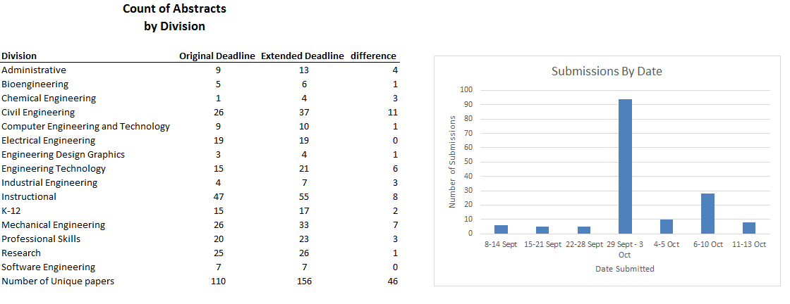
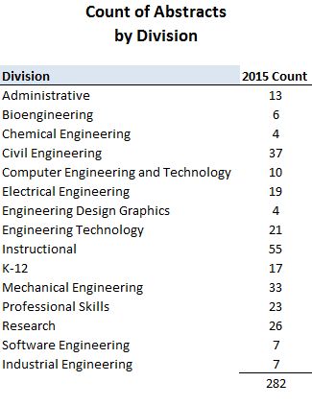
Please note: in the above, papers are counting in multiple categories
  - Items of note:
    - 129 Unique first authors
    - 55 papers listed as instructional.
    - Record number of abstracts submitted this year.
  - Preliminary schedule was presented but will be adjusted for 7 session rooms.
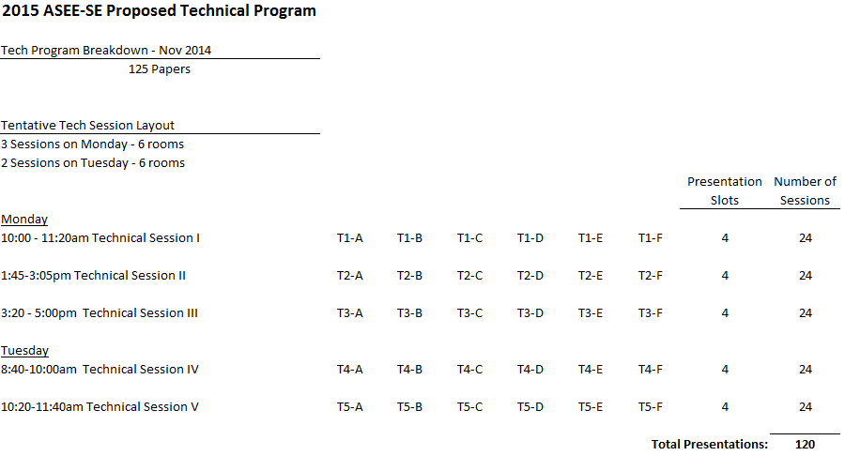
- Conference Publications (Tanya Kunbuerger)
  - Tanya brought up a number of questions on the topic of the Conference “book”
    - Should we go back to “Book of Abstracts” vs the “Conference Schedule” book that was used last year.
    - Should we drop Extended Abstracts (requiring only the short abstract).
    - How will the conference proceedings be distributed this year (CD/DVD/USB Thumb drive)
  - There was some discussion on these points, but since most of these items either affect the budget and/or were discussed at previous executive meeting, discussion and decisions on these topics were tabled until the executive meeting.

- 2016 Conference Site Report – University of Alabama (Beth Todd)
  - Due to changes in the Dean’s office, there was a delay in forming the organizing committee so the following is preliminary information and is subject to change.
  - New facilities at University of Alabama South Eng Research Center and North Eng Research Center will be utilized for the conference. The only issue will be the keynote session (no room in those buildings holds more than 90). Maybe a ball room at Hotel Capstone, Museum of Natural History or Tuscaloosa River Market will be utilized for this session.
  - Multiple hotel possibilities. Hotel Capstone $115 a night, Holiday Inn and Hampton Inn as alternates
  - Possible dates Spring Break March 13-15 2016 (or March 20-22) yet to be officially announced by provost approval.

- Old Business (none)

- New Business
  - It was decided that Taskforce to evaluate and investigate changes and clarification of divisions and sections (both to suit the needs of ASEE SE and to align our divisions to National’s). The Taskforce consists of Paul Palazolo (Chair), Tanya Kunberger, Beth Todd, David Calamas, Amber Thompson. Their report is due to the executive committee by Feb 1 so that, if bylaws and constitutions changes are needed, they can be developed and sent out 30 days before the conference (as required).

- Adjourned at 4:55pm

